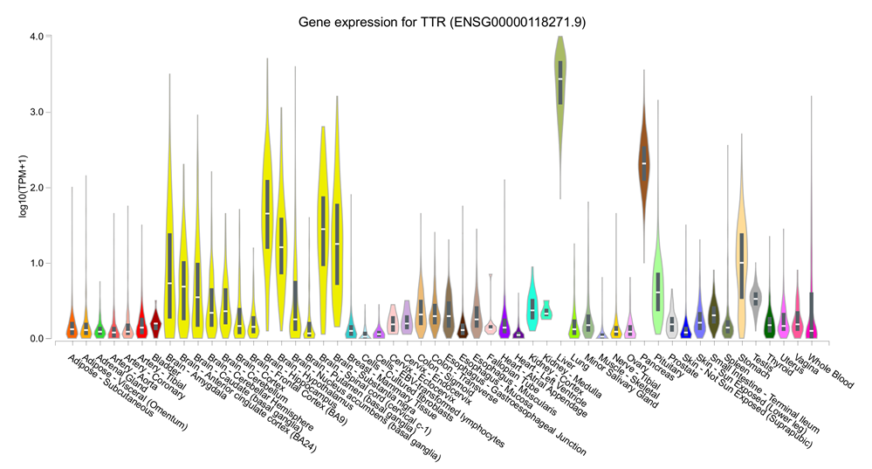

Supplementary Figure 1: TTR transcriptomic profile in 54 human tissues available from GTEx V8.

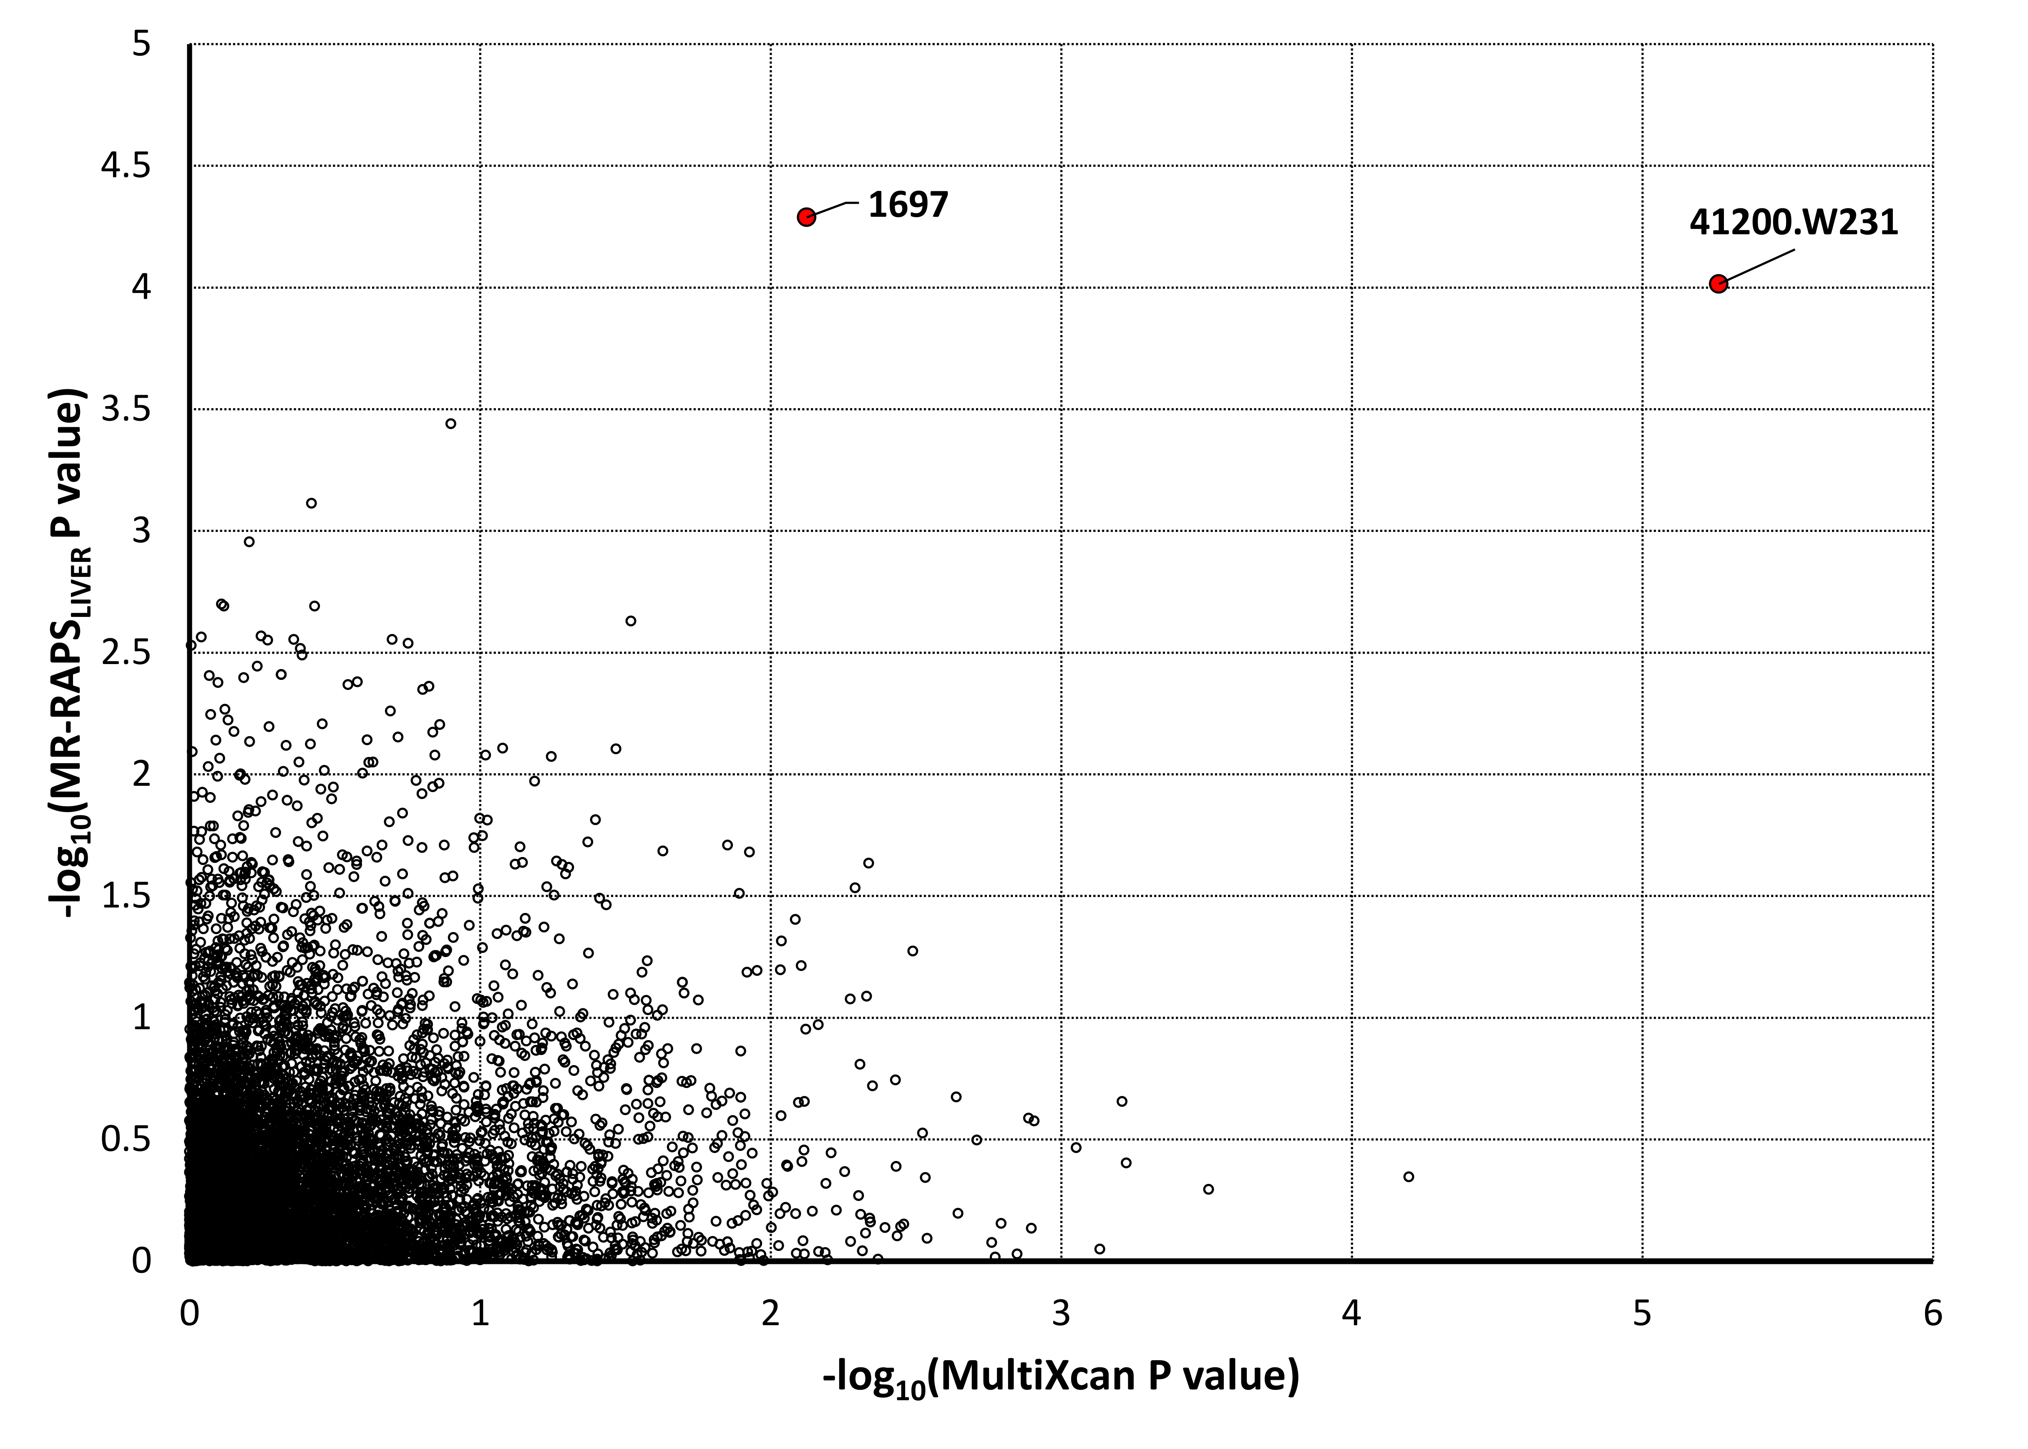

Supplementary Figure 2: Concordance between MultiXcan and MR-RAPS_{liver} associations across the 7,149 traits assessed in UK Biobank cohort.

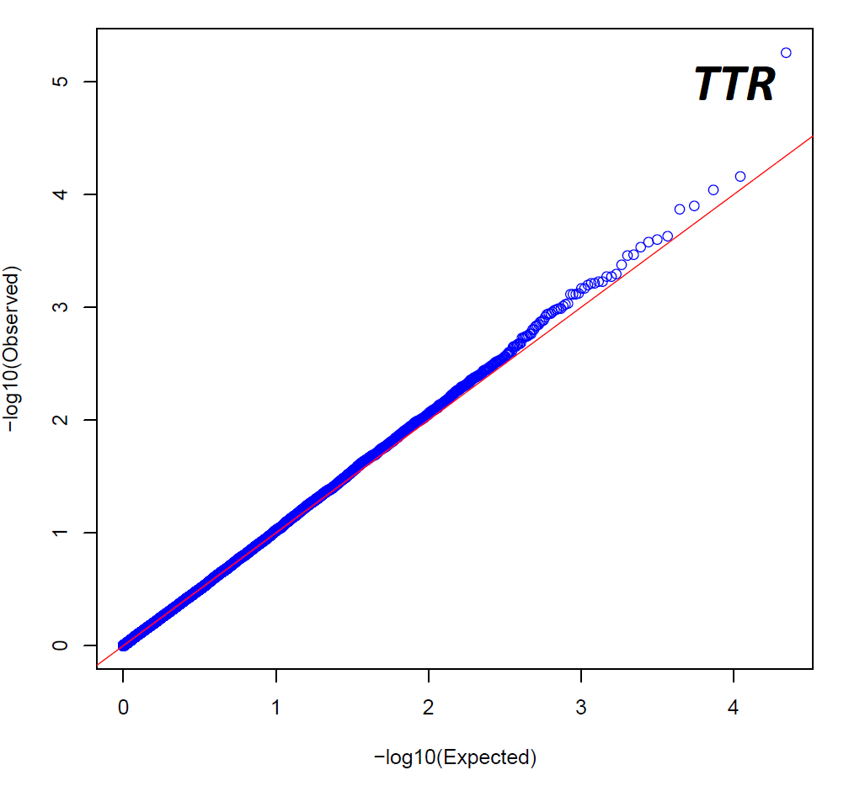

Supplementary Figure 3: QQ plot (λ_{gc}=0.996) of the transcriptome-wide association statics related to the phenotype 41200-W231.

