Supplementary Materials for

Zhong et al. Next generation plasma proteome profiling of COVID-19 patients with mild to moderate symptoms

The PDF file includes:

Supplementary Figure 1. Clustering of COVID-19 patients..
Supplementary Figure 2. Correlation between the 50 most significantly elevated proteins at COVID-19 infection

Other Supplementary Material for this manuscript includes the following:

Supplementary Table 1. Description of the COVID-19 patients
Supplementary Table 2. Full list of the analyzed plasma proteins
Supplementary Table 3. Plasma proteome profiling of the COVID-19 patients
Supplementary Table 4. Full list of the ANOVA results
Supplementary Table 5. Comparison of the differentially expressed proteins in mild-to-moderate and severe COVID-19 patients

Supplemental Figure 1.

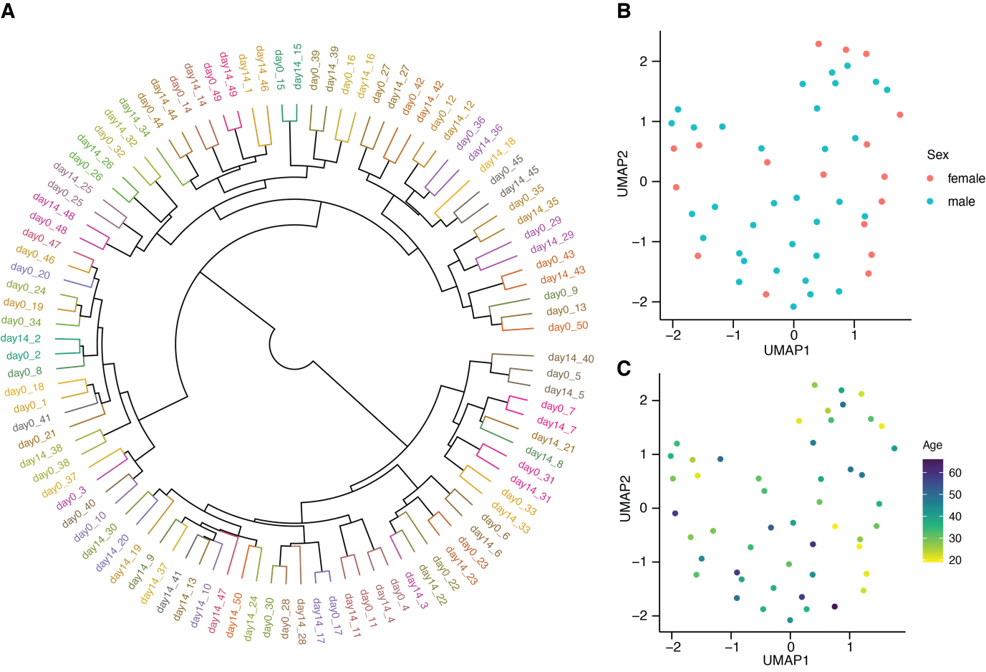
Supplemental Figure 1. Clustering of COVID-19 patients.
A. Dendrogram visualizing the results from hierarchical clustering of all samples. The color code indicates individuals.
B. UMAP plot showing the distribution of day-0 samples with ongoing COVID-19 infection. The color code indicates females and males.
C. UMAP plot showing the distribution of day-0 samples with ongoing COVID-19 infection. The color code indicates age differences.

Supplemental Figure 2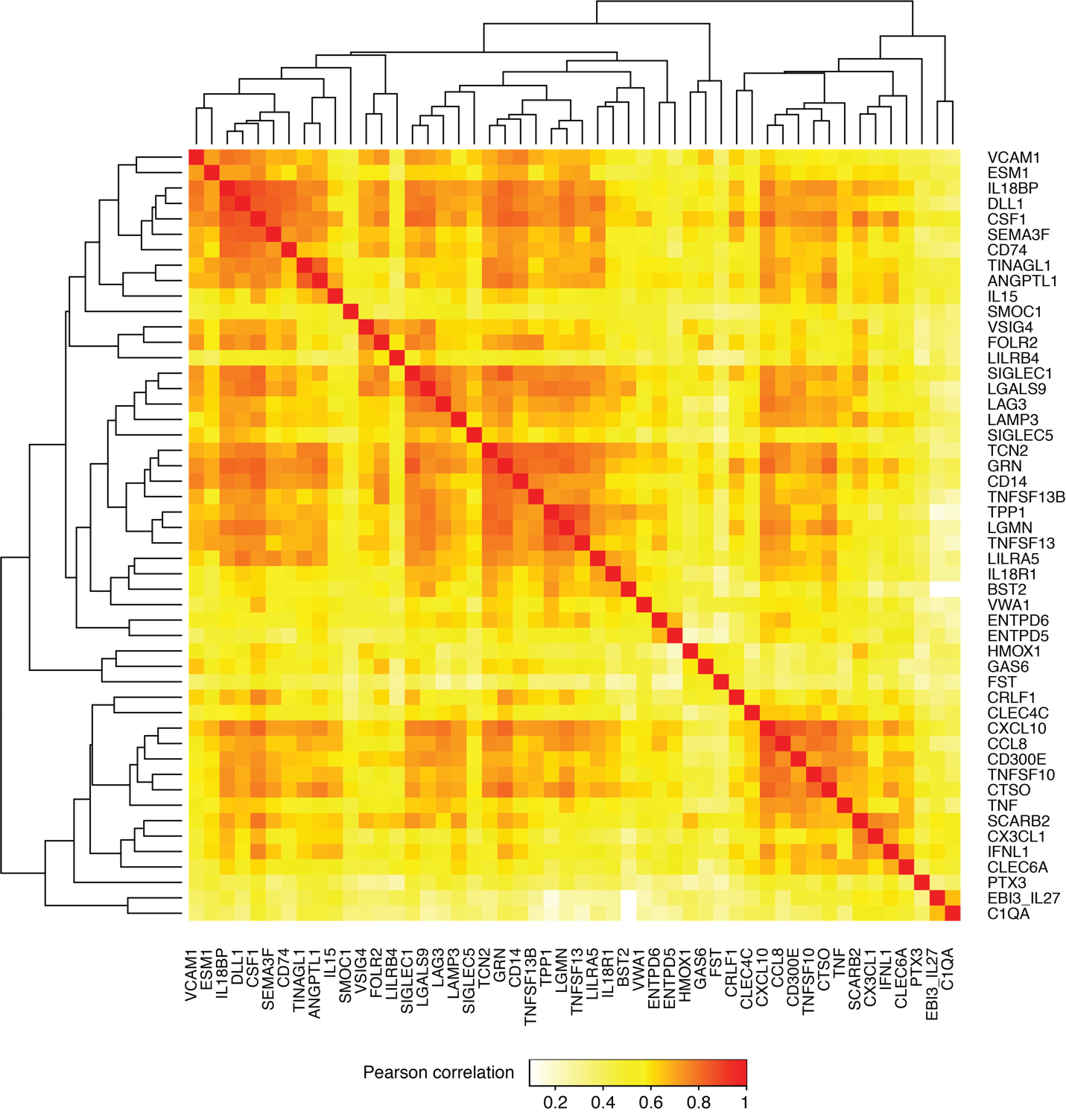
Supplemental Figure 2. Correlation between the 50 most significantly elevated proteins at COVID-19 infection.
Heatmap showing pairwise Pearson correlation between the expression profiles for the 50 proteins analyzed. The dendrogram is clustered by the correlation distance using the Ward2 algorithm.

