Table of contents
Supplementary Methods.
Supplementary Table 1. Search strategy performed on PubMed database search
Supplementary Table 2. Variables included in the generalized additive model
Supplementary Table 3. Studies selected for the meta-analysis
Supplementary Table 4. Pooled prevalence of symptoms and signs among COVID-19 inpatients
Supplementary Table 5. Risk of other symptoms in COVID-19 patients in studies where headache symptom is reported
Supplementary Table 6. Risk of other comorbid diseases in COVID-19 Patients in studies where headache symptom is reported
Supplementary Table 7. Sensitivity analysis of headache RR in COVID-19 patients
Supplementary Table 8. Variables associated with COVID-19 mortality across 171 nations in the generalized additive single-factor model
Supplementary Table 9. Variables associated with COVID-19 mortality across 171 nations in the generalized additive multi-factor model
Supplementary Table 10. Variables associated to COVID-19 mortality across 171 nations in the generalized additive multi-factor model in two different cohorts: Tropical (n=78) and non-tropical (n=93) nations.
Supplementary Table 11. Variables associated to Influenza mortality (2017) across 171 nations in the generalized additive multi-factor model
Supplementary Figure 1. The PRISMA flow diagram of the meta-analysis.
Supplementary Figure 2. Funnel plot on the risk of headache in COVID-19 patients after excluding outliers and over-influencer publications (n=41/48).
Supplementary Figure 3. Non-linear relationship (Spearman’s rho) between study variables.
Supplementary Figure 4. Influenza mortality (per million population) 2017 distribution across 171 nations based on diseases prevalence (according to GBD2019): (A) Urban population rate; (B) Population’s median age; (C) Population’s female rate; (D) National wealth; (E) Government effectiveness; (F) Capital’s latitude; (G) Headache disorders; (H) Diabetes mellitus; (I) Chronic kidney diseases; (J) Cirrhosis and Chronic liver diseases; (K) Chronic respiratory diseases and (L) Cardiovascular diseases.
Meta-analysis references

Supplementary Methods
- Meta-analysis
Search strategy
The search terms were “COVID-19” (OR “COVID-19 disease” OR “SARS-CoV-2” OR “SARS-CoV2” OR “nCoV”), “mortality” (OR “deceased” OR “died” OR “death” OR “fatality rate” OR “risk factor” OR “fatal” OR “dying”), “hospitalization” (OR “hospitalized” OR “hospitalized” OR “admission” OR “in-hospital”), “recovered” (OR “survived” OR “surviving” OR “survivors” OR “prognosis” OR “prognostic”) and “headache” (Supplementary Table 1). There was no restriction on study design, language nor laboratory confirmation of COVID-19 diagnosis. Studies were included if they clearly presented in their results or in the supplementary material: (1) study design; (2) COVID-19 confirmation method; (3) patient’s demographics; (4) ratio of COVID-19 survivors and non-survivors and (5) the presence of headache symptom in both cohorts.

Study selection and data extraction
Three investigators (VG, EC and PP-R) examined all titles and abstracts, and obtained full text of potentially relevant papers and data extraction was done by VG. For all eligible studies, we extracted information on study country, study size, COVID-19 confirmation, patients’ characteristics, including demographics and percentage of individuals with presence of other COVID-19 accompanying symptoms (anosmia, cough, diarrhea, dyspnea, fever, myalgia and nausea or vomiting), comorbidities (cardiovascular diseases, chronic kidney diseases, chronic liver diseases, chronic respiratory and diabetes) and our COVID-19 confirmation outcome of interest, the presence of headache.

Data analysis
In case of higher heterogeneity (I2 > 75%) in the RR analysis, if the publication’s CI did not overlap with the CI of the pooled effect, we considered these studies as outliers. Influence analyses of effect size between publications were also computed in order to assess whether the influence of a particular publication distorted the overall pooled effect. Other strategies considered in the sensitivity analysis were excluding small studies (n < 250); excluding studies lacking validated COVID-19 confirmation methods, and considering only prospective studies. Finally, publication bias was assessed through visual inspection (funnel plot) and significance test (Egger’s test). All of the statistical analysis and plots were generated using metaprop (version 2.4-0), meta (version 4.15-1) and dmetar (version 0.0.9) packages of R (version 4.0.3) software.

- COVID-19 mortality-related factors: headache disorders

Generalized additive models (GAMs) are regression models that can make more reasonable nonlinear fittings than traditional statistical models (Generalized Linear Models, GLMs). In particular, (i) they allow explanatory variables to be added into the model by function; and (ii) they can directly deal with the complex nonlinear relationship between multiple response and explanatory variables. GAMs require fewer data and can be applied to a variety of distribution types, like the Poisson distribution in this study. In the single-factor model, we evaluated all explanatory variables individually and we measured their significance (P value), deviance explained (%), adjusted R2 and the Akaike Information Criterion (AIC) for each variable. We used the adjusted R2 and variance interpretation rate (deviance explained) to evaluate the quality of the fitted GAM. We used the mgcv and car package in R 4.0.3 to analyze the GAM.
Supplementary Table 1. Search strategy performed on PubMed database search.

Search Terms
((((((((((((COVID-19[Title]) OR COVID19[Title]) OR coronavirus[Title]) OR nCoV[Title]) OR SARS-CoV-2[Title]) OR SARS-CoV2[Title])) AND
(((((((((((((((((((((mortality[Title/Abstract]) OR deceased [Title/Abstract]) OR died [Title/Abstract]) OR recovered [Title/Abstract]) OR death [Title/Abstract]) OR fatility rate [Title/Abstract]) OR risk factor [Title/Abstract]) OR fatal [Title/Abstract]) OR hospitalization [Title/Abstract]) OR survived [Title/Abstract]) OR surviving [Title/Abstract]) OR hospitalized [Title/Abstract]) OR non-survivors [Title/Abstract]) OR admission [Title/Abstract]) OR in-hospital [Title/Abstract]) OR hospitalised [Title/Abstract]) OR dying [Title/Abstract]) OR prognosis [Title/Abstract]) OR c [Title/Abstract]) OR headache [Title/Abstract])) AND ("2020/04/01"[Publication Date] : "3000"[Publication Date]))

Supplementary Table 2. Variables included in the generalized additive model.
Variable Name | Variable Description | Source Data
Population Density | People per km² of land area | Our World in Data¹
Urban Population Rate | Percentage of population urbanized | CIA²
Median age | Country’s median age (years)
Female rate | Percentage of female population | Worldwide Governance Indicators³
Wealth | GDP per capita (US dollars) | Worldometer⁴
Government effectiveness | World Bank Government Effectiveness Index (2019) | Worldwide Governance Indicators³
Pandemic preparedness | Global Health Security Index (2020) | GHS Index⁵
Pandemic response | Government Response Stringency Index (Max. valued obtained in 2020) | Our World in Data¹
Latitude of country’s capital | Degrees | Wikipedia⁶
Headache disorders prevalence | Prevalence/100k (2019), age standardized | Global Health Data Exchange⁷
Migraine prevalence | Prevalence/100k (2019), age standardized
Tension-type headache prevalence | Prevalence/100k (2019), age standardized
Diabetes prevalence | Prevalence/100k (2019), age standardized
Chronic kidney diseases prevalence | Prevalence/100k (2019), age standardized
Chronic liver diseases prevalence | Prevalence/100k (2019), age standardized
Chronic respiratory diseases prevalence | Prevalence/100k (2019), age standardized
Cardiovascular diseases prevalence | Prevalence/100k (2019), age standardized
Cumulative COVID-19 deaths | Prevalence/1m (14th December 2020) | Our World in Data¹
2017 Influenza death rates | Prevalence/100k (2017) | (36)

¹https://ourworldindata.org
²https://www.cia.gov
³https://info.worldbank.org
⁴https://www.worldometers.info
⁵https://www.ghsindex.org
⁶https://en.wikipedia.org/wiki/List_of_national_capitals_by_latitude
⁷http://ghdx.healthdata.org

Supplementary Table 3. Studies selected for the meta-analysis.
Author | Research  Timing | Design | Country | Region | All COVID19 Confirmation | Sample Size | Gender Predominance | Median Age | REF
Aksel G et al. | Prospective | Cohort Study | Turkey | Europe | Yes | 168 | Male | <60 years | (1)
Bellan M et al. | Retrospective | Cohort Study | Italy | Europe | Yes | 407 | Male | ≥70 years | (2)
Berenguer J et al. | Retrospective | Cohort Study | Spain | Europe | Yes | 4,035 | Male | 60-69 years | (3)
Caronna E et al. | Prospective | Cohort Study | Spain | Europe | No | 130 | Female | <60 years | (4)
Chen F et al. | Prospective | Cohort Study | China | Asia | Yes | 660 | Female | <60 years | (5)
Chen L et al. | Retrospective | Cohort Study | China | Asia | Yes | 1,859 | Male | <60 years | (6)
Chen R et al. | Retrospective | Cohort Study | China | Asia | Yes | 1,590 | Male | <60 years | (7)
Chen T et al. | Retrospective | Cohort Study | China | Asia | Yes | 274 | Male | 60-69 years | (8)
Cheng A et al. | Retrospective | Cohort Study | China | Asia | Yes | 305 | Male | 60-69 years | (9)
Deng Y et al. | Retrospective | Cohort Study | China | Asia | Yes | 225 | Male | <60 years | (10)
De Souza C et al. | Retrospective | Cross-Sectional | Brazil | South America | No | 9,807 | Female | 60-69 years | (11)
Du RH et al. | Retrospective | Cohort Study | China | Asia | No | 179 | Male | <60 years | (12)
Emara DM et al. | Retrospective | Cohort Study | Egypt | Africa | Yes | 120 | Male | <60 years | (13)
Gao S et al. | Retrospective | Cohort Study | China | Asia | Yes | 210 | Female | ≥70 years | (14)
Garibaldi BT et al. | Prospective | Cohort Study | US | North America | Yes | 832 | Male | 60-69 years | (15)
Gil-Rodrigo A et al. | Prospective | Cohort Study | Spain | Europe | Yes | 1,000 | Male | 60-69 years | (16)
Homayounieh F et al. | Retrospective | Cohort Study | Iran | Africa | Yes | 90 | Male | <60 years | (17)
Khalil K et al. | Prospective | Cohort Study | UK | Europe | Yes | 220 | Male | 60-69 years | (18)
Li J et al. | Retrospective | Cohort Study | China | Asia | Yes | 161 | Female | <60 years | (19)
Li M et al. | Retrospective | Cohort Study | China | Asia | Yes | 245 | Female | <60 years | (20)
Li X et al. | Retrospective | Cohort Study | US | North America | Yes | 1,022 | Male | 60-69 years | (21)
Ma X et al. | Retrospective | Cohort Study | China | Asia | Yes | 523 | Male | <60 years | (22)
Marengoni A et al. | Retrospective | Cohort Study | Italy | Europe | Yes | 165 | Male | 60-69 years | (23)
Martin-Moro F et al. | Retrospective | Cohort Study | Spain | Europe | No | 34 | Male | ≥70 years | (24)
Mendes A et al. | Retrospective | Cohort Study | Switzerland | Europe | No | 235 | Female | ≥70 years | (25)
Moon SS et al. | Retrospective | Cohort Study | Korea | Asia | Yes | 348 | Female | <60 years | (26)
Park JG et al. | Retrospective | Cohort Study | Korea | Asia | Yes | 289 | Female | ≥70 years | (27)
Rana MS et al. | Retrospective | Cohort Study | Pakistan | Africa | Yes | 100 | Male | <60 years | (28)
Rivera-Izquierdo M et al. | Retrospective | Cohort Study | Spain | Europe | Yes | 131 | Male | 60-69 years | (29)
Rodriguez-Molinero A et al. | Prospective | Cohort Study | Spain | Europe | Yes | 418 | Male | 60-69 years | (30)
Rodriguez-Nava G et al. | Retrospective | Cohort Study | US | North America | Yes | 313 | Male | 60-69 years | (31)
Rubio-Rivas M et al. | Retrospective | Cohort Study | Spain | Europe | Yes | 12,066 | Male | 60-69 years | (32)
Soares RDCM et al. | Retrospective | Cohort Study | Brazil | South America | No | 1,152 | Male | 60-69 years | (33)
Tomlins J et al. | Retrospective | Cohort Study | UK | Europe | Yes | 95 | Male | ≥70 years | (34)
Trigo J et al. | Retrospective | Cohort Study | Spain | Europe | Yes | 576 | Male | 60-69 years | (35)
Van Halem K et al. | Retrospective | Cohort Study | Belgium | Europe | Yes | 319 | Male | ≥70 years | (37)
Varol Y et al. | Retrospective | Cohort Study | Turkey | Europe | Yes | 383 | Male | <60 years | (38)
Vena A et al. | Retrospective | Cohort Study | Italy | Europe | Yes | 317 | Male | ≥70 years | (39)
Wang D et al. | Retrospective | Cohort Study | China | Asia | Yes | 107 | Male | <60 years | (40)
Wang L et al. | Retrospective | Cohort Study | China | Asia | Yes | 339 | Female | 60-69 years | (41)
Wang ZH et al. | Retrospective | Cohort Study | China | Asia | Yes | 59 | Male | 60-69 years | (42)
Yan Y et al. | Retrospective | Cohort Study | China | Asia | Yes | 193 | Male | 60-69 years | (43)
Yang X et al. | Retrospective | Cohort Study | China | Asia | Yes | 52 | Male | <60 years | (44)
Yu Z et al. | Retrospective | Cohort Study | China | Asia | Yes | 141 | Female | ≥70 years | (45)
Zhang J et al. | Retrospective | Cohort Study | China | Asia | Yes | 663 | Female | <60 years | (46)
Zhang L et al. | Retrospective | Cohort Study | China | Asia | Yes | 319 | Female | <60 years | (47)
Zhao Z et al. | Retrospective | Cohort Study | US | North America | Yes | 480 | Male | 60-69 years | (48)
Zhu J et al. | Retrospective | Cohort Study | US | North America | Yes | 181 | Male | <60 years | (49)

Supplementary Table 4. Pooled prevalence of symptoms and signs among COVID-19 inpatients

Symptoms | Symptom prevalence  [95% CI] | Number of studies included* | Total number of COVID-19 patients | Between-study heterogeneity |  | Publication bias, Egger’s test  (P value)
 |  |  |  | I² | P value
Anosmia | 0.066 [0.041-0.104] | 15/16 | 9,128 | 97% | <0.001 | 0.276
Cough | 0.650 [0.612-0.687] | 22/43 | 11,309 | 93% | <0.001 | 0.174
Diarrhoea | 0.113 [0.084-0.149] | 23/35 | 22,121 | 97% | <0.001 | 0.802
Dyspnoea | 0.419 [0.339-0.503] | 22/40 | 6,506 | 98% | <0.001 | 0.112
Fever (>37.3 ºC) | 0.779 [0.720-0.829] | 34/42 | 27,068 | 99% | <0.001 | 0.136
Headache | 0.097 [0.078-0.120] | 41/48 | 30,236 | 97% | <0.001 | 0.275
Myalgia | 0.176 [0.146-0.211] | 34/38 | 25,581 | 97% | <0.001 | 0.446
Nausea or Vomiting | 0.103 [0.077-0.137] | 27/30 | 14,191 | 97% | <0.001 | 0.109

*Studies with extreme effect sizes were discarded in order to obtain an unbiased publication effect (Egger’s test).
In bold are marked P values < 0.05

Supplementary Table 5. Risk of symptoms among COVID-19 inpatients, in studies where headache symptom is reported

COVID-19 symptom | Test for overall effect  (random-model) | Comorbidity-COVID19 RR  [95% CI] | Number of studies included* | Between-study heterogeneity |  | Publication bias, Egger’s test (P value)
 |  |  |  | I² | P value
Anosmia | t = 8.76  p<0.001 | 3.183 [2.397-4.226] | 15/16 | 0% | 0.890 | 0.560
Cough | t = 1.71  p = 0.102 | 1.036 [0.992-1.081] | 22/43 | 24% | 0.147 | 0.148
Diarrhea | t = 1.09  p = 0.287 | 1.078 [0.935-1.242] | 23/35 | 18% | 0.214 | 0.650
Dyspnea | t = -12.61  p<0.001 | 0.662 [0.618-0.708] | 22/40 | 25% | 0.142 | 0.550
Fever (>37.3 º0C) | t = 1.65  p = 0.109 | 1.025 [0.994-1.058] | 34/42 | 46% | 0.002† | 0.352
Headache | t = 10.75  p<0.001 | 2.178 [1.882-2.520] | 41/48 | 16% | 0.175 | 0.733
Myalgia | t = 7.75  p<0.001 | 1.574 [1.398-1.773] | 34/38 | 17% | 0.200 | 0.859
Nausea or Vomiting | t = 4.87  p<0.001 | 1.558 [1.292-1.879] | 27/30 | 22% | 0.158 | 0.604

*Studies with extreme effect sizes (outliers) and studies with higher influence on overall effect (Leave-One-Out influence analysis) were discarded in order to obtain a homogenized between-studies effect

†All models exploring fever as a RR resulted statistically significant heterogeneity between studies (there were studies where fever was reported at patient’s admission, other studies reported fever as a history symptom and the rest of studies did not specify the moment in which fever was considered)
In bold are marked P values < 0.05

Supplementary Table 6. Risk of comorbid diseases in COVID-19 inpatients, in studies where headache symptom is reported

Comorbidity | Test for overall effect  (random-model) | Comorbidity-COVID19 RR  [95% CI] | Number of studies included* | Between-study heterogeneity |  | Publication bias, Egger’s test (P value)
 |  |  |  | I² | P value
Cardiovascular diseases | t = -13.41  p<0.001 | 0.405 [0.352-0.466] | 23/34 | 30% | 0.090 | 0.179
Chronic kidney diseases | t = -11.78  p<0.001 | 0.338 [0.280-0.408] | 31/34 | 34% | 0.090 | 0.985
Chronic liver diseases | t = -5.72  p<0.001 | 0.530 [0.419-0.670] | 18/18 | 0% | 0.603 | 0.629
Chronic respiratory diseases | t = -10.13  p<0.001 | 0.519 [0.455-0.592] | 33/38 | 15% | 0.223 | 0.645
Diabetes | t = -9.75  p<0.001 | 0.613 [0.553-0.679] | 31/38 | 28% | 0.080 | 0.969

*Studies with extreme effect sizes (outliers) and studies with higher influence on overall effect (Leave-One-Out influence analysis) were discarded in order to obtain a homogenized between-studies effect

In bold are marked P values < 0.05
Supplementary Table 7. Sensitivity analysis of headache relative risk (RR) among COVID-19 inpatients

Strategy | Test for overall effect  (random-model) | Headache-COVID19 RR  [95% CI] | Between-study heterogeneity |  | Number of studies included | Publication bias, Egger’s test (P value)
 |  |  | I² | P value
Including all studies | t = 5.18  p<0.001 | 1.876 [1.469-2.390] | 79% | <0.001 | 48/48 | 0.787
Excluding outliers and over-influencer studies | t = 10.75  p<0.001 | 2.178 [1.882-2.520] | 16% | 0.175 | 41/48 | 0.733
Excluding retrospective studies | t = 3.55  p=0.012 | 3.380 [1.459-7.828] | 53% | 0.050 | 7/48 | 0.280
Excluding studies without COVID-19 confirmation method | t = 5.18  p<0.001 | 1.917 [1.489-2.469] | 76% | <0.001 | 44/48 | 0.457
Excluding small studies (n < 250 patients) | t = 7.26  p<0.001 | 2.251 [1.790-2.829] | 65% | <0.001 | 26/48 | 0.974

In bold, P values < 0.05

Supplementary Table 8. Variables associated with COVID-19 mortality across 171 nations in the generalized additive single-factor model
Smoothed variable | Deviance explained (%) | Edf | Ref.df | P value | F value | Adjust R² | AIC
Headache disorders prevalence | 37.8 | 8.675 | 8.969 | <2e-16** | 10.68 | 0.345 | 2421.46
Latitude of country’s capital | 34.8 | 7.113 | 8.173 | <2e-16** | 9.99 | 0.319 | 2426.49
Migraine prevalence | 32.0 | 8.262 | 8.843 | <2e-16** | 8.38 | 0.286 | 2435.79
Median age | 31.1 | 4.811 | 5.920 | <2e-16** | 12.12 | 0.291 | 2431.25
Chronic liver diseases prevalence | 28.6 | 4.627 | 5.707 | <2e-16** | 11.12 | 0.266 | 2437.02
Tension-type headache prevalence | 26.7 | 4.471 | 5.520 | <2e-16** | 10.41 | 0.247 | 2441.18
Wealth | 24.7 | 6.922 | 7.903 | 9.10e-07** | 6.40 | 0.215 | 2450.62
Pandemic preparedness | 19.8 | 1.092 | 1.179 | <2e-16** | 34.38 | 0.193 | 2449.83
Urban population rate | 17.3 | 1.000 | 1.000 | <2e-16** | 35.33 | 0.168 | 2454.88
Government effectiveness | 16.5 | 2.915 | 3.663 | 1.01e-05** | 8.45 | 0.150 | 2460.37
Cardiovascular diseases prevalence | 14.6 | 5.153 | 6.285 | 8.13e-4** | 4.00 | 0.119 | 2468.70
Chronic respiratory diseases prevalence | 13.6 | 2.948 | 3.700 | 1.17e-4** | 6.86 | 0.121 | 2466.15
Pandemic response | 7.8 | 1.117 | 1.225 | 0.001** | 12.04 | 0.071 | 2473.74
Chronic kidney diseases prevalence | 7.4 | 5.521 | 6.663 | 0.164 | 1.57 | 0.043 | 2483.20
Diabetes prevalence | 6.9 | 2.723 | 3.402 | 0.026* | 3.06 | 0.054 | 2478.48
Female rate | 2.4 | 1.604 | 2.008 | 0.183 | 1.73 | 0.015 | 2484.32
Population density | 0.4 | 1.000 | 1.000 | 0.388 | 0.75 | 0.000 | 2486.58

Estimated degree of freedom (Edf), degree of reference (Ref. df), P value, F value (measurement of the relative importance of smoothed variable), deviance explained (%), adjusted R2, and Akaike information criterion (AIC) for the smoothed variables (including population density, urban population rate, median age, female rate, wealth, government effectiveness, pandemic preparedness, pandemic response, latitude of country’s capital and comorbidities prevalence) in the single-factor model for COVID-19 mortality.

In bold are statistically significant smoothed variables in the single-factor model.
*This indicates P values < 0.05
**This indicates P values < 0.01
Supplementary Table 9. Variables associated with COVID-19 mortality across 171 nations in the generalized additive multi-factor model

Smoothed variable | Edf | Ref.df | P value | F value | Deviance explained (%) | Adjust R² | AIC
Urban population rate | 1.854 | 2.346 | 2.61e-4** | 8.14 | 65.5 | 0.591 | 2356.85
Median age | 1.000 | 1.000 | 0.346 | 0.90
Wealth | 1.000 | 1.000 | 4.83e-4** | 12.8
Pandemic preparedness | 1.980 | 2.482 | 0.204 | 1.53
Pandemic response | 1.000 | 1.000 | 0.217 | 1.54
Latitude of country’s capital | 8.501 | 8.918 | <2e-16** | 6.84
Migraine prevalence | 8.262 | 8.843 | 0.009* | 3.84
Diabetes prevalence | 1.000 | 1.000 | 0.216 | 1.54
Chronic liver diseases prevalence | 1.000 | 1.000 | 0.161 | 1.98
Chronic respiratory diseases prevalence | 4.147 | 5.139 | 0.201 | 1.55
Cardiovascular diseases prevalence | 3.096 | 3.930 | 0.051 | 2.367

Estimated degree of freedom (Edf), degree of reference (Ref. df), P value, F value, deviance explained (%), adjusted R2, and Akaike information criterion (AIC)
for the smoothed variables in the multi-factor model for COVID-19 mortality.

In the multi-factor model, only statistically significant variables from the single-factor were included. Government effectiveness was not considered because it presented a statistically significant high correlation (r≥0.70; p<0.05) with national wealth, pandemic preparedness and pandemic response. Headache disorders prevalence, migraine prevalence and tension-type headache prevalence were also highly correlated: Hence, we modelled individually in the multi-factor model and we selected the best model based on AIC (i.e., best model considering migraine prevalence instead of headache disorders prevalence or tension-type headache prevalence).

In bold are statistically significant smoothed variables in the multi-factor model.
*This indicates P values < 0.05
**This indicates P values < 0.01
Supplementary Table 10. Variables associated with COVID-19 mortality across 171 nations in the generalized additive multi-factor model in two different cohorts: Tropical (n=78) and non-tropical (n=93) nations.
Smoothed variable | Edf | Ref.df | P value | F value | Deviance explained (%) | Adjust R² | AIC
Non-Tropical countries (n=93)
Urban population rate | 1.000 | 1.000 | 0.009** | 7.07 | 68.3 | 0.575 | 1305.77
Median age | 4.131 | 5.114 | 0.023* | 2.82
Pandemic preparedness | 1.000 | 1.000 | 0.737 | 0.11
Latitude of country’s capital | 7.738 | 8.552 | 2.39e-5** | 5.22
Migraine prevalence | 1.712 | 2.133 | 0.004** | 5.56
Chronic kidney diseases prevalence | 5.752 | 6.872 | 0.156 | 1.61
Chronic liver diseases prevalence | 1.000 | 1.000 | 0.498 | 0.46
Chronic respiratory diseases prevalence | 1.000 | 1.000 | 0.435 | 0.61
Tropical countries (n=78)
Urban population rate | 7.235 | 7.917 | 0.001** | 4.58 | 96.6 | 0.914 | 913.50
Median age | 2.227 | 2.744 | 9.31e-4** | 7.50
National wealth | 8.347 | 8.711 | 2.15e-5** | 7.33
Pandemic preparedness | 8.740 | 8.944 | 1.24e-4** | 5.79
Migraine prevalence | 3.912 | 4.667 | 0.013* | 3.79
Chronic kidney diseases prevalence | 6.573 | 7.561 | 0.002** | 4.26
Cardiovascular diseases prevalence | 8.728 | 8.944 | <2e-16** | 14.52
Chronic liver diseases prevalence | 1.000 | 1.000 | 0.239 | 1.44

Estimated degree of freedom (Edf), degree of reference (Ref. df), P-value, F-value (which measures the relative importance of smoothed variable), deviance explained (%), adjusted R2, deviance contribution (%), and Akaike information criterion (AIC) for the smoothed variables in the multi-factor model between non-tropical and tropical countries. In the multivariate model, only statistically significant variables from the single-factor (tropical and non-tropical countries) were included. Headache disorders prevalence, migraine prevalence and tension-type headache prevalence were also highly correlated: hence, we modelled individually in the multi-factor model and we selected the best model based on AIC (model considering migraine prevalence).

In bold are marked statistically significant smoothed variables in the single-factor model.
*This indicates P values < 0.05; **This indicates P values < 0.01
Supplementary Table 11. Variables associated with Influenza mortality (2017) across 171 nations in the generalized additive multi-factor model
Smoothed variable | Edf | Ref.df | P value | F value | Deviance explained (%) | Adjust R² | AIC
Urban population rate | 6.941 | 7.999 | 0.175 | 1.46 | 84.3 | 0.802 | 1578.66
Median age | 1.324 | 1.577 | 0.121 | 1.85
Wealth | 1.000 | 1.000 | 0.603 | 0.27
Government effectiveness | 1.000 | 1.000 | 0.638 | 0.22
Latitude of country’s capital | 7.815 | 8.610 | 6.52e-6** | 5.41
Headache disorders prevalence | 1.977 | 2.505 | 0.016* | 4.08
Diabetes prevalence | 4.031 | 4.967 | 3.49e-4** | 4.96
Chronic kidney diseases prevalence | 1.000 | 1.000 | 1.25e-5** | 20.65
Chronic liver diseases prevalence | 2.613 | 3.338 | 4.33e-4** | 6.15
Chronic respiratory diseases prevalence | 1.847 | 2.311 | 0.277 | 1.17
Cardiovascular diseases prevalence | 5.107 | 6.200 | 0.065 | 1.99
Estimated degree of freedom (Edf), degree of reference (Ref. df), P value, F value, deviance explained (%), adjusted R2, and Akaike information criterion (AIC) for the smoothed variables in the multi-factor model for Influence mortality. In the multi-factor model, only statistically significant variables from the single-factor were included. Headache disorders prevalence, migraine prevalence and tension-type headache prevalence were highly correlated (r≥0.70; p<0.05): Hence, we modelled individually in the multi-factor model and we selected the best model based on AIC (best model considering tension-type headache prevalence instead of headache disorders prevalence or migraine prevalence).

In bold are marked statistically significant smoothed variables in the multi-factor model.
*This indicates P value < 0.001
**This indicates P value < 0.0001
Supplementary Figure 1. The PRISMA flow diagram of the meta-analysis

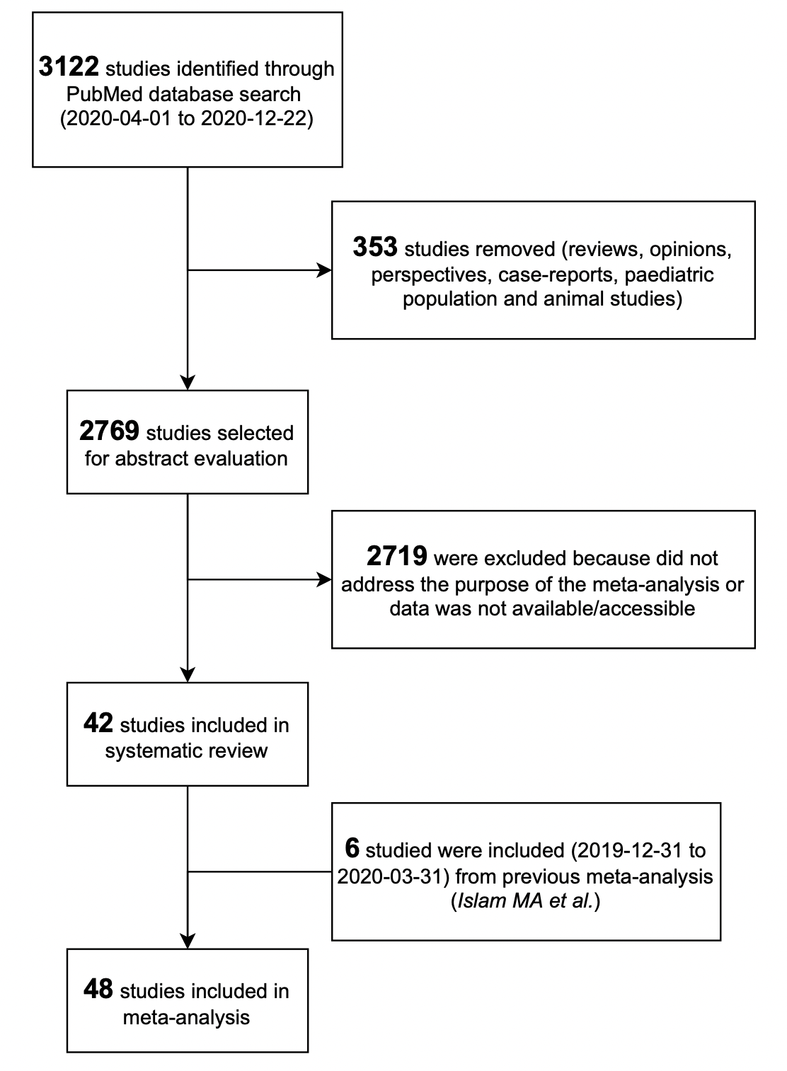

Supplementary Figure 2. Funnel plot on the risk of headache among COVID-19 inpatients, after excluding outliers and over-influencer publications (n=41/48).

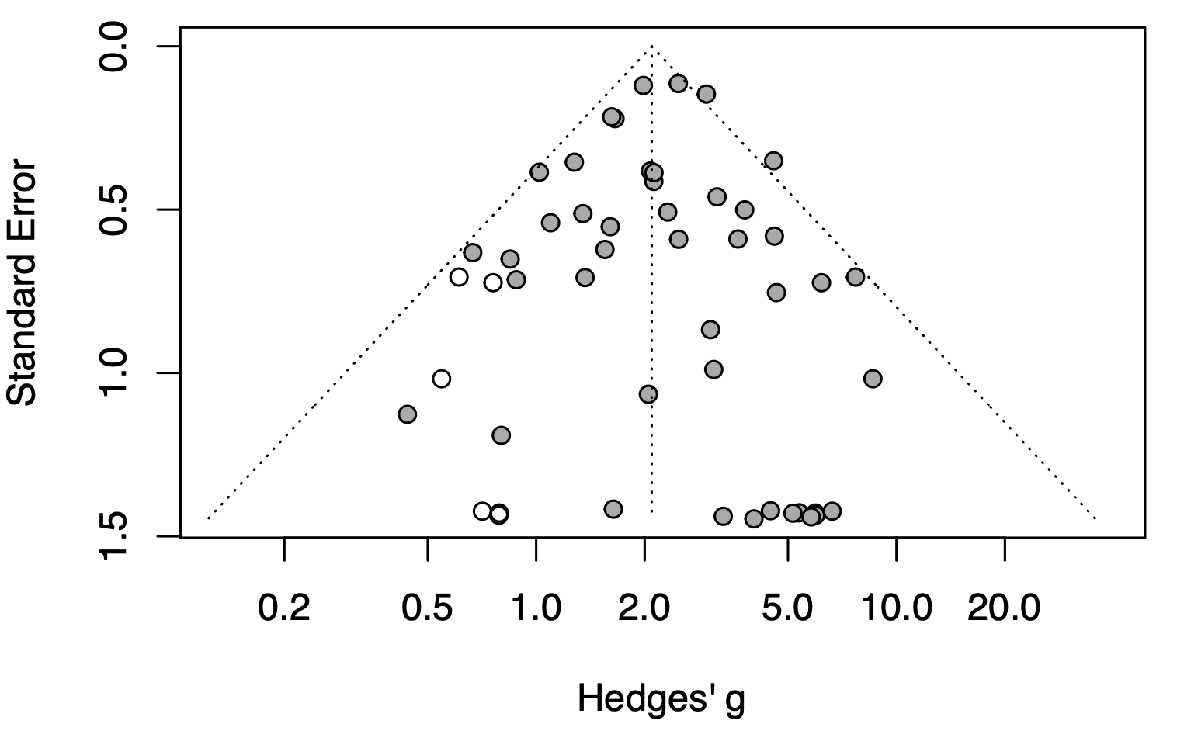

Egger’s test significance was P value = 0.733
Supplementary Figure 3. Non-linear relationship (Spearman’s rho) between study variables.
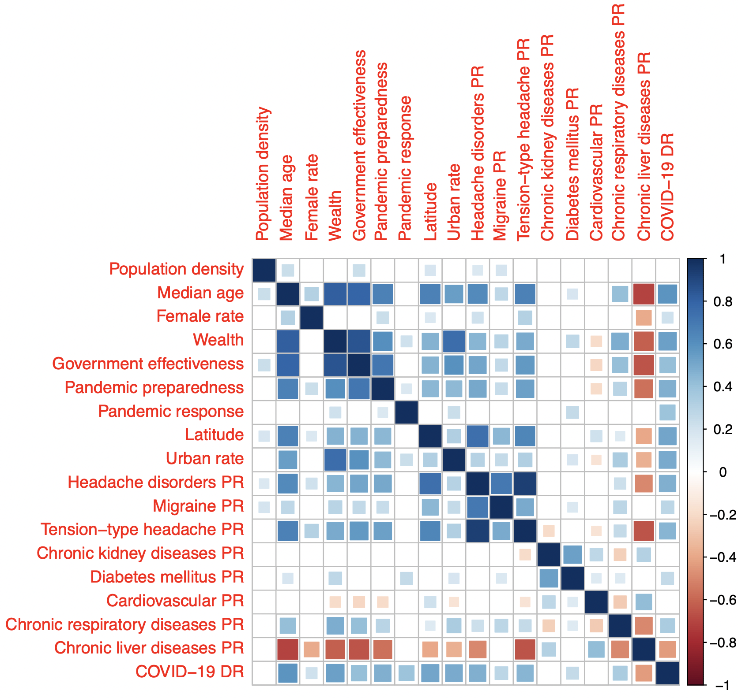
Blank cells mean non statistically significant correlation between each pair of variables. Blue indicates positive correlation and red indicates negative correlation between each pair of variables.

Abbreviations: PR: Prevalence; DR: Death Rate

Supplementary Figure 4. Influenza mortality (deaths per 100K) 2017 distribution across 171 nations based on diseases prevalence (according to GBD2017): (A) Urban population rate; (B) Population’s median age; (C) Population’s female rate; (D) National wealth; (E) Government effectiveness; (F) Capital’s latitude; (G) Headache disorders; (H) Diabetes mellitus; (I) Chronic kidney diseases; (J) Cirrhosis and Chronic liver diseases; (K) Chronic respiratory diseases and (L) Cardiovascular diseases.
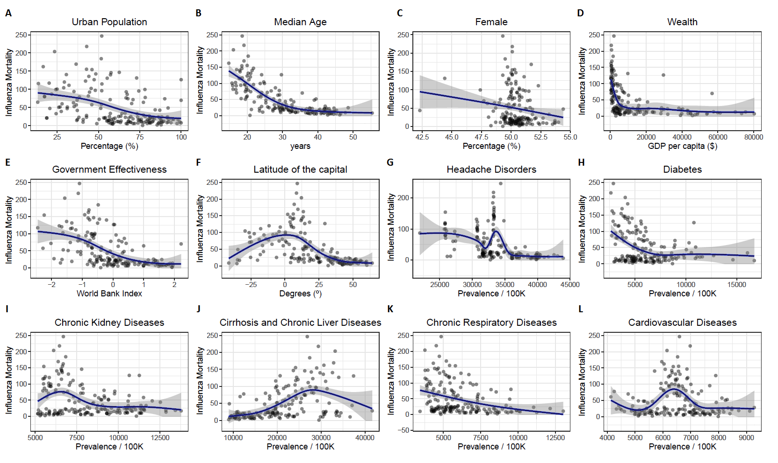
Abbreviations: GBD: Global Burden of Diseases
Meta-Analysis references

- Aksel G., İslam MM, Algın A, et al. Early predictors of mortality for moderate to severely ill patients with Covid-19. Am J Emerg Med. 2020;S0735-6757(20)30770-1.
- Bellan M, Patti G, Hayden E, et al. Fatality rate and predictors of mortality in an Italian cohort of hospitalized COVID-19 patients. Sci Rep. 2020;10(1):20731.
- Berenguer J, Ryan P, Rodríguez-Baño J, et al. Characteristics and predictors of death among 4035 consecutively hospitalized patients with COVID-19 in Spain. Clinical Microbiol Infect. 2020;26(11), 1525-1536.
- Caronna E, Ballvé A, Llauradó A, et al. Headache: A striking prodromal and persistent symptom, predictive of COVID-19 clinical evolution. Cephalalgia 2020;40(13):1410-1421.
- Chen F, sun W, Sun S, et al. Clinical characteristics and risk factors for mortality among inpatients with COVID‐19 in Wuhan, China. Clinical Transl Med 2020;10(2):e40.
- Chen L, Yu J, He W, et al. Risk factors for death in 1859 subjects with COVID-19. Leukemia 2020;34(8):2173-2183.
- Chen R, Liang W, Jiang M, et al. Risk factors of fatal outcome in hospitalized subjects with coronavirus disease 2019 from a nationwide analysis in China. Chest 2020;158(1):97-105
- Chen T, Wu D, Chen H, et al. Clinical characteristics of 113 deceased patients with coronavirus disease 2019: retrospective study. BMJ 2020;368:m1091.
- Cheng A, Hu L, Wang Y, et al. Diagnostic performance of initial blood urea nitrogen combined with D-dimer levels for predicting in-hospital mortality in COVID-19 patients. Int J Antimicrob Agents 2020;56(3):106110.
- Deng Y, Liu W, Liu K, et al. Clinical characteristics of fatal and recovered cases of coronavirus disease 2019 in Wuhan, China: a retrospective study. Chin Med J (Engl) 2020;133(11):1261-1267.
- de Souza CD, de Arruda Magalhães AJ, Lima AJ, et al. Clinical manifestations and factors associated with mortality from COVID‐19 in older adults: Retrospective population‐based study with 9807 older Brazilian COVID‐19 patients. Geriatr Geront Int 2020 Dec;20(12):1177-1181
- Du RH, Liang LR, Yang CQ, et al. Predictors of mortality for patients with COVID-19 pneumonia caused by SARS-CoV-2: a prospective cohort study. Eur Respir J 2020;55(5):2000524. 55(5).
- Emara DM, Naguib NN, Moustafa MA, et al. Typical and atypical CT chest imaging findings of novel coronavirus 19 (COVID-19) in correlation with clinical data: impact on the need to ICU admission, ventilation and mortality. EJRNM 2020;5(1):1-9.
- Gao S, Jiang F, Jin W, et al. Risk factors influencing the prognosis of elderly patients infected with COVID-19: a clinical retrospective study in Wuhan, China. Aging (Albany NY) 2020;12(13):12504-12516
- Garibaldi BT, Fiksel J, Muschelli J, et al. Patient Trajectories Among Persons Hospitalized for COVID-19: A Cohort Study. Ann Intern Med 2021;174(1):33-41.
- Gil-Rodrigo A, Miró Ò, Piñera P, et al. Evaluación de las características clínicas y evolución de pacientes con COVID-19 a partir de una serie de 1000 pacientes atendidos en servicios de urgencias españoles. Emergencias 2020;32(4):233-241.
- Homayounieh F, Zhang EW, Babaei R, et al. Clinical and imaging features predict mortality in COVID-19 infection in Iran. PloS One 2020;15(9):e0239519.
- Khalil K, Agbontaen K, McNally D, et al. Clinical characteristics and 28-day mortality of medical patients admitted with COVID-19 to a central London teaching hospital. J Infect 2020;81(3):e85-e89
- Li J, Long X, Luo H, et al. Clinical characteristics of deceased patients infected with SARS-Cov-2 in Wuhan, China. (2/24/2020). Available at SSRN: https://ssrn.com/abstract=3546043 or http://dx.doi.org/10.2139/ssrn.3546043
- Li M, Cheng B, Zeng W, et al. Analysis of the risk factors for mortality in adult COVID-19 patients in Wuhan: A multicenter study. Front Med (Lausanne) 2020;7:545. 7.
- Li X, Ge P, Zhu J, et al. Deep learning prediction of likelihood of ICU admission and mortality in COVID-19 patients using clinical variables. PeerJ 2020;8:e10337.
- Ma X, Li A, Jiao M, et al. Characteristic of 523 COVID-19 in Henan province and a death prediction model. Front Public Health 2020;8:475.
- Marengoni A, Zucchelli A, Vetrano DL, et al. Beyond chronological age: Frailty and multimorbidity predict in-hospital mortality in patients with coronavirus disease 2019. J Gerontol A Biol Sci Med Sci 2020;glaa291.
- Martín‐Moro F, Marquet J, Piris M, et al. Survival study of hospitalized patients with concurrent Covid‐19 and haematological malignancies. Br J Haematol 2020;190(1):e16-e20.
- Mendes A, Serratrice C, Herrmann FR, et al. Predictors of in-hospital mortality in older patients with COVID-19: the COVIDAge study. J Am Med Dir Assoc 2020;21(11):1546-1554.
- Moon SS, Lee K, Park J, et al. Clinical characteristics and mortality predictors of COVID-19 patients hospitalized at nationally-designated treatment hospitals. J Korean Med Sci 2020;35(36):e328.
- Park JG, Kang MK, Lee YR, et al. Fibrosis-4 index as a predictor for mortality in hospitalised patients with COVID-19: a retrospective multicentre cohort study. BMJ Open 2020;10(11):e041989.
- Rana MS. Clinical and laboratory characteristics of recovered versus deceased COVID-19 patients in Islamabad, Pakistan. J Infect 2020;S0163-4453(20)30705-2
- Rivera-Izquierdo M, del Carmen Valero-Ubierna M, R-delAmo JL, et al. Sociodemographic, clinical and laboratory factors on admission associated with COVID-19 mortality in hospitalized patients: A retrospective observational study. PLoS One 2020;15(6):e0235107.
- Rodríguez-Molinero A, Gálvez-Barrón C, Miñarro A, et al. Association between COVID-19 prognosis and disease presentation, comorbidities and chronic treatment of hospitalized patients. PloS One 2020;15(10):e0239571.
- Rodriguez-Nava G, Yanez-Bello MA, Trelles-Garcia DP, et al. Clinical characteristics and risk factors for mortality of hospitalized patients with COVID-19 in a community hospital: A retrospective cohort study. Mayo Clinic Proc Innov Qual Outcomes 2020.
- Rubio-Rivas M, Corbella X, Mora-Luján JM, et al. Predicting Clinical Outcome with Phenotypic Clusters in COVID-19 Pneumonia: An Analysis of 12,066 Hospitalized Patients from the Spanish Registry SEMI-COVID-19. J Clin Med 2020;9(11):3488.
- Soares RDCM, Mattos LR, Raposo LM. Risk factors for hospitalization and mortality due to COVID-19 in Espírito Santo State, Brazil. Am J Trop Med Hyg 2020;103(3):1184-1190.
- Tomlins J, Hamilton F, Gunning S, et al. Clinical features of 95 sequential hospitalised patients with novel coronavirus 2019 disease (COVID-19), the first UK cohort. J Infect 2020;81(2):e59-e61.
- Trigo J, García-Azorín D, Planchuelo-Gómez Á, et al. Factors associated with the presence of headache in hospitalized COVID-19 patients and impact on prognosis: a retrospective cohort study. J Headache Pain 2020;21(1):94.
- Troeger CE, Blacker BF, Khalil IA, et al. Mortality, morbidity, and hospitalisations due to influenza lower respiratory tract infections, 2017: an analysis for the Global Burden of Disease Study 2017. Lancet Respir Med 2019;7(1):69-89.
- van Halem K, Bruyndonckx R, van der Hilst J, et al. Risk factors for mortality in hospitalized patients with COVID-19 at the start of the pandemic in Belgium: a retrospective cohort study. BMC Infect Dis 2020;20(1):897.
- Varol Y, Hakoglu B, Cirak AK, et al. The Impact of Charlson Comorbidity Index on mortality from SARS‐CoV‐2 virus infection and A novel COVID 19 mortality index: CoLACD. Int J Clin Pract 2020;e13858.
- Vena A, Giacobbe DR, Di Biagio A, et al. Clinical characteristics, management and in-hospital mortality of patients with coronavirus disease 2019 in Genoa, Italy. Clin Microbiol Infect 2020;26(11):1537-1544.
- Wang D, Yin Y, Hu C, et al. Clinical course and outcome of 107 patients infected with the novel coronavirus, SARS-CoV-2, discharged from two hospitals in Wuhan, China. Crit Care 2020;24(1):188.
- Wang L, He W, Yu X, et al. Coronavirus disease 2019 in elderly patients: Characteristics and prognostic factors based on 4-week follow-up. J Infect 2020; 80(6):639-645.
- Wang ZH, Shu C, Ran X, et al. Critically Ill patients with coronavirus disease 2019 in a designated ICU: clinical Features and Predictors for mortality. Risk Manag Healthc Policy 2020;13:833-845.
- Yan Y, Yang Y, Wang F, et al. Clinical characteristics and outcomes of patients with severe covid-19 with diabetes. BMJ Open Diabetes Res Care 2020;8(1):e001343.
- Yang X, Yu Y, Xu J, et al. Clinical course and outcomes of critically ill patients with SARS-CoV-2 pneumonia in Wuhan, China: a single-centered, retrospective, observational study. Lancet Respir Med 2020;8(5):475-481.
- Yu Z, Ke Y, Xie J, et al. Clinical characteristics on admission predict in-hospital fatal outcome in patients aged≥ 75 years with novel coronavirus disease (COVID-19): a retrospective cohort study. BMC Geriatr 2020;20(1):514.
- Zhang J, Wang X, Jia X, et al. Risk factors for disease severity, unimprovement, and mortality of COVID-19 patients in Wuhan, China. Clin Microbiol Infect 2020;26(6):767-772
- Zhang L, Sun W, Chen L, et al. Clinical Features and a Simple Model for Predicting the Mortality of Coronavirus Disease 2019 Patients on Admission. (3/5/2020). Available at SSRN: https://ssrn.com/abstract=3551386 or http://dx.doi.org/10.2139/ssrn.3551386
- Zhao Z, Chen A, Hou W, et al. Prediction model and risk scores of ICU admission and mortality in COVID-19. PloS One 2020;15(7):e0236618.
- Zhu JS, Ge P, Jiang C, et al. Deep‐learning artificial intelligence analysis of clinical variables predicts mortality in COVID‐19 patients. J Am Coll Emerg Physicians Open 2020;1(6):1364-1373.

