SUPPLEMENTARY MATERIALS

Supplementary Figure 1: Categories of the top 100 most important image features in Cox-nnet.
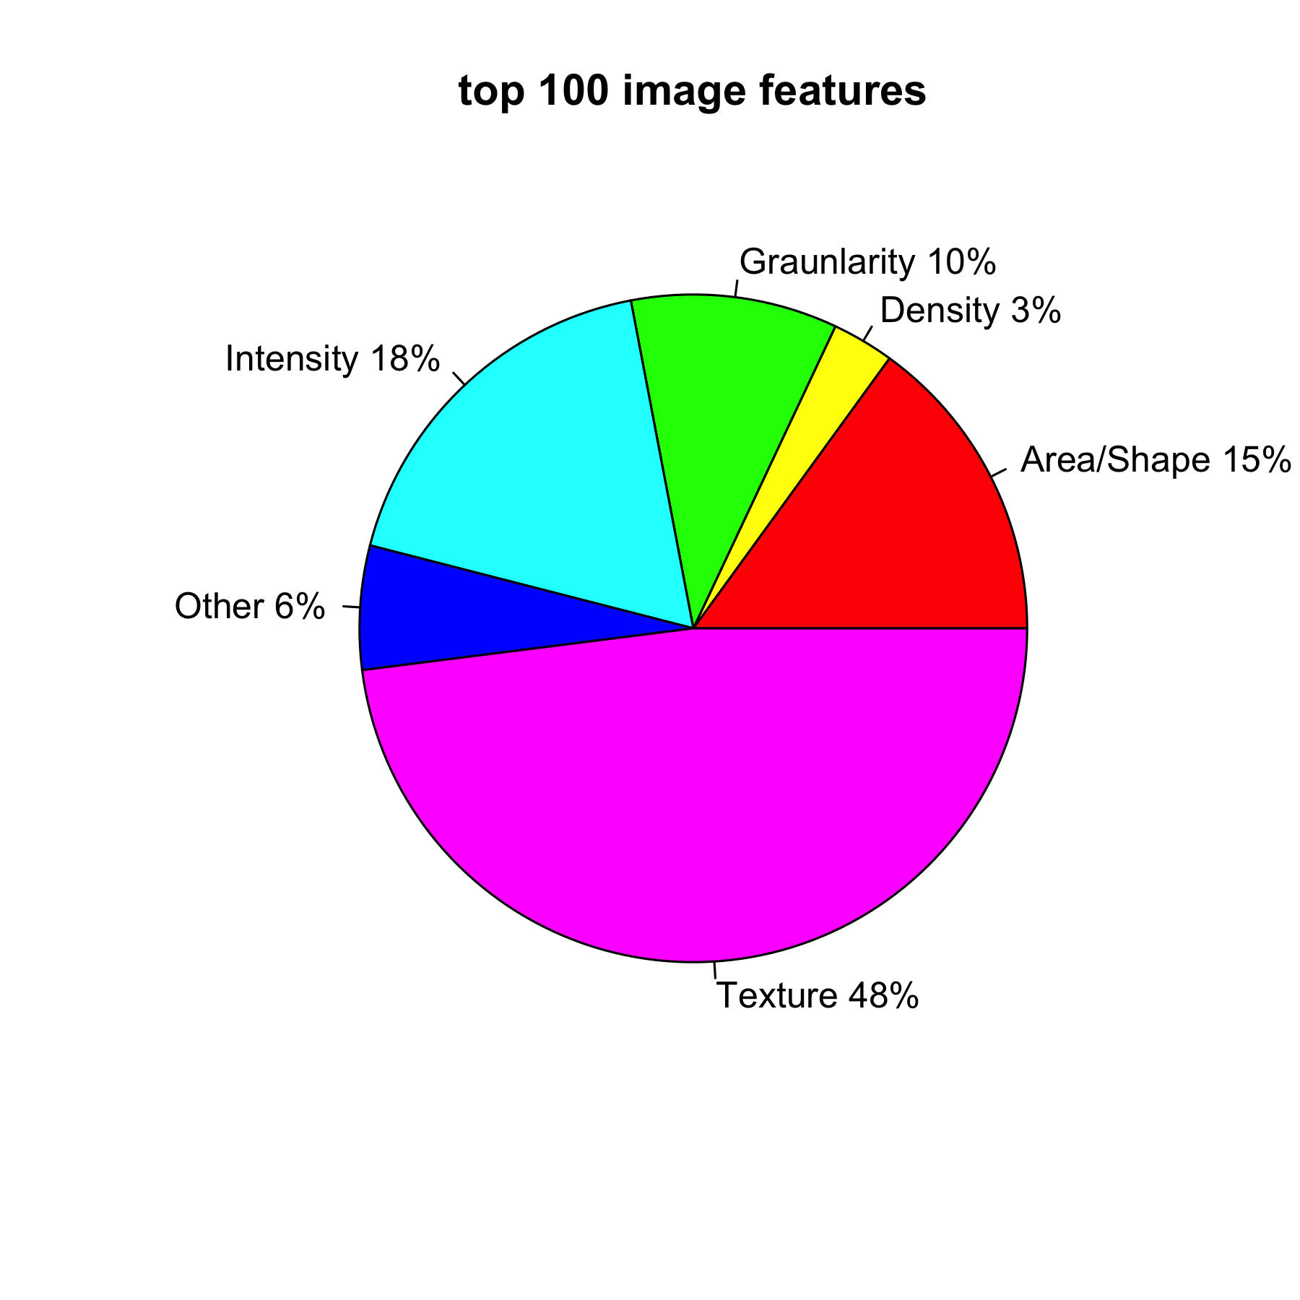

Supplementary Figure 2: Train/valid loss curves for PAGE-Net and Cox-nnet models:
(A) PAGE-Net (B) Cox-nnet - image (C) Cox-nnet - image+gene
The training loss curve of PAGE-Net fluctuates, maybe due to that the dataset has a small sample size (n=290) but high dimensionality (p=15,600), per communications with the authors of PAGE-Net.
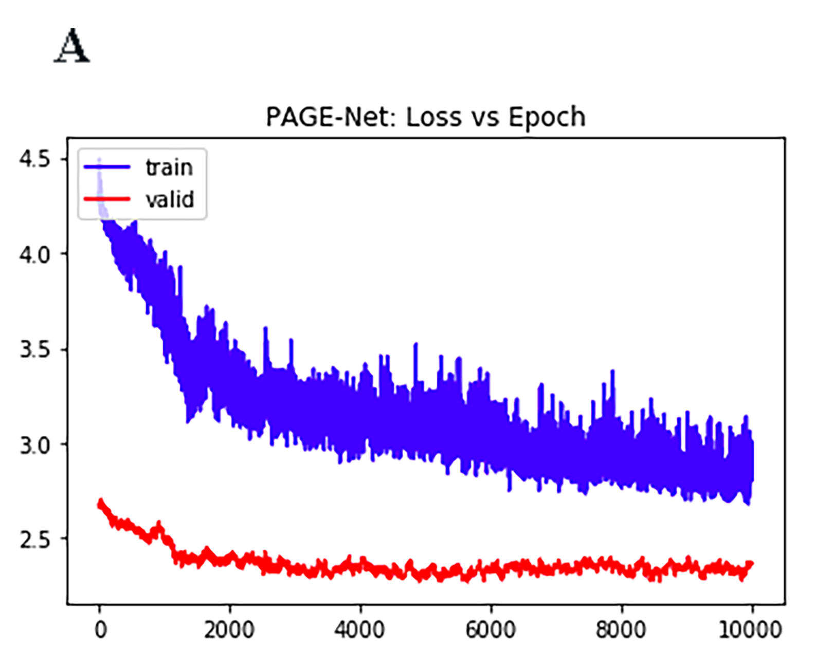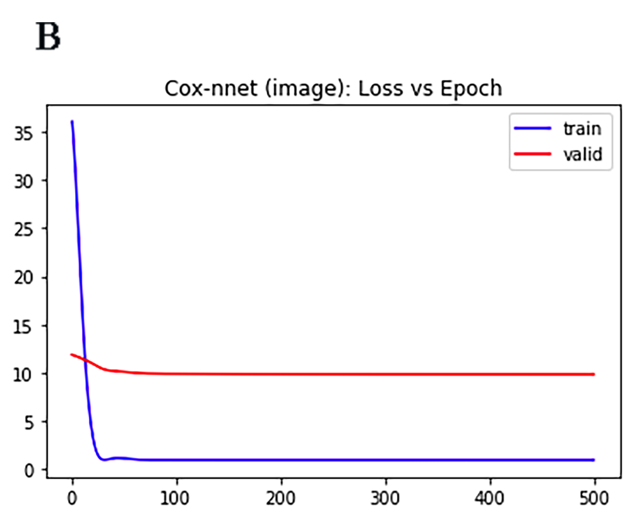
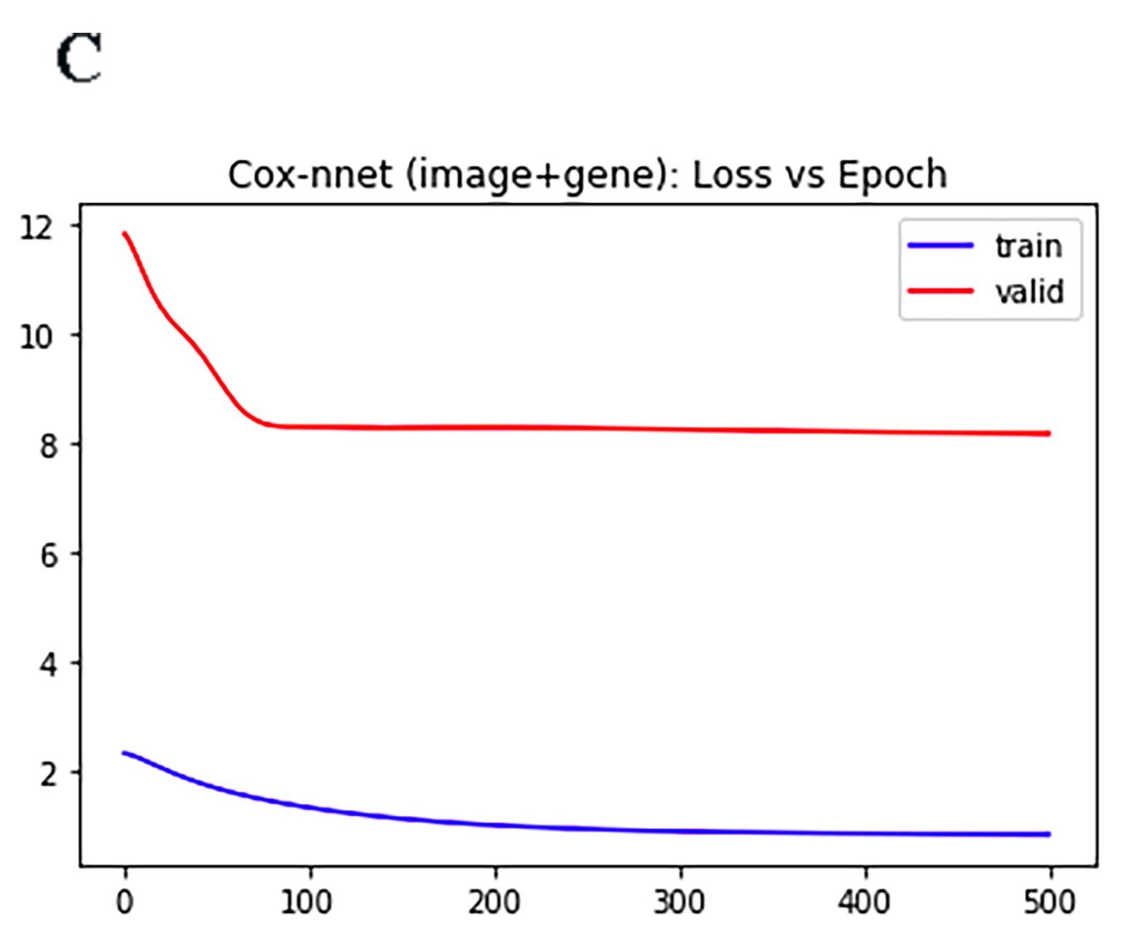

Supplementary Figure 3: Comparison of prognosis prediction among different models using pathology imaging data. Kaplan-Meier survival curves on training datasets using different methods. (A) Cox-nnet (B) CoxBoost (C) DeepSurv (D) Cox-PH (E) Random Survival Forests (RSF).
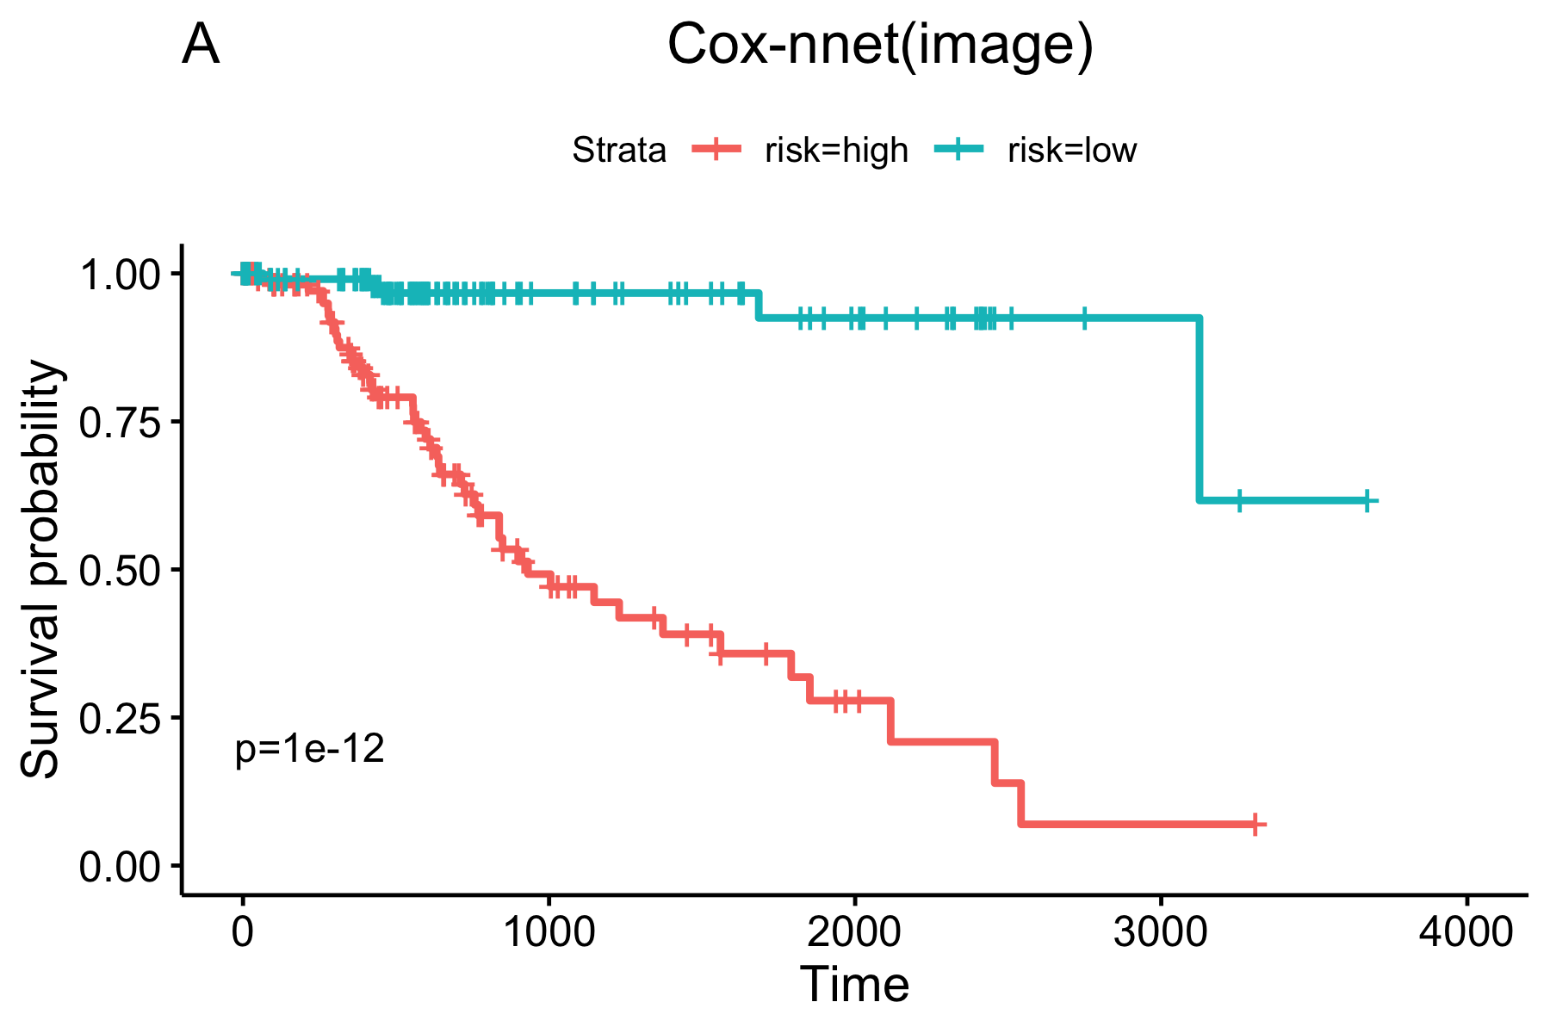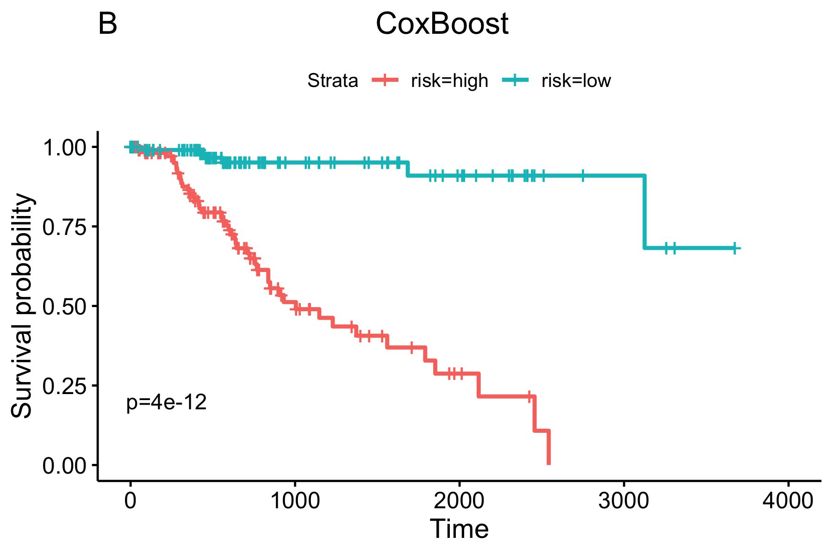
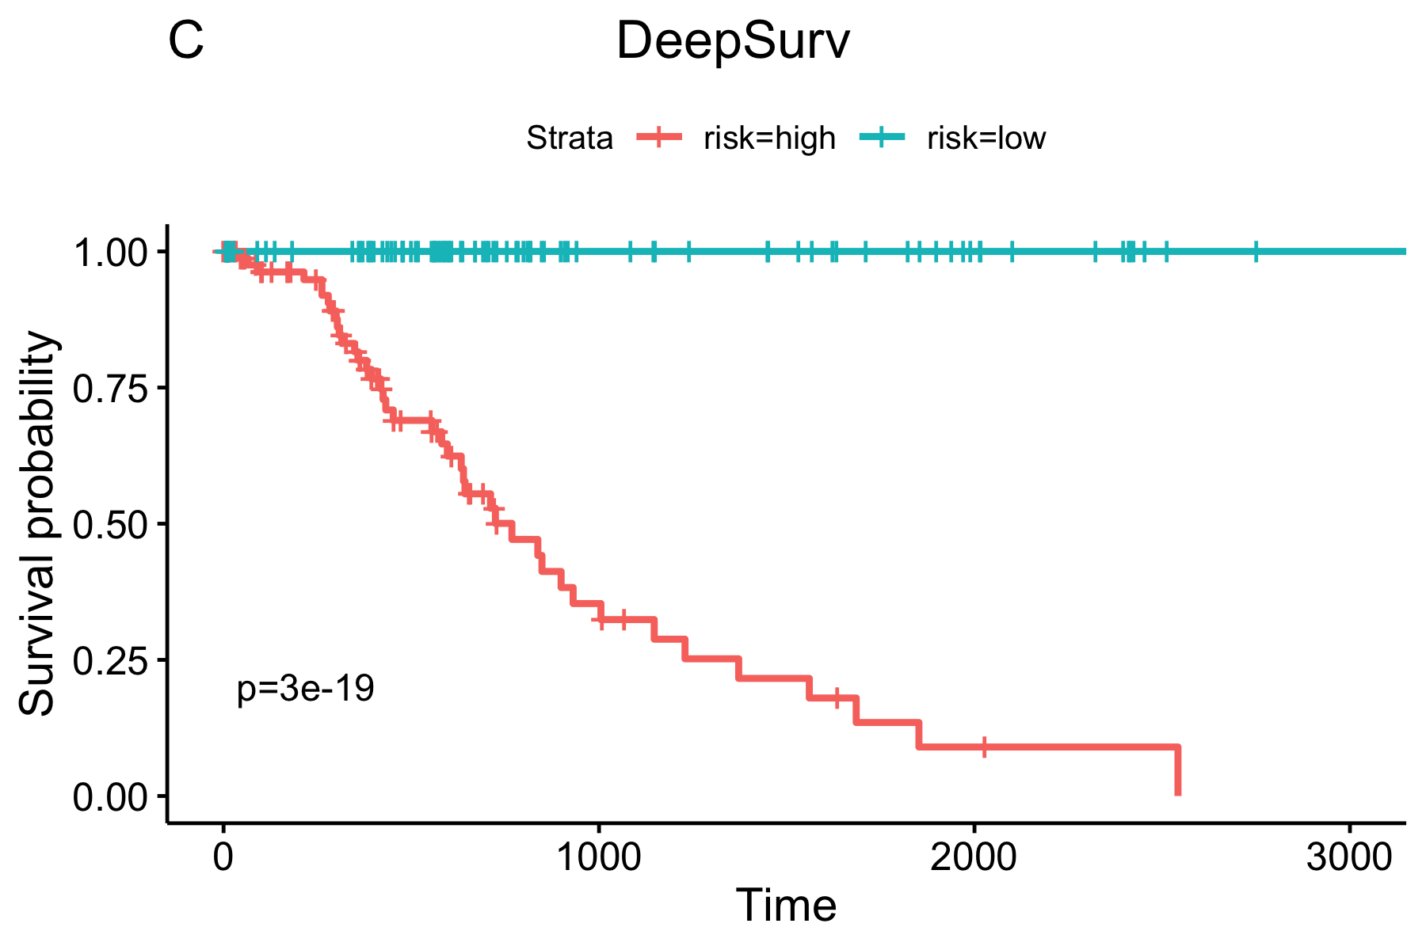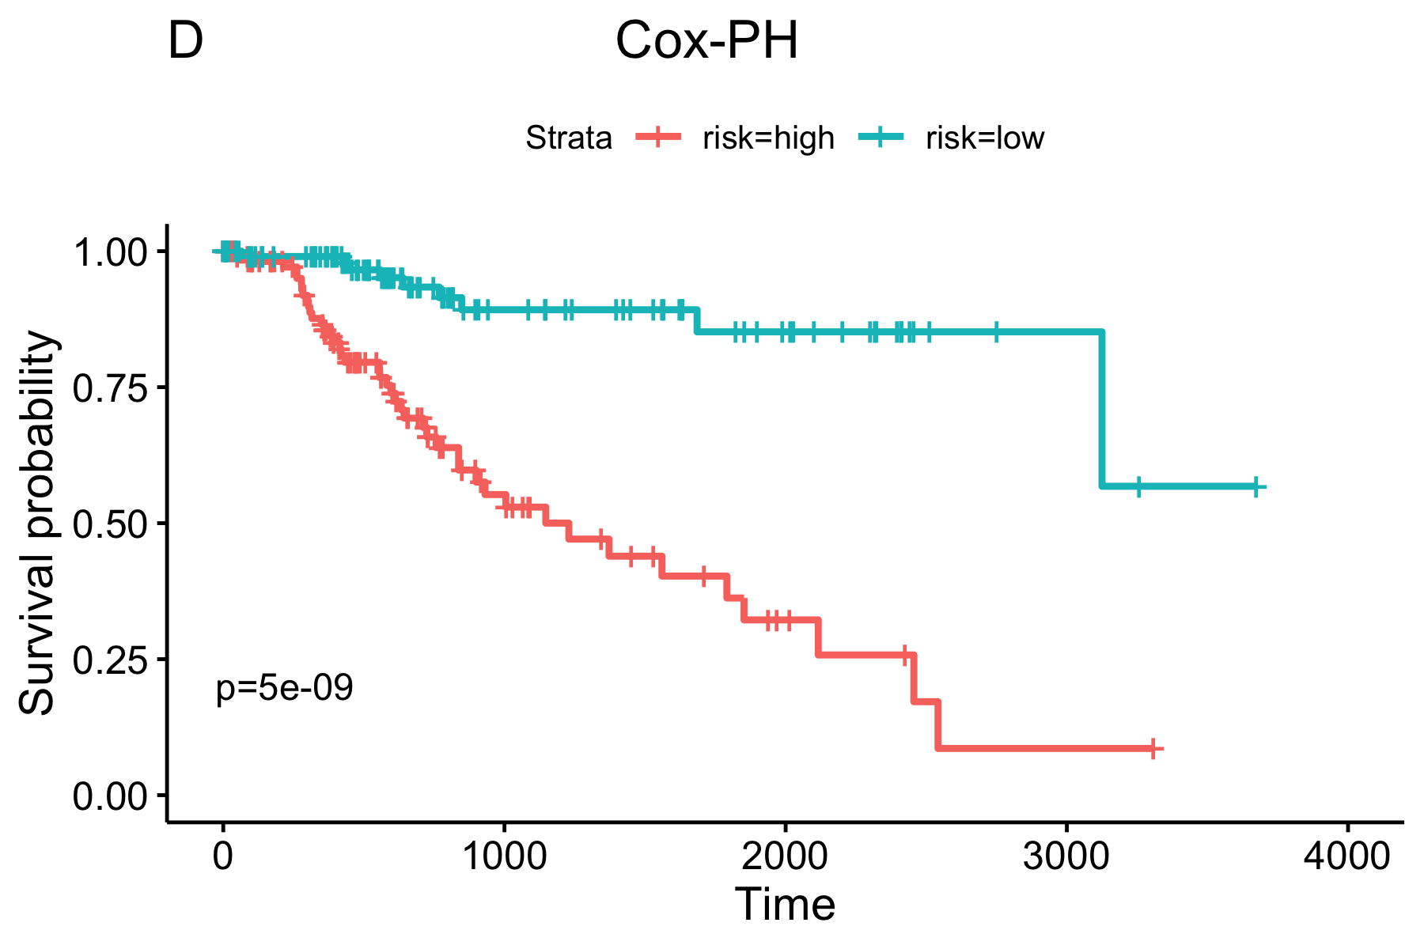
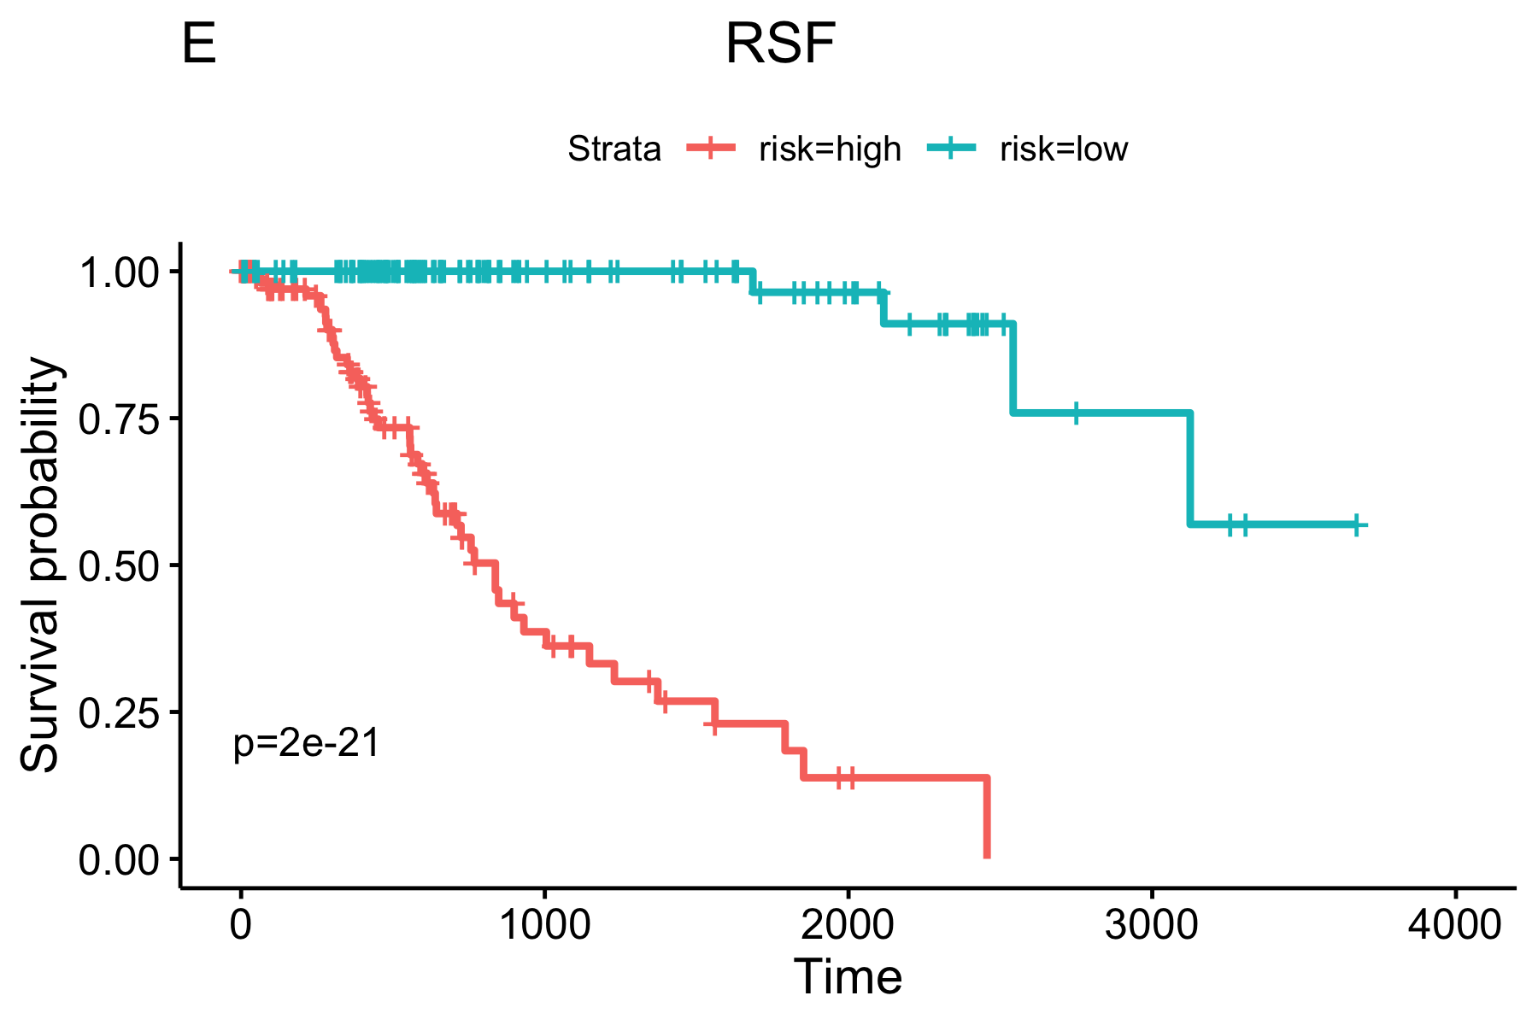

Supplementary Table 1 : Normalized feature importance scores of top 10 image features in Figure 6.
Top Image Feature | Importance score
Granularity_11_MaskedEWithoutOverlap | 2.90
Mean_FilteredNuclei_AreaShape_Orientation | 2.42
ImageQuality_MaxIntensity_MaskedHWithoutOverlap | 2.34
Intensity_MaxIntensity_MaskedHWithoutOverlap | 2.34
StDev_Cells_Neighbors_PercentTouching_Expanded | 2.29
Mean_Tissue_Location_Center_Y | 2.28
Mean_Nuclei_AreaShape_Orientation | 1.99
Granularity_5_MaskedEWithoutOverlap | 1.81
Mean_Nuclei_Texture_SumEntropy_MaskedHWithoutOverlap_3_0 | 1.72
Median_Nuclei_Texture_SumEntropy_MaskedHWithoutOverlap_3_135 | 1.67

