Supplemental Table 1. Reagents used in the B cell staining panel.

Antibody | Manufacturer | Clone
CD3 BV510 | BD Biosciences | HIT3a
CD14 BV510 | BD Biosciences | MφP9
CD56 BV510 | BD Biosciences | NCAM16.2
CD19 BUV395 | BD Biosciences | SJ25-C1
CD20 BUV737 | BD Biosciences | 2H7
CD21 PE-Cy7 | BD Biosciences | B-ly4
CD27 BV605 | BioLegend | O323
CD38 BB700 | BD Biosciences | HIT2
IgA VioBlue | Miltenyi Biotec | IS11-8E10
IgD BV650 | BD Biosciences | IA6-2
IgG BV786 | BD Biosciences | G18-145
IgM PE/Dazzle 594 | BioLegend | MHM-88
R-Phycoerythrin Streptavidin | Invitrogen | N/A
AlexaFluor 488 Streptavidin | Invitrogen | N/A
AlexaFluor 647 Streptavidin | Invitrogen | N/A
LIVE/DEAD Fixable Aqua Stain | Invitrogen | N/A

APC, allophycocyanin; BB, brilliant blue; BUV, brilliant ultraviolet; BV, brilliant violet; Cy, cyanine; FITC, fluorescein isothiocyanate; PE R-phycoerythrin; UViD, Live/Dead fiaxable ultraviolet dead cell stain

Supplemental Table 2. T cell intracellular cytokine staining flow cytometry panel.
Specificity | Fluorochrome | Clone | Vendor | Catalogue
Perforin | FITC | B-D48 | BioLegend | 353310
IL-5 | BB630 | TRFK5 | BD | Custom
IL-13 | BB630 | JES10-5A2 | BD | Custom
Ki67 | BB660 | B56 | BD | Custom
IL-4 | BB700 | MP4-25D2 | BD | Custom
CRTh2 | PE | BM16 | BioLegend | 350106
CD32 | PE-Dazzle594 | FUN-2 | BioLegend | 303218
CXCR3 (CD183) | PE-Cy5 | 1C6/CXCR3 | BD | 551128
FOXP3 | PE-Cy5.5 | PCH101 | Invitrogen | 35-4776-42
IL-17a | PE-Cy7 | BL168 | BioLegend | 512315
IL-2 | APC | MQ1-17H12 | BioLegend | 500310
Granzyme B | Alexa 700 | GB11 | BD | 560213
CD3 | APC-Fire750 | UCHT1 | BioLegend | 300470
TNF | BUV395 | MAb11 | BD | 563996
Viability | UViD | N/A | Invitrogen | 65-0863
CD45RA | BUV496 | HI100 | BD | 750258
CD19 | BUV563 | SJ25C1 | BD | 612916
CD14 | BUV661 | MΦP9 | BD | 741684
CD154 | BUV737 | TRAP1 | BD | 748983
CD8 | BUV805 | SK1 | BD | 612889
IFNγ | V450 | B27 | BD | 560371
CD4 | BV480 | SK3 | BD | 566104
CD16 | BV570 | 3G8 | BioLegend | 302036
CCR7 | BV605 | G034H7 | BioLegend | 353224
CD25 | BV650 | M-A251 | BD | 563719
CD64 | BV711 | 10.1 | BioLegend | 305042
CD56 | BV750 | 5.1H11 | BioLegend | 362556
CCR6 (CD196) | BV786 | 11A9 | BD | 563704

Figure S1. Viral dilutions yielding similar relative infectivity of Wuhan-Hu-1 and B.1.351 pseudoviruses in 293-ACE2 cells in the absence of antibody or sera were employed during neutralization experiments. Each dot represents the average entry of meausred n=8 replicate wells from an individual assay plate corresponding to the data shown in Figure Figure 3. The entry of pseudoviral particles produced without transfection with a spike-encoding plasmid are shown for comparison. (Δspike) The background is the luciferase signal obtained from n=8 replicate wells to which neither virus was added. The bars represent the mean and the error bars represent the SD.

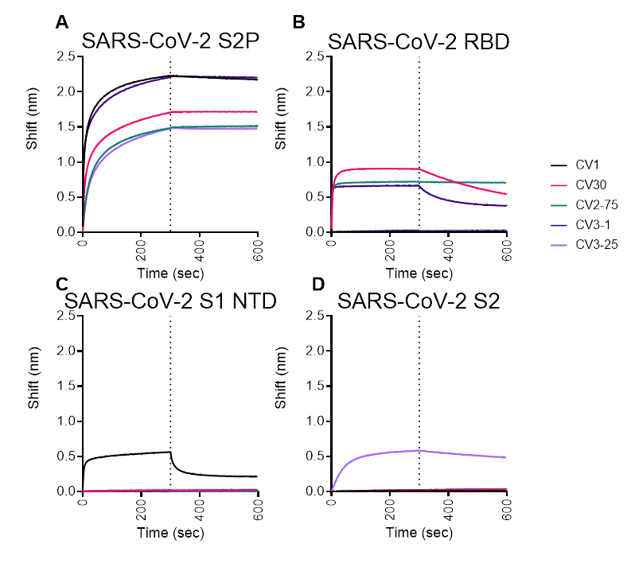
Figure S2. Binding of the indicated mAbs was measured to (A) SARS-CoV-2 S2P, (B) SARS-CoV-2 RBD, (C) SARS-CoV-2 S1 NTD, and (D) SARS CoV-2 S2 by BLI.

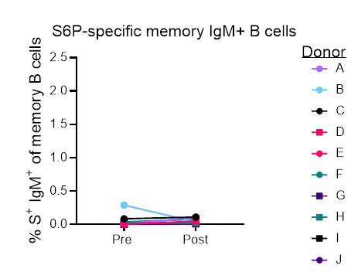
Figure S3. Frequency of S-specific IgM memory B cells (live, IgD⁻, CD19⁺, CD20⁺, CD3⁻, CD14⁻, CD56⁻, singlet, lymphocytes) before and after immunization.

Figure S4. The ability of sera from donors who recovered from SARS-CoV-2 were evaluated for their ability to neutralize the Wuhan Hu1 and B.1.351 pseudovirus infectivity before and after immunization as indicated. Serum collected from two donors prior to the pandemic were included as controls. Data is represenative of two independent experiments.
Figure S5: No significant correlation between pre-vaccination neutralization responses to Wuhan Hu1 or B.1.351 variant (mutant) spike. r, Spearman rank correlation.

Figure S6. No significant correlation between post-vaccination neutralization responses to Wuhan Hu1 or B.1.351 variant (mutant) spike. r, Spearman rank correlation.

Figure S7. No significant differences in pre-vaccination neutralization responses to Wuhan Hu1 or B.1.351 variant (mutant) spike seen by WHO scale (2 vs. 3). p, Wilcoxon rank sum p-values.

Figure S8. No significant differences in post-vaccination neutralization responses to Wuhan Hu1 or B.1.351 variant (mutant) spike seen by WHO scale (2 vs. 3). p, Wilcoxon rank sum p-values.

Figure S9. The ability of serum from donors who recovered from SARS-CoV-2 were evaluated for their ability to neutralize SARS-CoV-1 infectivity before and after immunization as indicated. Serum collected from two donors prior to the pandemic were included as controls.

