Supplement Figures
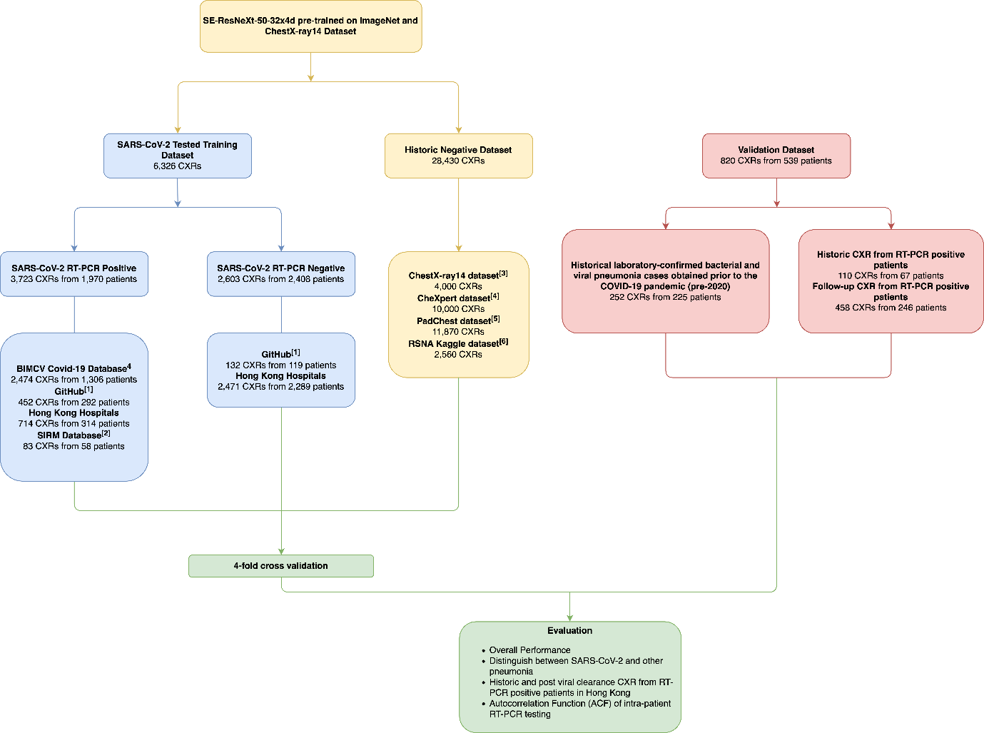
S1. Description of datasets and how they were used to construct and validate the RadGen model.
[1] GitHub COVID-19 image data collection (https://github.com/ieee8023/covid-chestxray-dataset), Actualmed COVID-19 Chest X-ray Dataset Initiative (https://github.com/agchung/Actualmed-COVID-chestxray-dataset), and Figure 1 COVID-19 Chest X-ray Dataset Initiative (https://github.com/agchung/Figure1-COVID-chestxray-dataset)
[2] Italian Society of Medical and Interventional Radiology (SIRM) COVID-19 Database (https://www.sirm.org/en/category/articles/covid-19-database/)
[3] 4,000 CXR were randomly selected from ChestXray14 dataset of 112,120 CXR for hard negative mining³. This dataset was not included for validation.
[4] 10,000 CXR were randomly selected from CheXpert dataset of 224,316 CXR for hard negative mining³. This dataset was not included for validation.
[5] 11,870 CXR were randomly selected from the PadChest dataset of over 160,000 CXR and the CXR with the highest false negative prediction scores were used for hard negative mining.
[6] The highest false negative prediction scores of the model from the RSNA pneumonia Detection Challenge dataset on Kaggle was used to perform hard negative mining.
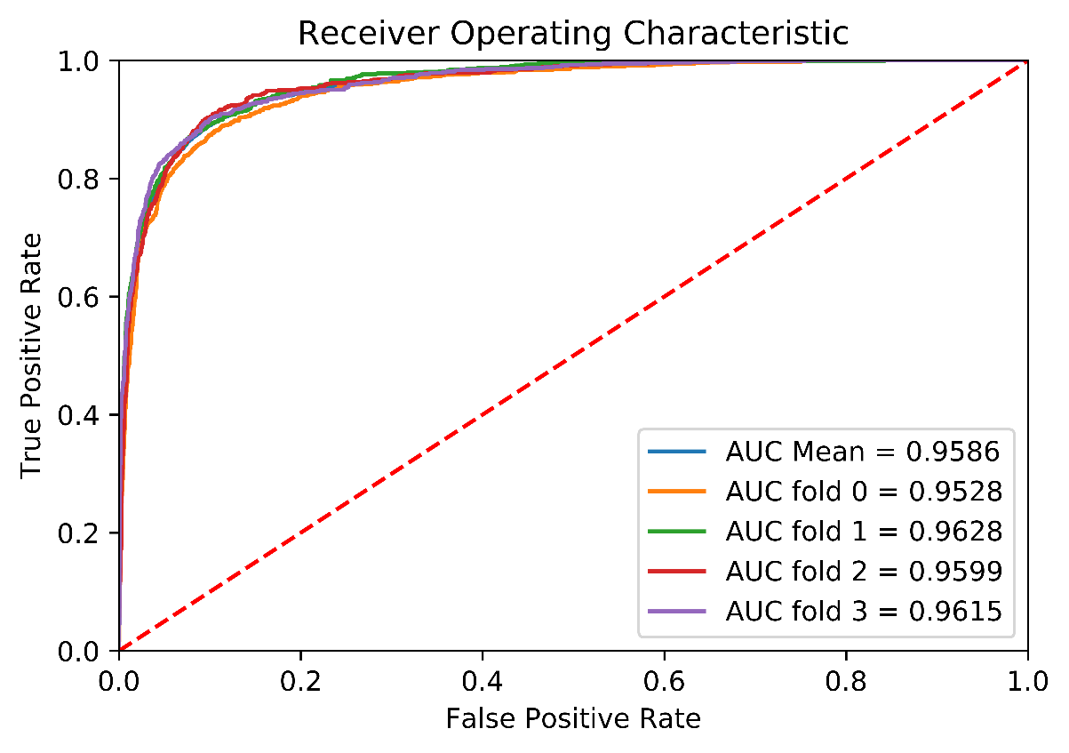

S2. Mean and individual Receiver Operating Characteristic (ROC) curves for each validation fold. The model’s operating point of 0.4 was selected based on the maximal Youden index.

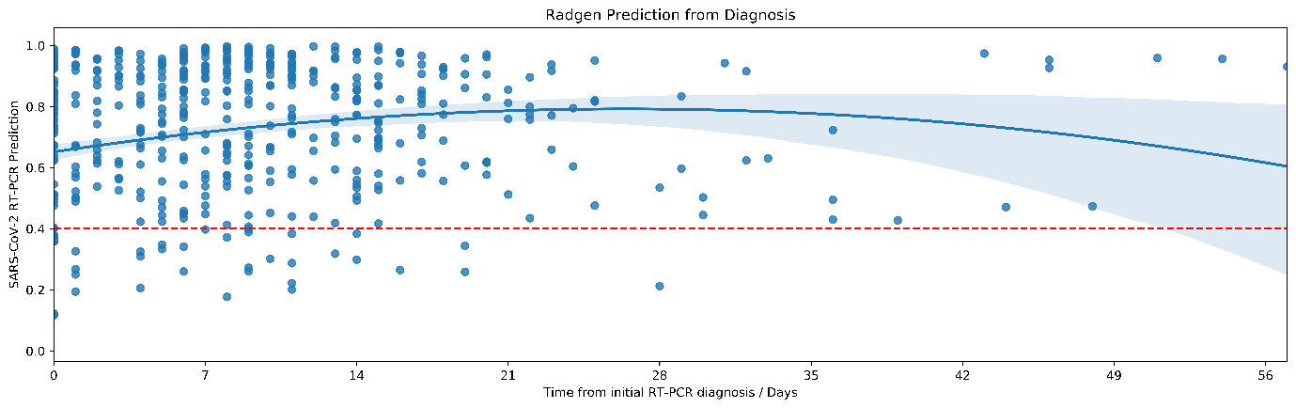
S3. Time series profile showing the distribution of prediction scores by RadGen on CXR of all RT-PCR positive patients from the time of their initial diagnosis. Blue area denotes the 95% confidence interval and red dash denotes the RadGen 0.4 cutpoint used to predict RT-PCR binary classification (RT-PCR positive prediction when RadGen score is >0.4).
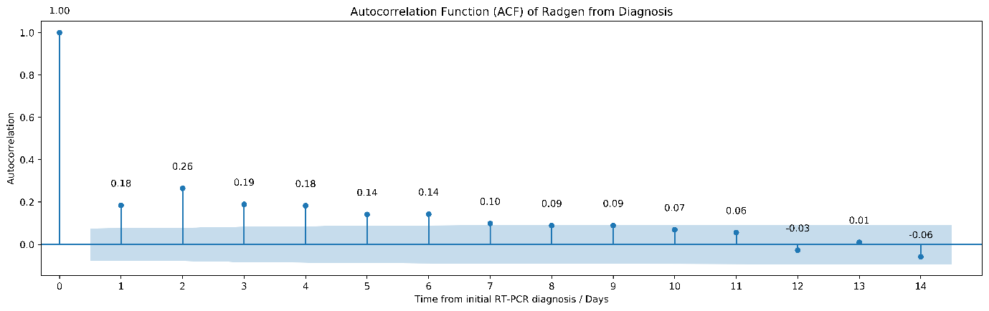

S4. Autocorrelation function (ACF) plot of the model demonstrating a time lag over the first 7 days (peak at day 2) between RadGen predicted and corresponding matched RT-PCR status; Blue area denotes 95%CI.

