Title: International risk of the new variant COVID-19 importations originating in the United Kingdom
Authors: Zhanwei Du^{1,2+}, Lin Wang³⁺, Bingyi Yang¹, Sheikh Taslim Ali^{1,2}, Tim K. Tsang¹, Songwei Shan^{1,2}, Peng Wu¹, Eric H. Y. Lau^{1,2}, Benjamin J. Cowling^{1,2*} and Lauren Ancel Meyers^{4,5*}
Affiliations:
- WHO Collaborating Centre for Infectious Disease Epidemiology and Control, School of Public Health, LKS Faculty of Medicine, The University of Hong Kong, Hong Kong Special Administrative Region, China
- Laboratory of Data Discovery for Health, Hong Kong Science and Technology Park, Hong Kong Special Administrative Region, China
- University of Cambridge, Cambridge CB2 3EH, UK
- The University of Texas at Austin, Austin, Texas 78712, The United States of America
- Santa Fe Institute, Santa Fe, New Mexico, The United States of America
⁺ These first authors contributed equally to this article
* Correspondence: Benjamin J. Cowling and Lauren Ancel Meyers (Email: bcowling@hku.hk; laurenmeyers@austin.utexas.com)

Supplement
Table S1. Model Parameters and Data Sources.
Symbol | Description | Values | Sources
 | Number of passengers between country and at day | daily mobility number from UK to other countries | Facebook Data for Good ¹
 | Symptomatic proportion of infections | 57% | Ref. ²
 | Number of COVID-19 hospital admissions in country at day | daily COVID-19 hospital admissions in each country | Refs. ^{3,4}
 | Proportion of symptomatic cases that are hospitalized | 3.4/77 | Ref. ⁵
 | Daily proportion of the 501Y variant (with amino acid deletion 69/70 circulating) among new SARS-CoV-2 cases | daily proportion of variant among all sequenced SARS-CoV-2 samples in UK | Following the weekly proportion in Ref. ⁶
 | Mean delay from infection to hospitalization | 9.5 days | Ref. ⁷
 | Mean incubation period for symptomatic cases | 5 days | Ref. ⁷
 | Mean duration of symptomatic state | 11 days | Ref. ⁷
 | Mean time from infection to recovery for asymptomatic cases | 11 days | Ref. ⁷
 | United Kingdom population | 66,796,807 (2019) | Ref. ⁸
 | Ratio of the reproduction numbers for the 501Y versus 501N variant | 1.25, 1.5, and 1.75 | Assumed based on Refs. ^{9–11}

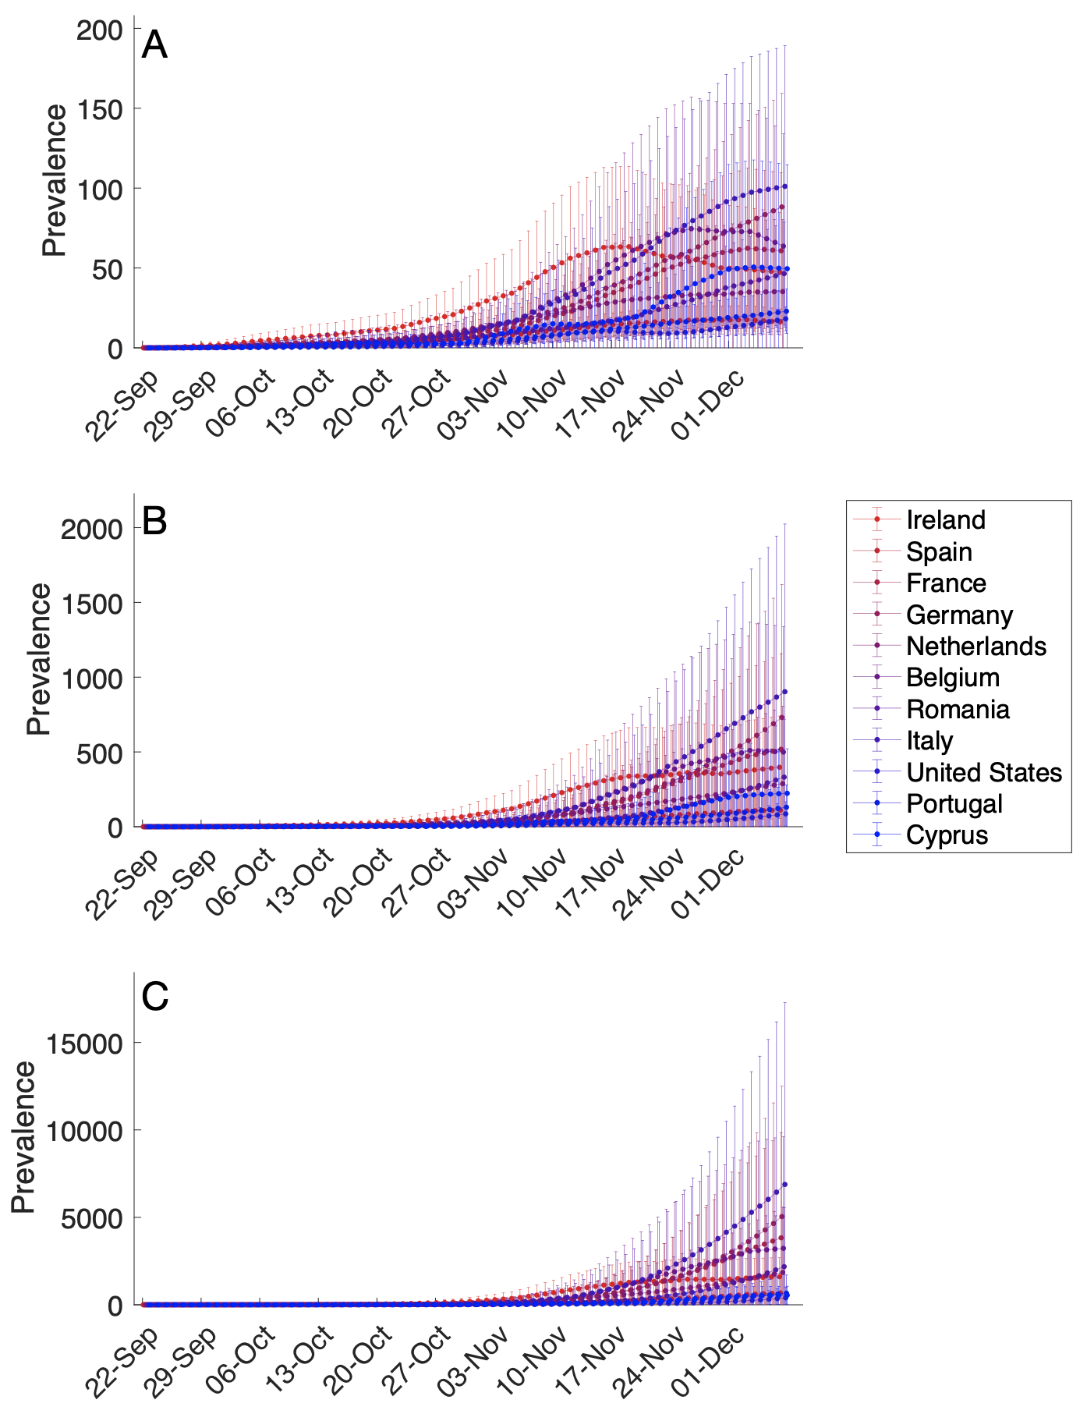
Figure S1. Estimated daily prevalence of the 501Y variant of SARS-CoV-2 in 19 countries between September 22 and December 7, 2020, assuming the variant is = (A) 25%, (B) 50%, and (C) 75% more transmissibility than 501N. Points and bars indicate means and standard deviation based on100 simulations.

Methods
Risk of exportation from infected residents
We assume the number of new cases (asymptomatic and symptomatic) of the mutant strain and infected in country i per day d are given as
,
.

where is the number of COVID-19 hospital admissions in country on day , is the daily proportion of new cases infected by the variant, is the symptomatic proportion, and is the mean delay from infection to hospitalization (Table S1).

The number of pre-symptomatic and asymptomatic infectious cases in country i at time d ( and ) is given by
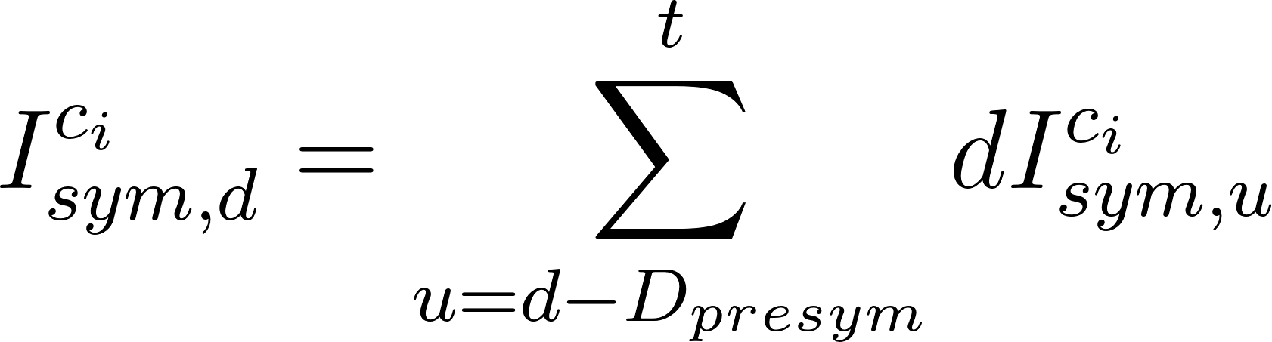,
.

and the prevalence of infectious cases is given by
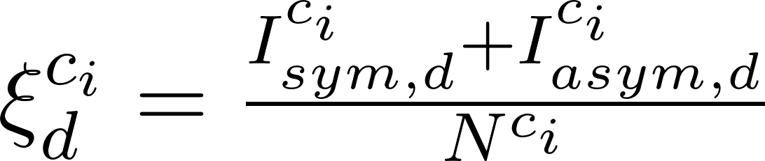,

where is the population size of country i, is the mean duration of symptomatic state, and is the mean time from infection to recovery for asymptomatic cases. We assume that visitors to a country have the same daily risk of infection as residents of this country. Under this assumption, the rate at which infected residents of country i travel to country j on day d is .
Assuming that the introduction of cases from the epidemic origin to each country j is essentially a non-homogeneous Poisson process ^{12–14}, we can calculate the probability of introducing at least one case from country i to country j by day d using
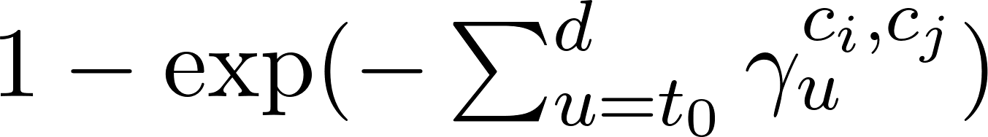

Daily prevalence of the 501Y (with amino acid deletion 69/70 circulating) mutant strains of SARS-CoV-2
Given the hospitalization admissions of country () on day ,
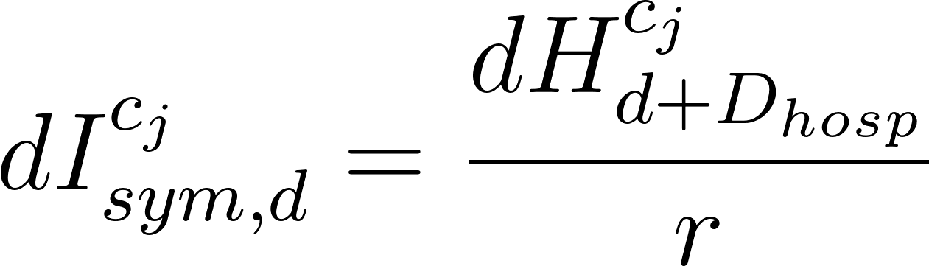,
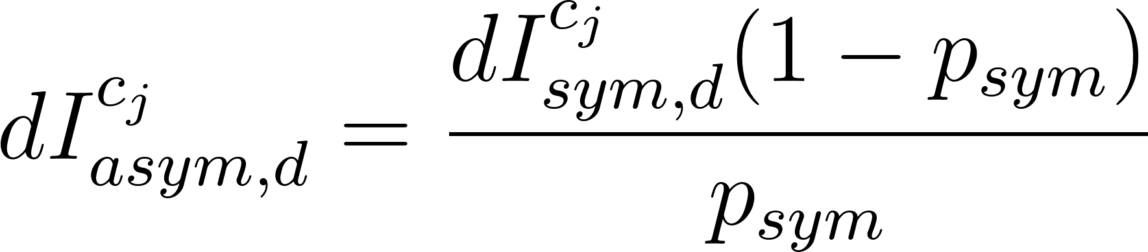 .

Let denote the ratio between the reproduction number of the 501Y variant and the reproduction number of the 501N variant. Then, the incidence of the 501Y (with amino acid deletion 69/70 circulating) mutant strains and 501N, and , are given by
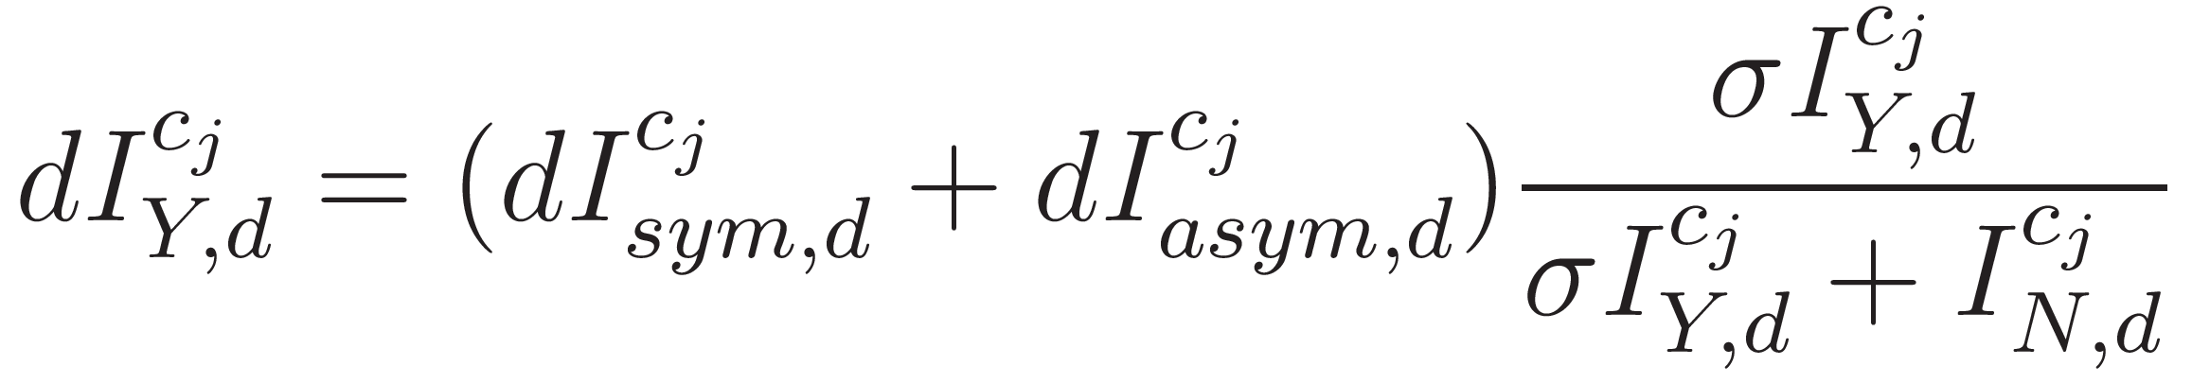,
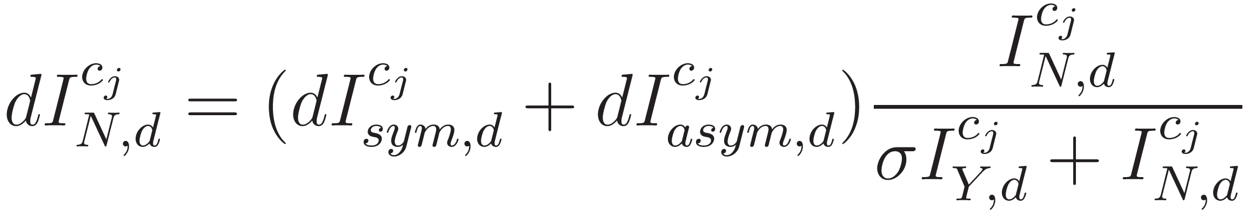,
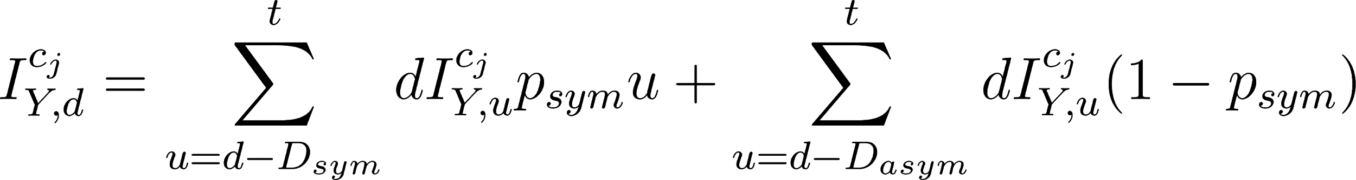,
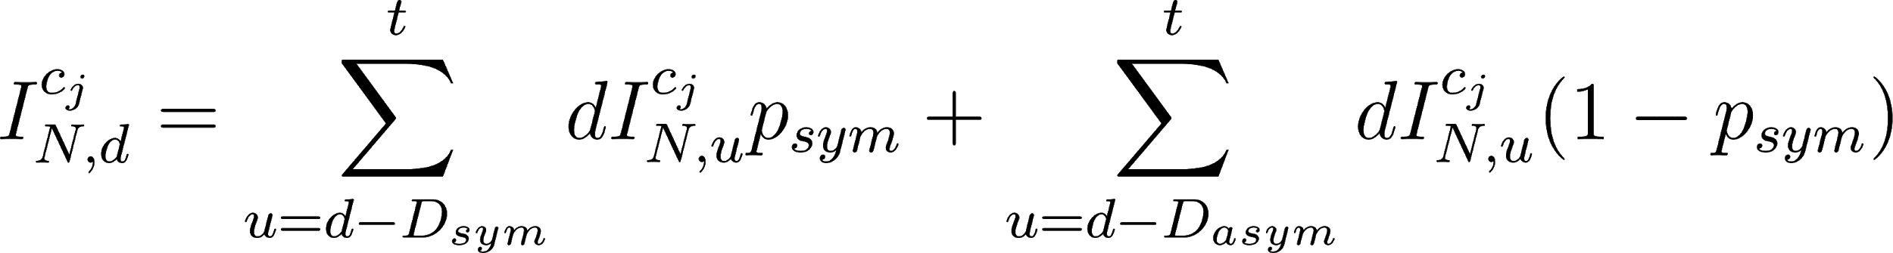.

We introduce the first symptomatic seed of 501Y to country according to the estimated seeding probability and then estimate the daily prevalence and prevalence of 501Y and 501N according to the above equations.

References
1. Home - Facebook Data for Good. https://dataforgood.fb.com/.
2. Gudbjartsson, D. F. et al. Spread of SARS-CoV-2 in the Icelandic Population. N. Engl. J. Med. 382, 2302–2315 (2020).
3. Official UK Coronavirus Dashboard. https://coronavirus.data.gov.uk/details/healthcare.
4. Coronavirus (COVID-19) Hospitalizations. https://ourworldindata.org/covid-hospitalizations.
5. CDC. Estimated Disease Burden of COVID-19. https://www.cdc.gov/coronavirus/2019-ncov/cases-updates/burden.html (2020).
6. Leung, K., Shum, M. H. H., Leung, G. M., Lam, T. T. Y. & Wu, J. T. Early transmissibility assessment of the N501Y mutant strains of SARS-CoV-2 in the United Kingdom, October to November 2020. Eurosurveillance 26, 2002106 (2021).
7. Aleta, A. et al. Modelling the impact of testing, contact tracing and household quarantine on second waves of COVID-19. Nat Hum Behav (2020) doi:10.1038/s41562-020-0931-9.
8. Park, N. Population estimates for the UK, England and Wales, Scotland and Northern Ireland - Office for National Statistics. https://www.ons.gov.uk/peoplepopulationandcommunity/populationandmigration/populationestimates/bulletins/annualmidyearpopulationestimates/mid2019estimates (2020).
9. Report 42 - Transmission of SARS-CoV-2 Lineage B.1.1.7 in England: insights from linking epidemiological and genetic data. https://www.imperial.ac.uk/mrc-global-infectious-disease-analysis/covid-19/report-42-sars-cov-2-variant/.
10. Leung, K., Shum, M. H. M., Leung, G. M., Lam, T. T. Y. & Wu, J. T. Early empirical assessment of the N501Y mutant strains of SARS-CoV-2 in the United Kingdom, October to November 2020. bioRxiv (2020) doi:10.1101/2020.12.20.20248581.
11. Davies, N. G., Barnard, R. C., Jarvis, C. I. & Kucharski, A. J. Estimated transmissibility and severity of novel SARS-CoV-2 Variant of Concern 202012/01 in England. medRxiv (2020).
12. Wang, L. & Wu, J. T. Characterizing the dynamics underlying global spread of epidemics. Nat. Commun. 9, 218 (2018).
13. Scalia Tomba, G. & Wallinga, J. A simple explanation for the low impact of border control as a countermeasure to the spread of an infectious disease. Math. Biosci. 214, 70–72 (2008).
14. Wu, J. T., Leung, K. & Leung, G. M. Nowcasting and forecasting the potential domestic and international spread of the 2019-nCoV outbreak originating in Wuhan, China: a modelling study. Lancet 395, 689–697 (2020).

