Supplementary Figure A. Observed high-sensitive cardiac troponin concentrations for individual patients in the RIPC group and control group

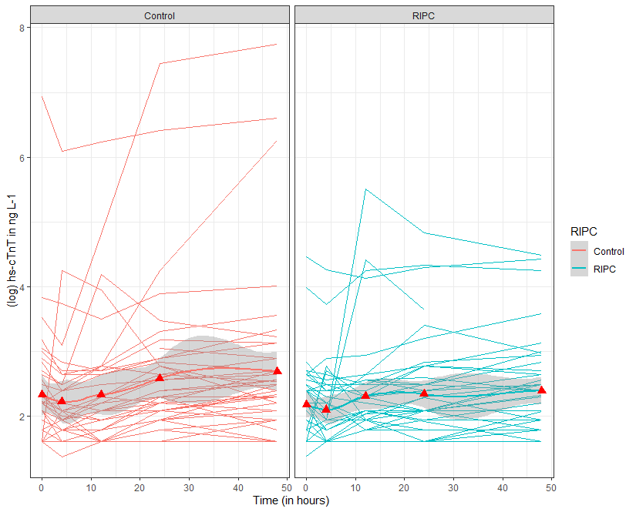
Red triangles represent mean high-sensitive cardiac troponin concentrations.
RIPC, remote ischemic preconditioning
Hs, high-sensitive
cTn, cardiac troponin

Supplementary Figure B. Observed interleukin-6 concentrations for individual patients in the RIPC group and control group
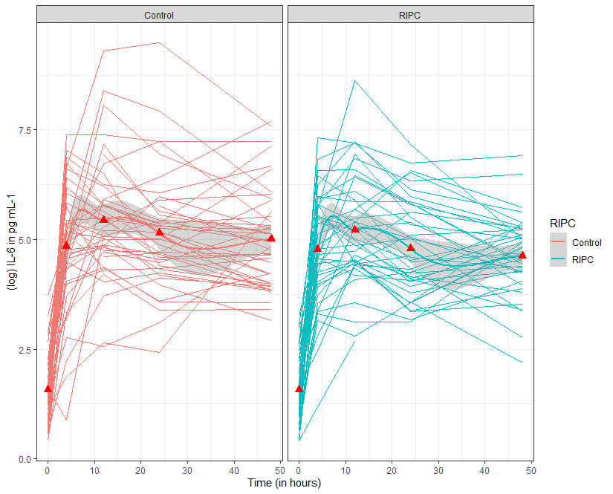
Red triangles represent mean interleukin-6 values.
RIPC, remote ischemic preconditioning
IL, interleukin

