Supplementary Materials for “International Comparisons of Harmonized Laboratory Value Trajectories to Predict Severe COVID-19: Leveraging the 4CE Collaborative Across 342 Hospitals and 6 Countries”

- Further Methods
  - AUC estimation for laboratory Tests
- Efigures
  - eFIGURE 1. Risk difference of severe disease between age groups 0-25, 26-49, 70-79, and 80+ compared to age group 50-69 stratified by country.
  - eFIGURE 2: A) Pooled laboratory values in ever-severe and never-severe patients for selected laboratory tests, and B) patient-level AUC at each day after admission for those labs.
  - eFIGURE 3: Site-level and country-level variation of laboratory tests.
  - eFIGURE 4: Patient level AUC of laboratory tests stratified by regions.

- Etables
  - eTABLE1: Membership of 4CE.
  - eTABLE2: Participating sites.
  - eTABLE 3: Definition of severe COVID-19 based on the 4CE Severity Algorithm.
  - eTABLE 4: Six comma-separated values (CSV) files and their descriptions.
  - eTABLE 5: Pooled difference between admission laboratory measures in ever-severe and never-severe patients over all sites.

- Further Methods

AUC estimation for laboratory tests
We estimated patient-level AUC under distribution assumptions. The averaged AUC over sites on day $t$ was calculated as ${\underline{AUC}}_{jt}=\frac{\sum_{j=1}^{K}{}{\hat{w_{j} AUC}}_{jt}}{\sum_{j=1}^{K}{}w_{j}}$, where $\hat{{AUC}_{jt}}=φ(\frac{μ_{jt1}-μ_{jt0}}{\sqrt{σ_{jt1}^{2}+σ_{jt0}^{2}}})$was the estimated AUC at the $j$th site, $w_{j}$was the maximum number of patients at the $j$the site over 14 days, $μ_{jt1}$, $μ_{jt0}$, $σ_{jt1}^{}$ and $σ_{jt0}^{}$ were mean and standard deviation of lab measures among ever-severe patients and those among never-severe patients at the $j$the site for $j=1,...,K_{}.$ We also calculated the standard error of ${\underline{AUC}}_{jt}$ via monte carlo simulation. Specifically, at the $j$th site on day $t$, we repeatedly generated the four measures: $μ_{jt1}^{(d)}$, $μ_{jt0}^{(d)}$, $σ_{jt1}^{2(d)}$ and $σ_{jt0}^{2(d)}$, for $d=1,...,1000$, where $μ_{jty}^{(d)}$ was generated from a normal distribution $N(μ_{ity}, σ_{jty}^{2}/n_{jty})$, and $σ_{jty}^{2(d)}$ was generated from a Chi-squared distribution ${χ^{2}(n_{jty}-1)σ_{jty}^{2}/(n_{jty}-1)}_{{}_{}}$ for $y=1,0$. We then calculated $\hat{{AUC}_{jt}^{(d)}}$ as the function of $μ_{jt1}^{(d)}$, $μ_{jt0}^{(d)}$, $σ_{jt1}^{2(d)}$ and $σ_{jt0}^{2(d)}$. The standard error of $\hat{{AUC}_{jt}^{}}$ was then calculated as ${{\hat{SE}}_{jt}}_{}=\sqrt{\frac{1}{1000}\sum_{d=1}^{1000}{}{{\hat{(AUC}}_{jt}^{(d)}-\frac{1}{1000}\sum_{d=1}^{1000}{}{\hat{(AUC}}_{jt}^{(d)})}^{2}}$. Finally, the averaged SE of AUC over sites on day $t$ was calculated as ${\underline{SE}}_{jt}=\frac{\sum_{j=1}^{K}{}w_{j}{\hat{SE}}_{jt}}{\sum_{j=1}^{K}{}w_{j}}$.

- eFIGURES

eFIGURE 1. Risk difference of severe disease between age groups 0-25, 26-49, 70-79, and 80+ compared to age group 50-69 stratified by country. Risk is defined as the likelihood of being ever-severe.

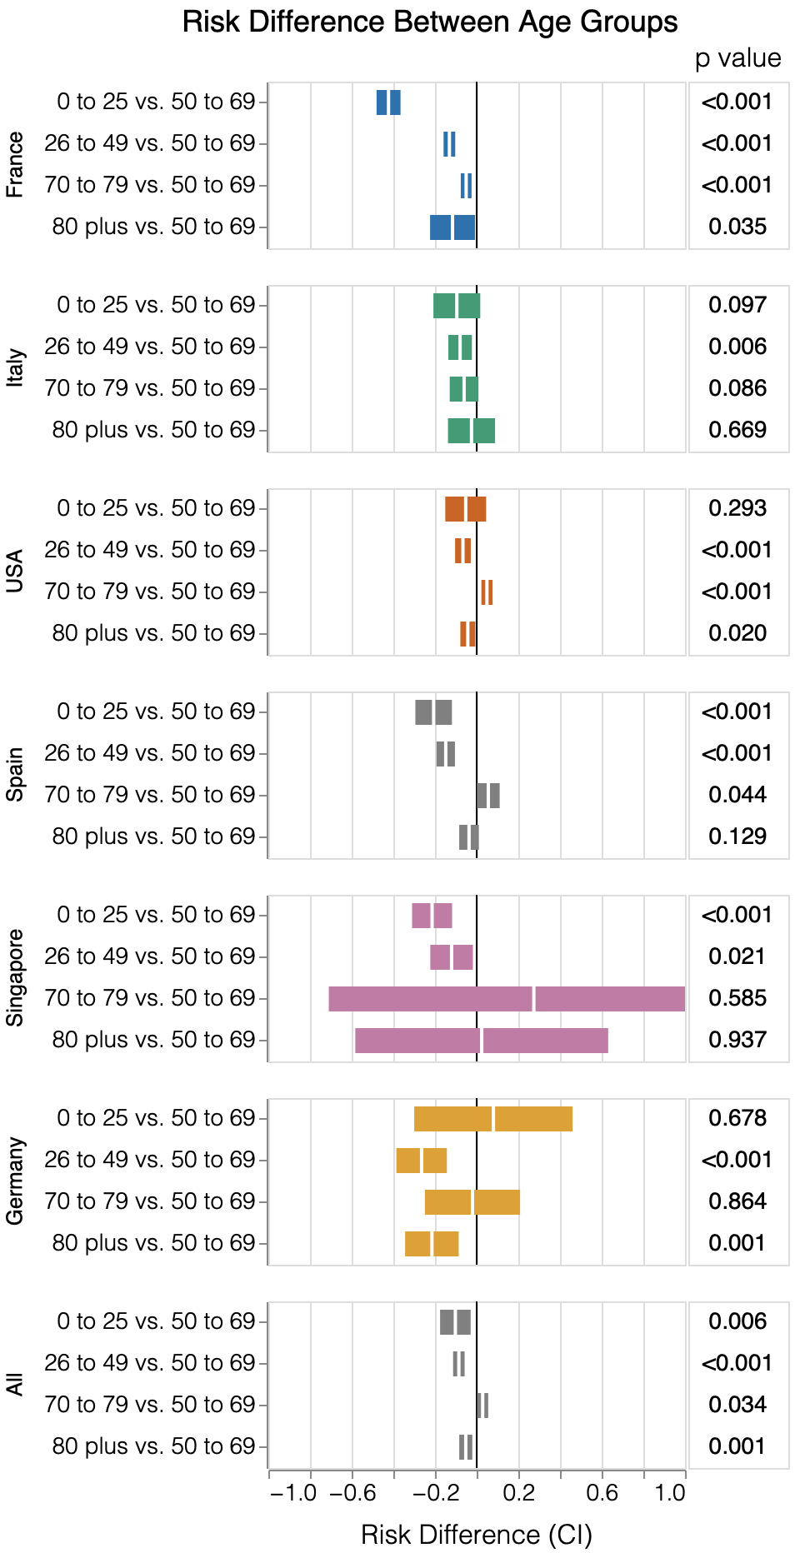

eFIGURE 2: A) Pooled laboratory values in ever-severe and never-severe patients for selected laboratory tests, and B) patient-level AUC at each day after admission for those labs. Inset shows AUC of laboratory value at admission and in-hospital to individually predict ever-severe as well as optimized thresholds.

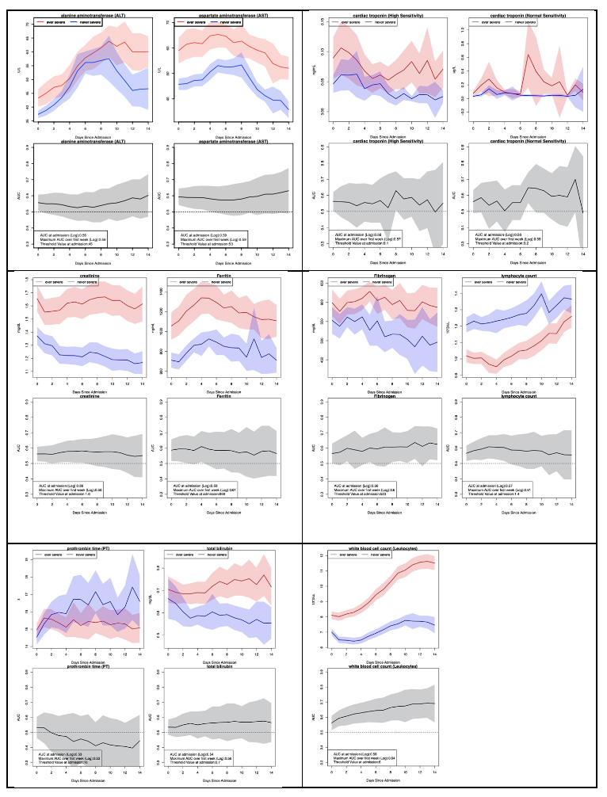

eFIGURE 3: Site-level and country-level variation of laboratory tests.
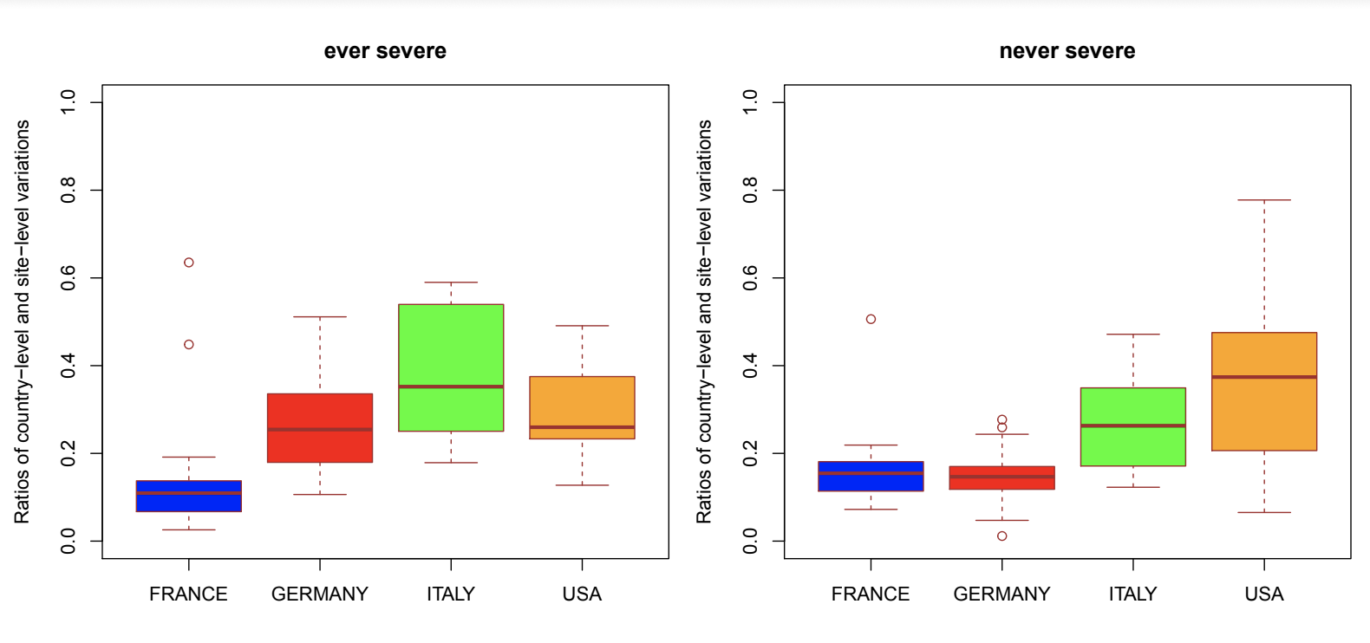

eFIGURE 4: Patient level AUC of laboratory tests stratified by regions.

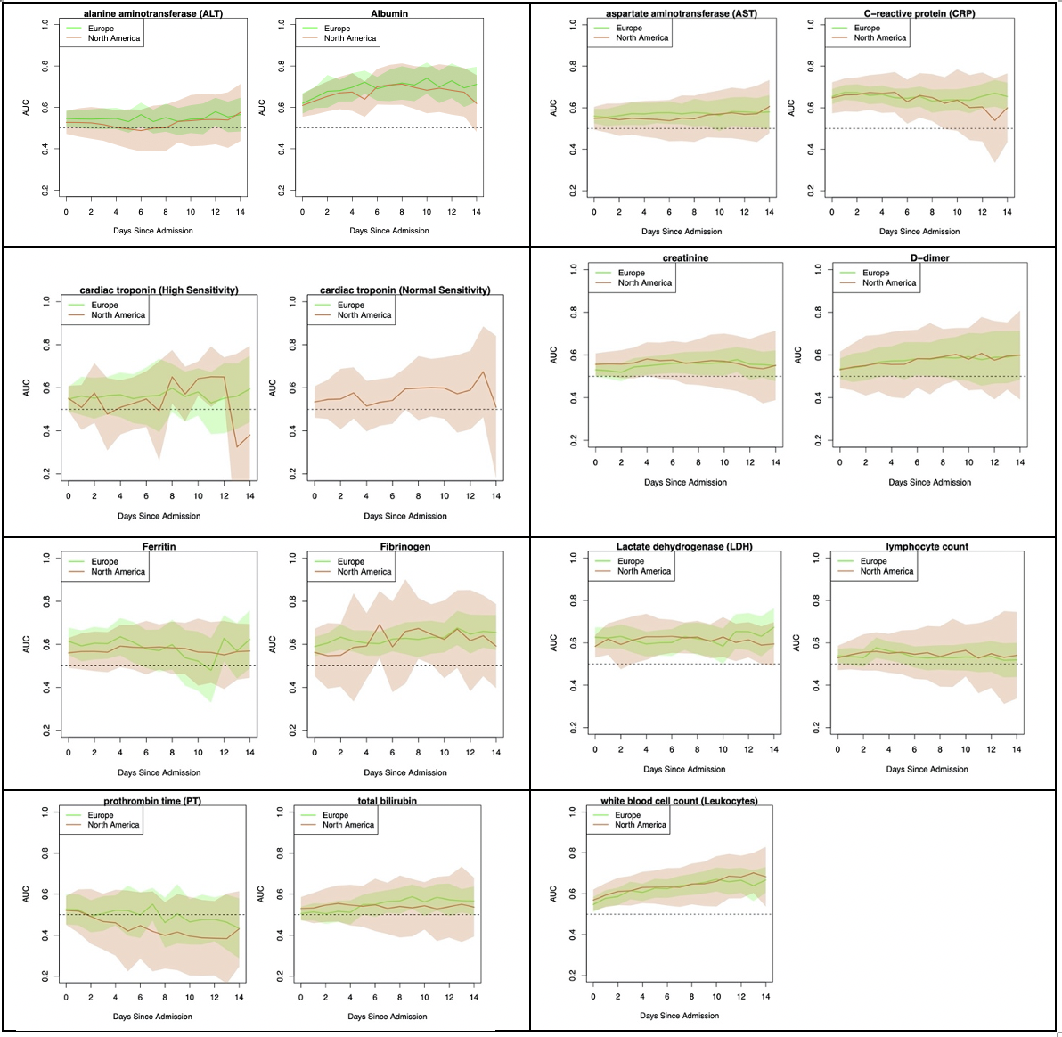

IV. eTABLES
eTABLE1: Membership of 4CE.

First Name | Middle Initial | Last Name | Degree(s) | Email Address | Primary Affiliation - Institution | Country
James | R | Aaron | MHA | james.aaron@uky.edu | University of Kentucky | United States
Giuseppe |  | Agapito | PhD | agapito@unicz.it | University Magna Graecia of Catanzaro, Italy | Italy
Adem |  | Albayrak |  | adem.albayrak@healthcatalyst.com | Health Catalyst, INC. | United States
Mario |  | Alessiani | MD, FACS | m.alessiani@unipv.it | ASST Pavia, Lombardia Region Health System | Italy
Danilo | F | Amendola | MD | daniloupeclin@gmail.com | Clinical Research Unit of Botucatu Medical School, São Paulo State University, Botucatu, Brazil | Brazil
Li | L.L.J | Anthony |  | anthony.li@mohh.com.sg | National Center for Infectious Diseases, Tan Tock Seng Hospital, Singapore | Singapore
Bruce | J | Aronow | PhD | bruce.aronow@cchmc.org | Cincinnati Children's Hospital Medical Center, University of Cincinnati | United States
Andrew |  | Atz | MD | atzam@musc.edu | Medical University of South Carolina | United States
Paul |  | Avillach | MD, PhD | paul_avillach@hms.harvard.edu | Harvard Medical School | United States
James |  | Balshi |  | James.Balshi@sluhn.org | St. Luke's University Health Network, Bethlehm PA | United States
Brett | K | Beaulieu-Jones | PhD | brett_beaulieu-jones@hms.harvard.edu | Harvard Medical School | United States
Douglas | S | Bell |  | dbell@mednet.ucla.edu | Department of Medicine, David Geffen School of Medicine at UCLA | United States
Antonio |  | Bellasi |  | abellasi@asst-pg23.it | UOC Ricerca, Innovazione e Brand reputation, ASST Papa Giovanni XXIII, Bergamo | Italy
Riccardo |  | Bellazzi | MS, PhD | riccardo.bellazzi@unipv.it | University of Pavia, Italy | Italy
Vincent |  | Benoit | PhD | vincent.benoit@aphp.fr | APHP Greater Paris University Hospital | France
Michele |  | Beraghi |  | michele_beraghi@asst-pavia.it | ASST Pavia | Italy
José Luis |  | Bernal Sobrino | MS | joseluis.bernal@salud.madrid.org | Hospital Universitario 12 de Octubre, Madrid, Spain | Spain
Mélodie |  | Bernaux |  | melodie.bernaux@aphp.fr | APHP Greater Paris University Hospital | France
Romain |  | Bey |  | romain.bey@aphp.fr | APHP Greater Paris University Hospital | France
Alvar |  | Blanco Martínez | MS | alvar.blanco@salud.madrid.org | Hospital Universitario 12 de Octubre, Madrid, Spain | Spain
Martin |  | Boeker |  | martin.boeker@imbi.uni-freiburg.de | Faculty of Medicine and Medical Center, University of Freiburg, Freiburg, Germany | Germany
Clara-Lea |  | Bonzel | MSc | clbonzel@hsph.harvard.edu | Harvard Medical School | United States
John |  | Booth | MSc | john.booth@gosh.nhs.uk | Great Ormond Street Hospital for Children, UK | United Kingdom
Silvano |  | Bosari |  | silvano.bosari@unimi.it | Scientific Direction, IRCCS Ca' Granda Ospedale Maggiore Policlinico di Milano | Italy
Florence | T | Bourgeois |  | florence.bourgeois@childrens.harvard.edu | Harvard Medical School | United States
Robert | L | Bradford |  | rbrad@med.unc.edu | North Carolina Translational and Clinical Sciences (NC TraCS) Institute, UNC Chapel Hill | United States
Gabriel | A | Brat | MD | gbrat@bidmc.harvard.edu | Harvard Medical School | United States
Stéphane |  | Bréant |  | stephane.breant@aphp.fr | APHP Greater Paris University Hospital | France
Mauro |  | Bucalo |  | mauro.bucalo@biomeris.it | BIOMERIS (BIOMedical Research Informatics Solutions) | Italy
Anita |  | Burgun |  | anita.burgun@aphp.fr | APHP Greater Paris University Hospital | France
Tianxi |  | Cai | PhD | tcai@hsph.harvard.edu | Harvard Medical School | United States
Mario |  | Cannataro | M.Sc. | cannataro@unicz.it | University Magna Graecia of Catanzaro, Italy | Italy
Aize |  | Cao |  | aize.cao@va.gov | Tennessee Valley Healthcare System Veterans Affairs Medical Center | United States
Aldo |  | Carmona |  | aldo.carmona@sluhn.org | Department of Anesthesia, St. Luke's University Health Network, Bethlehem, PA | United States
Charlotte |  | Caucheteux |  |  | Université Paris-Saclay, Inria, CEA | France
Julien |  | Champ |  | julien.champ@inria.fr | INRIA Sophia-Antipolis – ZENITH team, LIRMM, Montpellier, France | France
Jin |  | Chen | PhD | chen.jin@uky.edu | University of Kentucky | United States
Luca |  | Chiovato |  | luca.chiovato@icsmaugeri.it | Unit of Internal Medicine and Endocrinology, Istituti Clinici Scientifici Maugeri SpA SB IRCCS, Pavia, Italy and Department of Internal Medicine and Therapeutics, University of Pavia, Pavia, Italy. | Italy
James | J | Cimino |  | ciminoj@uab.edu | UAB Informatics Institute | United States
Tiago | K | Colicchio |  | tcolicchio@uabmc.edu | UAB Informatics Institute | United States
Sylvie |  | Cormont |  | sylvie.cormont@aphp.fr | APHP Greater Paris University Hospital | France
Sébastien |  | Cossin |  | sebastien.cossin@chu-bordeaux.fr | Bordeaux University Hospital / ERIAS - Inserm U1219 BPH | France
Jean | B | Craig | PhD | craigje@musc.edu | Medical University of South Carolina | United States
Juan Luis |  | Cruz Bermúdez | PhD | juanluis.cruz@salud.madrid.org | Hospital Universitario 12 de Octubre, Madrid, Spain | Spain
Jaime |  | Cruz Rojo | MD | jaime.cruz@salud.madrid.org | Hospital Universitario 12 de Octubre, Madrid, Spain | Spain
Arianna |  | Dagliati | MS, PhD | arianna.dagliati@unipv.it | University of Pavia, Italy | Italy
Mohamad |  | Daniar | MSIS | mohamad.daniar@childrens.harvard.edu | Boston Children's Hospital | United States
Christel |  | Daniel |  | christel.daniel@aphp.fr | APHP Greater Paris University Hospital, INSERM | France
Anahita |  | Davoudi | PhD | anahita.davoudi@pennmedicine.upenn.edu | University of Pennsylvania Perelman School of Medicine | United States
Batsal |  | Devkota |  | devkotab@email.chop.edu | Department of Biomedical and Health Informatics, Children's Hospital of Philadelphia | United States
Julien |  | Dubiel |  |  | APHP Greater Paris University Hospital | France
Scott | L | DuVall |  | scott.duvall@va.gov | VA Informatics and Computing Infrastructure, VA Salt Lake City Health Care System | United States
Loic |  | Esteve |  |  | SED/SIERRA, Inria Centre de Paris | France
Shirley |  | Fan |  | shirlfan@med.umich.edu | University of Michigan | United States
Robert | W | Follett |  | rfollett@mednet.ucla.edu | Department of Medicine, David Geffen School of Medicine at UCLA | United States
Paula | S. A | Gaiolla |  | paulagaiolla@gmail.com | Internal Medicine Department of Botucatu Medical School, São Paulo State University, Botucatu, Brazil | Brazil
Thomas |  | Ganslandt | MD | thomas.ganslandt@medma.uni-heidelberg.de | University Medicine Mannheim, Heidelberg University | Germany
Noelia |  | García Barrio | MS | ngbarrio@salud.madrid.org | Hospital Universitario 12 de Octubre, Madrid, Spain | Spain
Nils |  | Gehlenborg |  | nils@hms.harvard.edu | Harvard Medical School | United States
Alon |  | Geva | MD, MPH | alon.geva@childrens.harvard.edu | Boston Children's Hospital, Boston, MA | United States
Tobias |  | Gradinger | MD, BSc | tobias.gradinger@medma.uni-heidelberg.de | University Medicine Mannheim, Heidelberg University | Germany
Alexandre |  | Gramfort |  | alexandre.gramfort@inria.fr | Université Paris-Saclay, Inria, CEA | France
Romain |  | Griffier |  | romain.griffier@chu-bordeaux.fr | Bordeaux University Hospital | France
Nicolas |  | Griffon |  | nicolas.griffon@aphp.fr | APHP Greater Paris University Hospital, INSERM | France
Olivier |  | Grisel |  |  | Université Paris-Saclay, Inria, CEA | France
Alba |  | Gutiérrez-Sacristán | PhD | alba_gutierrez@hms.harvard.edu | Harvard Medical School | United States
David | A | Hanauer | MD, MS | hanauer@umich.edu | University of of Michigan Medical School, Ann Arbor, Michigan, USA | United States
Christian |  | Haverkamp |  |  | Institute of Digitalization in Medicine, Faculty of Medicine and Medical Center, University of Freiburg, Germany | Germany
Darren | W | Henderson |  | darren.henderson@uky.edu | University of Kentucky | United States
Martin |  | Hilka |  |  | APHP Greater Paris University Hospital | France
John | H | Holmes | MS, PhD | jhholmes@pennmedicine.upenn.edu | University of Pennsylvania Perelman School of Medicine (inst), Philadelphia, Pennsylvania, United States of America | United States
Chuan |  | Hong | PhD | Chuan_Hong@hms.harvard.edu | Harvard Medical School | United States
Petar |  | Horki |  | horki@imbi.uni-freiburg.de | Institute of Medical Biometry and Statistics, Medical Center, University of Freiburg | Germany
Meghan | R | Hutch | BS | meghan.hutch@northwestern.edu | Northwestern University | United States
Richard | W | Issitt | DClinP | richard.issitt@gosh.nhs.uk | Great Ormond Street Hospital for Children, UK | United Kingdom
Anne Sophie |  | Jannot |  | annesophie.jannot@aphp.fr | Department of Biomedical Informatics, HEGP, APHP Greater Paris University Hospital | France
Vianney |  | Jouhet | MD,PhD | vianney.jouhet@chu-bordeaux.fr | Bordeaux University Hospital | France
Mark | S | Keller |  | mark_keller@hms.harvard.edu | Harvard Medical School | United States
Katie |  | Kirchoff | MSHI | kirchoff@musc.edu | Medical University of South Carolina | United States
Jeffrey | G | Klann | MEng, PhD | jeff.klann@mgh.harvard.edu | Massachusetts General Hospital | United States
Isaac | S | Kohane | MD, PhD | isaac_kohane@harvard.edu | Harvard Medical School | United States
Ian | D | Krantz |  | krantz@email.chop.edu | Department of Pediatrics, Division of Human Genetcs, The Children's Hospital of Philadelphia and the Perelman School of Medicine at the University of Pennsylvania | United States
Detlef |  | Kraska | Dr. | detlef.kraska@uk-erlangen.de | University Hospital Erlangen | Germany
Ashok | K | Krishnamurthy | PhD | ashokk@email.unc.edu | University of North Carolina, Chapel Hill | United States
Sehi |  | L'Yi | PhD | sehi_lyi@hms.harvard.edu | Harvard Medical School | United States
Trang | T | Le | PhD | ttle@pennmedicine.upenn.edu | University of Pennsylvania Perelman School of Medicine | United States
Judith |  | Leblanc |  | judith.leblanc@aphp.fr | APHP Greater Paris University Hospital | France
Guillaume |  | Lemaitre |  |  | Université Paris-Saclay, Inria, CEA | France
Leslie |  | Lenert | MD, MS | lenert@musc.edu | Medical University of South Carolina | United States
Damien |  | Leprovost |  |  | Clevy.io | France
Molei |  | Liu | PhD | molei_liu@g.harvard.edu | Harvard T.H. Chan School of Public Health | United States
Ne Hooi Will |  | Loh | MBBS | will.loh@nus.edu.sg | National University Health System, Singapore | Singapore
Yuan |  | Luo | PhD | yuan.luo@northwestern.edu | Northwestern University | United States
Kristine | E | Lynch |  | kristine.lynch@va.gov | VA Informatics and Computing Infrastructure, VA Salt Lake City Health Care System | United States
Sadiqa |  | Mahmood |  | sadiqa.mahmood@healthcatalyst.com | Health Catalyst, INC. | United States
Sarah |  | Maidlow |  | smaidlow@umich.edu | University of Michigan | United States
Alberto |  | Malovini | PhD | alberto.malovini@icsmaugeri.it | Istituti Clinici Scientifici Maugeri SpA SB IRCCS, Pavia, Italy. | Italy
Kenneth | D | Mandl | MD, MPH | kenneth_mandl@harvard.edu | Boston Children's Hospital | United States
Chengsheng |  | Mao | PhD | chengsheng.mao@northwestern.edu | Northwestern University | United States
Patricia |  | Martel |  | patricia.martel@aphp.fr | APHP Greater Paris University Hospital | France
Aaron | J | Masino | PhD | masinoa@email.chop.edu | Children's Hospital of Philadelphia | United States
Michael | E | Matheny |  | michael.matheny@va.gov | Tennessee Valley Healthcare System Veterans Affairs Medical Center | United States
Thomas |  | Maulhardt |  | thomas.maulhardt@uniklinik-freiburg.de | University Medical Center Freiburg, Germany | Germany
Maria |  | Mazzitelli | PhD | m.mazzitelli88@gmail.com | University Magna Graecia of Catanzaro, Italy | Italy
Michael | T | McDuffie |  | michael_mcduffie@hms.harvard.edu | Harvard Medical School | United States
Arthur |  | Mensch |  |  | ENS, PSL University | France
Marianna |  | Milano | PhD | m.milano@unicz.it | University Magna Graecia of Catanzaro, Italy | Italy
Marcos | F | Minicucci |  |  | Internal Medicine Department of Botucatu Medical School, São Paulo State University, Botucatu, Brazil | Brazil
Bertrand |  | Moal | PhD | bertrand.moal@chu-bordeaux.fr | Bordeaux University Hospital | France
Jason | H | Moore | PhD | jhmoore@upenn.edu | University of Pennsylvania Perelman School of Medicine | United States
Jeffrey | S | Morris |  | jeffrey.morris@pennmedicine.upenn.edu | University of Pennsylvania Perelman School of Medicine | United States
Michele |  | Morris | BA | mim18@pitt.edu | University of Pittsburgh | United States
Karyn | L | Moshal |  | karyn.moshal@gosh.nhs.uk | Great Ormond Street Hospital for Children, UK | United Kingdom
Sajad |  | Mousavi | PhD | sayedsajad_mousavi@hms.harvard.edu | Harvard Medical School | United States
Danielle | L | Mowery | PhD | dlmowery@pennmedicine.upenn.edu | University of Pennsylvania Perelman School of Medicine | United States
Douglas | A | Murad |  | dmurad@mednet.ucla.edu | David Geffen School of Medicine at UCLA | United States
Shawn | N | Murphy | MD, PhD | snmurphy@partners.org, googledoc is snmurphy00@gmail.com | Massachusetts General Hospital | United States
Thomas | P | Naughton | BA | thomas_naughton@hms.harvard.edu | Harvard Medical School | United States
Antoine |  | Neuraz | MD, PhD | antoine.neuraz@aphp.fr | Hôpital Necker-Enfants Malade, Assistance Publique Hôpitaux de Paris (APHP), University of Paris | France
Kee Yuan |  | Ngiam | MBBS, MRCS, MMed, FRCS | kee_yuan_ngiam@nuhs.edu.sg | National Univerisity Health Systems Singapore | Singapore
Jihad |  | Obeid | MD, FAMIA | jobeid@musc.edu | Medical University of South Carolina | United States
Marina | P | Okoshi | PhD | marina.okoshi@unesp.br | Internal Medicine Department of Botucatu Medical School, São Paulo State University, Botucatu, Brazil | Brazil
Karen | L | Olson | PhD | karen.olson@childrens.harvard.edu | Boston Children's Hospital and Harvard Medical School | United States
Gilbert | S. | Omenn | MD, PhD | gomenn@umich.edu | University of Michigan | United States
Nina |  | Orlova |  |  | APHP Greater Paris University Hospital | France
Brian | D | Ostasiewski |  | bostasie@wakehealth.edu | CTSI, WFBMI, Wake Forest School of Medicine | United States
Nicolas |  | Paris |  | nicolas.paris@aphp.fr | APHP Greater Paris University Hospital | France
Lav | P | Patel | MS | lpatel@kumc.edu | University Of Kansas Medical Center | United States
Miguel |  | Pedrera Jimenez | MS | miguel.pedrera@salud.madrid.org | Hospital Universitario 12 de Octubre, Madrid, Spain | Spain
Nathan | P | Palmer | PhD | nathan_palmer@hms.harvard.edu | Harvard Medical School | United States
Danielle |  | Pillion | MS | danielle_pillion@hms.harvard.edu | Harvard Medical School | United States
Hans | U | Prokosch |  | ulli.prokosch@uk-erlangen.de | University of Erlangen-Nürnberg | Germany
Robson | A | Prudente | PhD | robsonapp@gmail.com | Clinical Research Unit São Paulo State University, Brazil | Brazil
Víctor |  | Quirós González | MS | victor.quiros@salud.madrid.org | Hospital Universitario 12 de Octubre, Madrid, Spain | Spain
Rachel | B | Ramoni |  | rachel.ramoni@va.gov | Office of Research and Development, Department of Veterans Affairs | United States
Maryna |  | Raskin |  | maryna.raskin@healthcatalyst.com | Health Catalyst, INC. | United States
Siegbert |  | Rieg |  | siegbert.rieg@uniklinik-freiburg.de | Division of Infectious Diseases, Department of Medicine II, Medical Center – University of Freiburg, Faculty of Medicine | Germany
Gustavo |  | Roig Domínguez | MS | gustavo.roig@h12o.es | Hospital Universitario 12 de Octubre, Madrid, Spain | Spain
Elisa |  | Salamanca |  | e_l_salamanca@yahoo.fr | APHP Greater Paris University Hospital | France
Malarkodi | J | Samayamuthu | MD | mas609@pitt.edu | University of Pittsburgh | United States
Arnaud |  | Sandrin |  | arnaud.sandrin@aphp.fr | APHP Greater Paris University Hospital | France
Maria |  | Savino | MS | maria1_savino@asst-pavia.it | Management Engineer, Direction | Italy
Emily | R | Schriver | MS | emily.schriver@pennmedicine.upenn.edu | University of Pennsylvania Health System | United States
Juergen |  | Schuettler |  | juergen.schuettler@kfa.imed.uni-erlangen.de | Department of Anesthesiology, University Hospital Erlangen, FAU Erlangen-Nürnberg, Germany | Germany
Luigia |  | Scudeller |  | luigia.scudeller@policlinico.mi.it | Scientific Direction, IRCCS Ca' Granda Ospedale Maggiore Policlinico di Milano | Italy
Neil | J | Sebire | MD, FRCPath | neil.sebire@gosh.nhs.uk | Great Ormond Street Hospital for Children NIHR BRC, UK | United Kingdom
Pablo |  | Serrano Balazote | MD,MS | pserranob@salud.madrid.org | Hospital Universitario 12 de Octubre, Madrid, Spain | Spain
Patricia |  | Serre |  |  | APHP Greater Paris University Hospital | France
Arnaud |  | Serret-Larmande | MD | arnaud.serret-larmande@aphp.fr |  | France
Domenick |  | Silvio |  | silviod@umich.edu | University of Michigan, MICHR | United States
Piotr |  | Sliz |  | piotr.sliz@childrens.harvard.edu | Boston Children's Hospital | United States
Jiyeon |  | Son | MD | sonj@upmc.edu | University of Pittsburgh Medical Center | United States
Charles |  | Sonday |  | Charles.Sonday@sluhn.org | Critical Care Medicine, Department of Medicine, St. Luke's University Health Network, Bethlehm PA | United States
Andrew | M | South | MD, MS | asouth@wakehealth.edu | Brenner Children's Hospital, Wake Forest School of Medicine | United States
Anastasia |  | Spiridou | PhD, MSc | natassa.spiridou@gosh.nhs.uk | Great Ormond Street Hospital for Children, UK | United Kingdom
Amelia | LM | Tan | BSc, PhD | amelia_tan@hms.harvard.edu | Harvard Medical School | United States
Bryce | W.Q. | Tan | MBBS | bryce_tan@nuhs.edu.sg | National University Hospital, Singapore | Singapore
Byorn | W.L. | Tan | MBBS | byorn_wl_tan@nuhs.edu.sg | National University Hospital, Singapore | Singapore
Suzana | E | Tanni |  | suzanapneumo@gmail.com | Internal Medicine Department of Botucatu Medical School, São Paulo State University, Botucatu, Brazil | Brazil
Deanne | M | Taylor | PhD | taylordm@email.chop.edu | The Children's Hospital of Philadelphia and the University of Pennsylvania Perelman Medical School | United States
Ana | I | Terriza Torres | MS | anaisabel.terriza@salud.madrid.org | Hospital Universitario 12 de Octubre, Madrid, Spain | Spain
Valentina |  | Tibollo |  | valentina.tibollo@icsmaugeri.it | Laboratory of Informatics and Systems Engineering for Clinical Research, Istituti Clinici Scientifici Maugeri SpA SB IRCCS, Pavia, Italy. | Italy
Patric |  | Tippmann | MSc | tippmann@imbi.uni-freiburg.de | Institute of Medical Biometry and Statistics, Medical Center, University of Freiburg | Germany
Carlo |  | Torti | PhD | torti@unicz.it | University Magna Graecia of Catanzaro, Italy | Italy
Enrico | M | Trecarichi | PhD | em.trecarichi@unicz.it | University Magna Graecia of Catanzaro, Italy | Italy
Andrew | K | Vallejos |  | avallejo@mcw.edu | Clinical & Translational Science Institute, Medical College of Wisconsin | United States
Gael |  | Varoquaux |  |  | Université Paris-Saclay, Inria, CEA, Montréal Neurological Institute, McGill University | France
Jill-Jênn |  | Vie |  |  | SequeL, Inria Lille | France
Shyam |  | Visweswaran | MD, PhD | shv3@pitt.edu | University of Pittsburgh | United States
Michele |  | Vitacca | MD, PhD | michele.vitacca@icsmaugeri.it | ICS S. Maugeri IRCCS Pavia Italy | ITALY
Kavishwar | B | Wagholikar | MBBS, PhD | kwagholikar@mgh.harvard.edu | Department of Medicine, Massachusetts General Hospital, Boston, USA | United States
Lemuel | R | Waitman |  | russ.waitman@health.missouri.edu | University of Missouri, Columbia. MO | United States
Demian |  | Wassermann |  |  | Université Paris-Saclay, Inria, CEA | France
Griffin | M | Weber |  | weber@hms.harvard.edu | Harvard Medical School | United States
Yuan |  | William |  | william_yuan@g.harvard.edu | Harvard Medical School | United States
Zongqi |  | Xia | MD, PhD | zxia1@post.harvard.edu | University of Pittsburgh | United States
Nadir |  | Yehya | MD, MSCE | yehyan@email.chop.edu | Children's Hospial of Philadelphia and University of Pennsylvania | United States
Alberto |  | Zambelli |  | alberto.zambelli@asst-pg23.it | ASST Papa Giovanni XXIII, Bergamo | Italy
Harrison | G | Zhang |  | harrison_zhang@hms.harvard.edu | Harvard Medical School | United States
Chiara |  | Zucco | PhD | chiara.zucco@unicz.it | University Magna Graecia of Catanzaro, Italy | Italy
James | B | Norman |  | james_norman@hms.harvard.edu | Harvard Medical School | United States
Anupama |  | Maram | MS | anupama_maram@hms.harvard.edu | Harvard Medical School | United States
Nicholas | W | Brown | MEng | nicholas_brown@hms.harvard.edu | Harvard Medical School | United States
Kenneth | M | Huling | HS | kenneth.huling@gmail.com | Harvard Medical School | United States
Emily | R | Pfaff | PhD | epfaff@email.unc.edu | UNC Chapel Hill | United States
Lorenzo |  | Chiudinelli | PhD | chiudinelli.lorenzo@gmail.com | ASST Papa Giovanni XXIII, Bergamo | Italy
Yi-Ju |  | Tseng | PhD | yjtseng.info@gmail.com | Chang Gung University | Taiwan

eTABLE2: Participating sites.

Healthcare System | Acronym | City | Country | Patient Population | Hospitals | Beds | Inpatient discharges/year | Obfuscation small count mask threshold (e.g., <10)
Assistance Publique - Hôpitaux de Paris | APHP | Paris | France | Adult & Pediatric | 39 | 20098 | 1375538 | <3
Bordeaux University Hospital | FRBDX | Bordeaux | France | Adult & Pediatric | 3 | 2676 | 130033 | <3
Erlangen University Hospital | UKER | Erlangen | Germany | Adult & Pediatric | 1 | 1400 | 65000 | <5
Medical Center, University of Freiburg | UKFR | Freiburg | Germany | Adult & Pediatric | 1 | 1660 | 71500 | <4
University Medicine Mannheim | UMM | Mannheim | Germany | Adult & Pediatric | 1 | 1352 | 50748 | <3
ICSM Pavia Hospital | ICSM1 | Pavia | Italy | Adult | 1 | 426 | 8616 | none
ICSM Lumezzane/Brescia Hospitals | ICSM5 | Lumezzane/Brescia | Italy | Adult | 1 | 149 | 1296 | none
ICSM Milano Hospital | ICSM20 | Milan | Italy | Adult | 1 | 200 | 2432 | none
Policlinico di Milano | POLIMI | Milan | Italy | Adult & Pediatric | 1 | 900 | 40000 | <5
ASST Papa Giovanni XXIII Bergamo | HPG23 | Bergamo | Italy | Adult & Pediatric | 1 | 1080 | 45000 | <=5
National University Hospital | NUH | Singapore | Singapore | Adult & Pediatric | 1 | 1556 | 100977 | none
Beth Israel Deaconess Medical Center | BIDMC | Boston, MA | USA | Adult | 1 | 673 | 40752 | <10
University of Kansas Medical Center | KUMC | Kansas City, KS | USA | Adult & Pediatric | 1 | 794 | 54659 | <=10
Mass General Brigham (Partners Healthcare) | MGB | Boston, MA | USA | Adult & Pediatric | 10 | 3418 | 163521 | <10
Medical University of South Carolina | MUSC | Charleston, SC | USA | Adult & Pediatric | 8 | 1600 | 55664 | <15
University of Pennsylvania | UPenn | Philadelphia, PA | USA | Adult | 5 | 2469 | 118188 | <10
University of California, LA | UCLA | Los Angeles, CA | USA | Adult & Pediatric | 2 | 786 | 40526 | <10
University of Michigan | UMICH | Ann Arbor, MI | USA | Adult & Pediatric | 3 | 1000 | 49008 | none
University of North Carolina at Chapel Hill | UNC | Chapel Hill, NC | USA | Adult & Pediatric | 11 | 3095 | 52000 | <10
UT Southwestern Medical Center | UTSW | Dallas, TX | USA | Adult | 1 | 608 | 26905 | <6
Northwestern University | NWU | Chicago, IL | USA | Adult & Pediatric | 10 | 2234 | 103279
University of Pittsburgh / UPMC | UPITT | Pittsburgh, PA | USA | Adult & Pediatric | 39 | 8085 | 369300 | none
Medical College of Wisconsin | MCWCTSI | Milwaukee, WI | USA | Adult | 3 | 876 | 44655 | <11
Hospital Universitario 12 de Octubre | H12O | Madrid | Spain | Adult & Pediatric | 1 | 1256 | 45035 | <10
Wake Forest School of Medicine & Brenner Children's Hospital | WFSM | Winston Salem, NC | USA | Adult & Pediatric | 5 | 1536 | 67541 | <10
University Magna Graecia of Catanzaro & Mater Domini University Hospital, Catanzaro | UNICZ | Catanzaro | Italy | Adult | 1 | 210 | 11987 | none
St. Luke's University Health Network | SLHN | Bethlehem, PA | USA | Adult & Pediatric | 12 | 1700 | 75000
University of Kentucky | UKY | Lexington, KY | USA | Adult & Pediatric | 3 | 881 | 45714 | none
Riverside Health System | RIVHS | Newport News, VA | USA | Adult & Pediatric | 5 | 670 | 30000
ASST della provincia di Pavia | ASSTPAVIA | Pavia | Italy | Adult & Pediatric | 7 | 958 | 29103 | none
VISN1 - VA New England Health Care System | VA1 | Bedford, MA | USA | Adult | 11 |  |  | <10
VISN2 - VA Healthcare New York/New Jersey | VA2 | Bronx, NY | USA | Adult | 14 |  |  | <10
VISN4 - VISN4 network (PA, DE, NJ, OH) | VA4 | Pittsburgh, PA | USA | Adult | 11 |  |  | <10
VISN5 - VA Capitol Healthcare Network | VA5 | Linthicum, MD | USA | Adult | 5 |  |  | <10
VISN6 - VA Mid-Atlantic Health Care Network | VA6 | Durgham, NC | USA | Adult | 8 |  |  | <10
VISN7 - VA Southeast Network | VA7 | Duluth, GA | USA | Adult | 10 |  |  | <10
VISN8 - VA Sunshine Healthcare Network | VA8 | Saint Petersburg, FL | USA | Adult | 10 |  |  | <10
VISN9 - VA MidSouth Healthcare Network | VA9 | Nashville, TN | USA | Adult | 9 |  |  | <10
VISN10 - VA Healthcare System VISN10 | VA10 | Cincinnati, OH | USA | Adult | 15 |  |  | <10
VISN12 - VA Great Lakes Healthcare System | VA12 | Hines, IL | USA | Adult | 6 |  |  | <10
VISN15 - VA Heartland Network | VA15 | Kansas City, MO | USA | Adult | 9 |  |  | <10
VISN16 - South Central VA Healthcare Network | VA16 | Ridgeland, MS | USA | Adult | 11 |  |  | <10
VISN17 - VA Heart of Texas Healthcare System | VA17 | Arlington, TX | USA | Adult | 7 |  |  | <10
VISN19 - VA Rocky Mountain Network | VA19 | Glendale, CO | USA | Adult | 6 |  |  | <10
VISN20 - VA Northwest Health Network | VA20 | Vancouver, WA | USA | Adult | 8 |  |  | <10
VISN21 - VA Sierra Pacific Network | VA21 | Mare Island, CA | USA | Adult | 9 |  |  | <10
VISN22 - VA Desert Pacific Healthcare Network | VA22 | Long Beach, CA | USA | Adult | 5 |  |  | <10
VISN23 - VA Midwest Healthcare Network | VA23 | Minneapolis, MN | USA | Adult | 9 |  |  | <10

eTABLE 3: Definition of severe COVID-19 based on the 4CE Severity Algorithm. Please refer to Klann et al. for further information.
EHR Code Category | Clinical Events
Diagnoses | Acute respiratory distress syndrome, ventilator-associated pneumonia
Procedures | Insertion of endotracheal tube; invasive mechanical ventilation
Laboratory results | PaCO2, PaO2
Anesthetic Medications | General anesthetics: ketamine, propofol  Benzodiazepine derivatives: midazolam  Muscle relaxants: cisatracurium, rocuronium, vecuronium  Other hypnotics and sedatives: dexmedetomidine
Vasopressor Medications | Adrenergic and dopaminergic agents: Dopamine, Epinephrine, Norepinephrine, Phenylephrine, Milrinone, Dobutamine  Other cardiac stimulants: Angiotensin II  Other respiratory system products:  phosphodiesterase inhibitors, Epoprostenol, Nitric Oxide  Vasopressin and analogs: Vasopressin

eTABLE 4: Six comma-separated values (CSV) files and their descriptions. Sites optionally obfuscated the values in any of these files by replacing small counts with “-99.” Sites indicated missing data or data that they were unable to obtain (e.g., race and ethnicity not collected at some sites) with “-999.”

Data File | Description
DailyCounts.csv | Contained one row per calendar date. Each row included the date, the cumulative number of patients admitted by this date, the cumulative number of patients who had developed severe disease by this date, the cumulative number of patients who had died by this date, the number of patients in the hospital on this date (i.e., excluding patients who have been discharged or have died), and the number of patients who became severe and are in the hospital on this date.
ClinicalCourse.csv | Contained one row per day since admission. For example, the first row contained aggregate data about patients on their admission date, and the second row contained aggregate data on the day following their admission. Each row indicated the number of total patients in the cohort and the number of severe patients in the hospital on that day. Patients who were discharged and then readmitted were counted for each day they were an inpatient.
Demographics.csv | Contained breakdown counts for both the total cohort and the severe patients by sex, age group (0-2, 3-5, 6-11, 12-17, 18-25, 26-49, 50-69, 70-79, and 80+ years old), and race and ethnicity category (American Indian or Alaska Native, Asian, Black or African American, Hispanic or Latino, Native Hawaiian or Other Pacific Islander, White) [https://grants.nih.gov/grants/guide/notice-files/not-od-15-089.html]. Reporting of the race categories was mostly restricted to the United States sites.
Labs.csv | Contained the daily trajectories of select laboratory tests. Each row corresponded to a laboratory test (identified using a LOINC code) and the number of days since admission. The values in each row were the number of patients who had a test result on that day, the mean and standard deviation of the test results, and the mean and standard deviation of the natural logarithm of the test results plus 0.5 (to avoid log zero). These statistics were provided for both the total cohort and the severe patients. If a patient had multiple results for the same test on the same day, then those were replaced by the mean of that day’s test results before averaging across all patients. Log mean values are more meaningful summaries for tests such as D-dimer with highly skewed distributions.
Diagnoses.csv | Contained one row per ICD9 or ICD10 diagnosis code, truncated to just their first 3 characters. This was a basic approach to rolling up diagnoses into broader categories and reducing the effect of coding differences between sites. For each truncated diagnosis code, the number of total and severe patients before and since admission with the code were listed. Before admission meant day -365 to day -15 relative to the index admission date. The two weeks immediately prior to admission were ignored to ensure that these diagnoses occurred before patients had symptoms concerning for COVID-19. Since admission meant day 0, the index date, until the day when the data were extracted.
Medications.csv | The sixth file, Medications.csv, had one row per each of 12 medication classes. For each medication class, the number of total and severe patients before and since admission for whom the medication was ordered were listed. Similar to diagnoses, before meant day -365 to -15, and since meant day 0+ relative to the index date.

eTABLE5: Pooled difference between admission laboratory measures in ever-severe and never-severe patients over all sites.

 |  | Difference of Laboratory Measures
Scale | Labs | EST | SE | CI_95L | CI_95U
original | alanine aminotransferase (ALT) | 5.17 | 1.24 | 2.73 | 7.61
 | albumin | -0.21 | 0.02 | -0.24 | -0.17
 | aspartate aminotransferase (AST) | 12.11 | 1.86 | 8.47 | 15.76
 | C-reactive protein (CRP) (Normal Sensitivity) | 48.72 | 3.67 | 41.53 | 55.92
 | cardiac troponin (High Sensitivity) | 0.03 | 0.03 | -0.02 | 0.09
 | cardiac troponin (Normal Sensitivity) | 0.01 | 0.01 | 0.00 | 0.03
 | creatinine | 0.24 | 0.04 | 0.17 | 0.32
 | D-dimer | 171.14 | 39.12 | 94.47 | 247.80
 | Ferritin | 299.10 | 53.50 | 194.24 | 403.95
 | Fibrinogen | 46.75 | 7.98 | 31.12 | 62.38
 | lactate dehydrogenase (LDH) | 116.86 | 13.87 | 89.69 | 144.04
 | lymphocyte count | -0.17 | 0.02 | -0.21 | -0.13
 | neutrophil count | 1.05 | 0.07 | 0.92 | 1.18
 | procalcitonin | 0.51 | 0.09 | 0.34 | 0.68
 | prothrombin time (PT) | 0.45 | 0.15 | 0.16 | 0.74
 | total bilirubin | 0.05 | 0.01 | 0.03 | 0.07
 | white blood cell count (Leukocytes) | 1.08 | 0.10 | 0.88 | 1.27
log | alanine aminotransferase (ALT) | 0.13 | 0.02 | 0.09 | 0.17
 | albumin | -0.05 | 0.01 | -0.06 | -0.04
 | aspartate aminotransferase (AST) | 0.21 | 0.02 | 0.17 | 0.25
 | C-reactive protein (CRP) (Normal Sensitivity) | 0.70 | 0.04 | 0.61 | 0.79
 | cardiac troponin (High Sensitivity) | 0.05 | 0.01 | 0.02 | 0.08
 | cardiac troponin (Normal Sensitivity) | 0.04 | 0.01 | 0.01 | 0.06
 | creatinine | 0.10 | 0.01 | 0.08 | 0.12
 | D-dimer | 0.26 | 0.06 | 0.14 | 0.39
 | Ferritin | 0.37 | 0.05 | 0.27 | 0.47
 | Fibrinogen | 0.07 | 0.02 | 0.04 | 0.10
 | lactate dehydrogenase (LDH) | 0.27 | 0.03 | 0.21 | 0.32
 | lymphocyte count | -0.10 | 0.01 | -0.12 | -0.08
 | neutrophil count | 0.17 | 0.01 | 0.14 | 0.19
 | procalcitonin | 0.29 | 0.03 | 0.24 | 0.34
 | prothrombin time (PT) | 0.03 | 0.01 | 0.02 | 0.04
 | total bilirubin | 0.04 | 0.00 | 0.03 | 0.05
 | white blood cell count (Leukocytes) | 0.12 | 0.01 | 0.10 | 0.14

eTABLE6: IRB Approval Across Data-Contributing Sites

Institutional Review Board | Determination
Assistance Publique - Hôpitaux de Paris | Approved
Bordeaux University Hospital | Exempt
Erlangen University Hospital | Approved
Medical Center, University of Freiburg | Exempt
University Medicine Mannheim | Approved
Instituti Clinici Scientifici Maugeri (ICSM) | Waived
Policlinico di Milano | Approved
ASST Papa Giovanni XXIII Bergamo | Approved
National University Hospital | Waived
Beth Israel Deaconess Medical Center | Exempt
University of Kansas Medical Center | Approved
Mass General Brigham (Partners Healthcare) | Exempt
Medical University of South Carolina | Waived
University of Pennsylvania | Exempt
University of California, LA | Exempt
University of Michigan | Exempt
UT Southwestern Medical Center | Approved
Northwestern University | Approved
University of Pittsburgh / UPMC | Approved
Hospital Universitario 12 de Octubre | Approved
Wake Forest School of Medicine & Brenner Children's Hospital | Approved
University Magna Graecia of Catanzaro & Mater Domini University Hospital | Approved
St. Luke's University Health Network | Waived
VA New England Health Care System | Approved
VA Healthcare New York/New Jersey | Approved
VISN4 network (PA, DE, NJ, OH) | Approved
VA Capitol Healthcare Network | Approved
VA Mid-Atlantic Health Care Network | Approved
VA Southeast Network | Approved
VA Sunshine Healthcare Network | Approved
VA MidSouth Healthcare Network | Approved
VA Healthcare System VISN10 | Approved
VA Great Lakes Healthcare System | Approved
VA Heartland Network | Approved
South Central VA Healthcare Network | Approved
VA Heart of Texas Healthcare System | Approved
VA Rocky Mountain Network | Approved
VA Northwest Health Network | Approved
VA Sierra Pacific Network | Approved
VA Desert Pacific Healthcare Network | Approved
VA Midwest Healthcare Network | Approved

