Supplemental Figures

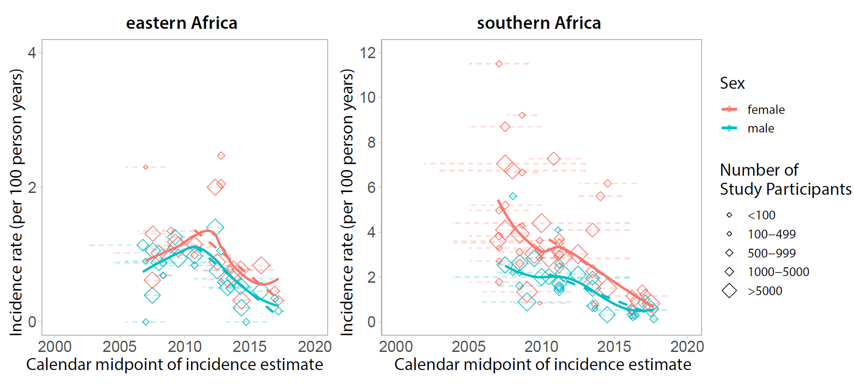
Supplemental Figure 1. Sensivity analysis of time trends excluding studies that did not report a minimum or maximum age range for the study.

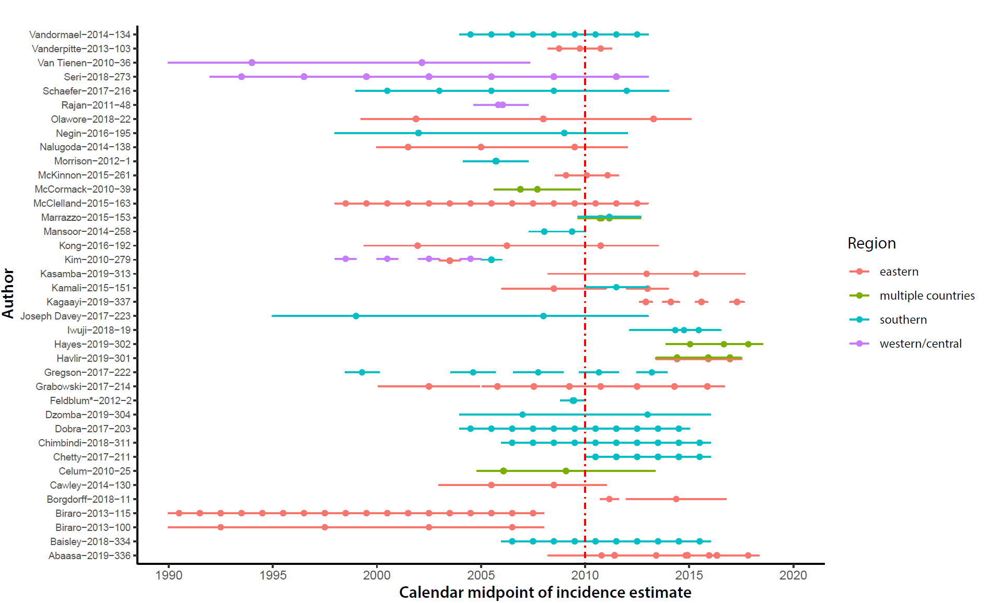
Supplemental Figure 2. 38 studies reporting two or more incidence rate estimates in unique calendar periods. The dots represent the calendar midpoint of the incidence estimate and the lines the time period over which incidence was measured. *This study’s prior incidence estimate was in 1993 and is not shown.

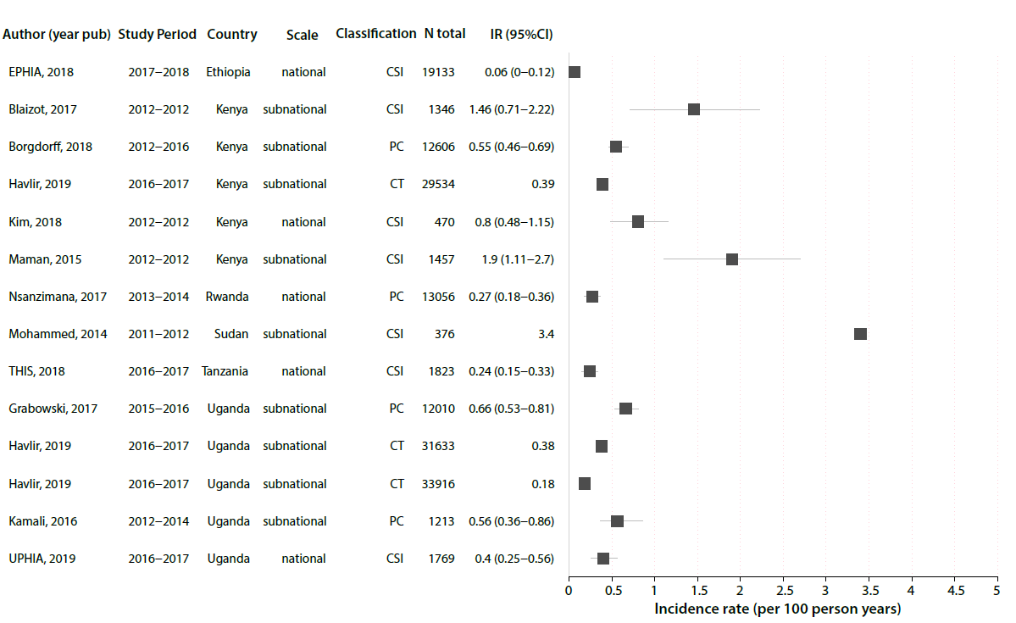
Supplemental Figure 3. Forest plot of HIV incidence estimates after 2010 for general population studies in eastern Africa. Only the most recent HIV incidence estimate for a cohort/study population are shown. Incidence rates are reported as the number of new cases per 100 person-years and the error bars represent 95% CI. Estimates without error bars did not report a confidence interval/standard error for the estimate. Study references are reported in supplemental Table 1. PC=prospective cohort; CSI=cross-sectional incidence study; CT=Clinical trial
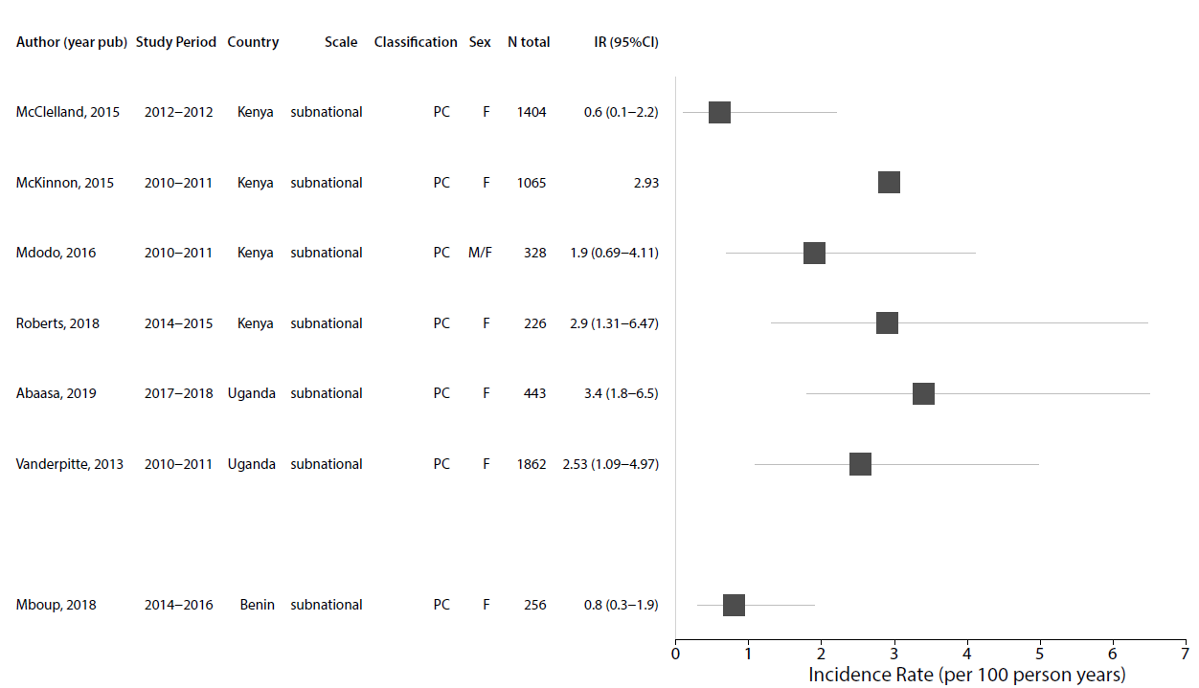

Supplemental Figure 4. Forest plot of HIV incidence estimates after 2010 for studies among female sex workers (SW). Only the most recent HIV incidence estimate for a cohort/study population are shown. Incidence rates are reported as the number of new cases per 100 person-years and the error bars represent 95% CI. Estimates without error bars did not report a confidence interval/standard error for the estimate. Study references are reported in supplemental Table 1. PC=prospective cohort; SCS=serial cross-sectional study
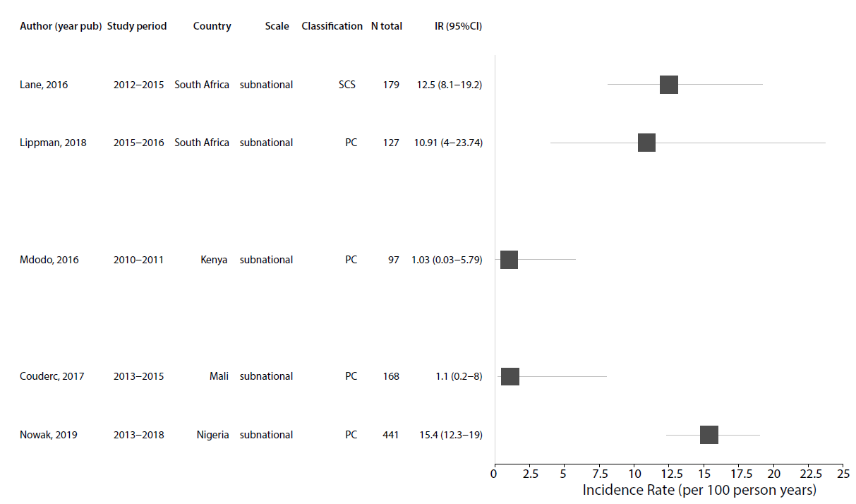
Supplemental Figure 5. Forest plot of HIV incidence estimates after 2010 for studies among men who have sex with men (MSM). Only the most recent HIV incidence estimate for a cohort/study population are shown. Incidence rates are reported as the number of new cases per 100 person-years and the error bars represent 95% CI. Estimates without error bars did not report a confidence interval/standard error for the estimate. Study references are reported in supplemental Table 1. PC=prospective cohort; SCS=serial cross-sectional study

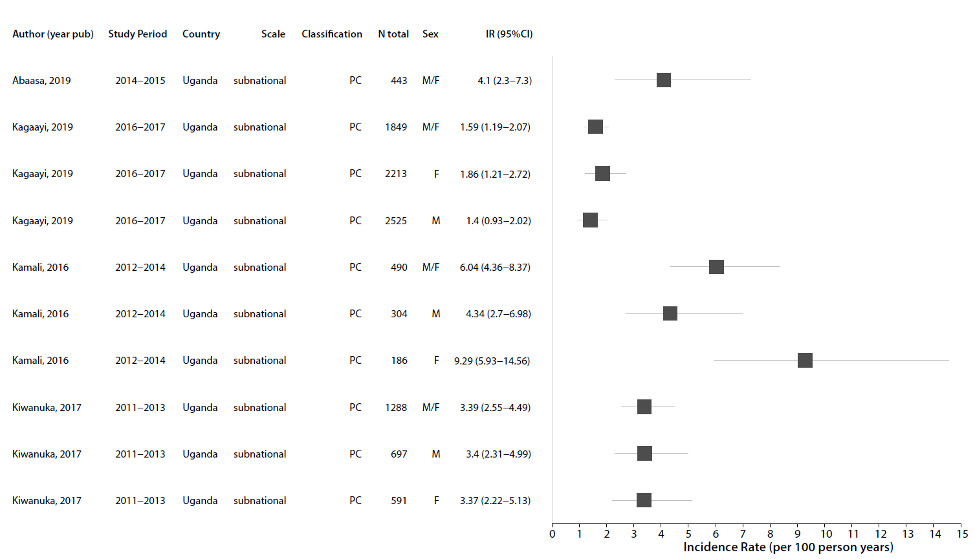
Supplemental Figure 6. Forest plot of HIV incidence estimates after 2010 for studies of Lake Victoria fisherfolk in Eastern Africa. Only the most recent HIV incidence estimate for a cohort/study population are shown. Incidence rates are reported as the number of new cases per 100 person-years and the error bars represent 95% CI. Estimates without error bars did not report a confidence interval/standard error for the estimate. Study references are reported in supplemental Table 1. PC=prospective cohort

