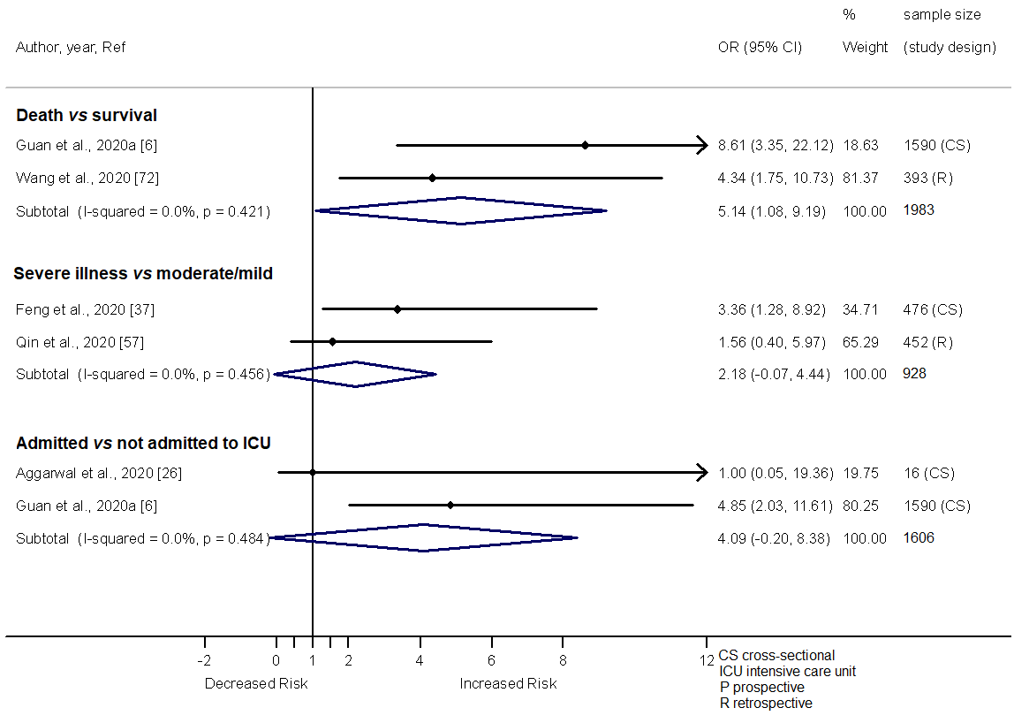

Additional file 7. Forest plot showing the relationship of Cerebrovascular disease with the odds of death, severe illness and admission in ICU among COVID-19 patients.

