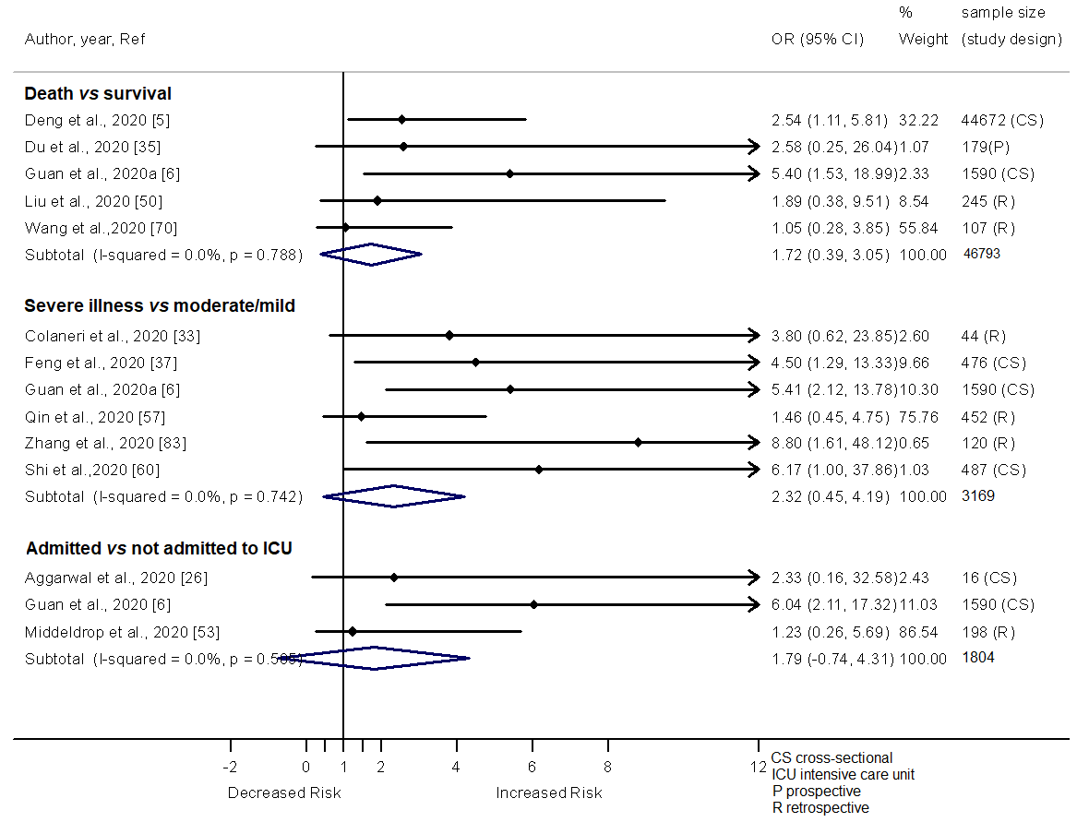
Additional file 4. Forest plot showing the relationship of cancer with the odds of death, severe illness and admission in ICU among COVID-19 patients.

