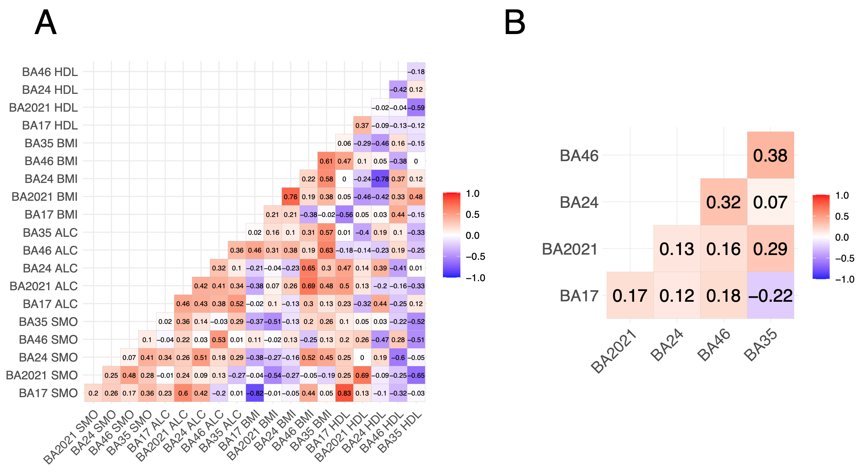
Supplementary Fig. 1. Heatmaps showing correlations for (A) predictor scores and (B) DNA methylation at the CpG site cg05575921 across the five brain regions in the brain bank group. Spearman correlation coefficients are presented in each case. There were 14 measurements available, except one individual for which hippocampal (BA35) sampling was not available. BA: Brodmann’s area. HDL: high density lipoprotein. BMI: body mass index. ALC: alcohol. SMO: smoking.

