Supplementary File

Table of contents
S1 Search strategy 2
S2 PRISMA Checklist and PROSPERO Protocol 5
The PROSPERO Protocol is available under the number: CRD42020177154 7
S3 List of laboratory parameters of eligible studies not included in the meta-analysis due to unphysiological values 8
S4 Figures Risk of bias assessment 10
S5 Forest Plots for difference of medians for mortality vs. survived across different indicators 17
S6 Forest plots for difference of medians in ICU admission vs. non- ICU admission across different indicators 43
S7 Results for all available indicators in Intubated vs Non-Intubated analyses 59
S8 Results for all available indicators in hospitalization vs. non hospitalization 60
S9 Sensitivity analyses 61
S10 Funnel plots for mortality vs. survival across different indicators 62
S11 Funnel plots for ICU admission vs. non-ICU admission across different indicators 65
S12 List of data items extracted from studies 68

S1 Search strategy
Search Terms for Pubmed

Search with concept of COVID-19 AND (predictive variables OR clinically relevant outcomes) conducted on 04.04.2020:

("severe acute respiratory syndrome coronavirus 2"[Supplementary Concept] OR "severe acute respiratory syndrome coronavirus 2"[tw] OR "ncov"[tw] OR "n cov"[tw] OR "2019nCoV"[tw] OR "covid-19"[supplementary concept] OR "covid"[tw] OR "covid19"[tw] OR "sars cov 2"[tw] OR "sarscov2"[tw] OR "sars2"[tw] OR "sars 2"[tw] OR "new coronavirus"[tw] OR "new coronaviruses"[tw] OR ((("wuhan"[All Fields] OR "china"[mesh] OR "china"[all fields] OR "chinese"[all fields] OR novel[tw] OR 2019[tw]) AND ("coronavirus"[MeSH Terms] OR "coronavirus"[tw] OR "coronaviruses"[tw] OR "corona virus"[tw] OR "corona viruses"[tw] OR "pneumonia virus"[tw] OR "pneumonia viruses"[tw] OR "hcov"[tw] OR "h cov"[tw])) AND 2019/12/1 : 2030/12/31[Date - Publication])) AND (("risk"[mesh] OR risk factor*[tw] OR risk*[ti] OR predict*[tw] OR "epidemiology"[sh] OR "epidemiologic factors"[mesh] OR epidemiolog*[tw] OR age factor*[tw] OR age*[ti] OR sex*[ti] OR ((sex[tw] OR age[tw]) AND variable*[tw]) OR comorbid*[tw] OR multimorbid*[tw] OR multiple morbidit*[tw] OR pre-existing[tw] OR preexisting[tw] OR "clinical laboratory techniques"[mesh] OR "lymphopenia"[mesh] OR "fibrin fragment D"[Supplementary Concept] OR lymphopeni*[tw] OR lymphopaeni*[tw] OR "Leukopenia"[Mesh] OR leukopeni*[tw] OR leukopaeni*[tw] OR "Ferritins"[Mesh] OR ferritin*[tw] OR "C-Reactive Protein"[Mesh] OR "crp"[tw] OR c reactive protein*[tw] OR "Procalcitonin"[Mesh] OR procalcitonin*[tw] OR "Transferrin"[Mesh] OR transferrin*[tw] OR ldh[tw] OR tnt[tw] OR prebnp[tw] OR pro bnp[tw] OR d dimer*[tw] OR clinical*[tw] OR laborator*[tw] OR demograph*[tw] OR baseline[tw] OR sever*[tw] OR "Smoking"[Mesh] OR "Smokers"[Mesh] OR smoking[tw] OR smoker*[tw] OR o2 requirement*[tw] OR o2 consumption*[tw] OR oxygen requirement*[tw] OR oxygen consumption*[tw] OR "intubation"[mesh] OR intubat*[tw] OR "Immunosuppression"[Mesh] OR "Immunocompromised Host"[Mesh] OR immunosuppress*[tw] OR immunocompromis*[tw] OR immune suppress*[tw] OR immune compromis*[tw] OR "Heart Diseases"[Mesh] OR "Lung Diseases"[Mesh] OR heart disease*[tw] OR cardiac disease*[tw] OR cardiovascular disease*[tw] OR lung disease*[tw] OR pulmonary disease*[tw]) OR ("prognosis"[mesh] OR prognos*[tw] OR fatal*[tw] OR death*[tw] OR surviv*[tw] OR outcome*[tw] OR "mortality"[mesh] OR "mortality"[sh] OR mortalit*[tw] OR morbidit*[tw] OR "hospitalization"[mesh] OR hospitaliz*[tw] OR hospitalis*[tw] OR "ventilation"[mesh] OR ventilat*[tw] OR "intensive care units"[mesh] OR intensive care[tw] OR ICU[tw] OR ICUs[tw] OR PICU[tw] OR PICUs[tw] OR NICU[tw] OR NICUs[tw] OR intermediate care[tw] OR IMCU[tw] OR IMCUs[tw] OR "critical care"[mesh] OR critical care[tw] OR critically ill[tw] OR critical ill*[tw] OR "patient outcome assessment"[mesh] OR outcome*[tw] OR CFR[tw]))

Search with concept of COVID AND predictive variables AND clinically relevant outcomes conducted on 31.05.2020:

("severe acute respiratory syndrome coronavirus 2"[Supplementary Concept] OR "severe acute respiratory syndrome coronavirus 2"[tw] OR "ncov"[tw] OR "n cov"[tw] OR "2019nCoV"[tw] OR "covid-19"[supplementary concept] OR "covid"[tw] OR "covid19"[tw] OR "sars cov 2"[tw] OR "sarscov2"[tw] OR "sars2"[tw] OR "sars 2"[tw] OR "new coronavirus"[tw] OR "new coronaviruses"[tw] OR ((("wuhan"[All Fields] OR "china"[mesh] OR "china"[all fields] OR "chinese"[all fields] OR novel[tw] OR 2019[tw]) AND ("coronavirus"[MeSH Terms] OR "coronavirus"[tw] OR "coronaviruses"[tw] OR "corona virus"[tw] OR "corona viruses"[tw] OR "pneumonia virus"[tw] OR "pneumonia viruses"[tw] OR "hcov"[tw] OR "h cov"[tw])) AND 2019/12/1 : 2030/12/31[Date - Publication])) AND (("risk"[mesh] OR risk factor*[tw] OR risk*[ti] OR predict*[tw] OR "epidemiology"[sh] OR "epidemiologic factors"[mesh] OR epidemiolog*[tw] OR age factor*[tw] OR age*[ti] OR sex*[ti] OR ((sex[tw] OR age[tw]) AND variable*[tw]) OR comorbid*[tw] OR multimorbid*[tw] OR multiple morbidit*[tw] OR pre-existing[tw] OR preexisting[tw] OR "clinical laboratory techniques"[mesh] OR "lymphopenia"[mesh] OR "fibrin fragment D"[Supplementary Concept] OR lymphopeni*[tw] OR lymphopaeni*[tw] OR "Leukopenia"[Mesh] OR leukopeni*[tw] OR leukopaeni*[tw] OR "Ferritins"[Mesh] OR ferritin*[tw] OR "C-Reactive Protein"[Mesh] OR "crp"[tw] OR c reactive protein*[tw] OR "Procalcitonin"[Mesh] OR procalcitonin*[tw] OR "Transferrin"[Mesh] OR transferrin*[tw] OR ldh[tw] OR tnt[tw] OR prebnp[tw] OR pro bnp[tw] OR d dimer*[tw] OR clinical*[tw] OR laborator*[tw] OR demograph*[tw] OR baseline[tw] OR sever*[tw] OR "Smoking"[Mesh] OR "Smokers"[Mesh] OR smoking[tw] OR smoker*[tw] OR o2 requirement*[tw] OR o2 consumption*[tw] OR oxygen requirement*[tw] OR oxygen consumption*[tw] OR "intubation"[mesh] OR intubat*[tw] OR "Immunosuppression"[Mesh] OR "Immunocompromised Host"[Mesh] OR immunosuppress*[tw] OR immunocompromis*[tw] OR immune suppress*[tw] OR immune compromis*[tw] OR "Heart Diseases"[Mesh] OR "Lung Diseases"[Mesh] OR heart disease*[tw] OR cardiac disease*[tw] OR cardiovascular disease*[tw] OR lung disease*[tw] OR pulmonary disease*[tw]) AND ("prognosis"[mesh] OR prognos*[tw] OR fatal*[tw] OR death*[tw] OR surviv*[tw] OR outcome*[tw] OR "mortality"[mesh] OR "mortality"[sh] OR mortalit*[tw] OR morbidit*[tw] OR "hospitalization"[mesh] OR hospitaliz*[tw] OR hospitalis*[tw] OR "ventilation"[mesh] OR ventilat*[tw] OR "intensive care units"[mesh] OR intensive care[tw] OR ICU[tw] OR ICUs[tw] OR PICU[tw] OR PICUs[tw] OR NICU[tw] OR NICUs[tw] OR intermediate care[tw] OR IMCU[tw] OR IMCUs[tw] OR "critical care"[mesh] OR critical care[tw] OR critically ill[tw] OR critical ill*[tw] OR "patient outcome assessment"[mesh] OR outcome*[tw] OR CFR[tw])) AND (("2020/04/03"[PDat] : "2020/05/31"[PDat]))

Search Terms of Web of Science (Science Citation Index Expanded (SCI-EXPANDED), Social Sciences Citation Index (SSCI), BIOSIS Previews, KCI-Korean Journal Database, Russian Science Citation Index, SciELO Citation Index)

Search with concept of COVID-19 AND (predictive variables OR clinically relevant outcomes) conducted on 04.04.2020:

( TS=("severe acute respiratory syndrome coronavirus 2" OR "ncov" OR "n cov" OR "2019nCoV" OR "covid" OR "covid19" OR "sars cov 2" OR "sarscov2" OR “sars2” OR "sars 2" OR “new coronavirus*”) OR TS=(("wuhan" OR "china" OR "chinese" OR novel OR 2019) AND ("coronavirus" OR "coronaviruses" OR "corona virus" OR "corona viruses" OR "pneumonia virus" OR "pneumonia viruses" OR "hcov" OR "h cov"))) AND PY=(2019 OR 2020) AND ( ( ( TS=( “sex” OR “age”) AND TS=(variable*) ) OR TI=(“age*” OR “sex*”) OR TS=(“risk factor*”) OR TI=(“risk*”) OR TI=(“predict*” OR “epidemiolog* factor*” OR “age factor*” OR “comorbid*” OR “multimorbid*” OR “multiple morbidit*” OR “pre-existing” OR “preexisting” OR "lymphopeni*" OR “lymphopaeni*” OR “leukopeni*” OR “leukopaeni*” OR “ferritin*” OR "crp" OR “c reactive protein*” OR “procalcitonin*” OR “transferrin*” OR “ldh” OR “tnt” OR “prebnp” OR “pro bnp” OR “d dimer*” OR “clinical*” OR “laborator*” OR “demograph*” OR “baseline” OR “sever*” OR “smoking” OR “smoker*” OR “o2 requirement*” OR “o2 consumption*” OR “oxygen requirement*” OR “oxygen consumption*” OR “intubat*” OR "Immunocompromised Host" OR “immunosuppress*” OR “immunocompromis*” OR “immune suppress*” OR “immune compromis*” OR “heart disease*” OR “cardiac disease*” OR “cardiovascular disease*” OR “lung disease*” OR “pulmonary disease*”OR "epidemiology" OR "clinical laboratory techniques"OR "fibrin fragment D") ) OR TS = (“prognos*” OR “fatal*” OR “death*” OR “surviv*” OR “outcome*” OR “mortalit*” OR “morbidit*” OR “hospitaliz*” OR “hospitalis*” OR “ventilat*” OR "intensive care units" OR “intensive care” OR “ICU” OR “ICUs” OR “PICU” OR “PICUs” OR “NICU” OR “NICUs” OR “intermediate care” OR “IMCU” OR “IMCUs” OR “critical care” OR “critically ill” OR “critical ill*” OR “outcome*” OR “CFR” OR "patient outcome assessment") )

Search for preprint Paper on medRxiv and bioRxiv

All COVID-19 SARS-CoV-2 preprints from medRxiv and bioRxiv were included, that were listed on https://connect.biorxiv.org/relate/content/181 on 04.04.2020

S2 PRISMA Checklist and PROSPERO Protocol

Section/topic | # | Checklist item | Reported on page #
TITLE
Title | 1 | Identify the report as a systematic review, meta-analysis, or both. | 1
ABSTRACT
Structured summary | 2 | Provide a structured summary including, as applicable: background; objectives; data sources; study eligibility criteria, participants, and interventions; study appraisal and synthesis methods; results; limitations; conclusions and implications of key findings; systematic review registration number. | 2
INTRODUCTION
Rationale | 3 | Describe the rationale for the review in the context of what is already known. | 3
Objectives | 4 | Provide an explicit statement of questions being addressed with reference to participants, interventions, comparisons, outcomes, and study design (PICOS). | 4,5
METHODS
Protocol and registration | 5 | Indicate if a review protocol exists, if and where it can be accessed (e.g., Web address), and, if available, provide registration information including registration number. | S2
Eligibility criteria | 6 | Specify study characteristics (e.g., PICOS, length of follow-up) and report characteristics (e.g., years considered, language, publication status) used as criteria for eligibility, giving rationale. | 4
Information sources | 7 | Describe all information sources (e.g., databases with dates of coverage, contact with study authors to identify additional studies) in the search and date last searched. | 4,5
Search | 8 | Present full electronic search strategy for at least one database, including any limits used, such that it could be repeated. | S1
Study selection | 9 | State the process for selecting studies (i.e., screening, eligibility, included in systematic review, and, if applicable, included in the meta-analysis). | 4,5
Data collection process | 10 | Describe method of data extraction from reports (e.g., piloted forms, independently, in duplicate) and any processes for obtaining and confirming data from investigators. | 4,5
Data items | 11 | List and define all variables for which data were sought (e.g., PICOS, funding sources) and any assumptions and simplifications made. | 4,5; S13
Risk of bias in individual studies | 12 | Describe methods used for assessing risk of bias of individual studies (including specification of whether this was done at the study or outcome level), and how this information is to be used in any data synthesis. | 4,5; S5
Summary measures | 13 | State the principal summary measures (e.g., risk ratio, difference in means). | 4,5
Synthesis of results | 14 | Describe the methods of handling data and combining results of studies, if done, including measures of consistency (e.g., I²) for each meta-analysis. | 4,5

Page 1 of 2
Section/topic | # | Checklist item | Reported on page #
Risk of bias across studies | 15 | Specify any assessment of risk of bias that may affect the cumulative evidence (e.g., publication bias, selective reporting within studies). | 6, 13, S5
Additional analyses | 16 | Describe methods of additional analyses (e.g., sensitivity or subgroup analyses, meta-regression), if done, indicating which were pre-specified. | 7, S12
RESULTS
Study selection | 17 | Give numbers of studies screened, assessed for eligibility, and included in the review, with reasons for exclusions at each stage, ideally with a flow diagram. | 6
Study characteristics | 18 | For each study, present characteristics for which data were extracted (e.g., study size, PICOS, follow-up period) and provide the citations. | 6,7; S4, S13
Risk of bias within studies | 19 | Present data on risk of bias of each study and, if available, any outcome level assessment (see item 12). | S5
Results of individual studies | 20 | For all outcomes considered (benefits or harms), present, for each study: (a) simple summary data for each intervention group (b) effect estimates and confidence intervals, ideally with a forest plot. | 13-16  S6,S7,S8,S9
Synthesis of results | 21 | Present results of each meta-analysis done, including confidence intervals and measures of consistency. | 13-16  S6,S7,S8,S9
Risk of bias across studies | 22 | Present results of any assessment of risk of bias across studies (see Item 15). | 6, 13, S5
Additional analysis | 23 | Give results of additional analyses, if done (e.g., sensitivity or subgroup analyses, meta-regression [see Item 16]). | 7, S12
DISCUSSION
Summary of evidence | 24 | Summarize the main findings including the strength of evidence for each main outcome; consider their relevance to key groups (e.g., healthcare providers, users, and policy makers). | 8,9
Limitations | 25 | Discuss limitations at study and outcome level (e.g., risk of bias), and at review-level (e.g., incomplete retrieval of identified research, reporting bias). | 8,9
Conclusions | 26 | Provide a general interpretation of the results in the context of other evidence, and implications for future research. | 9
FUNDING
Funding | 27 | Describe sources of funding for the systematic review and other support (e.g., supply of data); role of funders for the systematic review. | 9

From: Moher D, Liberati A, Tetzlaff J, Altman DG, The PRISMA Group (2009). Preferred Reporting Items for Systematic Reviews and Meta-Analyses: The PRISMA Statement. PLoS Med 6(7): e1000097. doi:10.1371/journal.pmed1000097
For more information, visit: www.prisma-statement.org.

The PROSPERO Protocol is available under the number: CRD42020177154

S3 List of laboratory parameters of eligible studies not included in the meta-analysis due to unphysiological values

Publication | Indicator | Outcome
Wang, K., et al. The experience of high-flow nasal cannula in hospitalized patients with 2019 novel coronavirus-infected pneumonia in two hospitals of Chongqing, China. Ann. Intensive Care 10, 37 (2020). https://doi.org/10.1186/s13613-020-00653-z | Hemoglobin | Hospitalized vs. non hospitalized
Guo, W., et al. Diabetes is a risk factor for the progression and prognosis of COVID‐19. Diabetes Metab Res Rev. 2020; 36:e3319. https://doi.org/10.1002/dmrr.3319 | Hemoglobin | Hospitalized vs. non hospitalized
Elisa Maria Stroppa, et al. Coronavirus disease-2019 in cancer patients. A report of the first 25 cancer patients in a western country (Italy) Future Oncology 2020 16:20, 1425-1432 | Lymphocytes | Mortality vs. survived
Goicoechea, Marian, et al. COVID-19: clinical course and outcomes of 36 hemodialysis patients in Spain Kidney International, Volume 98, Issue 1, 27 - 34 | Hemoglobin | Mortality vs. survived
Zhang, F., et al. Obesity predisposes to the risk of higher mortality in young COVID‐19 patients. J Med Virol. 2020; 92: 2536– 2542. https://doi.org/10.1002/jmv.26039 | Lymphocytes | Mortality vs. survived
Bicheng Zhang, et al. Clinical characteristics of 82 death cases with COVID-19 medRxiv 2020.02.26.20028191; doi: https://doi.org/10.1101/2020.02.26.20028191 | CD-4 | Mortality vs. survived
Desborough, Michael J.R., et al. Image-proven thromboembolism in patients with severe COVID-19 in a tertiary critical care unit in the United Kingdom Thrombosis Research, Volume 193, 1 - 4 | CRP | Mortality vs. survived
Crespo, M., et al. COVID‐19 in elderly kidney transplant recipients. Am J Transplant. 2020; 20: 2883– 2889. https://doi.org/10.1111/ajt.16096 | IL-6 | Mortality vs. survived
XU, Bo, et al. Suppressed T cell-mediated immunity in patients with COVID-19: A clinical retrospective study in Wuhan, China Journal of Infection, Volume 81, Issue 1, e51 - e60 | PCT | Mortality vs. survived
Zhang, L., et al. Clinical characteristics of COVID-19-infected cancer patients: a retrospective case study in three hospitals within Wuhan, China Annals of Oncology, Volume 31, Issue 7, 894 - 901 | Creatinine | Hospitalized vs. non hospitalized
Fan, Hua et al. Cardiac injuries in patients with coronavirus disease 2019: Not to be ignored  International Journal of Infectious Diseases, Volume 96, 294 - 297 | D-Dimer | Mortality vs. survived
Martín‐Moro, F. et al. (2020), Survival study of hospitalised patients with concurrent COVID‐19 and haematological malignancies. Br J Haematol, 190: e16-e20. doi:10.1111/bjh.16801 | D-Dimer | Mortality vs. survived
Qiao Shi, et al. Clinical Characteristics and Risk Factors for Mortality of COVID-19 Patients With Diabetes in Wuhan, China: A Two-Center, Retrospective Study  Diabetes Care Jul 2020, 43 (7) 1382-1391; DOI: 10.2337/dc20-0598 | D-Dimer | Mortality vs. survived
Jianlei Cao et al. Clinical Features and Short-term Outcomes of 102 Patients with Coronavirus Disease 2019 in Wuhan, China, Clinical Infectious Diseases, Volume 71, Issue 15, 1 August 2020, Pages 748–755, https://doi.org/10.1093/cid/ciaa243 | D-Dimer | Mortality vs. survived
Yang, Xiao et al. Extracorporeal Membrane Oxygenation for Coronavirus Disease 2019-Induced Acute Respiratory Distress Syndrome: A Multicenter Descriptive Study*, Critical Care Medicine: September 2020 - Volume 48 - Issue 9 - p 1289-1295 doi: 10.1097/CCM.0000000000004447 | D-Dimer | Mortality vs. survived
Pan F. et al Factors associated with death outcome in patients with severe coronavirus disease-19 (COVID-19): a case-control study. Int J Med Sci 2020; 17(9):1281-1292. doi:10.7150/ijms.46614. Available from http://www.medsci.org/v17p1281.htm | Troponin I | Mortality vs. survived
Rong-Hui Du et al., Predictors of mortality for patients with COVID-19 pneumonia caused by SARS-CoV-2: a prospective cohort study, European Respiratory Journal May 2020, 55 (5) 2000524; DOI: 10.1183/13993003.00524-2020 | Troponin I | Mortality vs. survived
Zhihua Wang et al. Elevated serum IgM levels indicate poor outcome in patients with coronavirus disease 2019 pneumonia: A retrospective case-control study  medRxiv 2020.03.22.20041285; doi: https://doi.org/10.1101/2020.03.22.20041285 | D-Dimer | Mortality vs. survived
Zhang, J. et al. The clinical data from 19 critically ill patients with coronavirus disease 2019: a single-centered, retrospective, observational study. J Public Health (Berl.) (2020). https://doi.org/10.1007/s10389-020-01291-2 | CRP | Mortality vs. survived

S4 Figures Risk of bias assessment

Q1… What is the risk of bias that the sample size was too small to be representative for the relevant population (Covid-19 patients)?
Q2… What is the chance of applicability that the sample within the screened patients was a true or close representation of the target population?
Q3… What was the patient selection?
Q4… What is the risk of bias of the sampling procedure?
Q5… What is the risk that there was a selection bias?
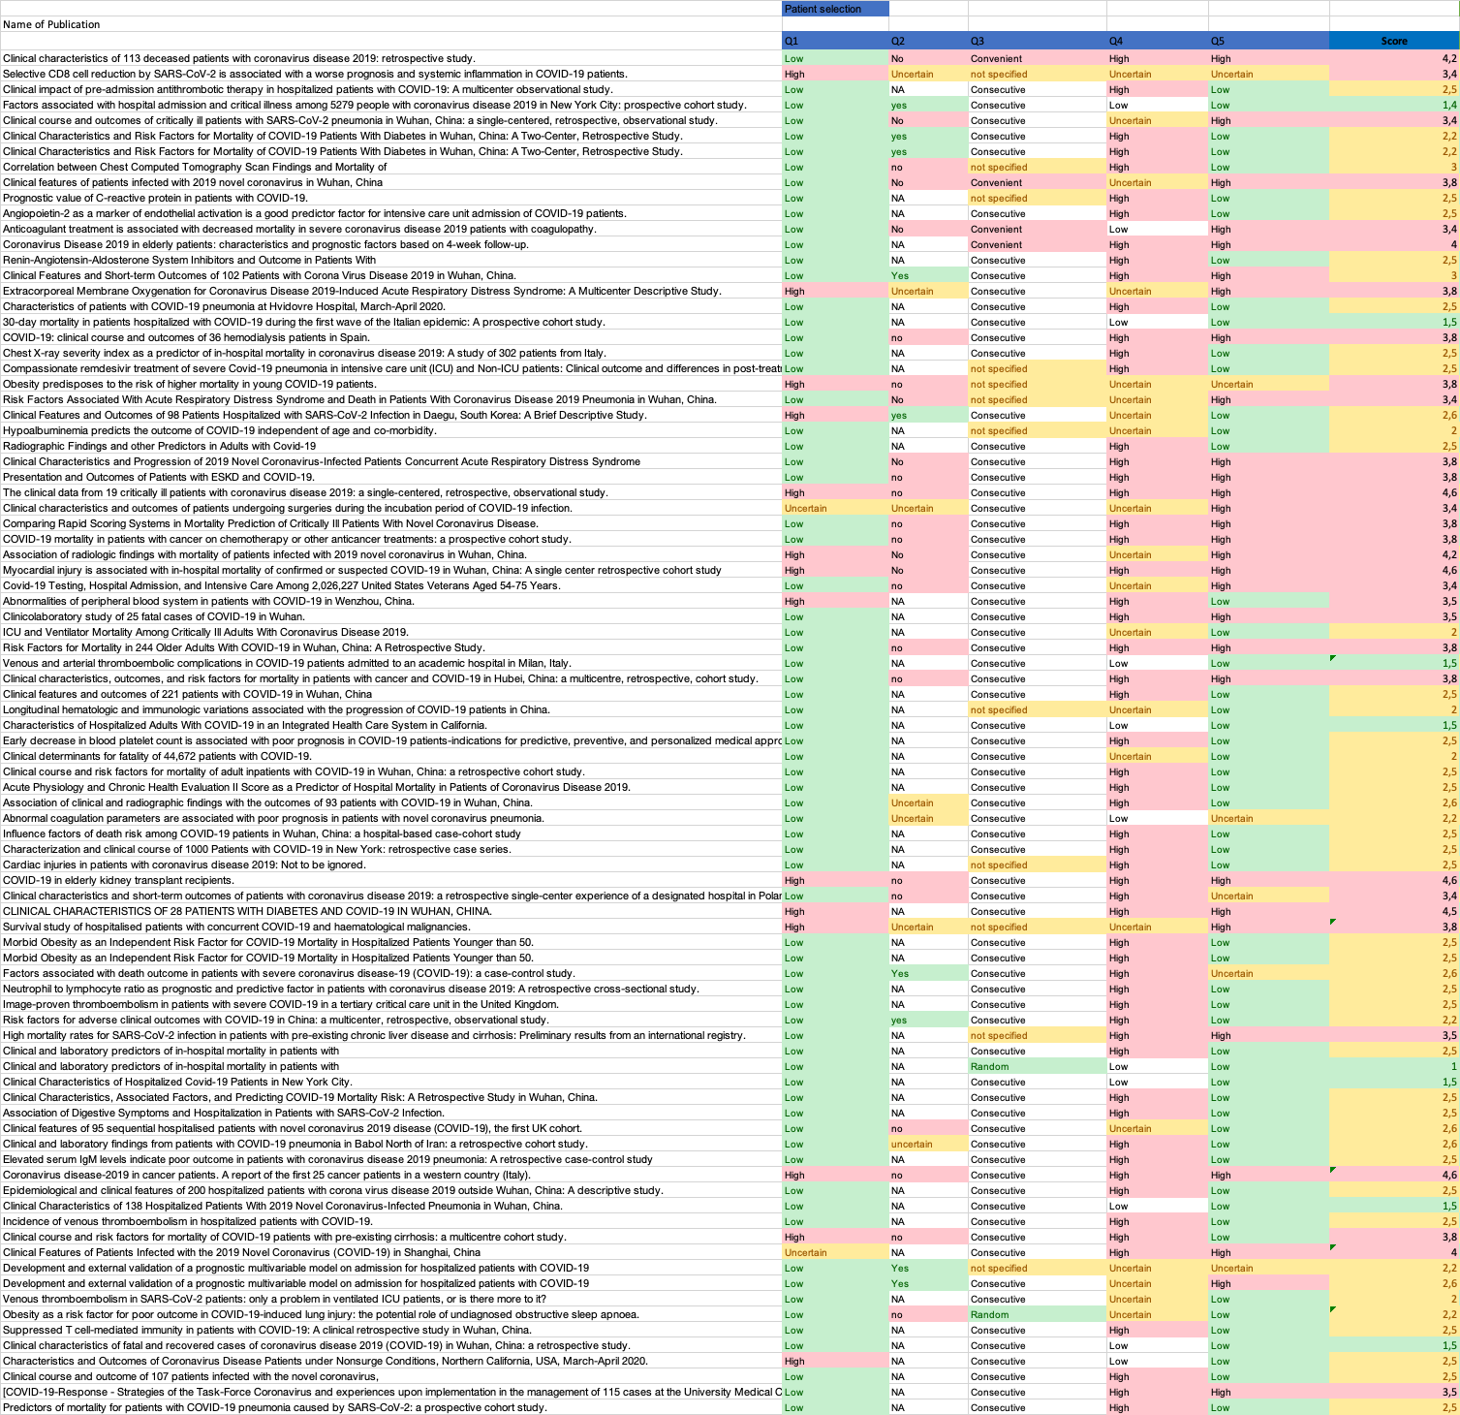
Figure 1 - Risk of bias assessment for 'Patient selection'
Q6… Were there inappropriate exclusions?
Q7… Does the study report number screen, number enrolled, and number assessed?
Q8… Are the patients reported that are excluded for a reported reason?
Q9… What is the risk of incomplete outcome data?
Q10… Were data collected directly form the patients (as opposed to a registry)?

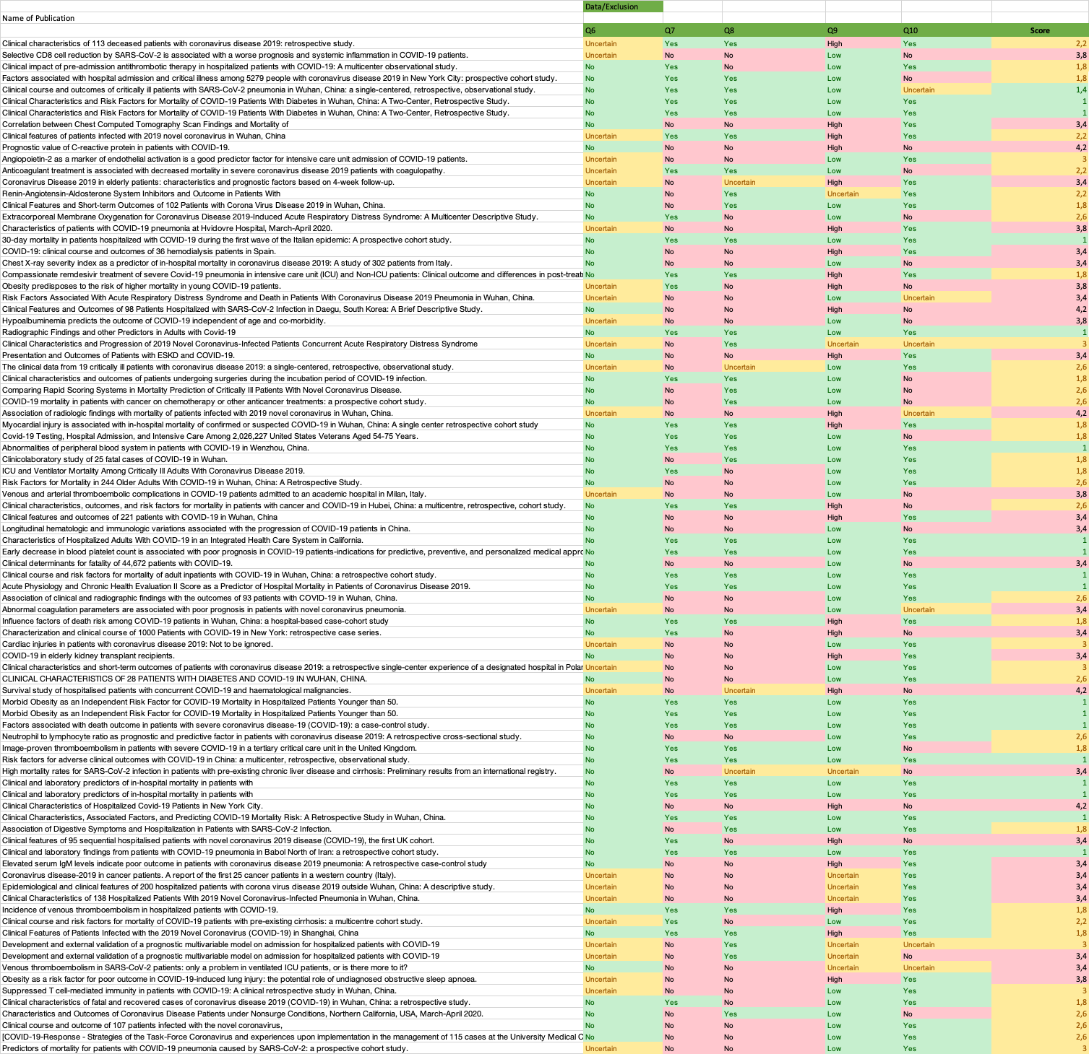
Figure 2 - Risk of bias assessment for 'Data availability and Exclusions'
Q11… What is the risk of applicability of the case definition used in this study?
Q12… Was the same case definition used on all patients?
Q13… Were definitions severe/critical as proposed by the WHO proposition?

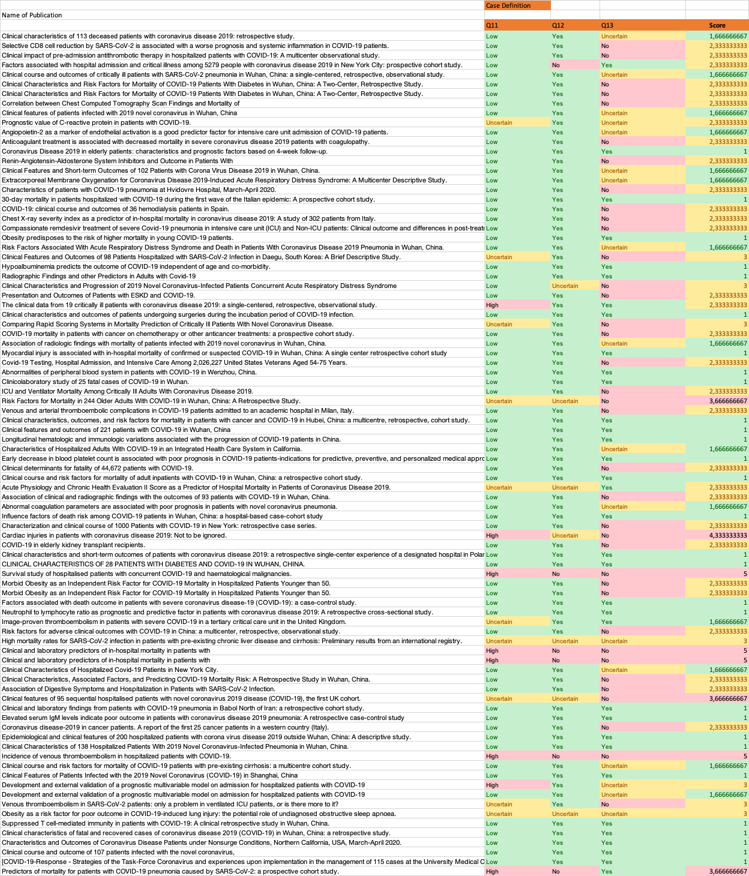
Figure 3 - Risk of bias assessment for 'Covid- and severity case definition'

Supplementary Table 1 - Risk of bias assessment for ‘Patient selection and chance of applicability'
 | Low Risk | Intermediate Risk | High Risk
Q1 – Representative Sample Size | n>30 |  | n<30
Q2 – Selection of screened patients representative | Multicenter study | Singlecenter study with n>30 | Singlecenter study n<30
Q3 – Patient selection | randomized | consecutive | convenient
Q4 – Risk of bias of sampling procedure | randomized |  | Non randomized
Q5 – Risk of selection bias | No subgroup or special treatment | Specialized treatment, e.g. drug-trial | Specialized subgroup, e.g. cancer patients, transplant recipients, dialysis, etc.

Supplementary Table 2 - Risk of bias assessment for ‘Patient data availability and exclusions’
 | Low Risk | Intermediate Risk | High Risk
Q6 – Inappropriate Exclusions | All exclusion criterias listed |  | No exclusion criterias listed
Q7 – Numbers Reported | Screened, enrolled, analyzed listed | Only two listed | Non/one listed
Q8 – Exclusions reported | All exclusions reported with cause of exclusion | Only numbers reported | No exclusions reported
Q9 – Risk of incomplete outcome data | All patients have a definitive outcome |  | Some are still in hospital
Q10 – Data directly from patients | From patient or patient file |  | From a registry

Supplementary Table 3 - Risk of bias assessment for 'Covid-19 and severity case definition'
 | Low Risk | Intermediate Risk | High Risk
Q11 – COVID-19 Case definition | PCR Test | Combination from  - Symptom screen  - CT scan | Only  Symptom screen or CT scan
Q12 – Definiton used for all patients | yes |  | no
Q13 – Severity definitions as proposed by WHO | yes | Local guidelines used | None used

S5 Forest Plots for difference of medians for mortality vs. survived across different indicators

Figure 4 - Forest plot for difference of medians of Age in those who died vs. survived 18
Figure 5 - Forest plot for difference of medians of Leukocyte in those who died vs. survived 19
Figure 6 - Forest plot for difference of medians of Lymphocyte in those who died vs. survived 20
Figure 7 - Forest plot for difference of medians of Neutrophils in those who died vs. survived 21
Figure 8 - Forest plot for difference of medians of Platelets in those who died vs. survived 22
Figure 9 - Forest plot for difference of medians of Oxygen Saturation (SpO2) without oxygen (O2) in those who died vs. survived 22
Figure 10 - Forest plot for difference of medians of Respiratory Rate in those who died vs. survived 23
Figure 11 - Forest plot for difference of medians of D-Dimer in those who died vs. survived. The study by Yang et al. used a different laboratory assay. The left panel contains the forest plot of the analysis including the study by Yang et al., and the right panel contains the forest plot of the analysis excluding the study by Yang et al. 24
Figure 12 - Forest plot for difference of medians of Troponin I (TnI) in those who died vs. survived 25
Figure 13 - Forest plot for difference of medians of C-reactive protein (CRP) in those who died vs. survived. Xie et al. developed a mortality prediction tool and had substantial higher values of CRP than other studies. The left panel contains the forest plot for the analysis including the study by Xie et al., and the right panel contains the forest plot for the analysis excluding the study by Xie et al. 26
Figure 14 - Forest plot for difference of medians of Creatinine in those who died vs. survived 27
Figure 15 - Forest plot for difference of medians of Lactate Dehydrogenase (LDH) in those who died vs. survived 28
Figure 16 - Forest plot for Odds Ratio and 95% Confidence Interval (CI) of Asthma for those who died vs. survived 28
Figure 17 - Forest plot for Odds Ratio and 95% Confidence Interval (CI) of Cancer for those who died vs. survived 29
Figure 18 - Forest plot for Odds Ratio and 95% Confidence Interval (CI) of Cerebrovascular disease for those who died vs. survived 30
Figure 19 - Forest plot for Odds Ratio and 95% Confidence Interval (CI) of Chronic lung disease for those who died vs. survived 31
Figure 20 - Forest plot for Odds Ratio and 95% Confidence Interval (CI) of chronic obstructive pulmonary disease (COPD) for those who died vs. survived 32
Figure 21 - Forest plot for Odds Ratio and 95% Confidence Interval (CI) of Cardiovascular disease for those who died vs. survived 33
Figure 22 - Forest plot for Odds Ratio and 95% Confidence Interval (CI) of Diabetes for those who died vs. survived 34
Figure 23 - Forest plot for Odds Ratio and 95% Confidence Interval (CI) of Dyspnea for those who died vs. survived 35
Figure 24 - Forest plot for Odds Ratio and 95% Confidence Interval (CI) of extra corporal membrane oxygenation (ECMO) for those who died vs. survived 36
Figure 25 - Forest plot for Odds Ratio and 95% Confidence Interval (CI) of Fatigue for those who died vs. survived 37
Figure 26 - Forest plot for Odds Ratio and 95% Confidence Interval (CI) of Hypertension for those who died vs. survived 38
Figure 27 - Forest plot for Odds Ratio and 95% Confidence Interval (CI) of Chronic kidney disease for those who died vs. survived 39
Figure 28 - Forest plot for Odds Ratio and 95% Confidence Interval (CI) of Acute kidney injury for those who died vs. survived 40
Figure 29 - Forest plot for Odds Ratio and 95% Confidence Interval (CI) of non-invasive ventilation (NIV) for those who died vs. survived 41
Figure 30 - Forest plot for Odds Ratio and 95% Confidence Interval (CI) of Smoking for those who died vs. survived 42

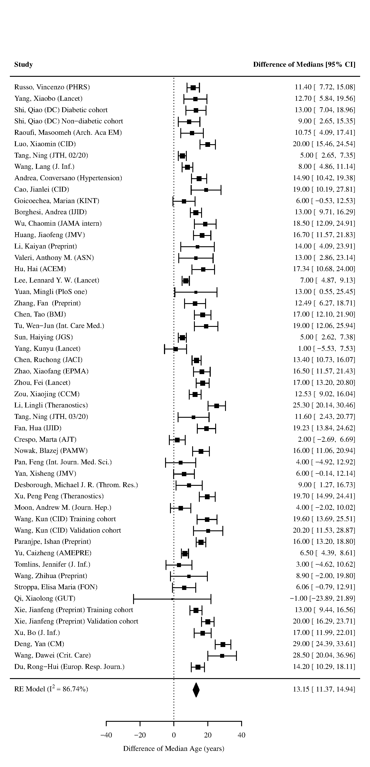
Figure 4 - Forest plot for difference of medians of Age in those who died vs. survived
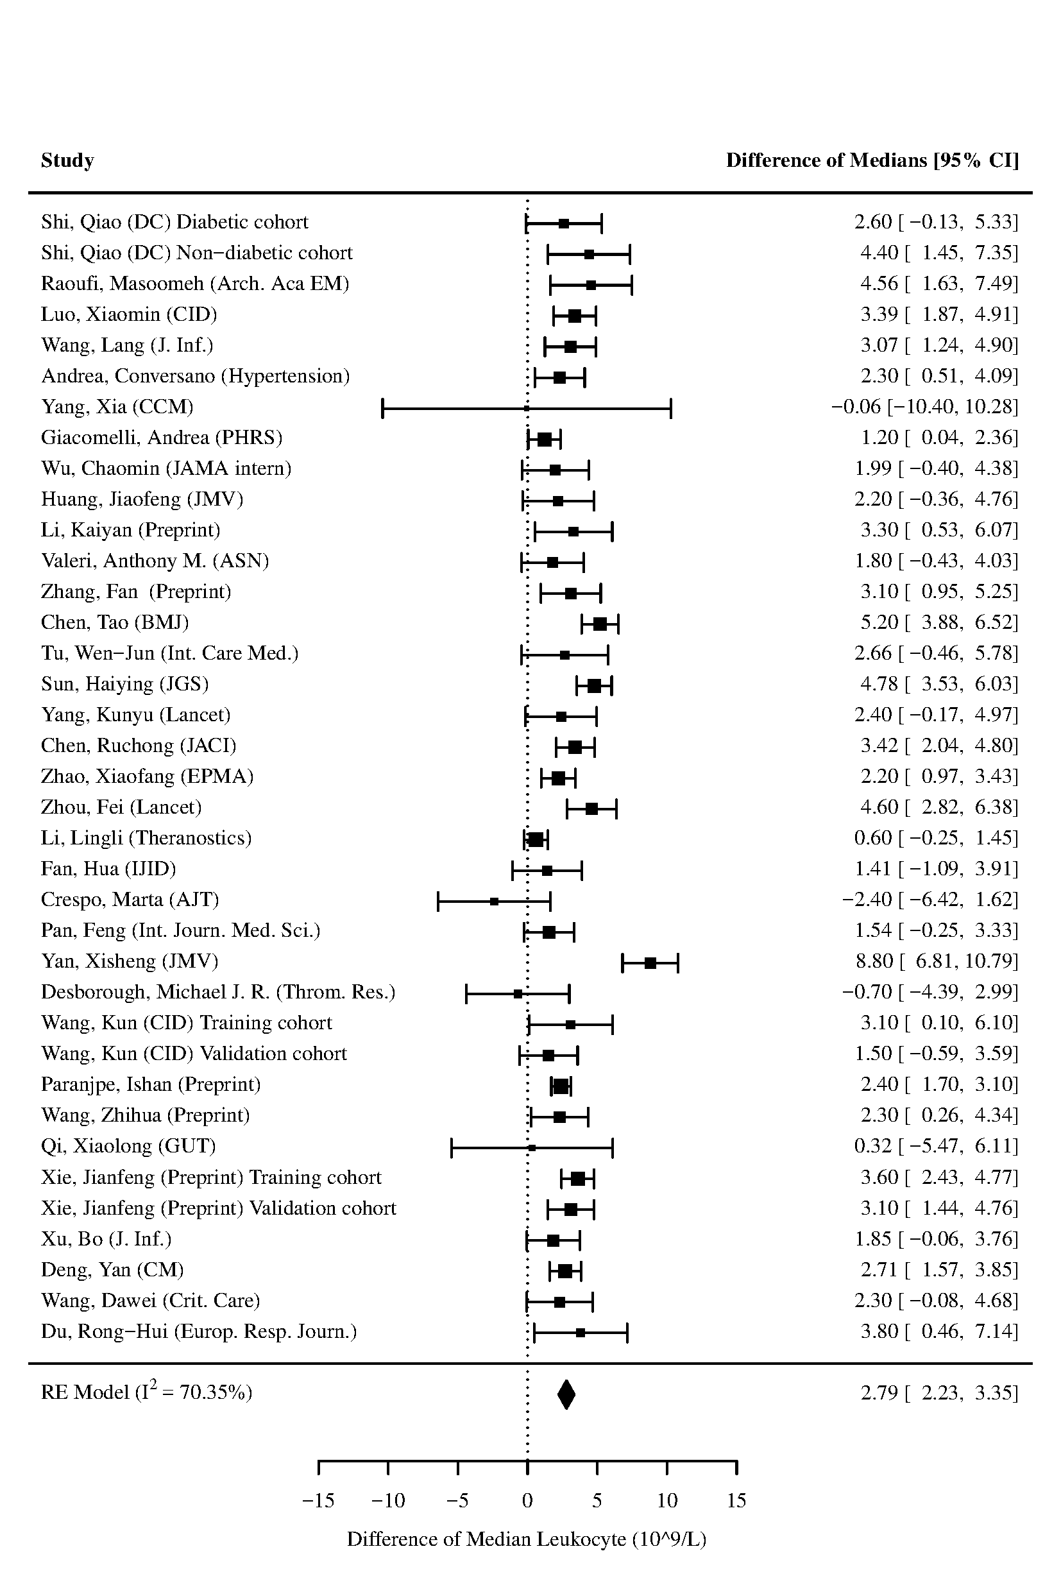
Figure 5 - Forest plot for difference of medians of Leukocyte in those who died vs. survived
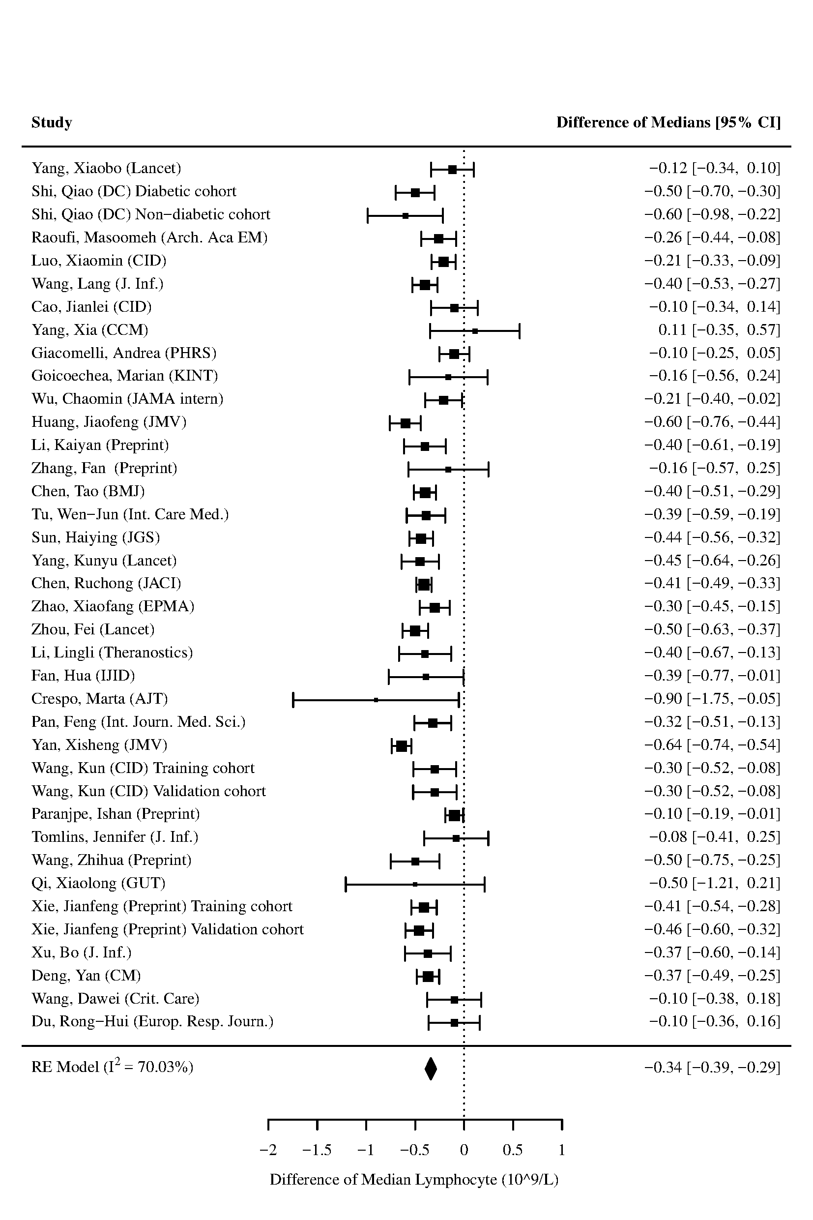
Figure 6 - Forest plot for difference of medians of Lymphocyte in those who died vs. survived

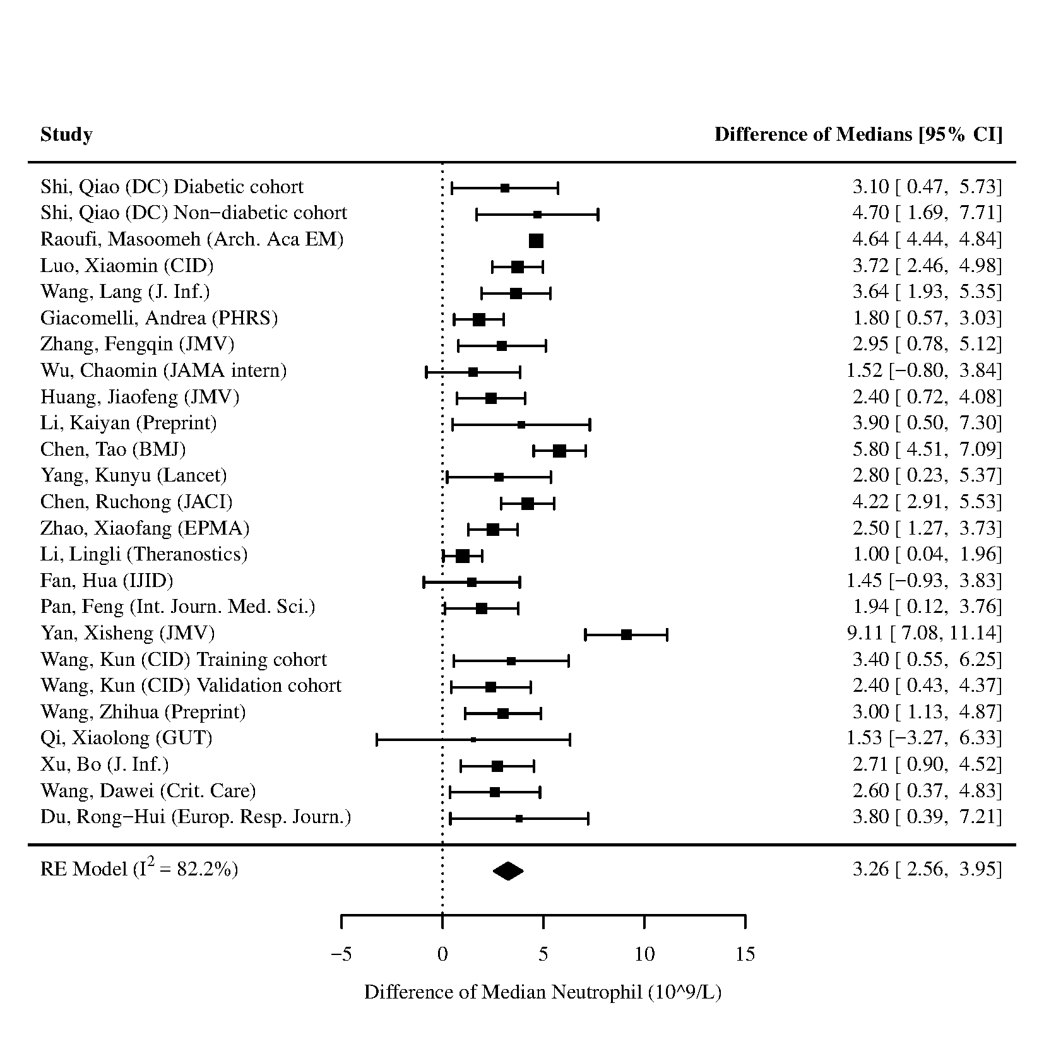
Figure 7 - Forest plot for difference of medians of Neutrophils in those who died vs. survived
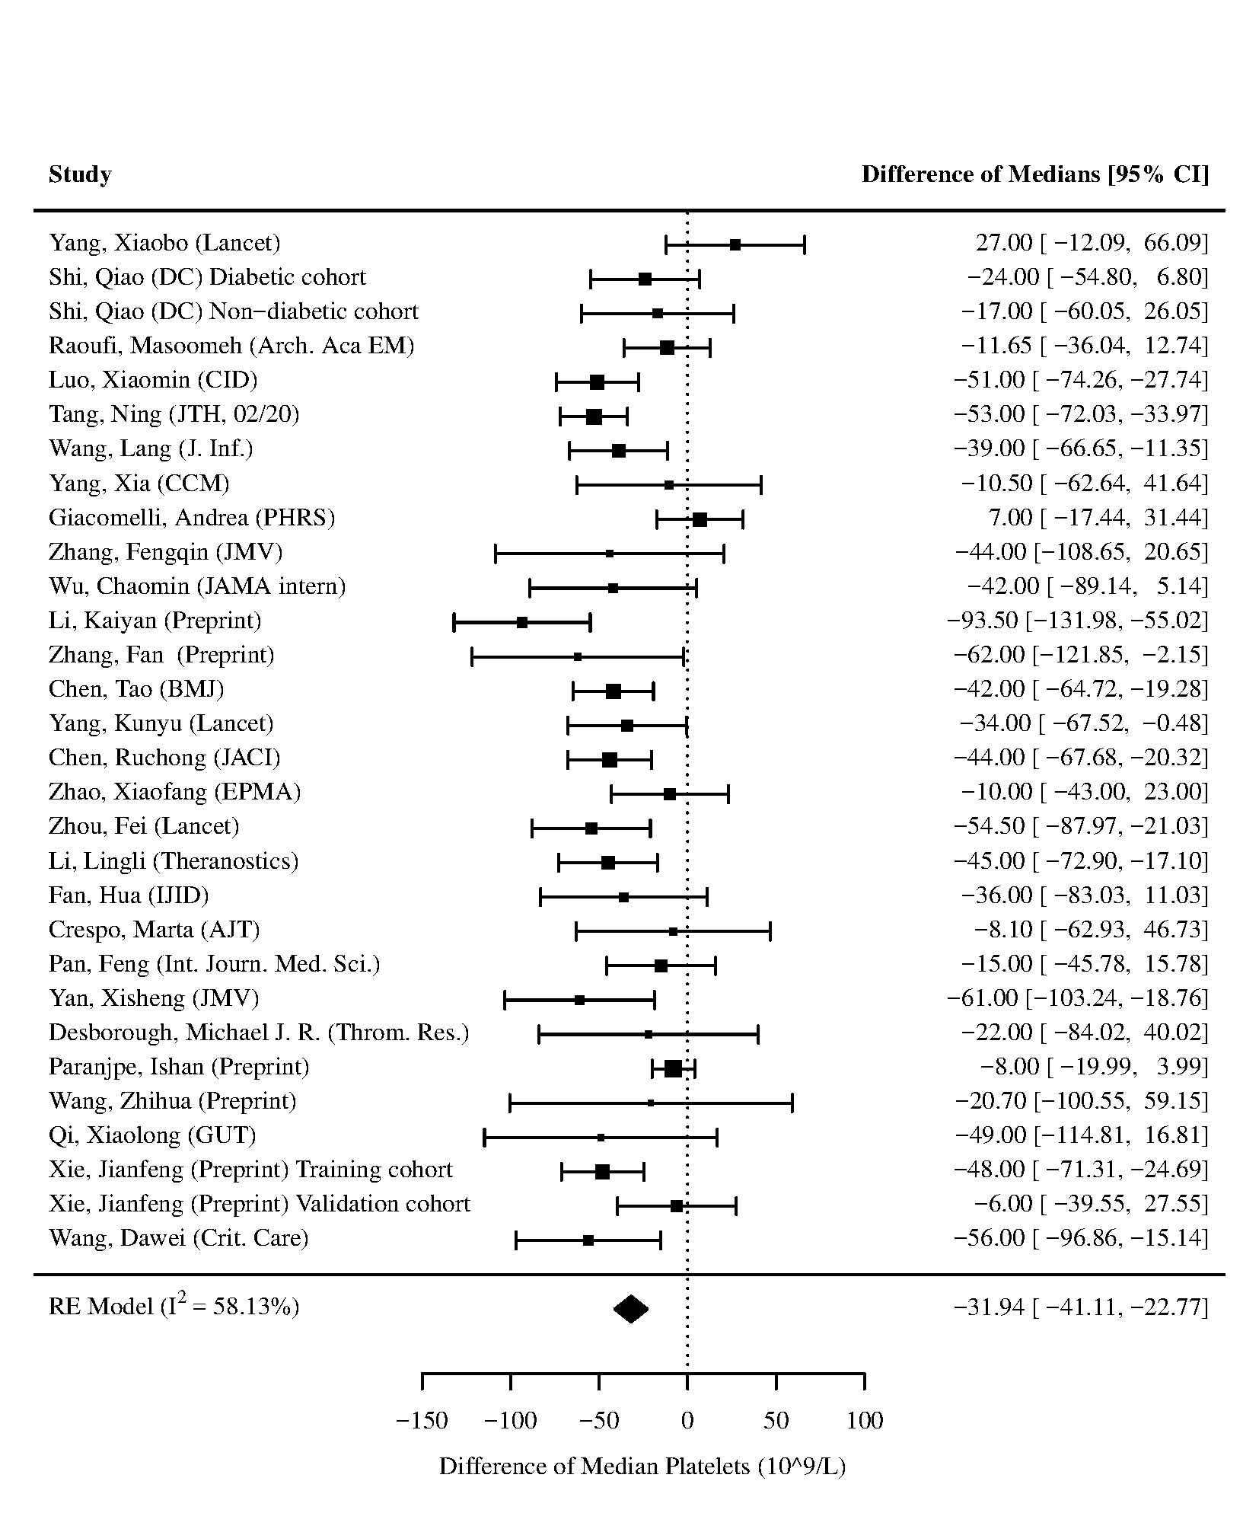
Figure 8 - Forest plot for difference of medians of Platelets in those who died vs. survived
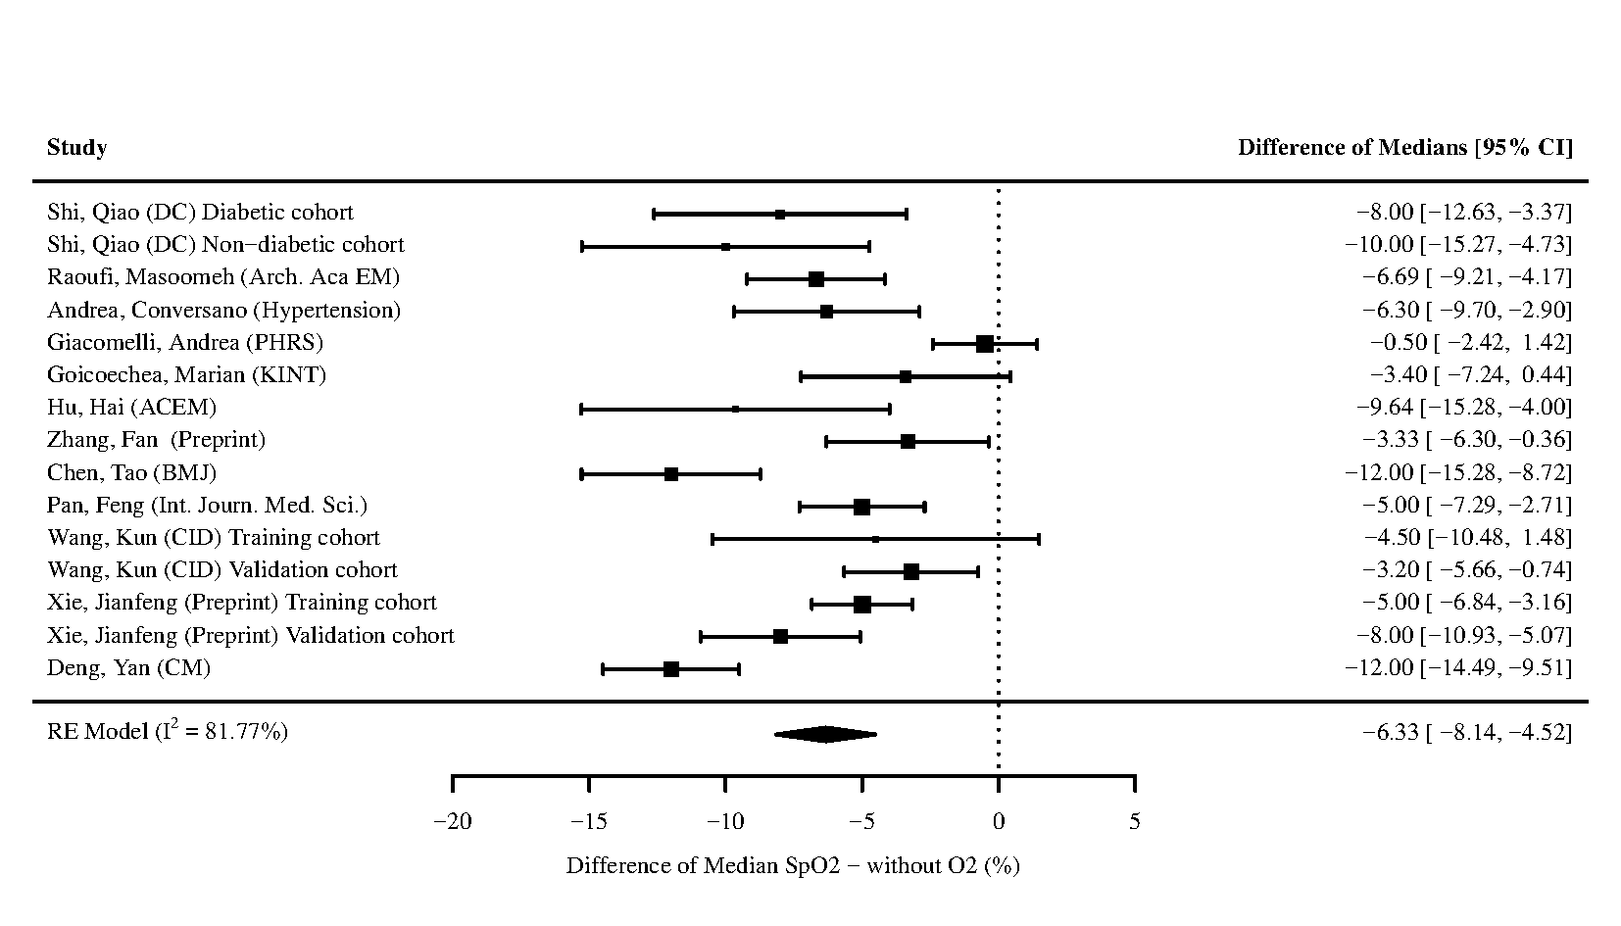
Figure 9 - Forest plot for difference of medians of Oxygen Saturation (SpO2) without oxygen (O2) in those who died vs. survived
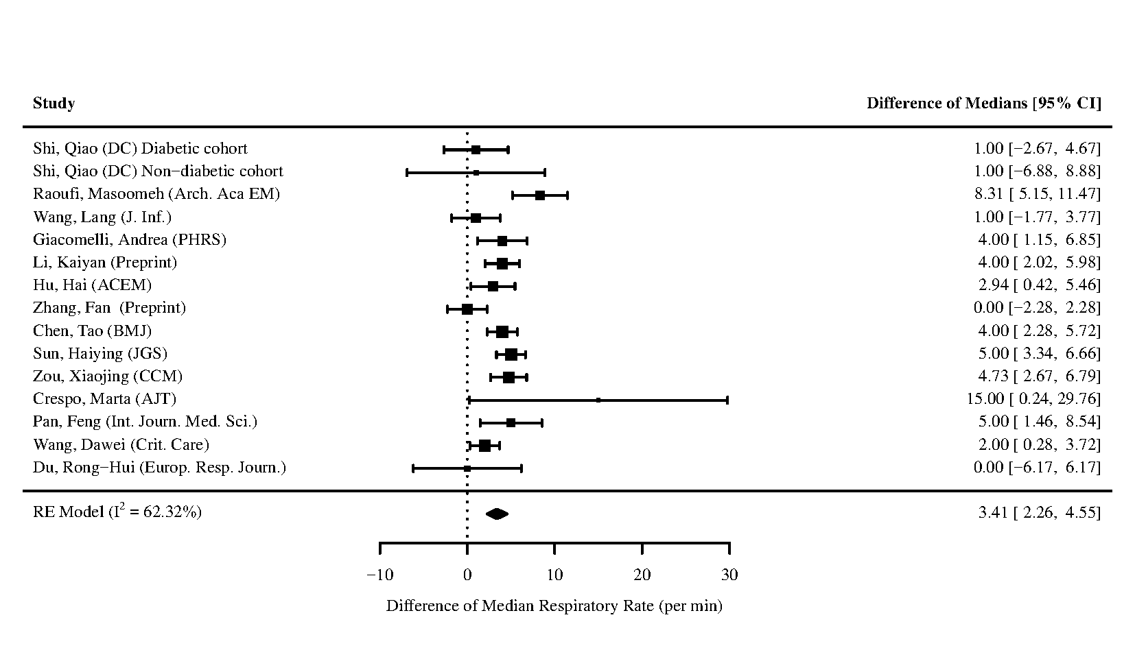
Figure 10 - Forest plot for difference of medians of Respiratory Rate in those who died vs. survived

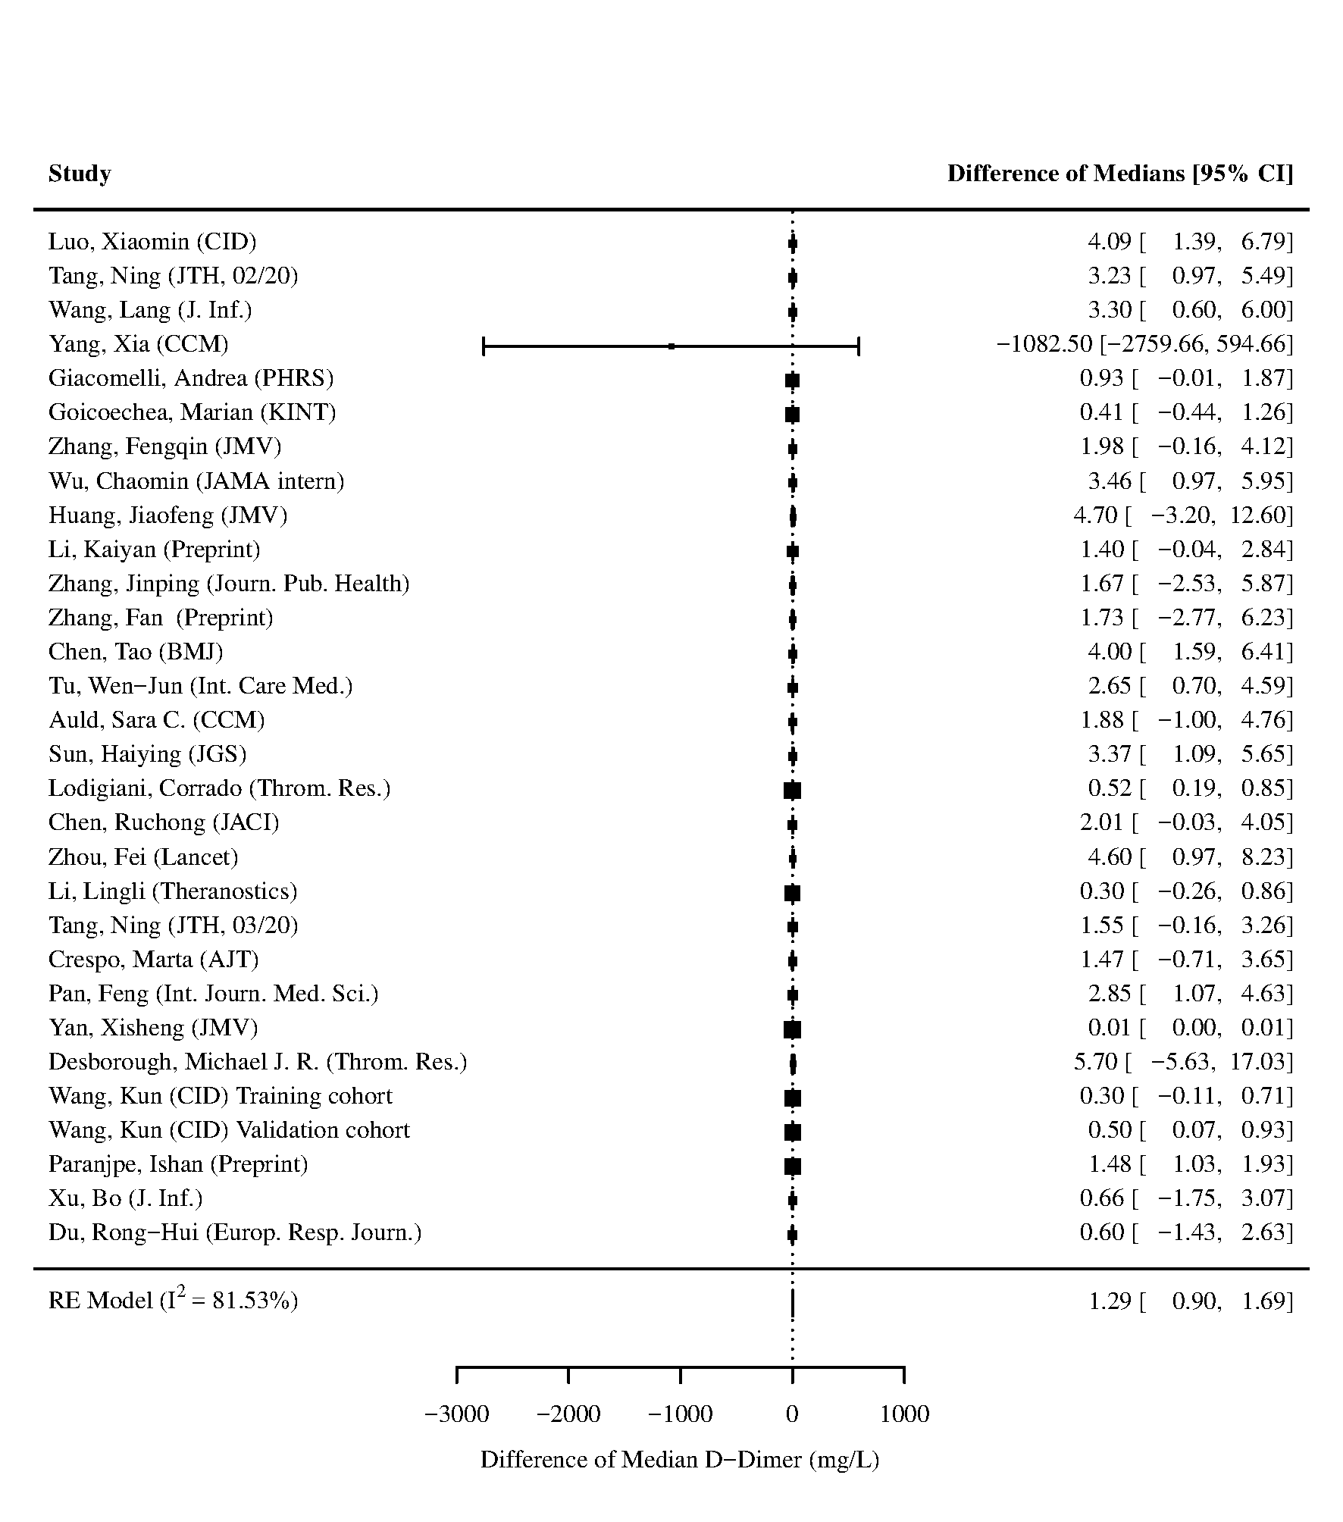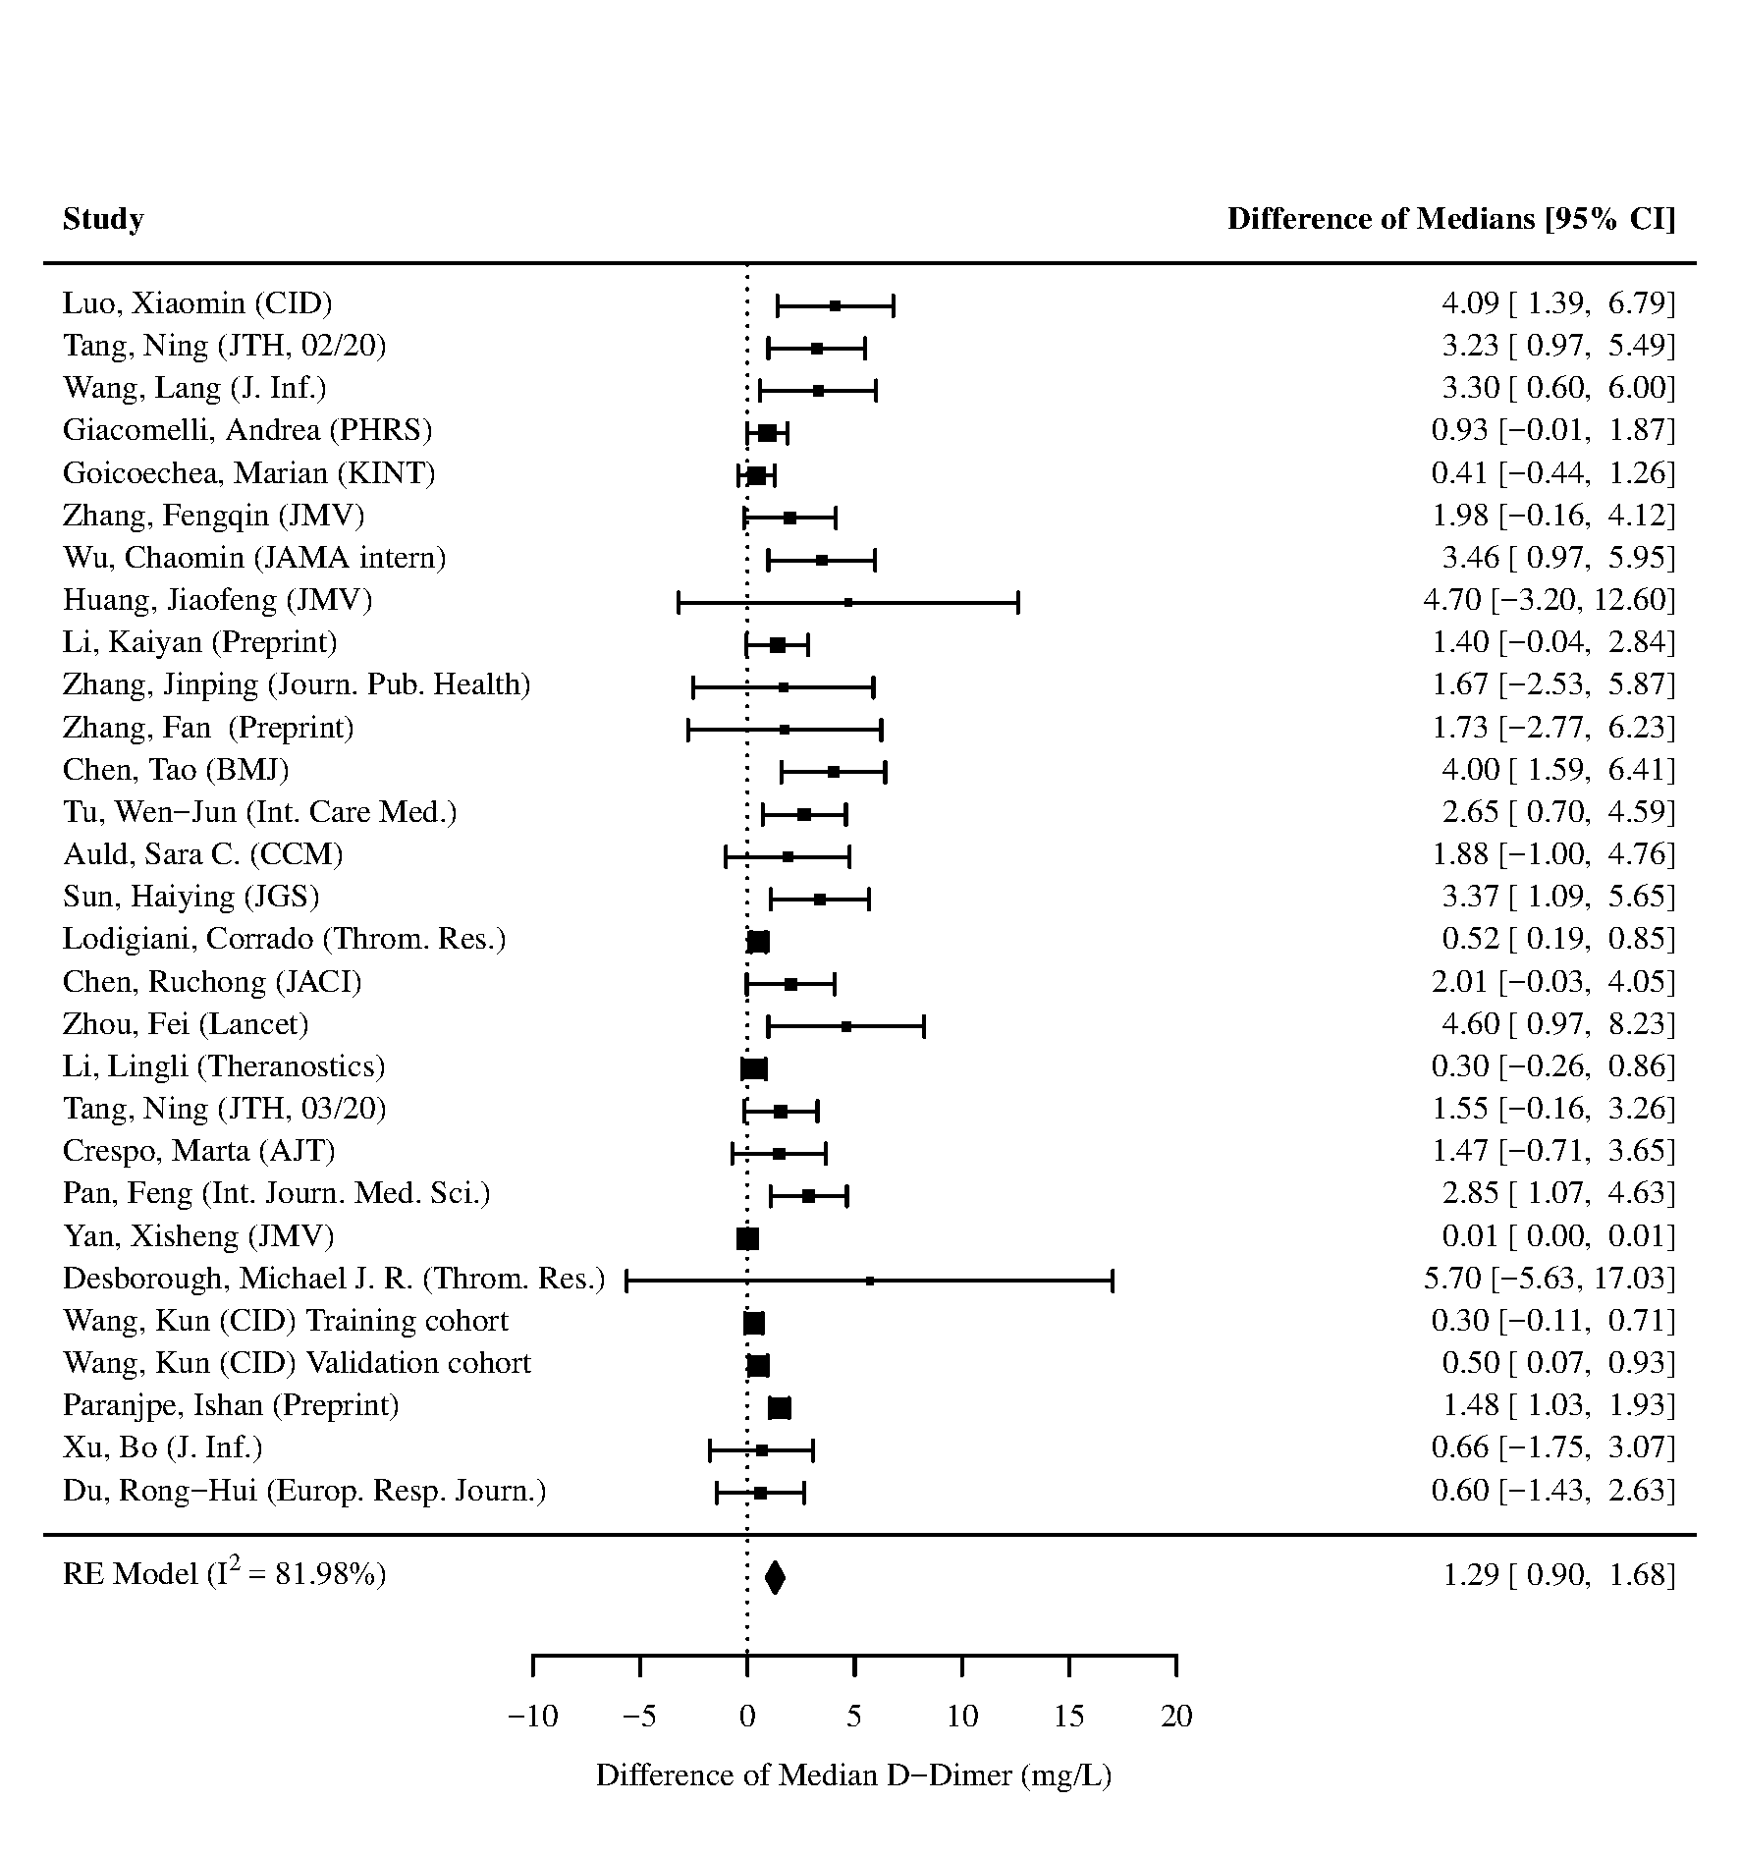
Figure 11 - Forest plot for difference of medians of D-Dimer in those who died vs. survived. The study by Yang et al. used a different laboratory assay. The left panel contains the forest plot of the analysis including the study by Yang et al., and the right panel contains the forest plot of the analysis excluding the study by Yang et al.

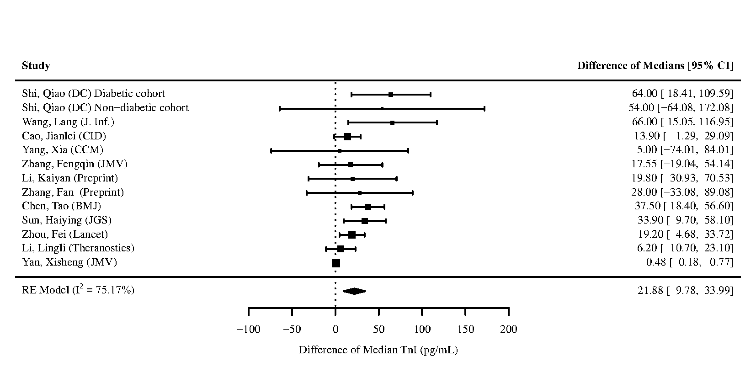
Figure 12 - Forest plot for difference of medians of Troponin I (TnI) in those who died vs. survived

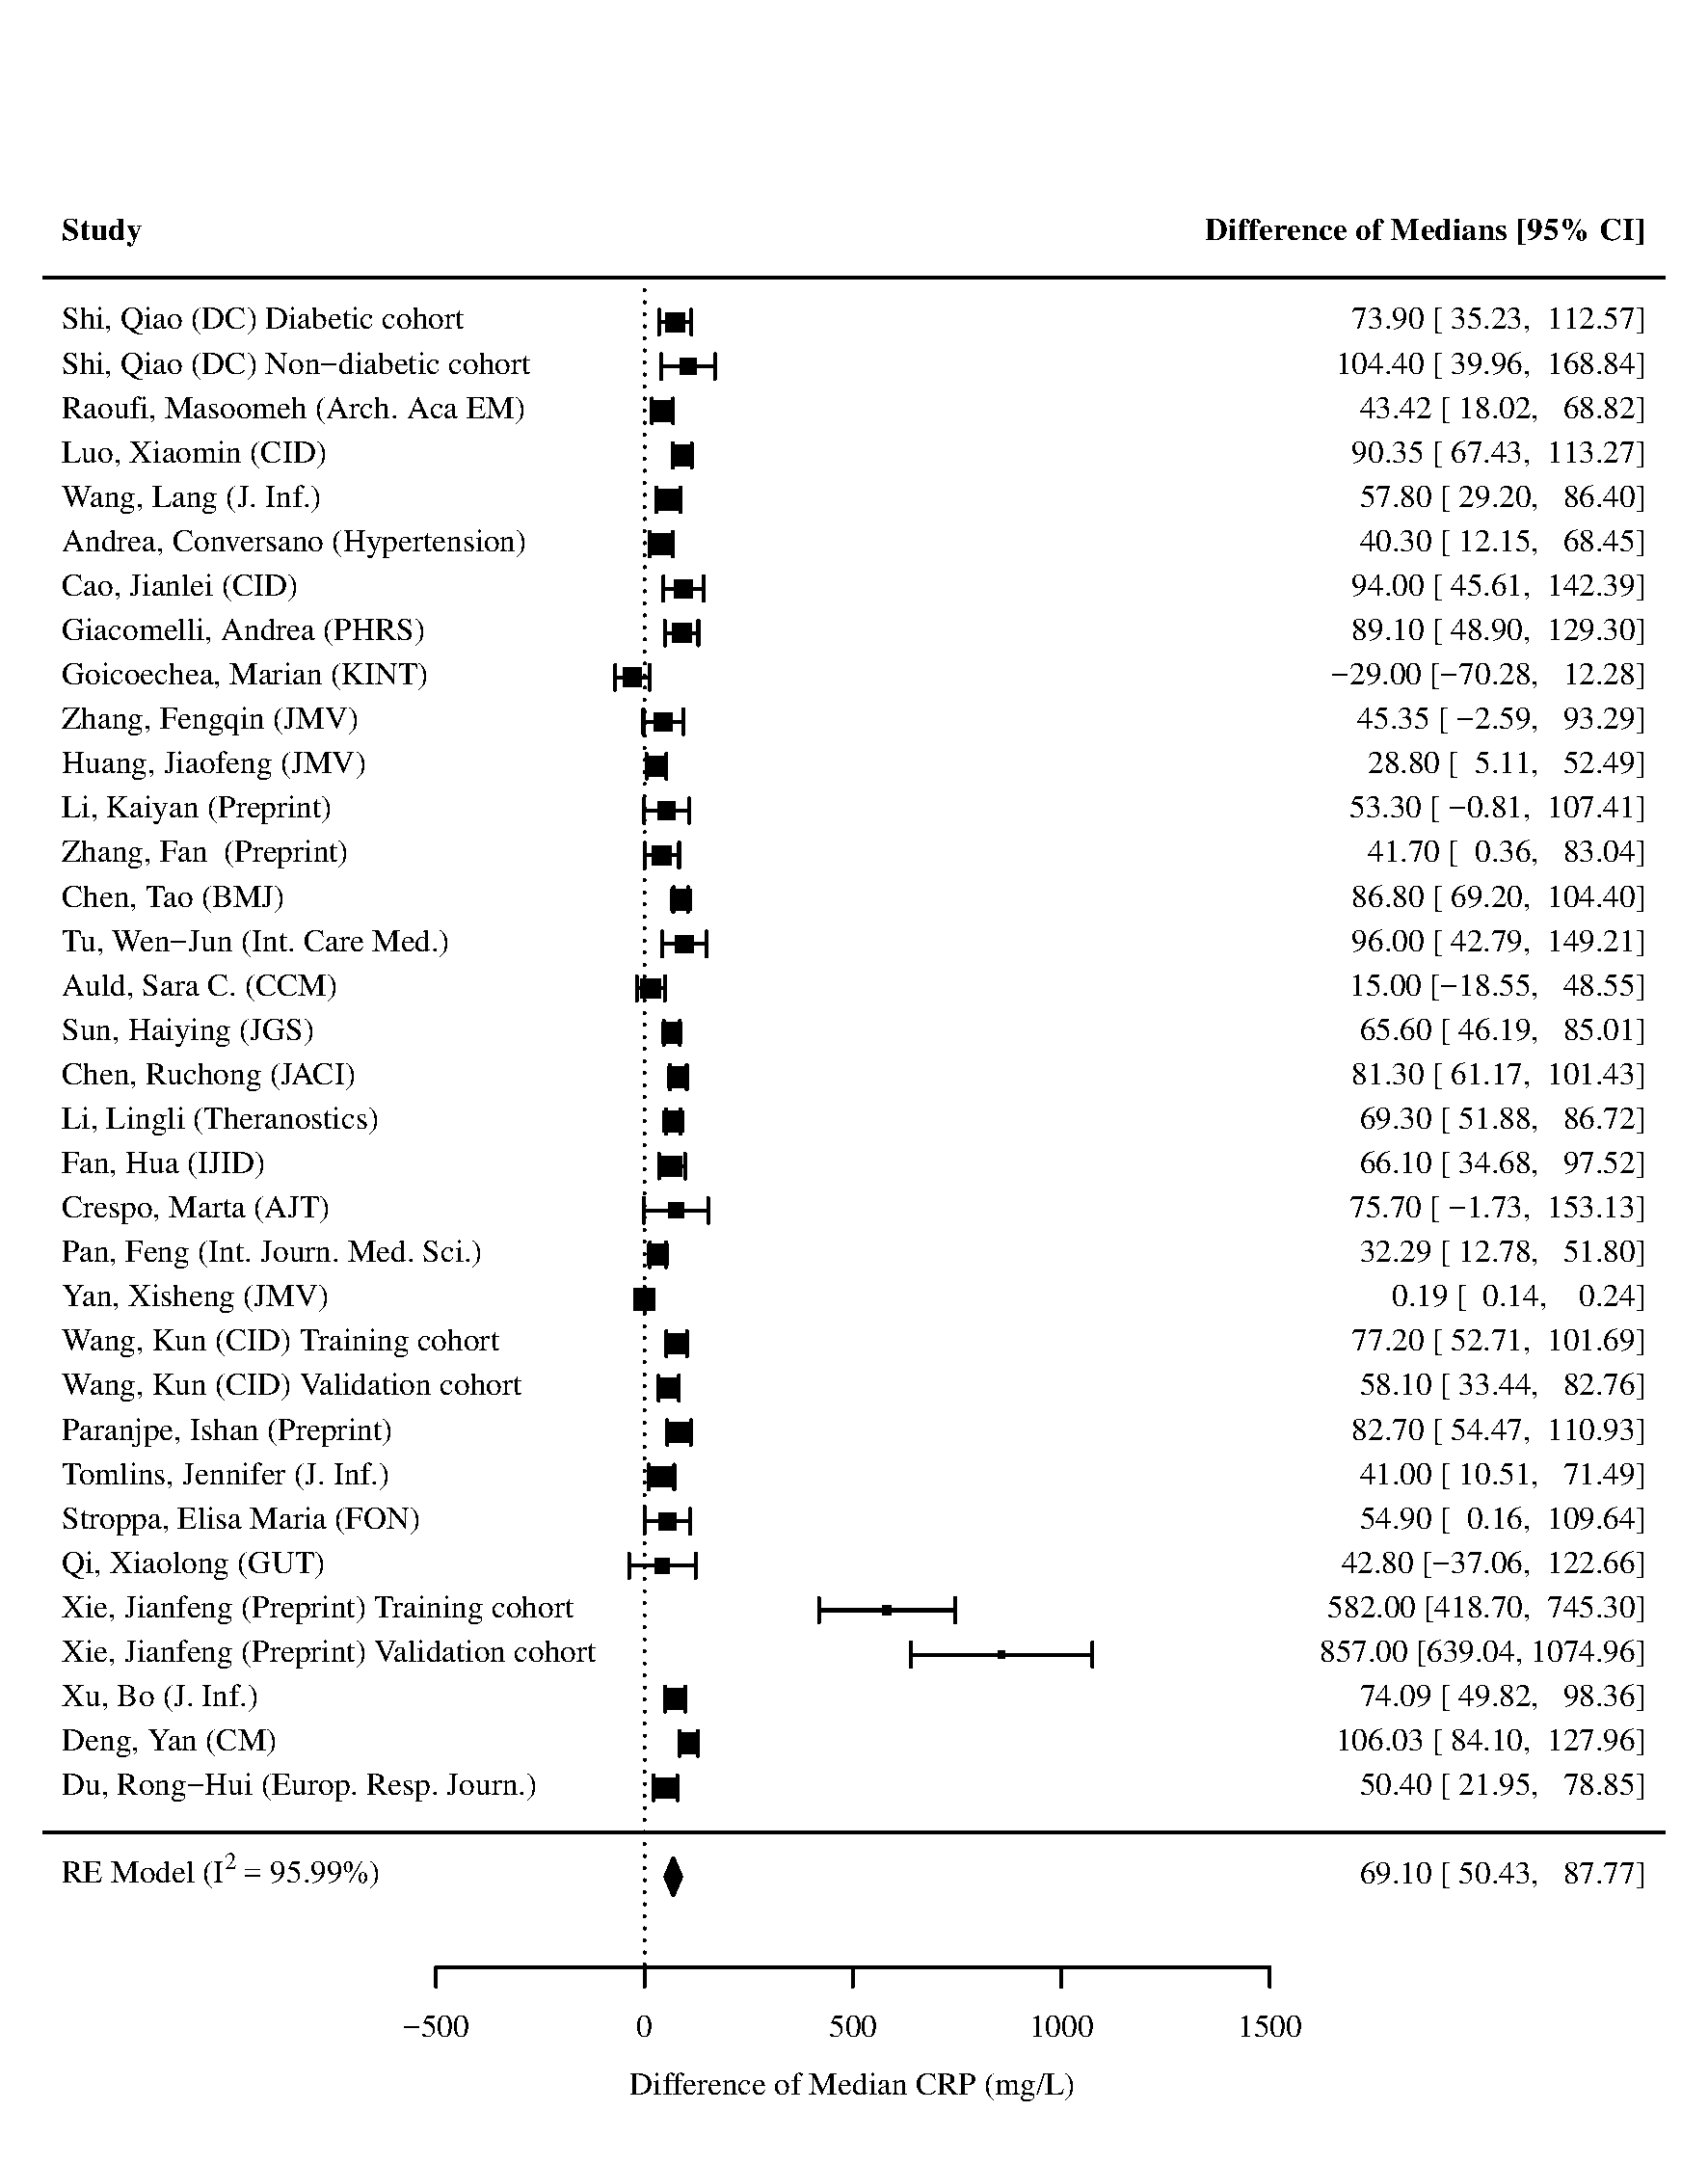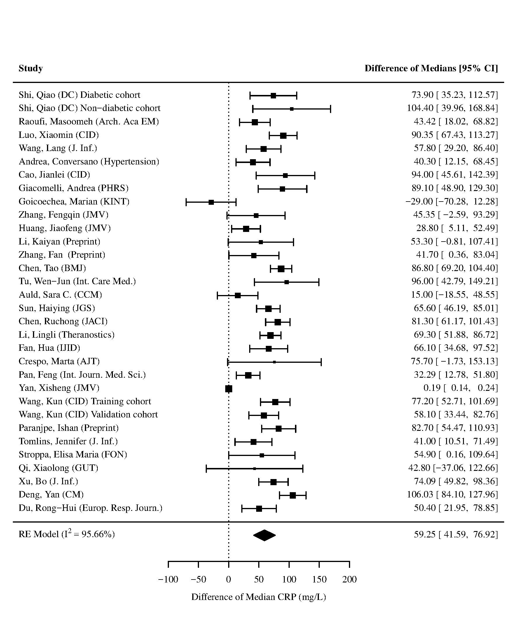

Figure 13 - Forest plot for difference of medians of C-reactive protein (CRP) in those who died vs. survived. Xie et al. developed a mortality prediction tool and had substantial higher values of CRP than other studies. The left panel contains the forest plot for the analysis including the study by Xie et al., and the right panel contains the forest plot for the analysis excluding the study by Xie et al.

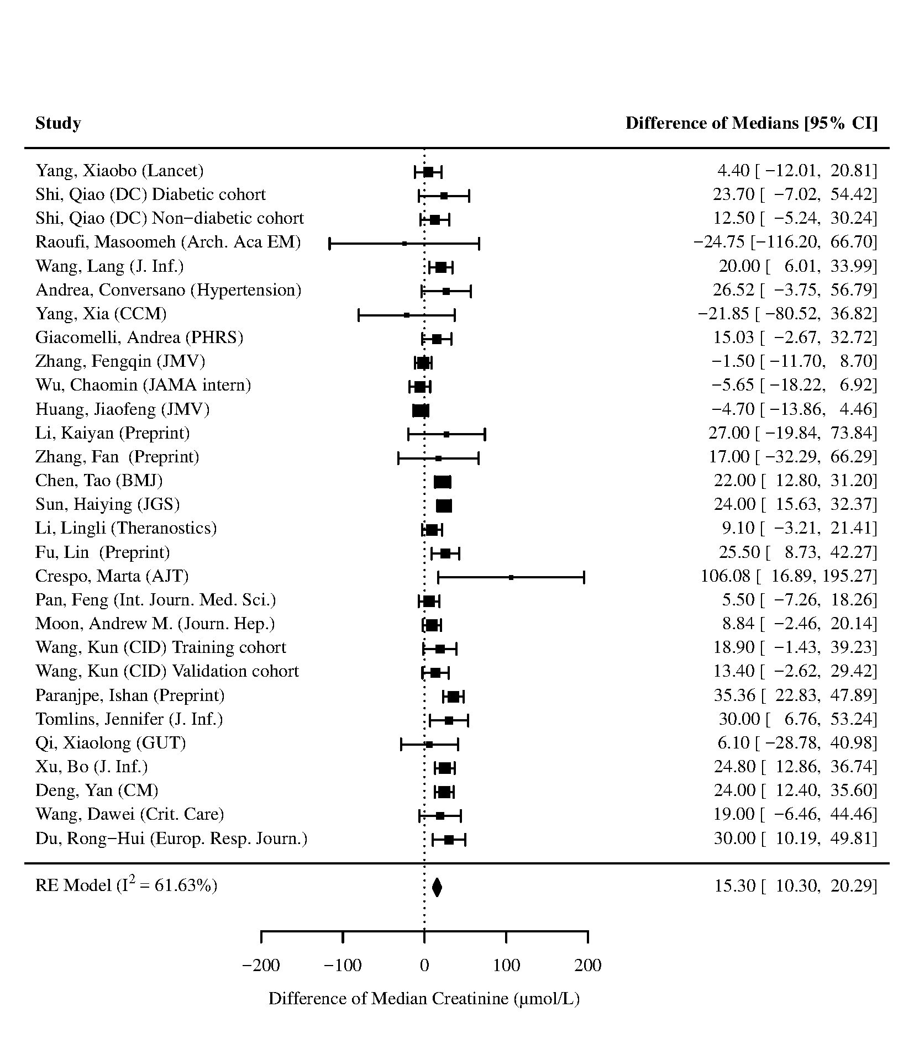
Figure 14 - Forest plot for difference of medians of Creatinine in those who died vs. survived
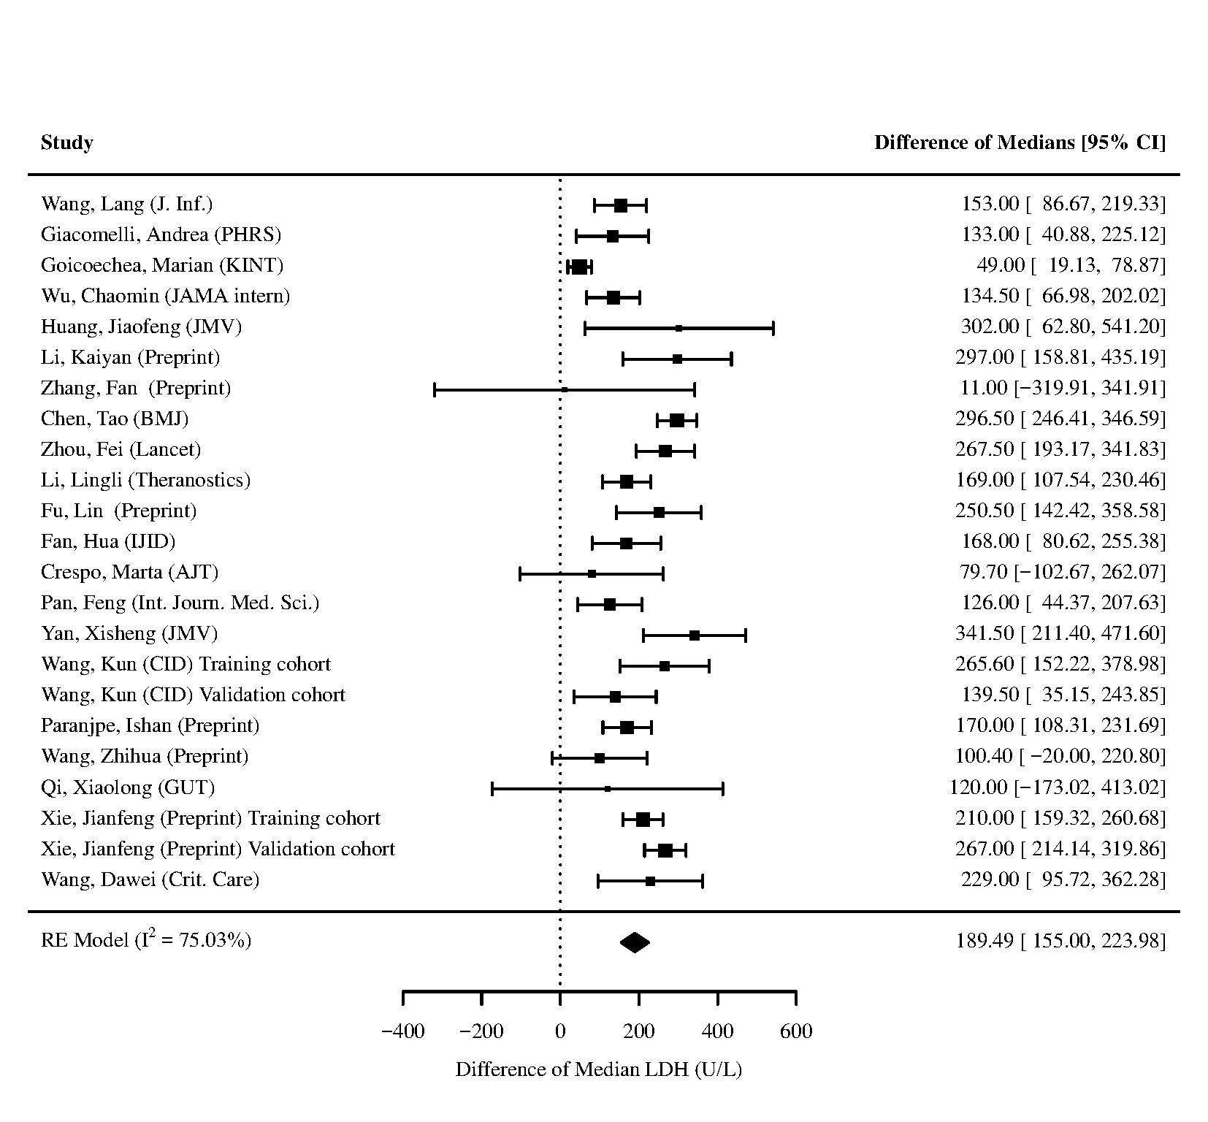
Figure 15 - Forest plot for difference of medians of Lactate Dehydrogenase (LDH) in those who died vs. survived

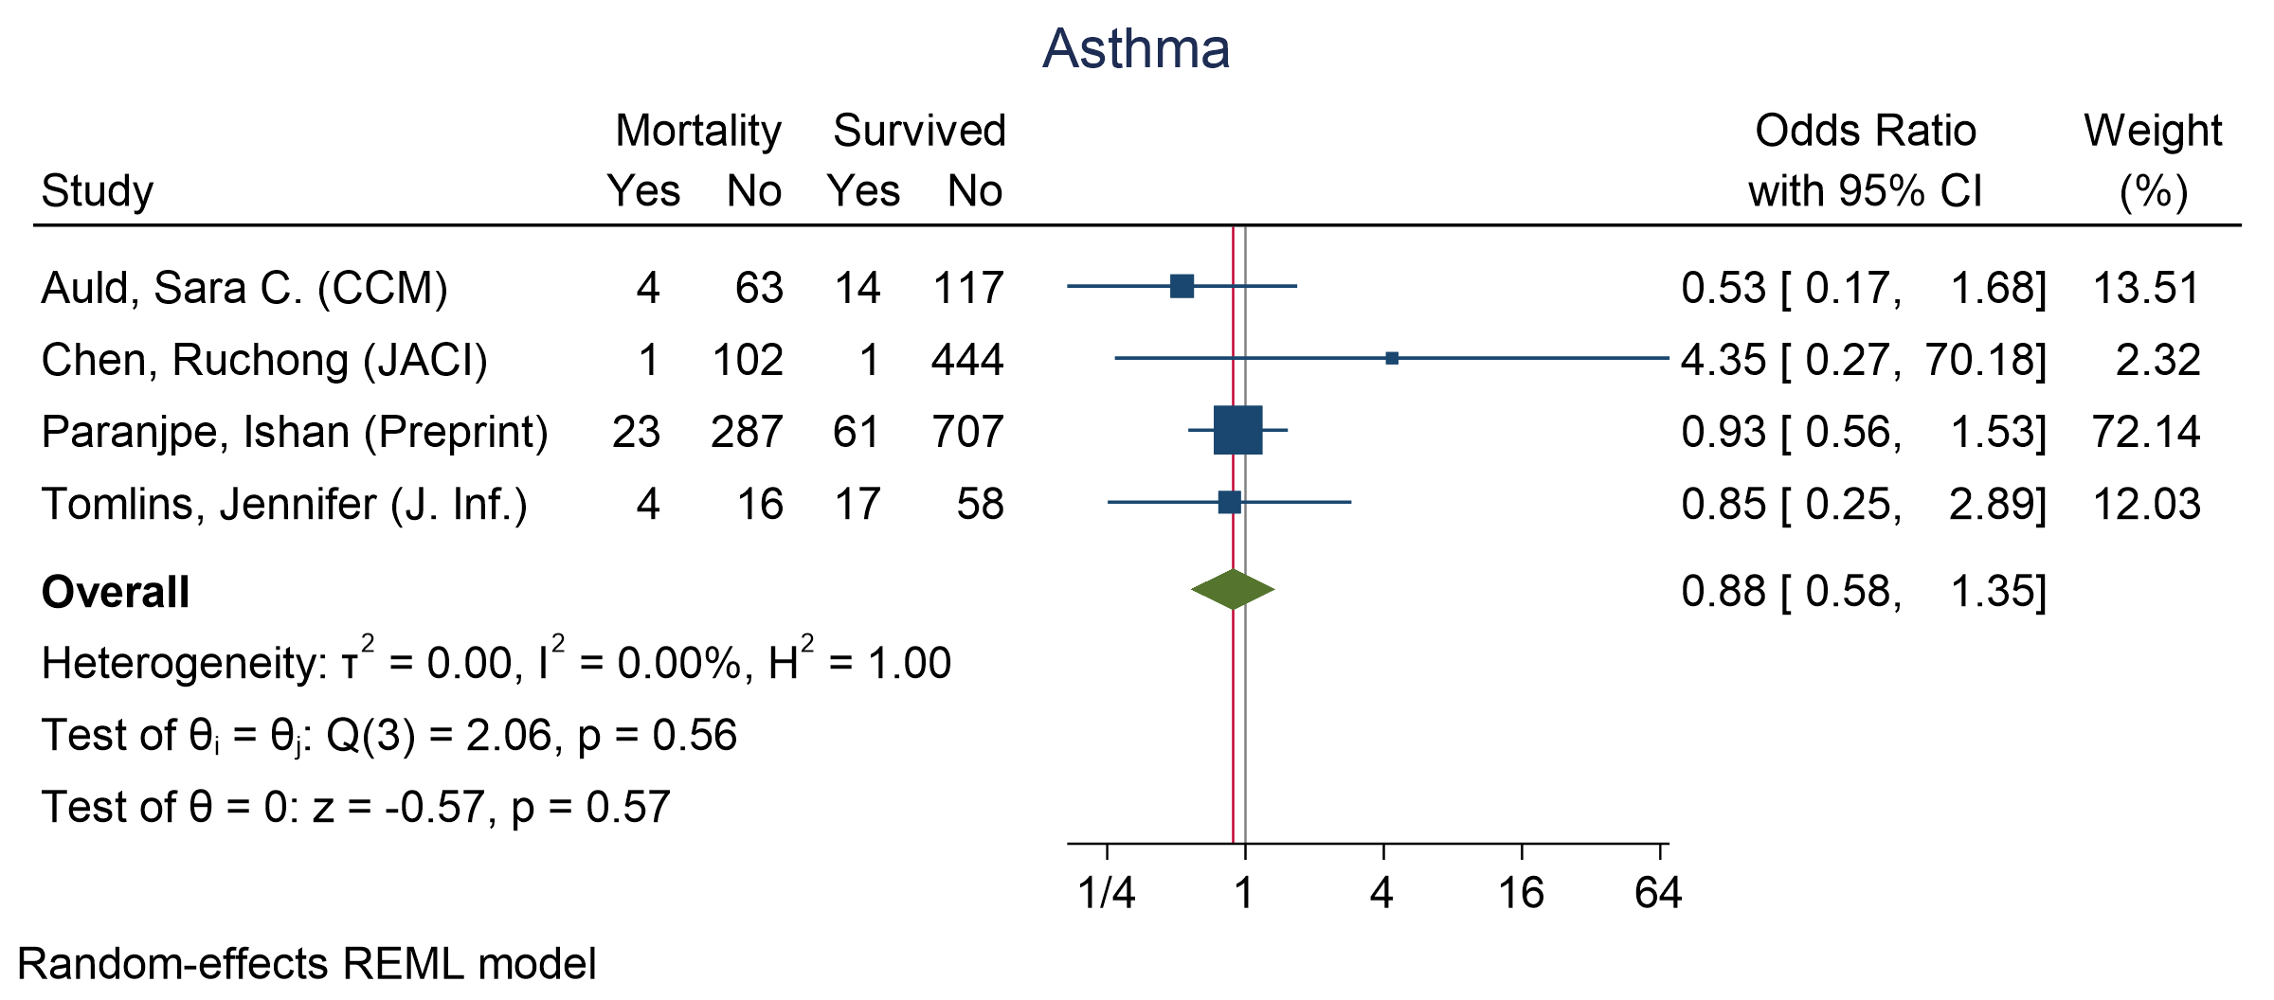
Figure 16 - Forest plot for Odds Ratio and 95% Confidence Interval (CI) of Asthma for those who died vs. survived
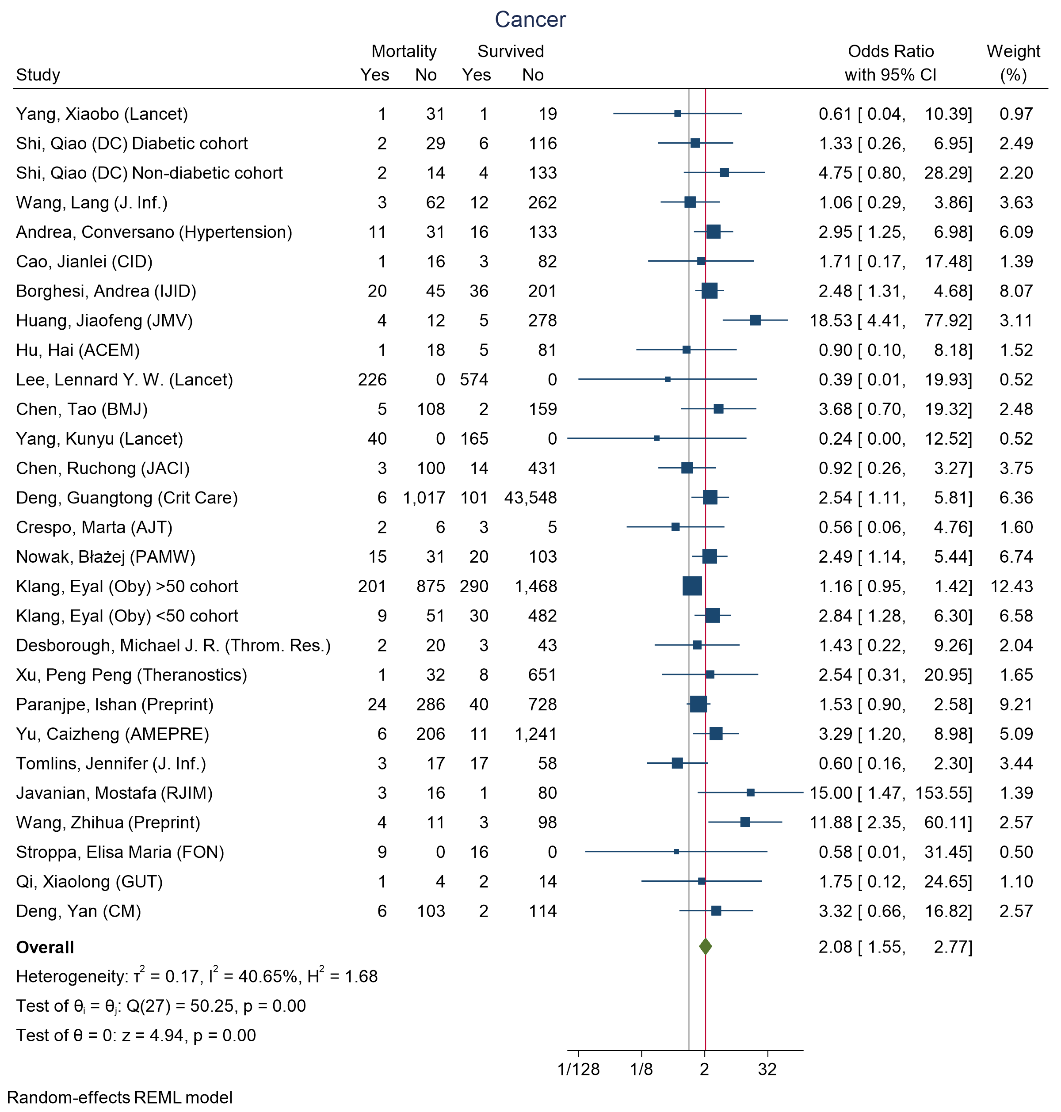
Figure 17 - Forest plot for Odds Ratio and 95% Confidence Interval (CI) of Cancer for those who died vs. survived

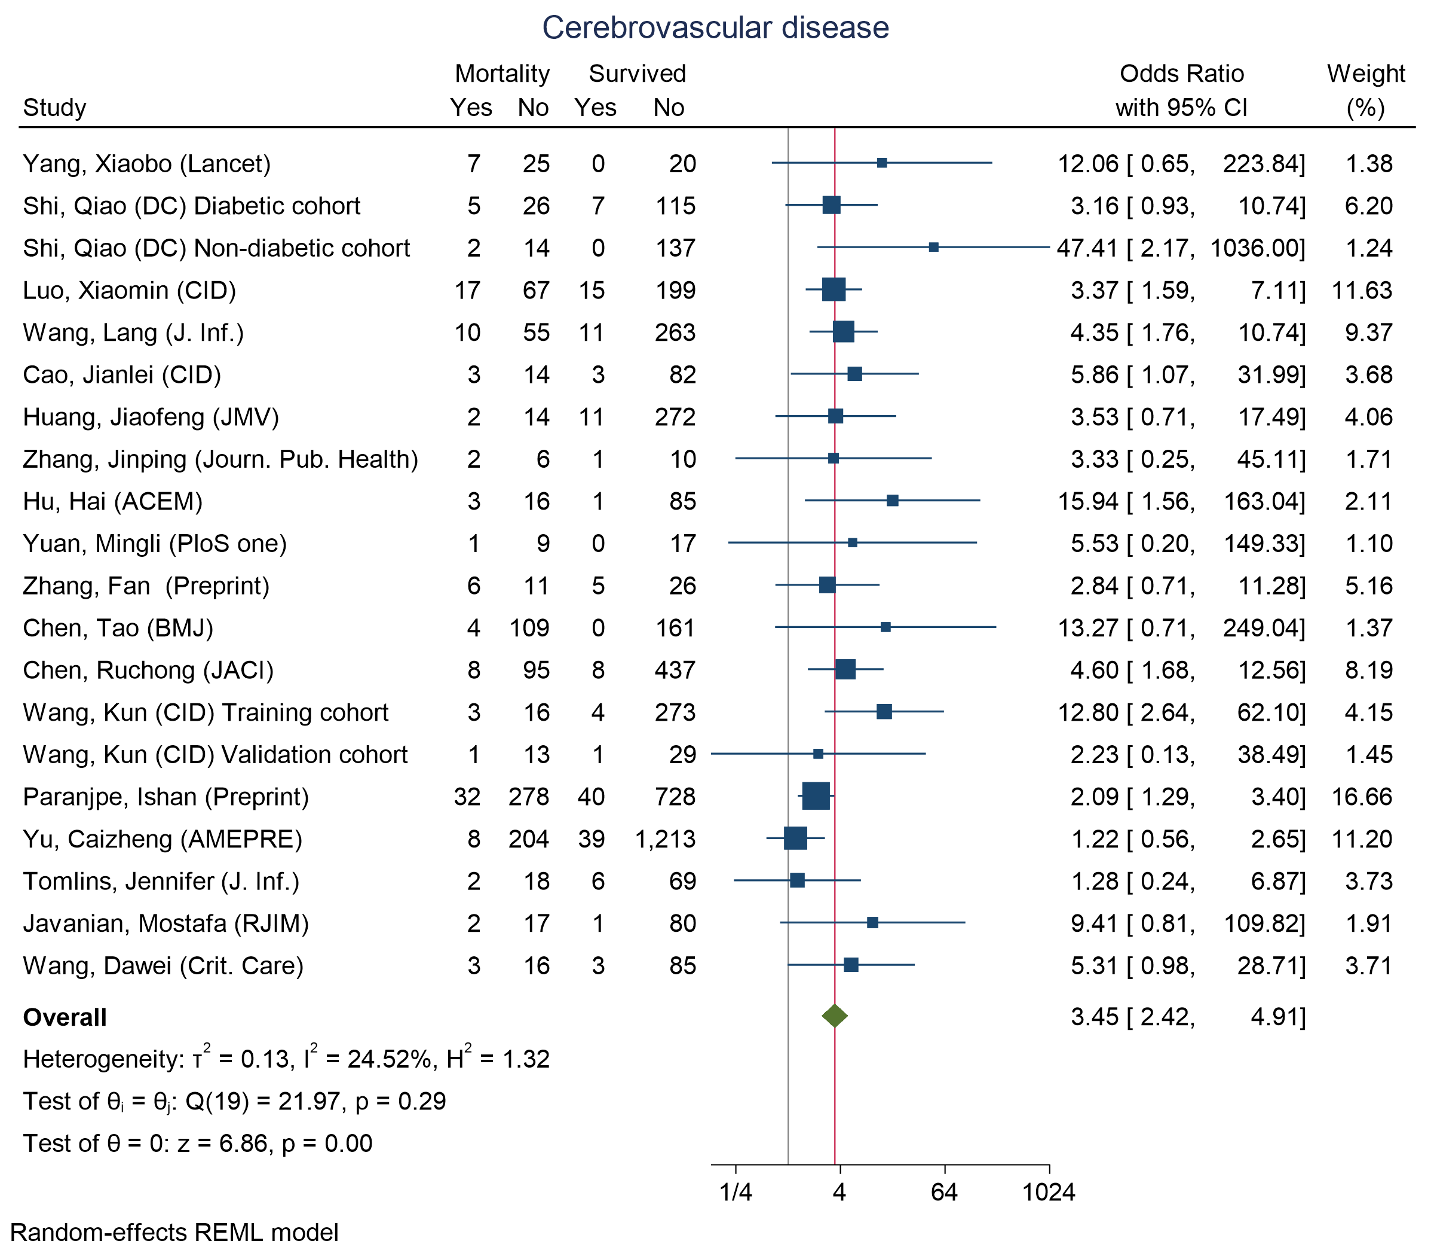
Figure 18 - Forest plot for Odds Ratio and 95% Confidence Interval (CI) of Cerebrovascular disease for those who died vs. survived

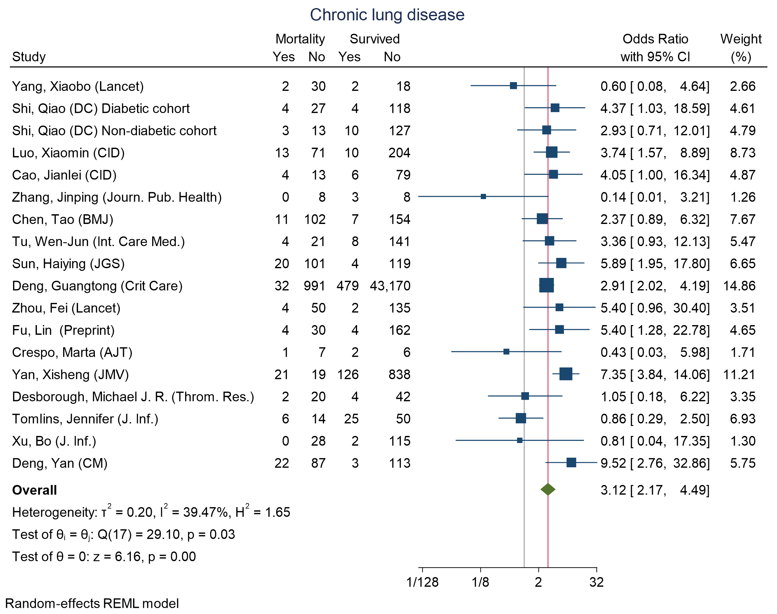
Figure 19 - Forest plot for Odds Ratio and 95% Confidence Interval (CI) of Chronic lung disease for those who died vs. survived
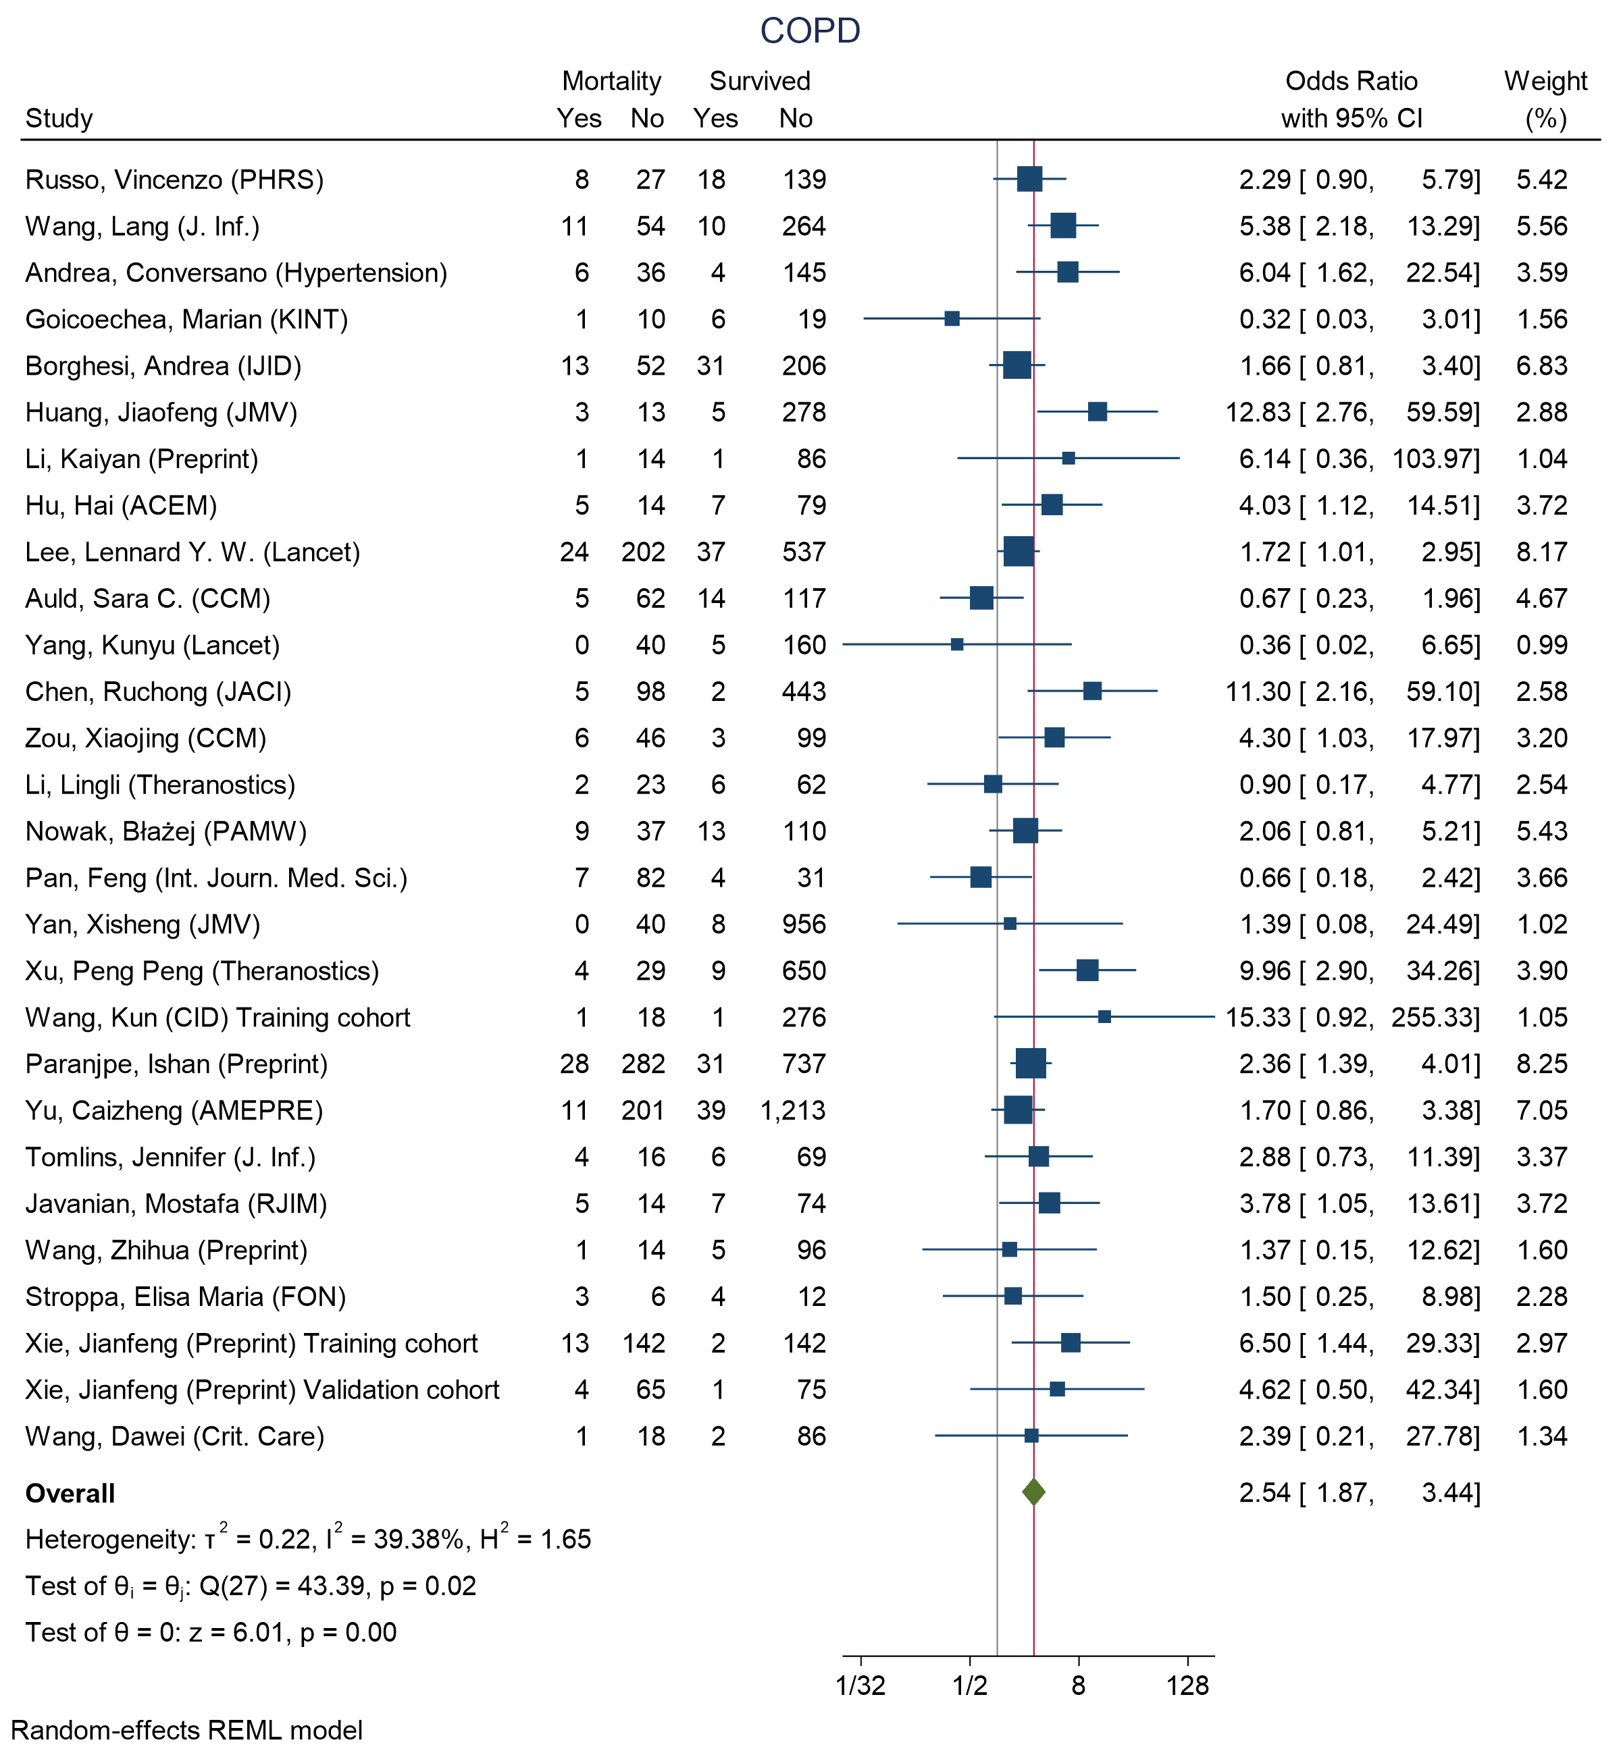
Figure 20 - Forest plot for Odds Ratio and 95% Confidence Interval (CI) of chronic obstructive pulmonary disease (COPD) for those who died vs. survived
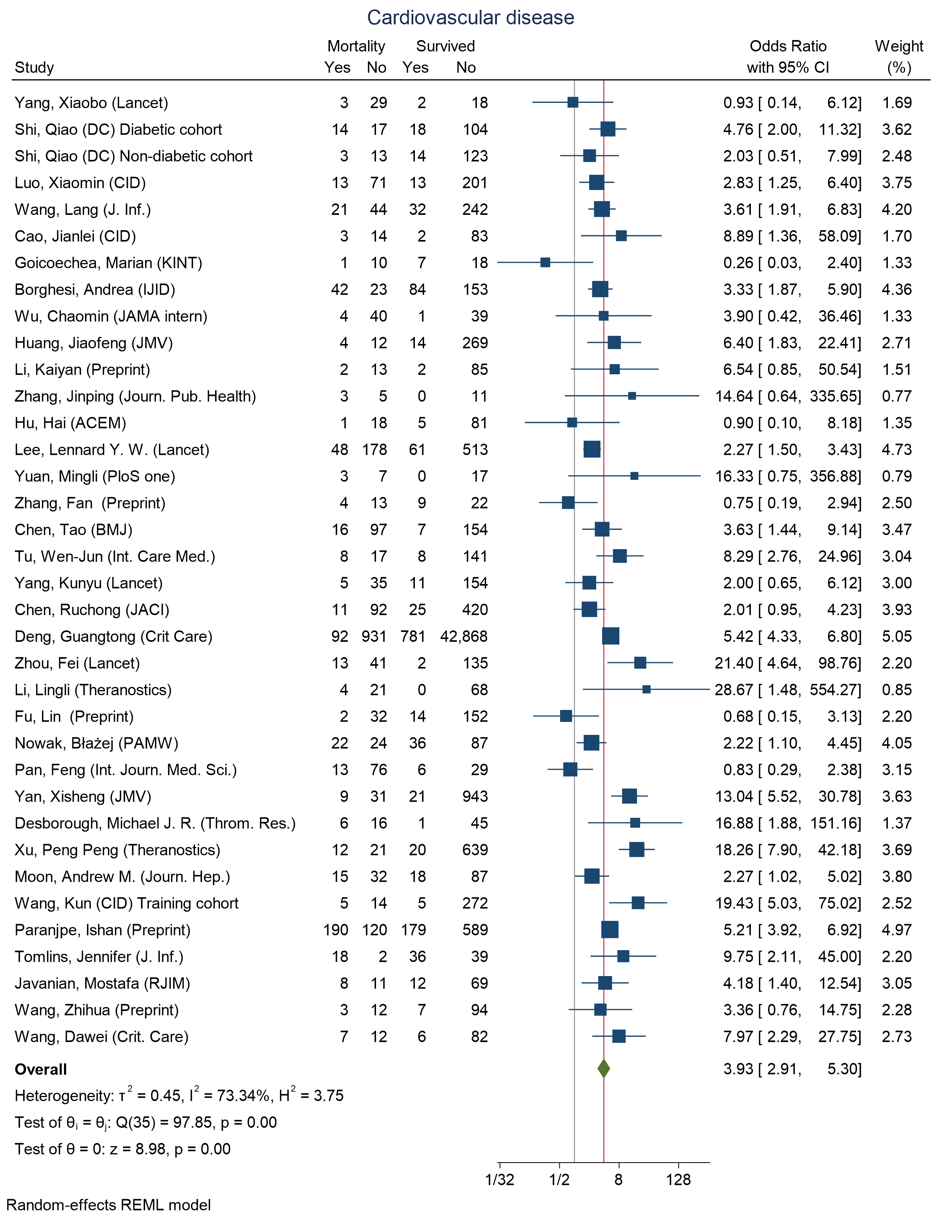
Figure 21 - Forest plot for Odds Ratio and 95% Confidence Interval (CI) of Cardiovascular disease for those who died vs. survived
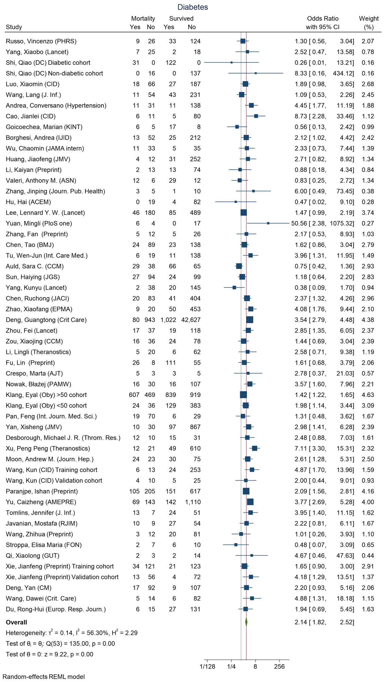
Figure 22 - Forest plot for Odds Ratio and 95% Confidence Interval (CI) of Diabetes for those who died vs. survived
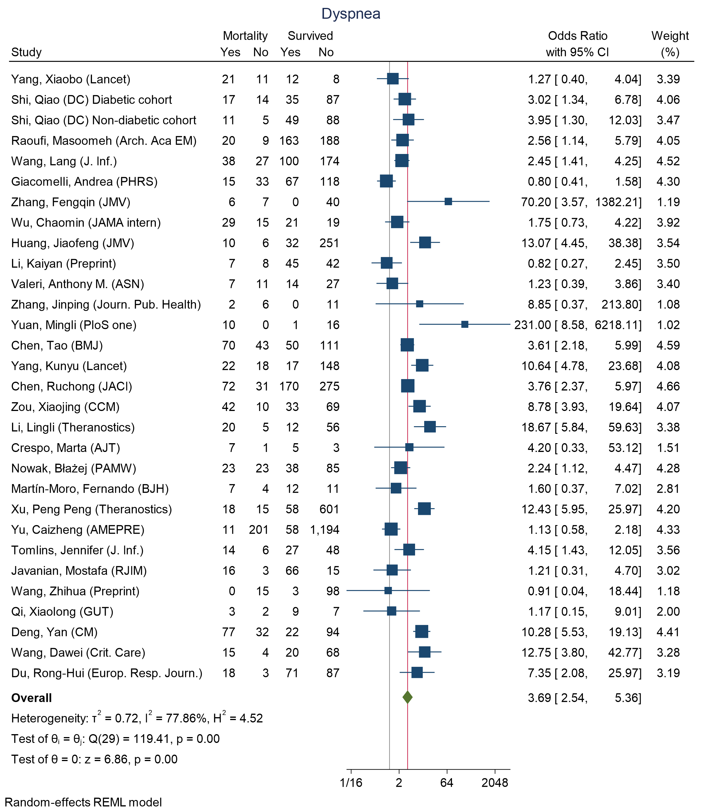
Figure 23 - Forest plot for Odds Ratio and 95% Confidence Interval (CI) of Dyspnea for those who died vs. survived
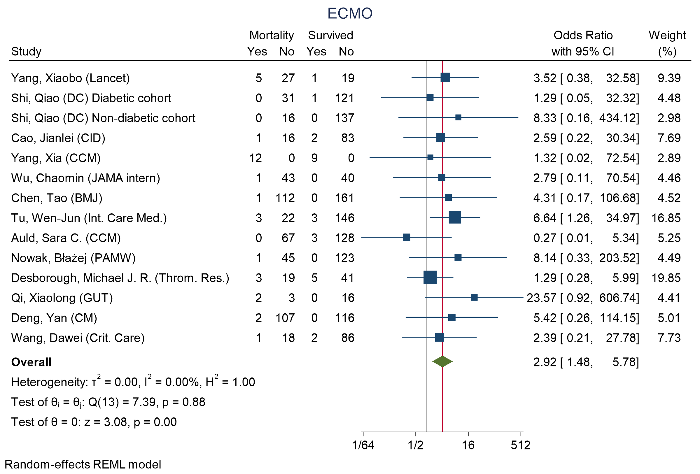
Figure 24 - Forest plot for Odds Ratio and 95% Confidence Interval (CI) of extra corporal membrane oxygenation (ECMO) for those who died vs. survived
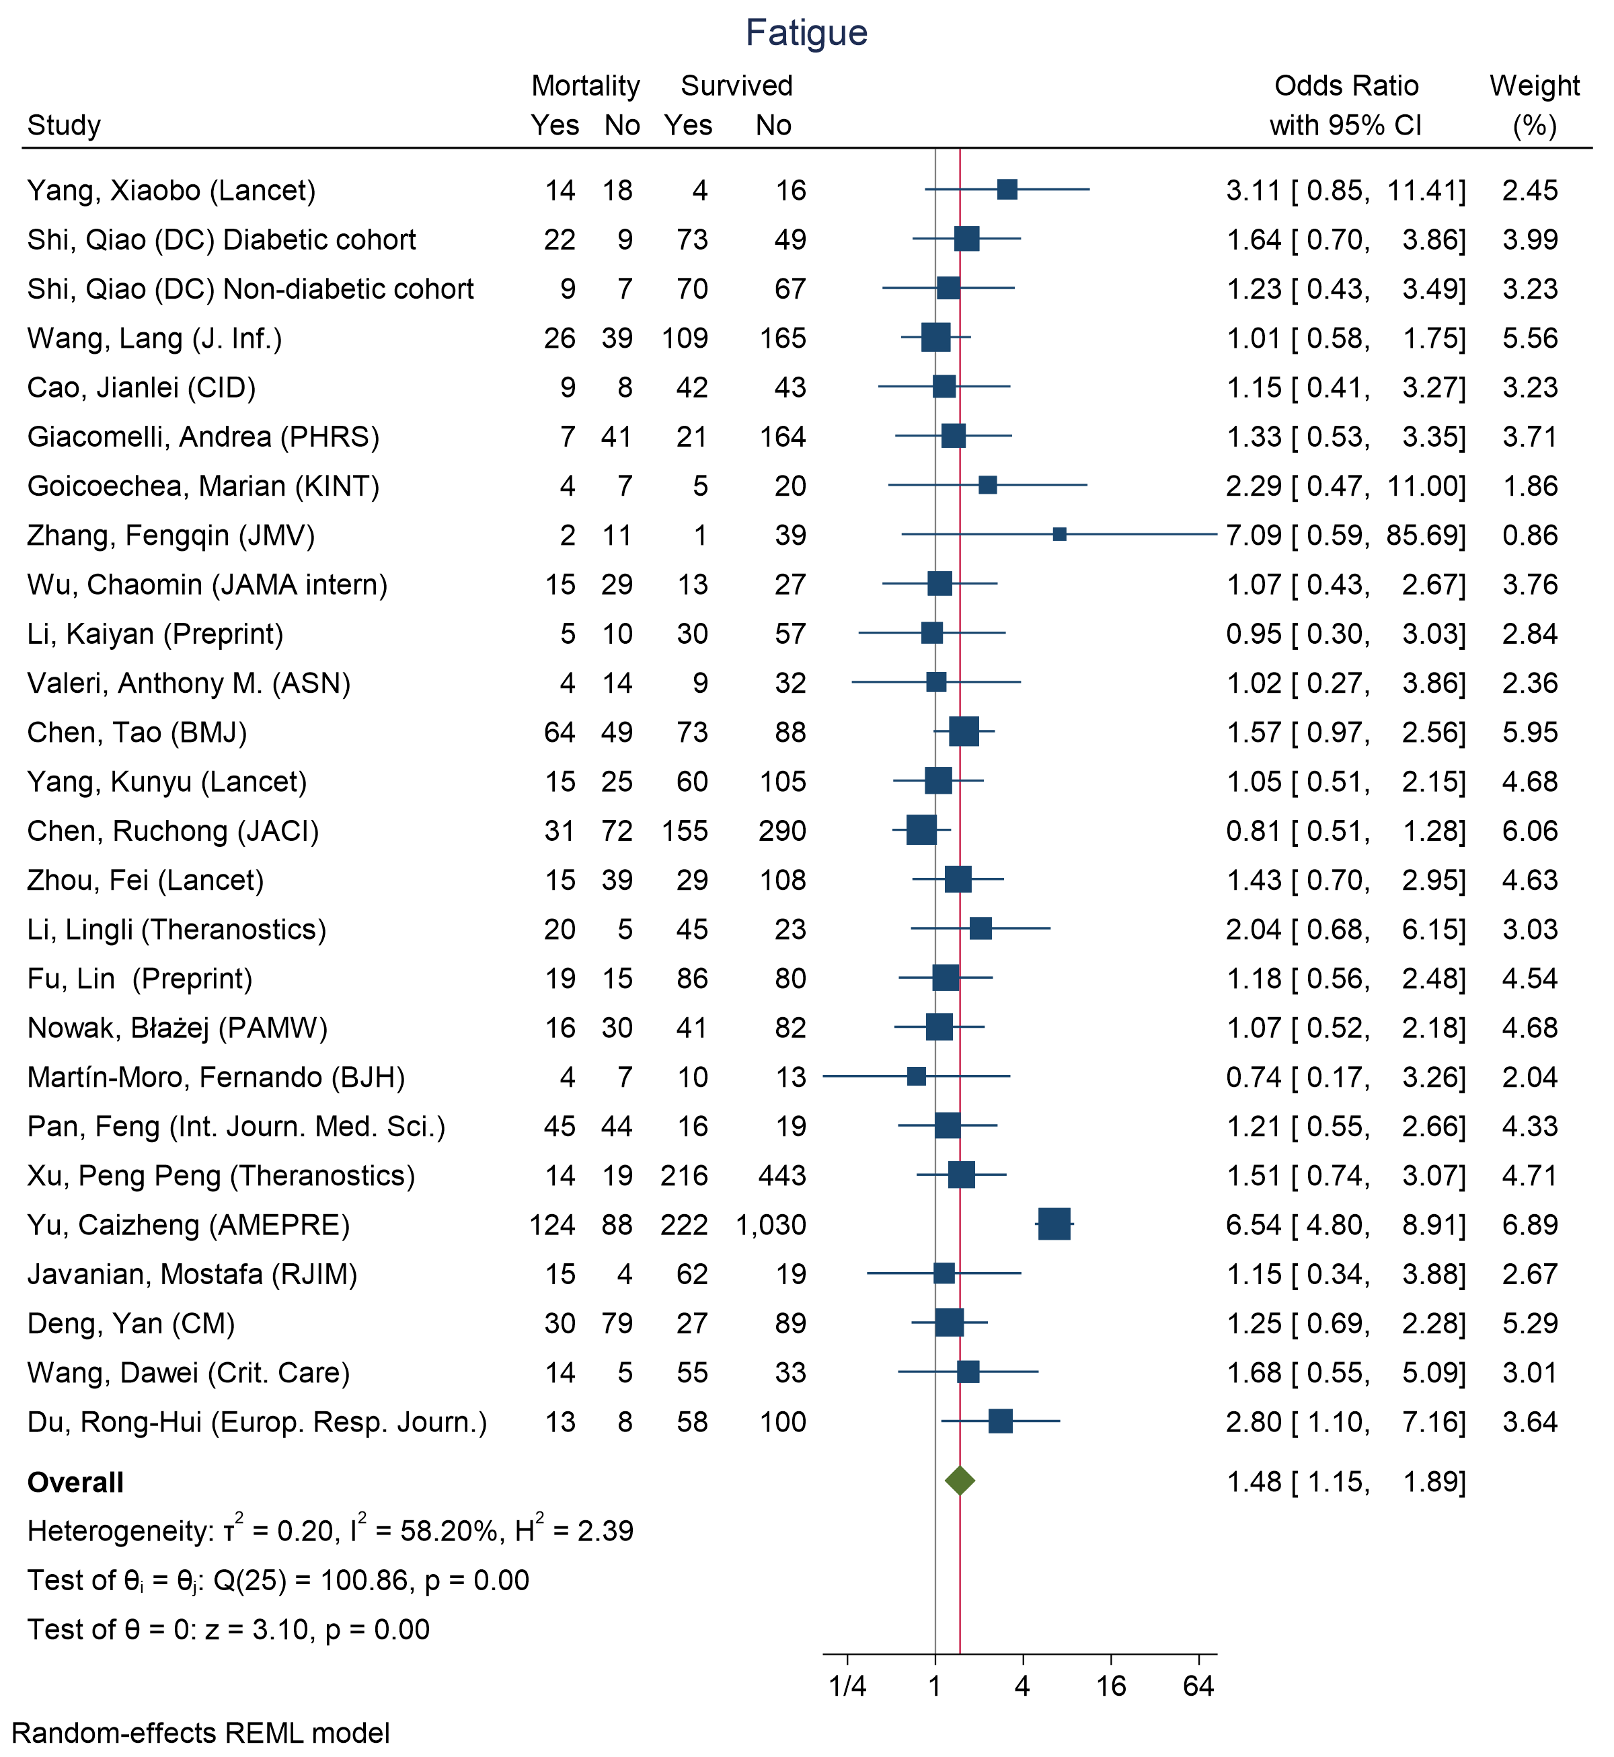
Figure 25 - Forest plot for Odds Ratio and 95% Confidence Interval (CI) of Fatigue for those who died vs. survived
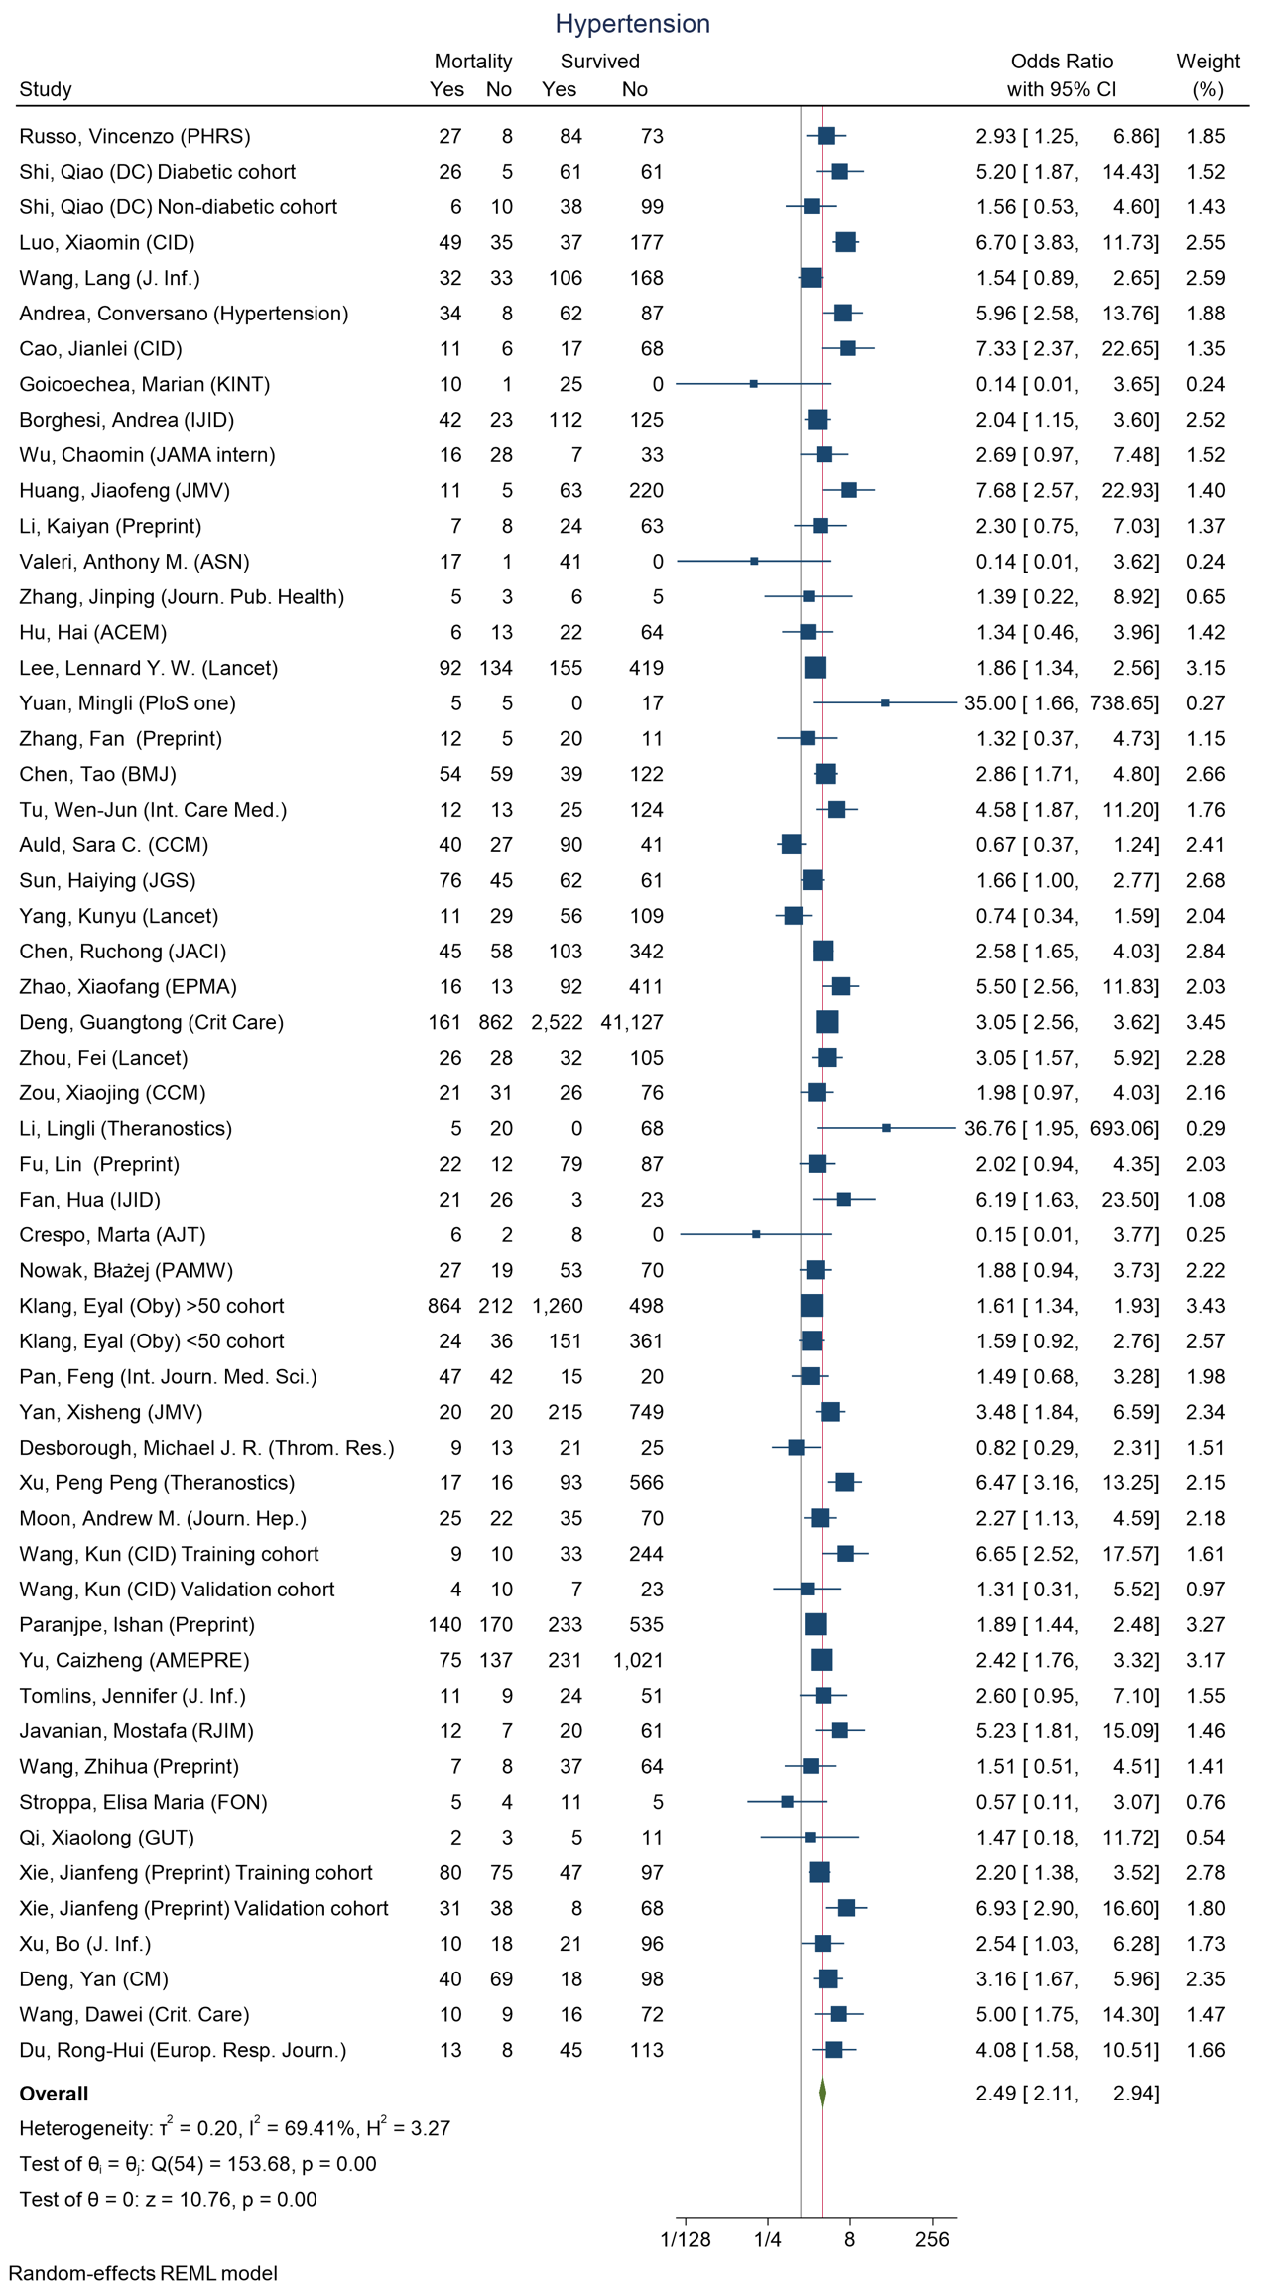
Figure 26 - Forest plot for Odds Ratio and 95% Confidence Interval (CI) of Hypertension for those who died vs. survived
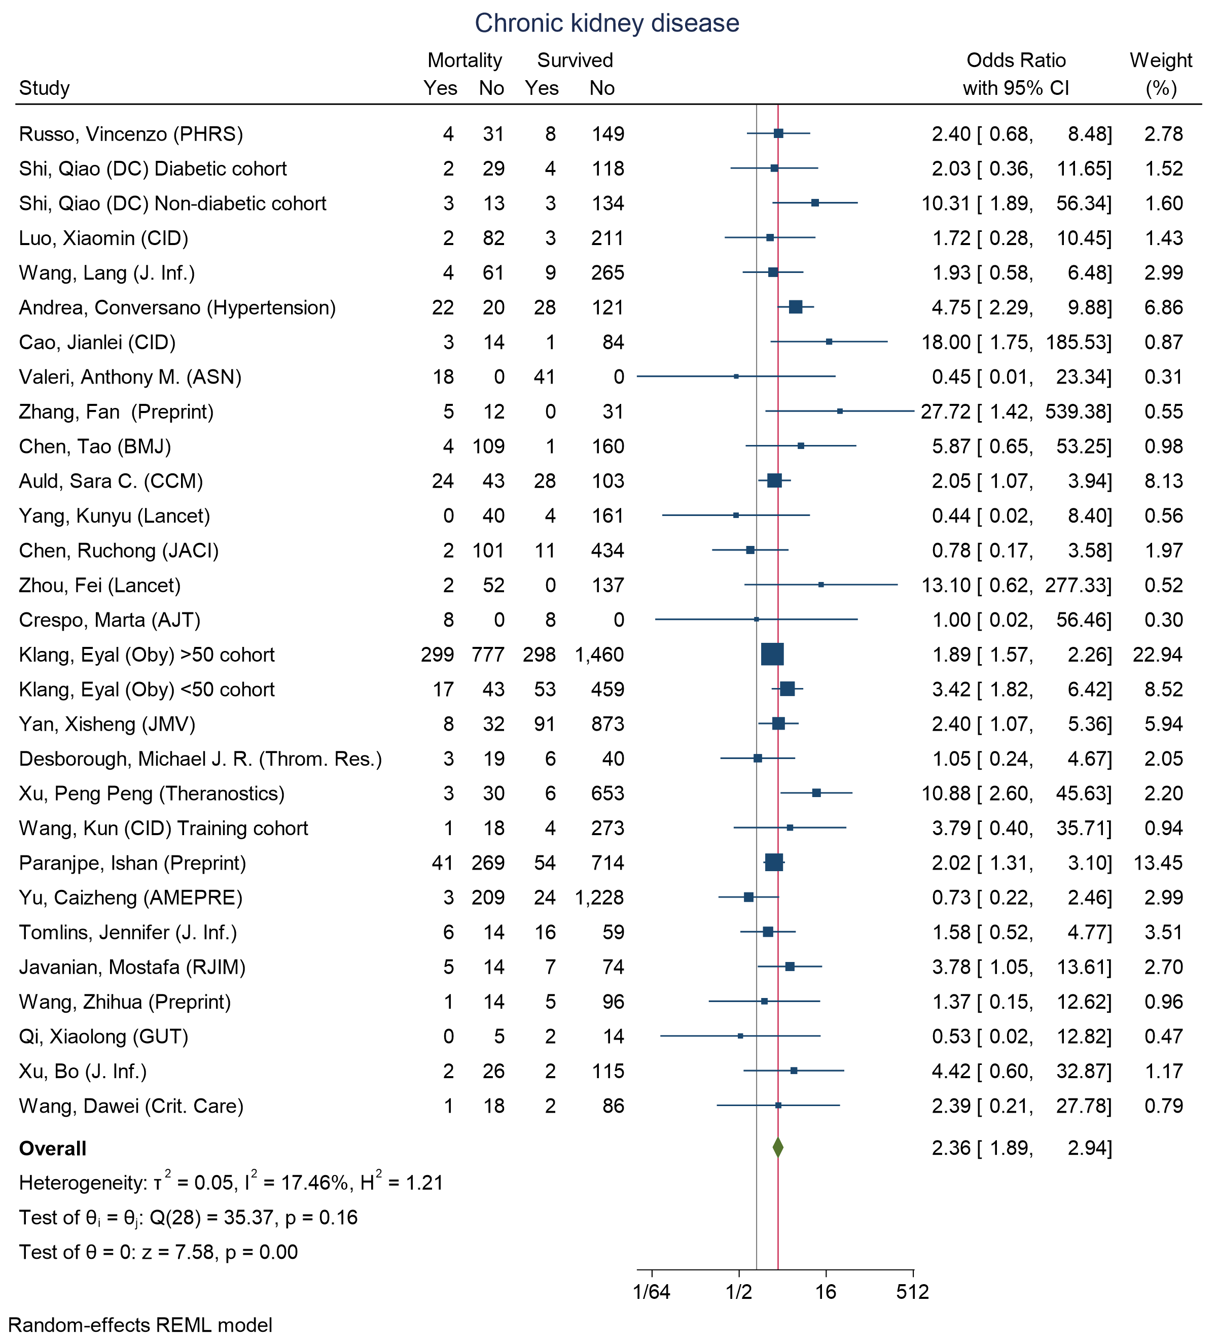
Figure 27 - Forest plot for Odds Ratio and 95% Confidence Interval (CI) of Chronic kidney disease for those who died vs. survived
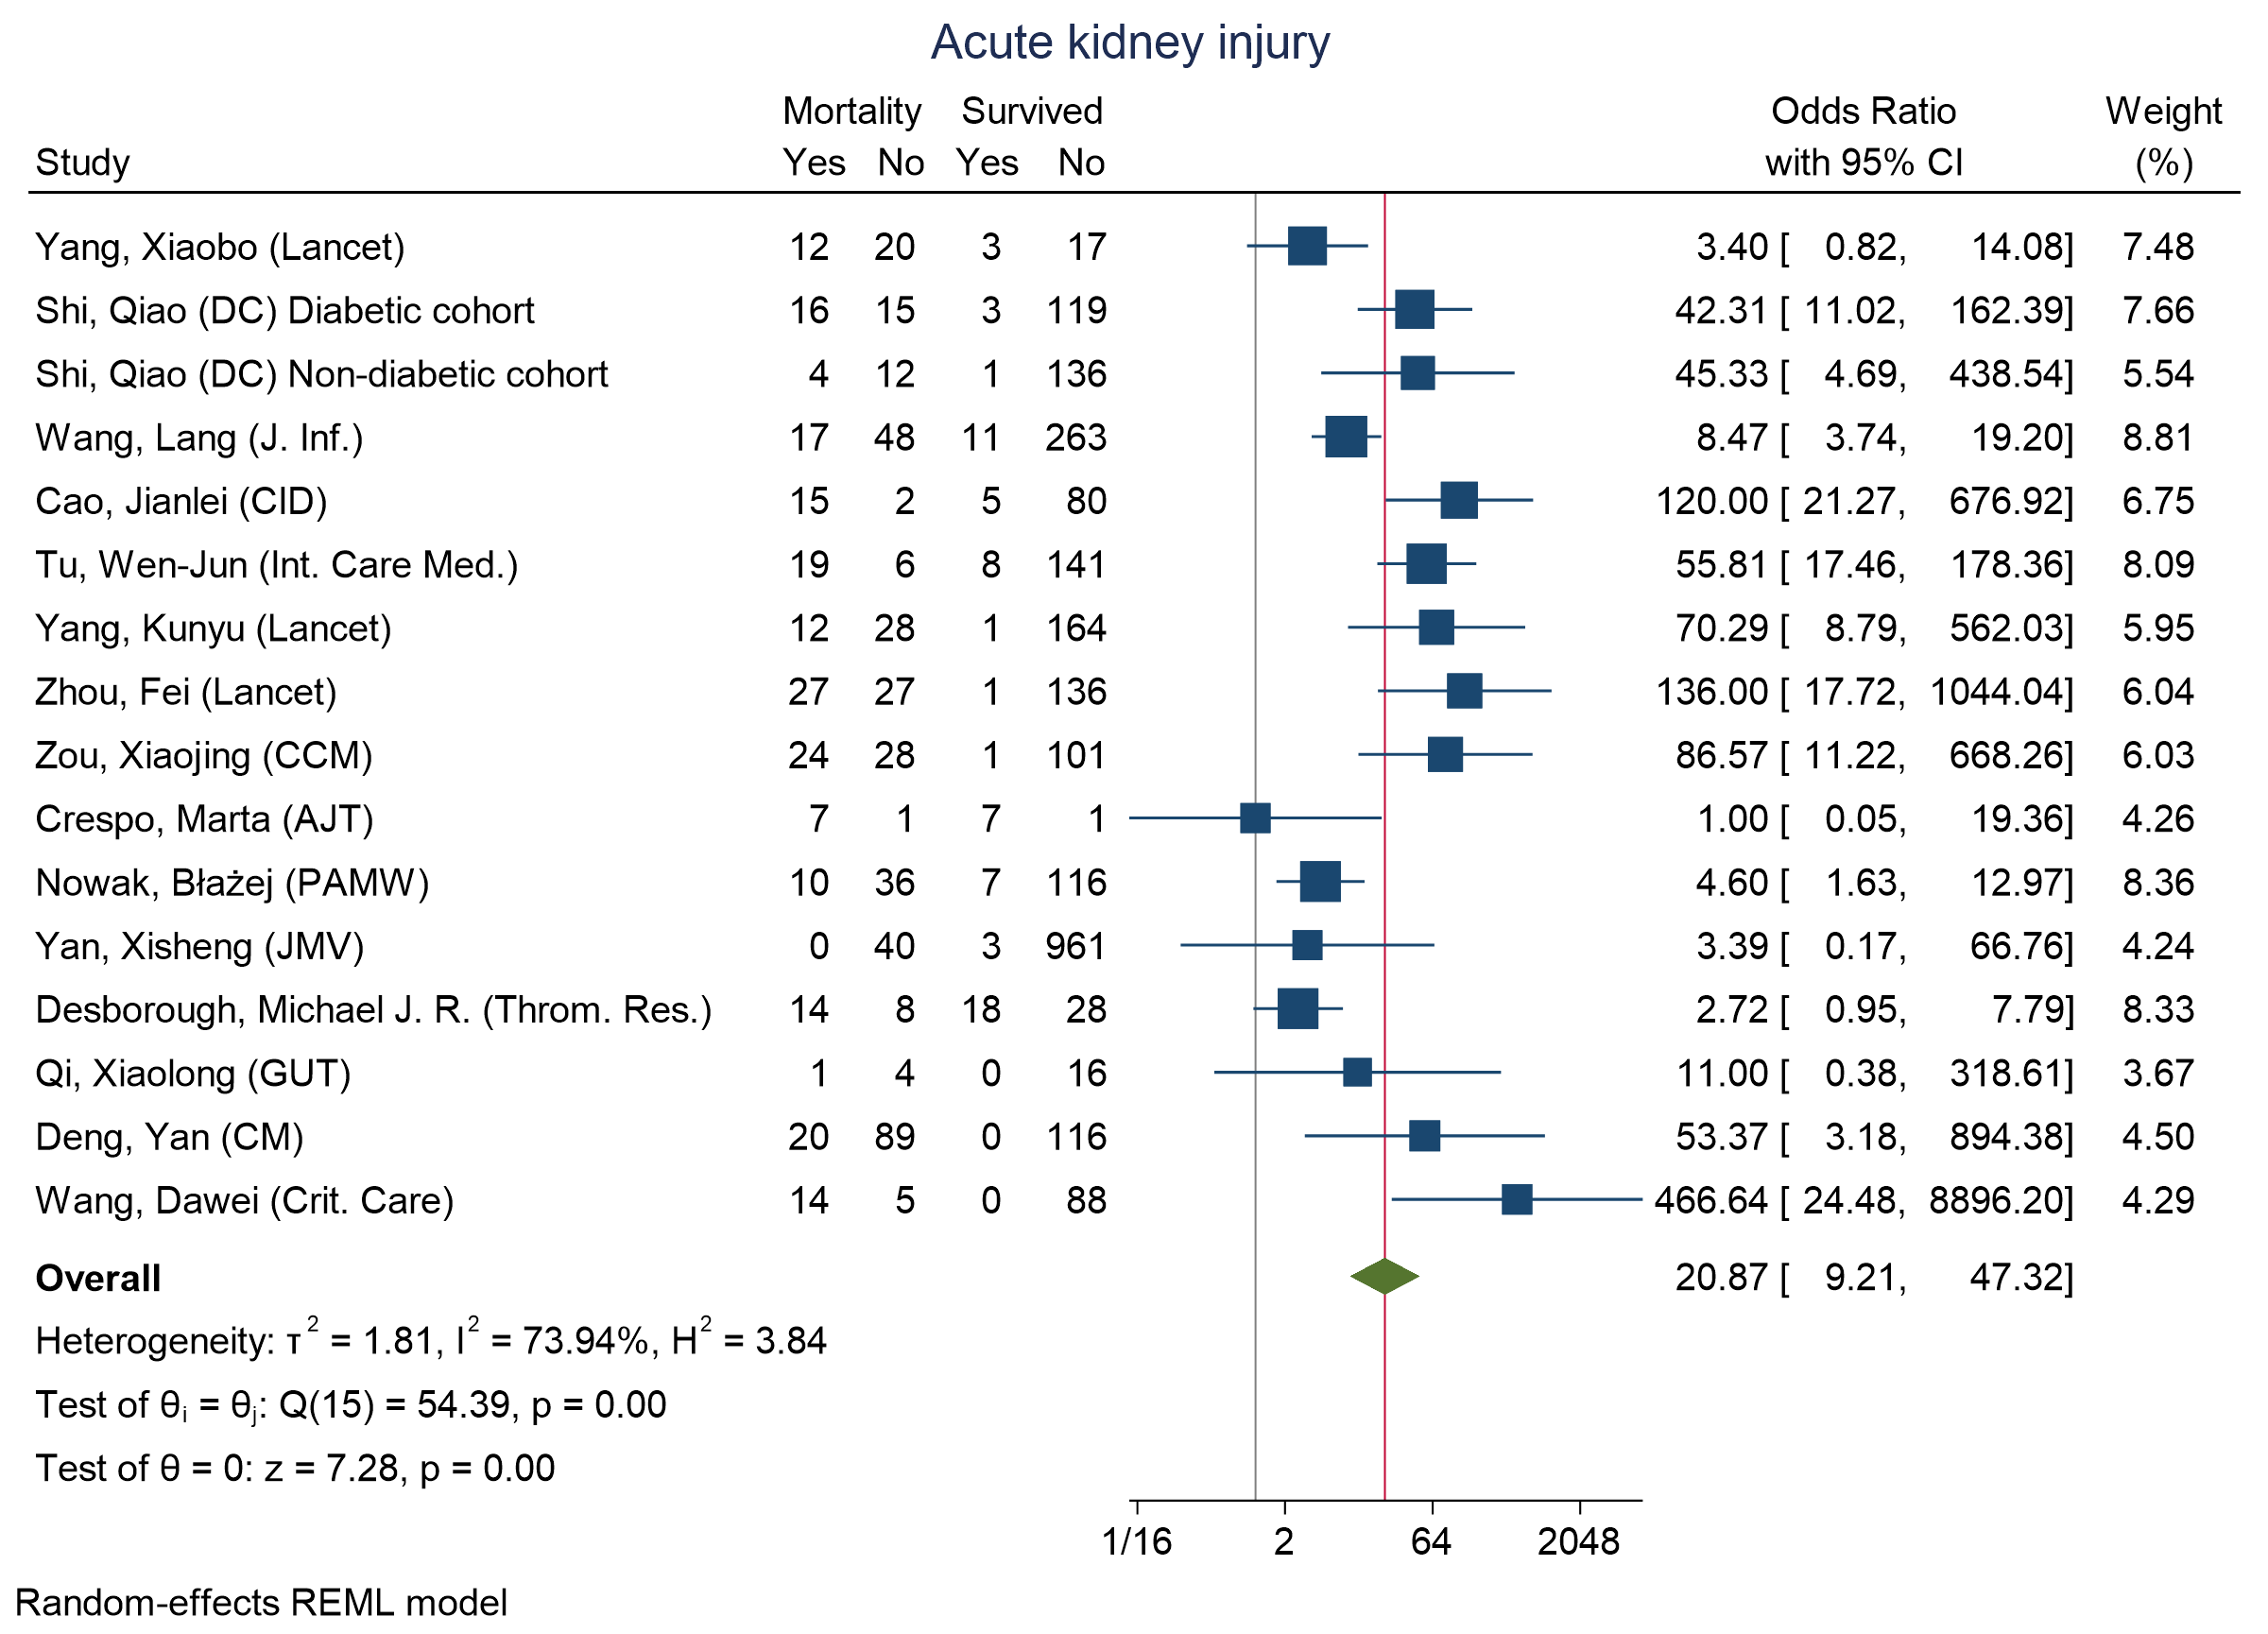
Figure 28 - Forest plot for Odds Ratio and 95% Confidence Interval (CI) of Acute kidney injury for those who died vs. survived
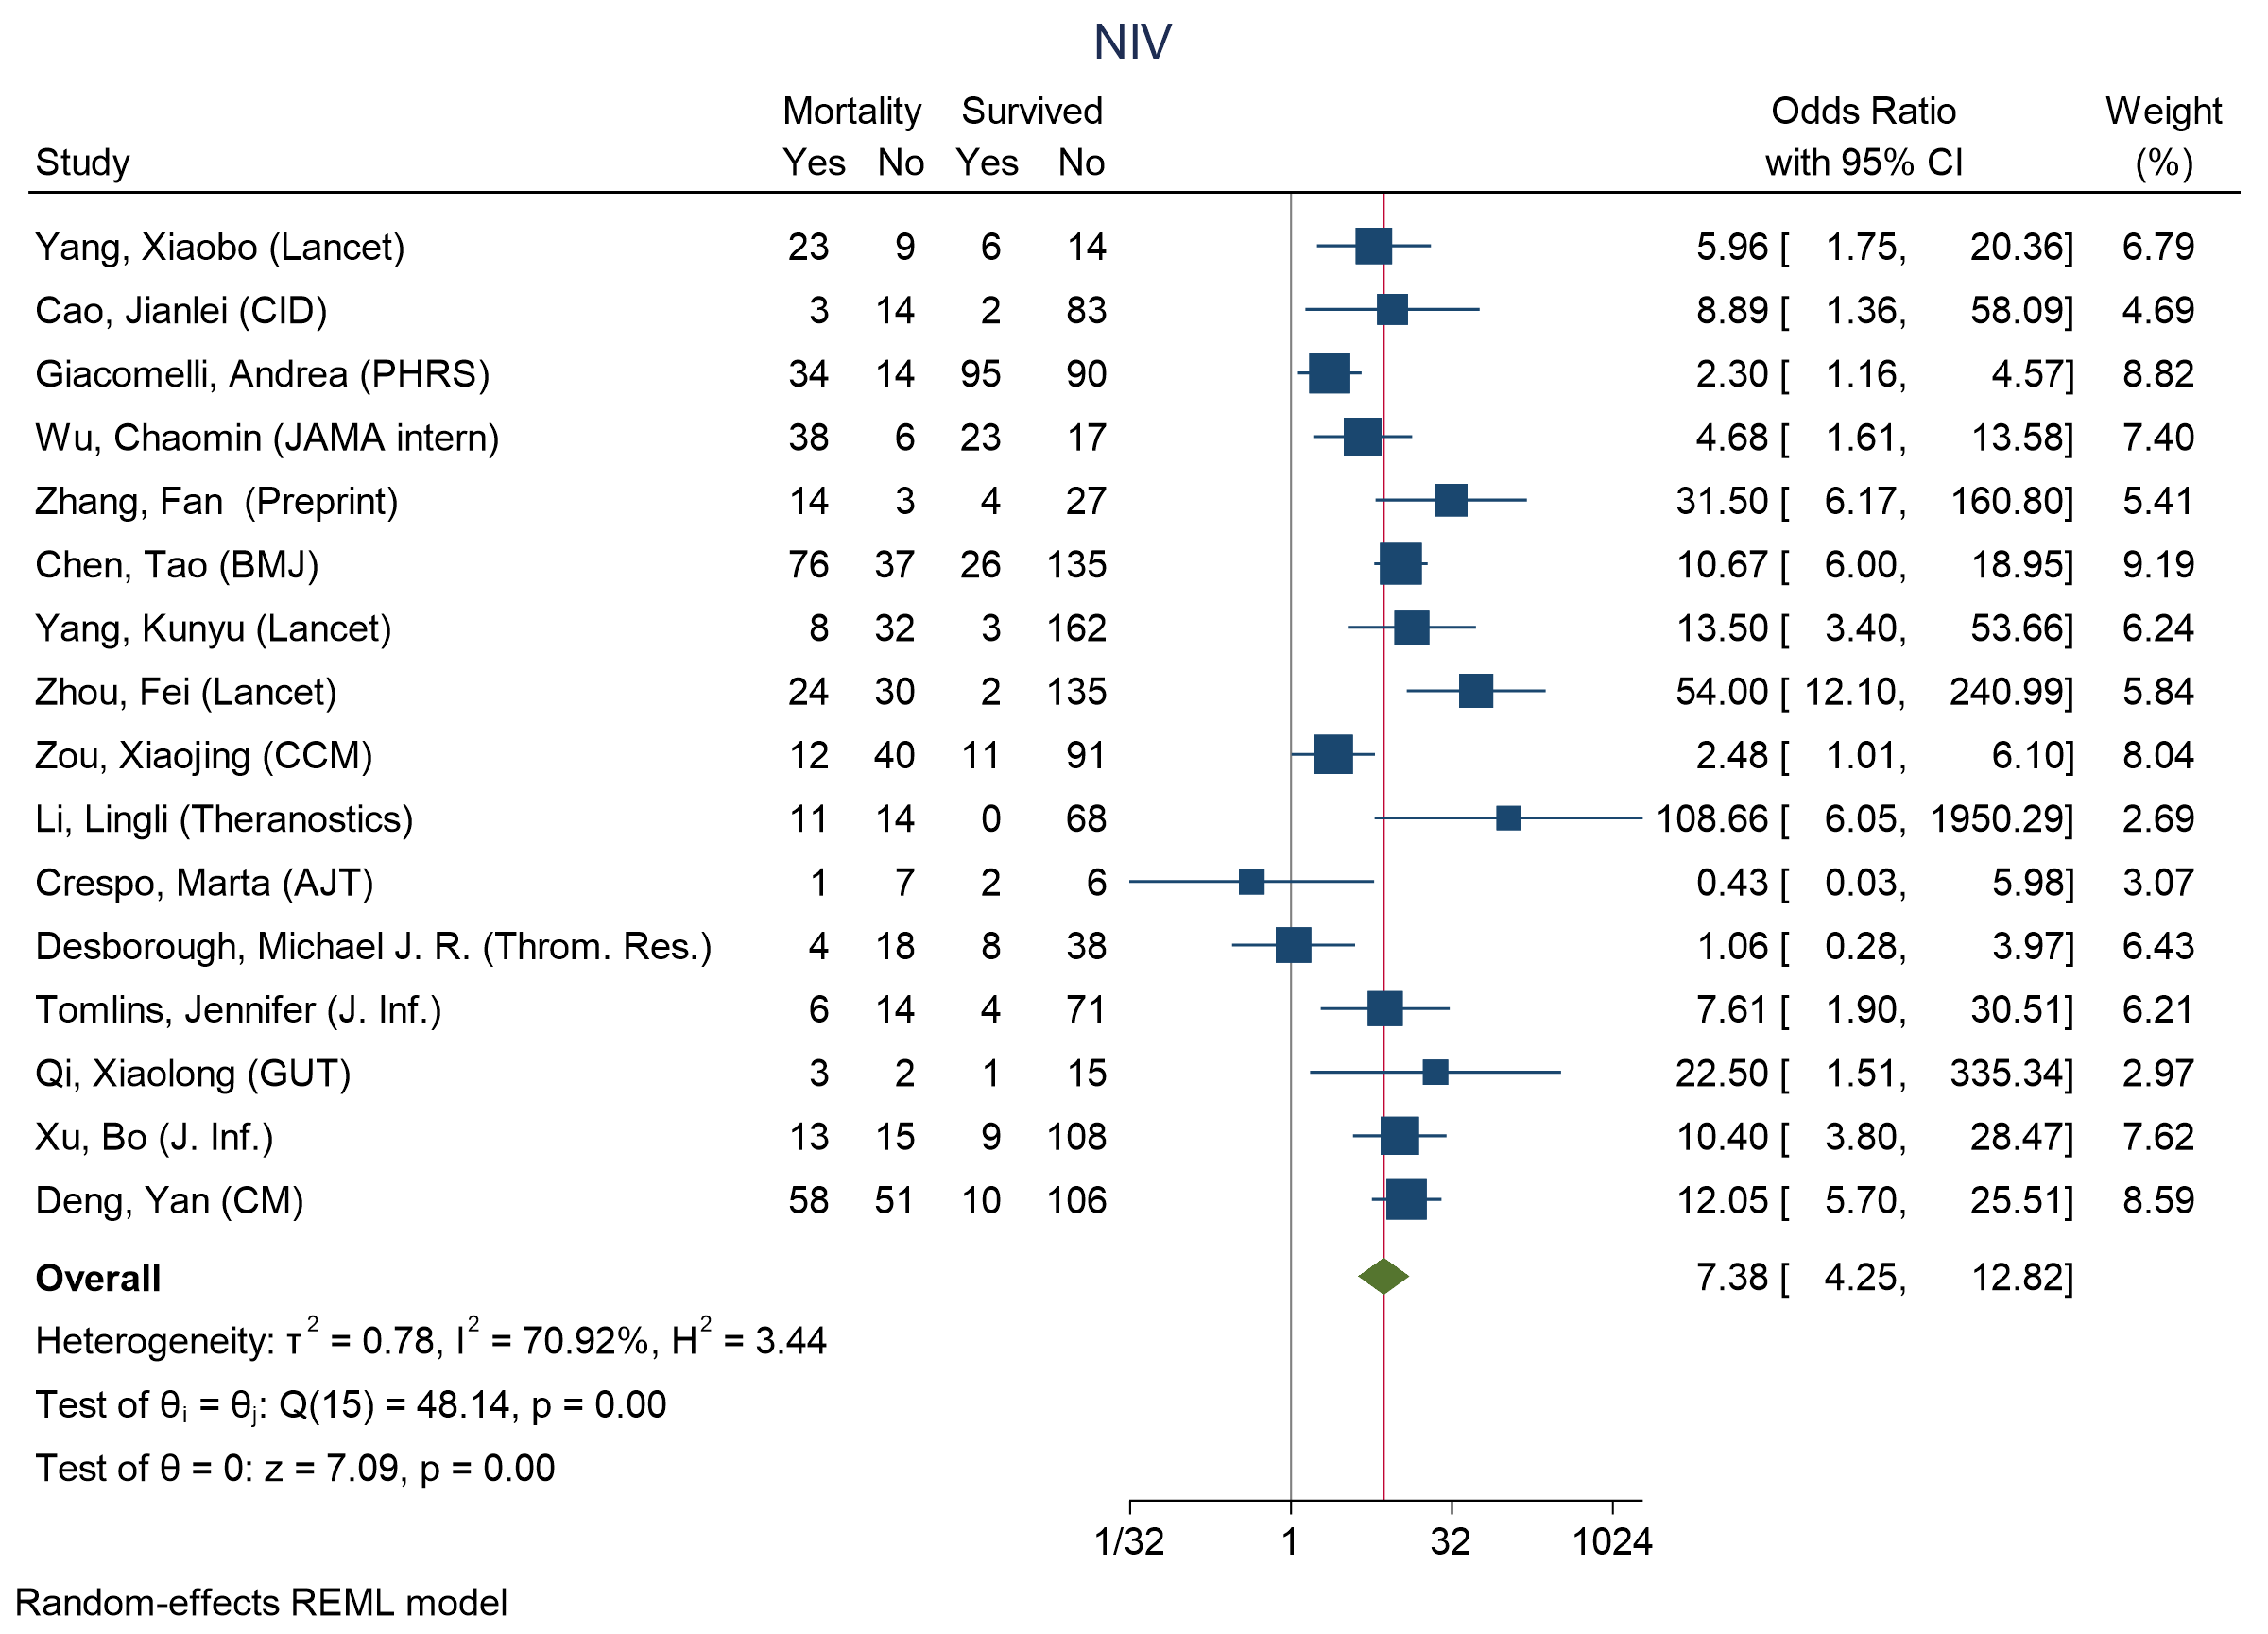
Figure 29 - Forest plot for Odds Ratio and 95% Confidence Interval (CI) of non-invasive ventilation (NIV) for those who died vs. survived
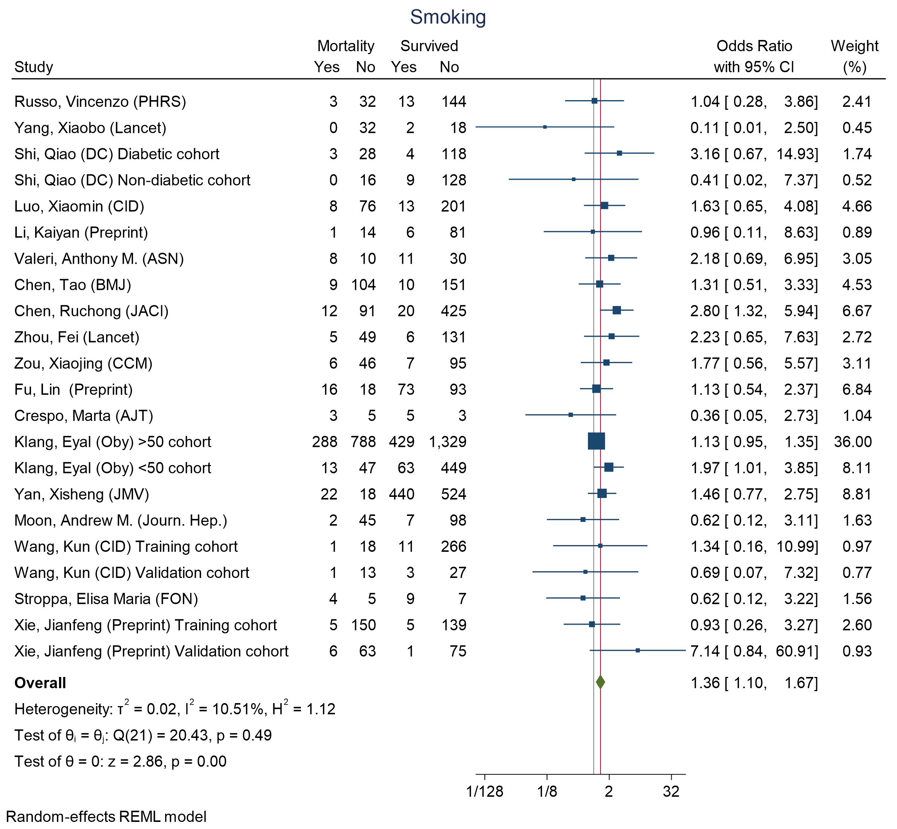
Figure 30 - Forest plot for Odds Ratio and 95% Confidence Interval (CI) of Smoking for those who died vs. survived

S6 Forest plots for difference of medians in ICU admission vs. non- ICU admission across different indicators

Figure 31 - Forest plot for difference of medians of Age for those who require ICU admission vs. non-ICU admission 44
Figure 32 - Forest plot for difference of medians of Leukocytes for those who require ICU admission vs. non-ICU admission 44
Figure 33 - Forest plot for difference of medians of Lymphocyte for those who require ICU admission vs. non-ICU admission 45
Figure 34 - Forest plot for difference of medians of Neutrophil for those who require ICU admission vs. non-ICU admission 45
Figure 35 - Forest plot for difference of medians of Platelets for those who require ICU admission vs. non-ICU admission 46
Figure 36 - Forest plot for difference of medians of Respiratory Rate for those who require ICU admission vs. non-ICU admission 46
Figure 37 - Forest plot for difference of medians of D-Dimer for those who require ICU admission vs. non-ICU admission. Note that some studies used different laboratory assays leading to different ranges. The left panel contains the forest plot of the analysis including the studies by Liu, Yanli, Zhang, Guqin, and Wang, Dawei, and the right panel contains the forest plot of the analysis excluding the studies by Liu, Yanli, Zhang, Guqin, and Wang, Dawei. 47
Figure 38 - Forest plot for difference of medians of Troponin I (TnI) for those who require ICU admission vs. non-ICU admission 48
Figure 39 - Forest plot for difference of medians of C-reactive protein (CRP) for those who require ICU admission vs. non-ICU admission 48
Figure 40 - Forest plot for difference of medians of Creatinine for those who require ICU admission vs. non-ICU admission 49
Figure 41 - Forest plot for difference of medians of Lactate Dehydrogenase (LDH) for those who require ICU admission vs. non-ICU admission 49
Figure 42 - Forest plot for Odds Ratio and 95% Confidence Interval (CI) of Cerebrovascular disease for those who require ICU admission vs. non-ICU admission 50
Figure 43 - Forest plot for Odds Ratio and 95% Confidence Interval (CI) of Chronic Lung disease for those who require ICU admission vs. non-ICU admission 50
Figure 44 - Forest plot for Odds Ratio and 95% Confidence Interval (CI) of COPD for those who require ICU admission vs. non-ICU admission 51
Figure 45 - Forest plot for Odds Ratio and 95% Confidence Interval (CI) of Cardiovascular disease for those who require ICU admission vs. non-ICU admission 52
Figure 46 - Forest plot for Odds Ratio and 95% Confidence Interval (CI) of Diabetes for those who require ICU admission vs. non-ICU admission 53
Figure 47 - Forest plot for Odds Ratio and 95% Confidence Interval (CI) of Dyspnea for those who require ICU admission vs. non-ICU admission 54
Figure 48 - Forest plot for Odds Ratio and 95% Confidence Interval (CI) of Fatigue for those who require ICU admission vs. non-ICU admission 54
Figure 49 - Forest plot for Odds Ratio and 95% Confidence Interval (CI) of Fever for those who require ICU admission vs. non-ICU admission 55
Figure 50 - Forest plot for Odds Ratio and 95% Confidence Interval (CI) of Hypertension for those who require ICU admission vs. non-ICU admission 56
Figure 51 - Forest plot for Odds Ratio and 95% Confidence Interval (CI) of chronic kidney disease for those who require ICU admission vs. non-ICU admission 57
Figure 52 - Forest plot for Odds Ratio and 95% Confidence Interval (CI) of acute kidney injury for those who require ICU admission vs. non-ICU admission 57
Figure 53 - Forest plot for Odds Ratio and 95% Confidence Interval (CI) of Smoking for those who require ICU admission vs. non-ICU admission 58

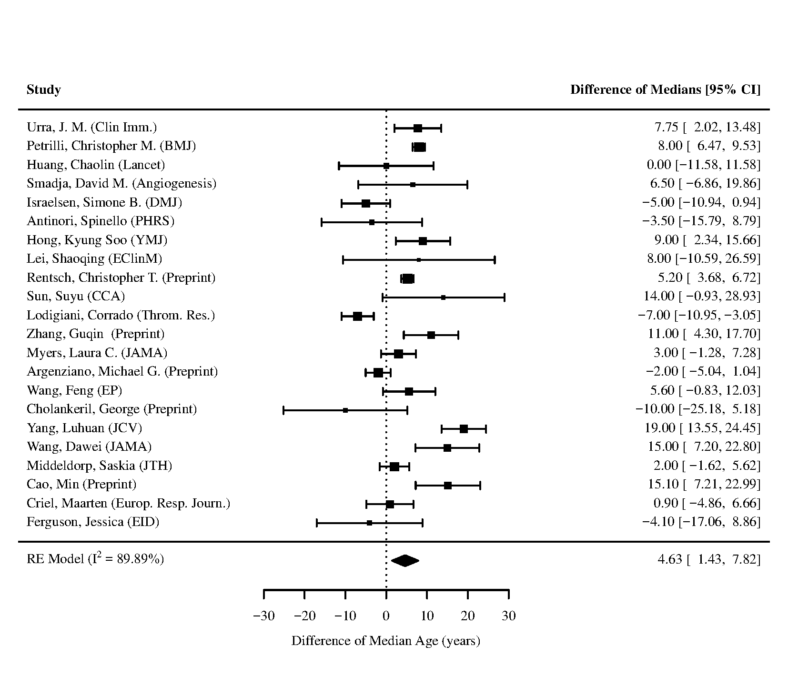
Figure 31 - Forest plot for difference of medians of Age for those who require ICU admission vs. non-ICU admission

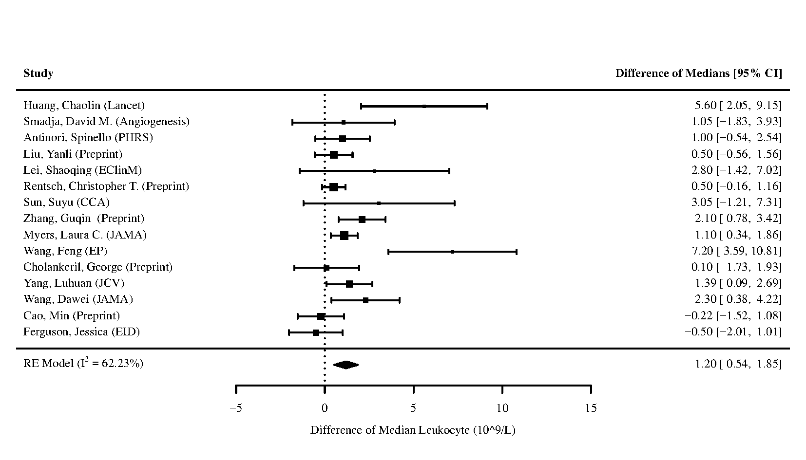
Figure 32 - Forest plot for difference of medians of Leukocytes for those who require ICU admission vs. non-ICU admission

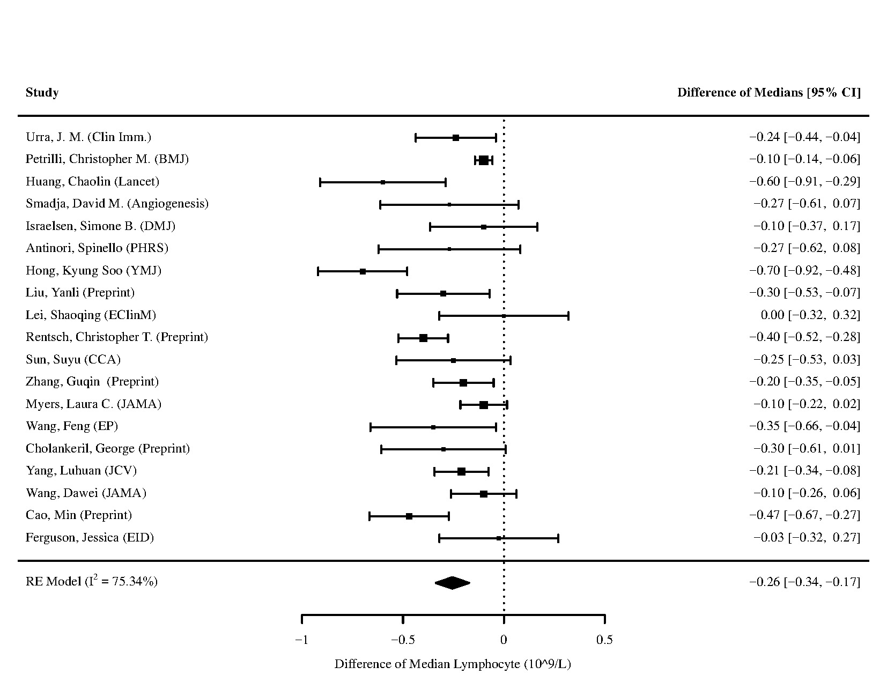
Figure 33 - Forest plot for difference of medians of Lymphocyte for those who require ICU admission vs. non-ICU admission
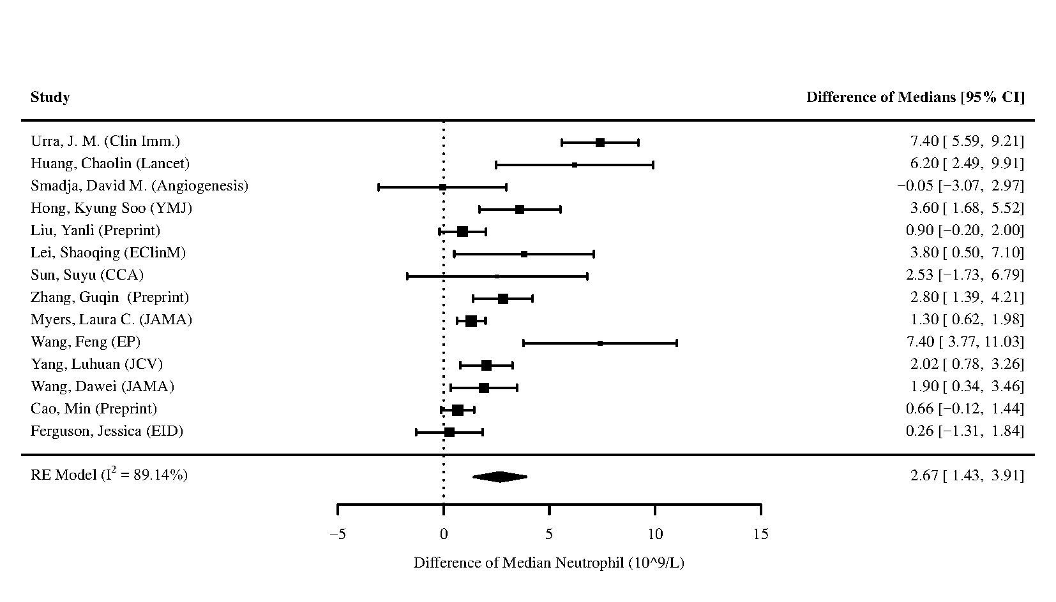
Figure 34 - Forest plot for difference of medians of Neutrophil for those who require ICU admission vs. non-ICU admission
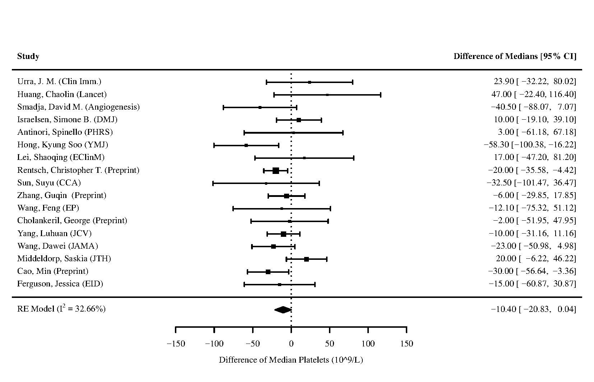
Figure 35 - Forest plot for difference of medians of Platelets for those who require ICU admission vs. non-ICU admission
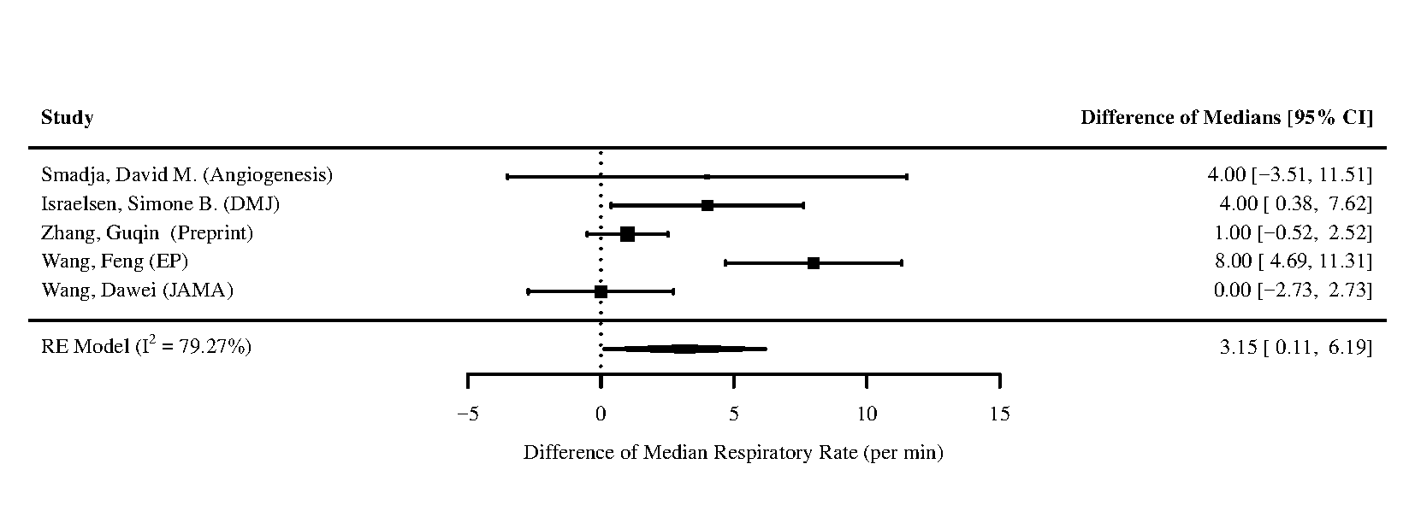
Figure 36 - Forest plot for difference of medians of Respiratory Rate for those who require ICU admission vs. non-ICU admission

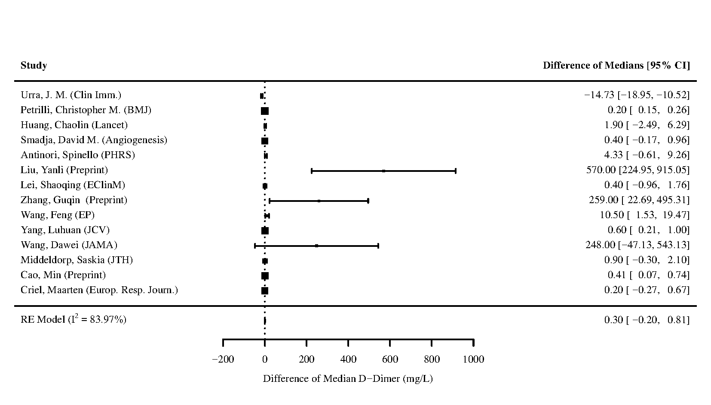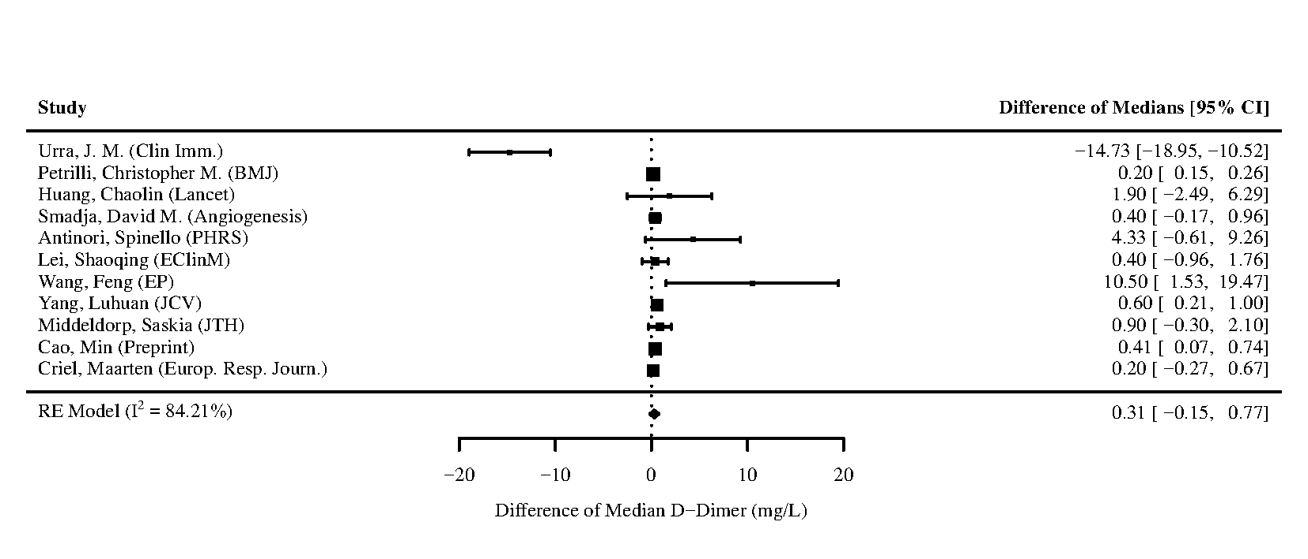
Figure 37 - Forest plot for difference of medians of D-Dimer for those who require ICU admission vs. non-ICU admission. Note that some studies used different laboratory assays leading to different ranges. The left panel contains the forest plot of the analysis including the studies by Liu, Yanli, Zhang, Guqin, and Wang, Dawei, and the right panel contains the forest plot of the analysis excluding the studies by Liu, Yanli, Zhang, Guqin, and Wang, Dawei.

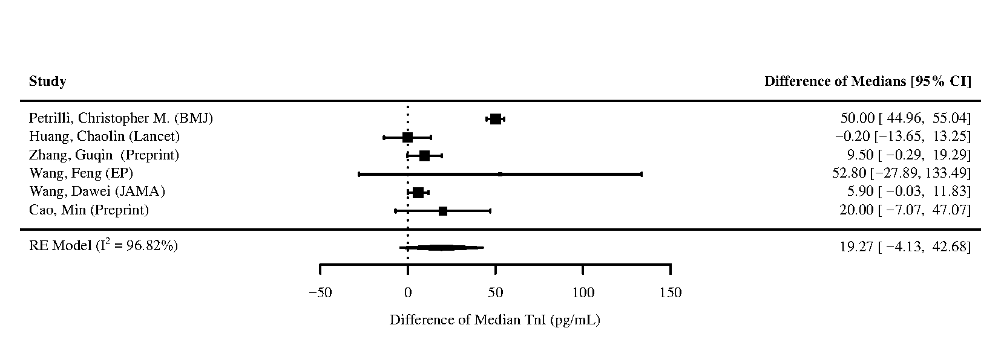
Figure 38 - Forest plot for difference of medians of Troponin I (TnI) for those who require ICU admission vs. non-ICU admission
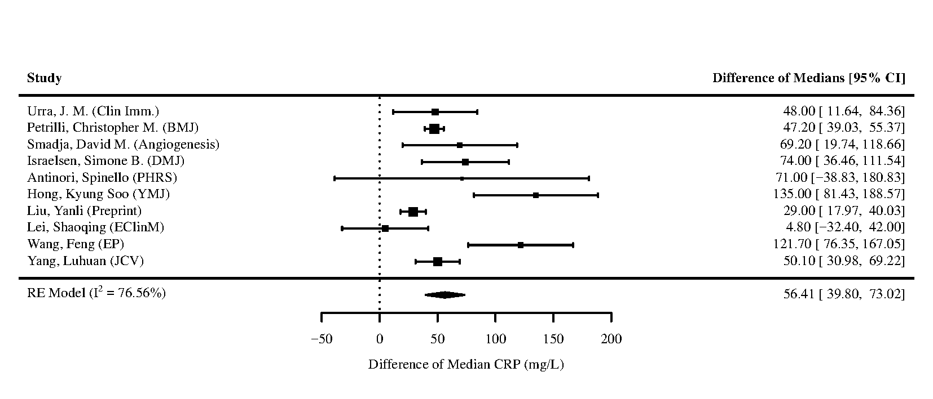
Figure 39 - Forest plot for difference of medians of C-reactive protein (CRP) for those who require ICU admission vs. non-ICU admission
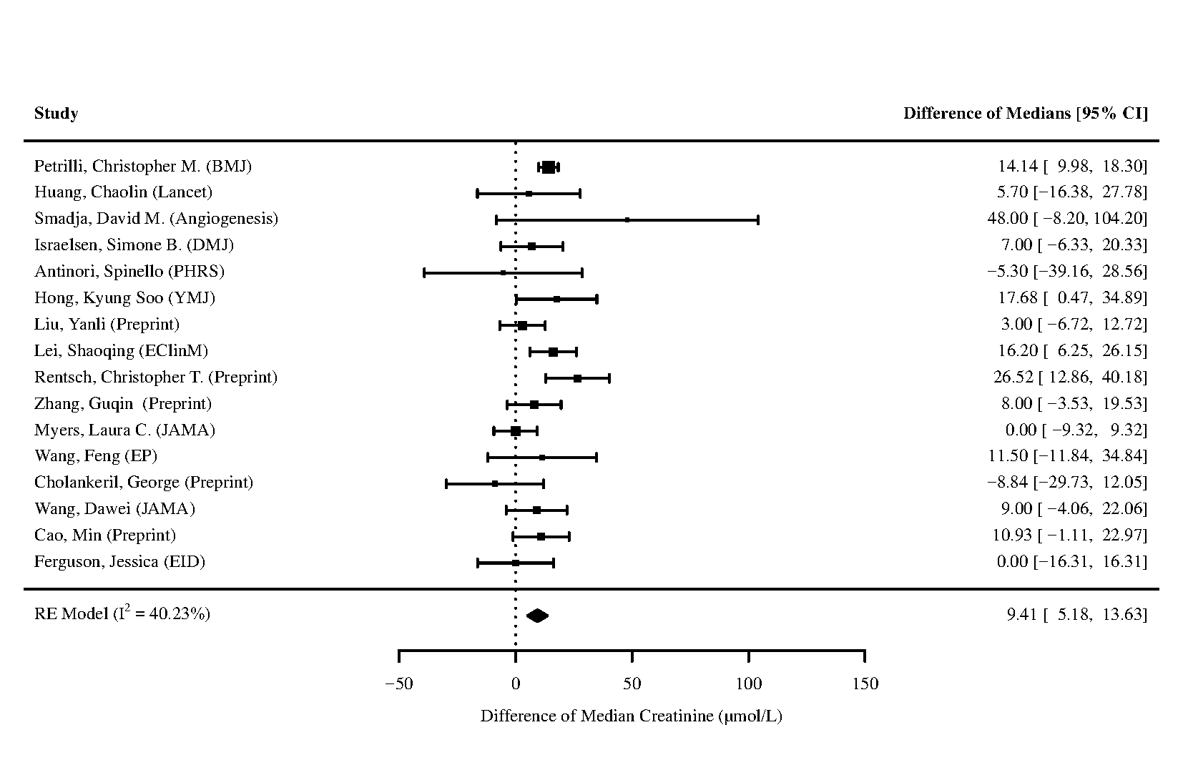
Figure 40 - Forest plot for difference of medians of Creatinine for those who require ICU admission vs. non-ICU admission
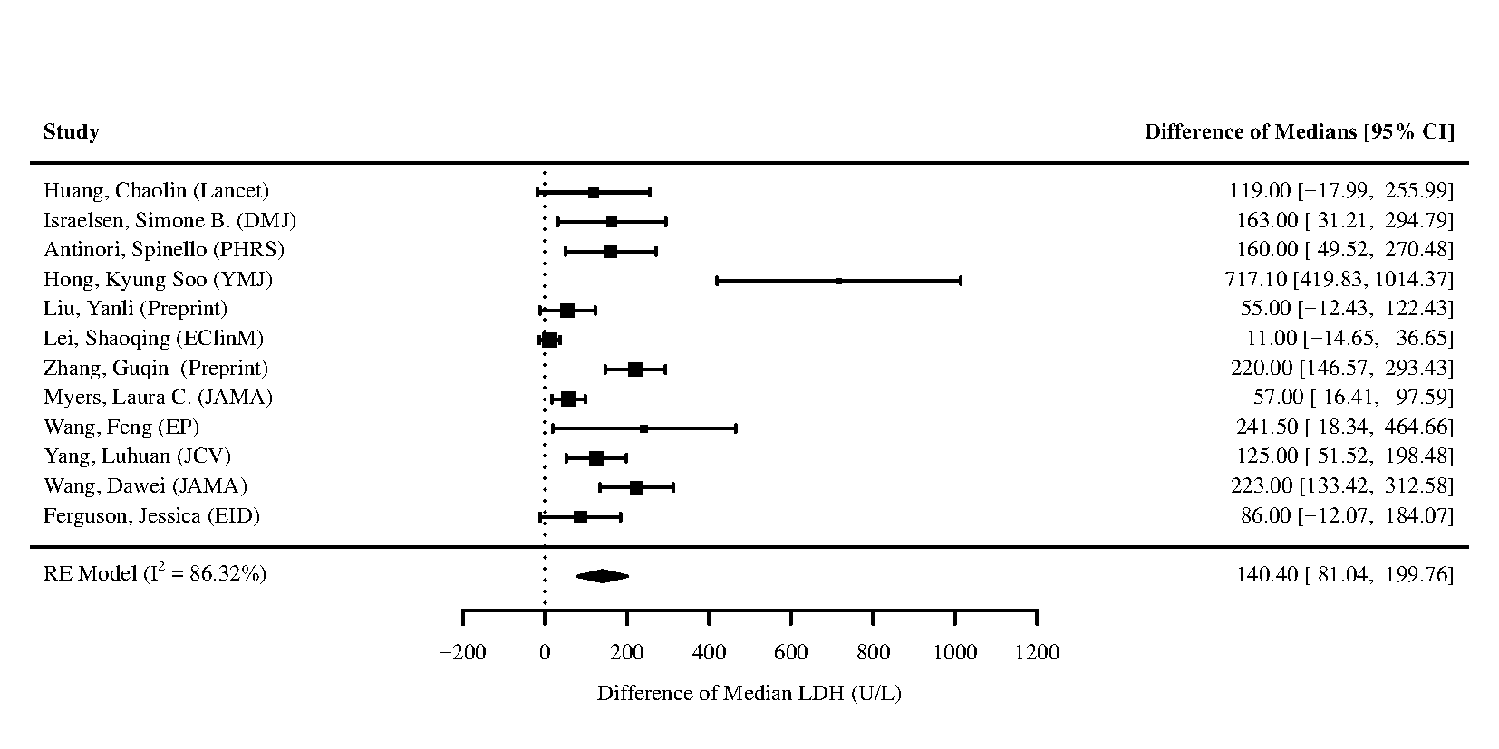
Figure 41 - Forest plot for difference of medians of Lactate Dehydrogenase (LDH) for those who require ICU admission vs. non-ICU admission

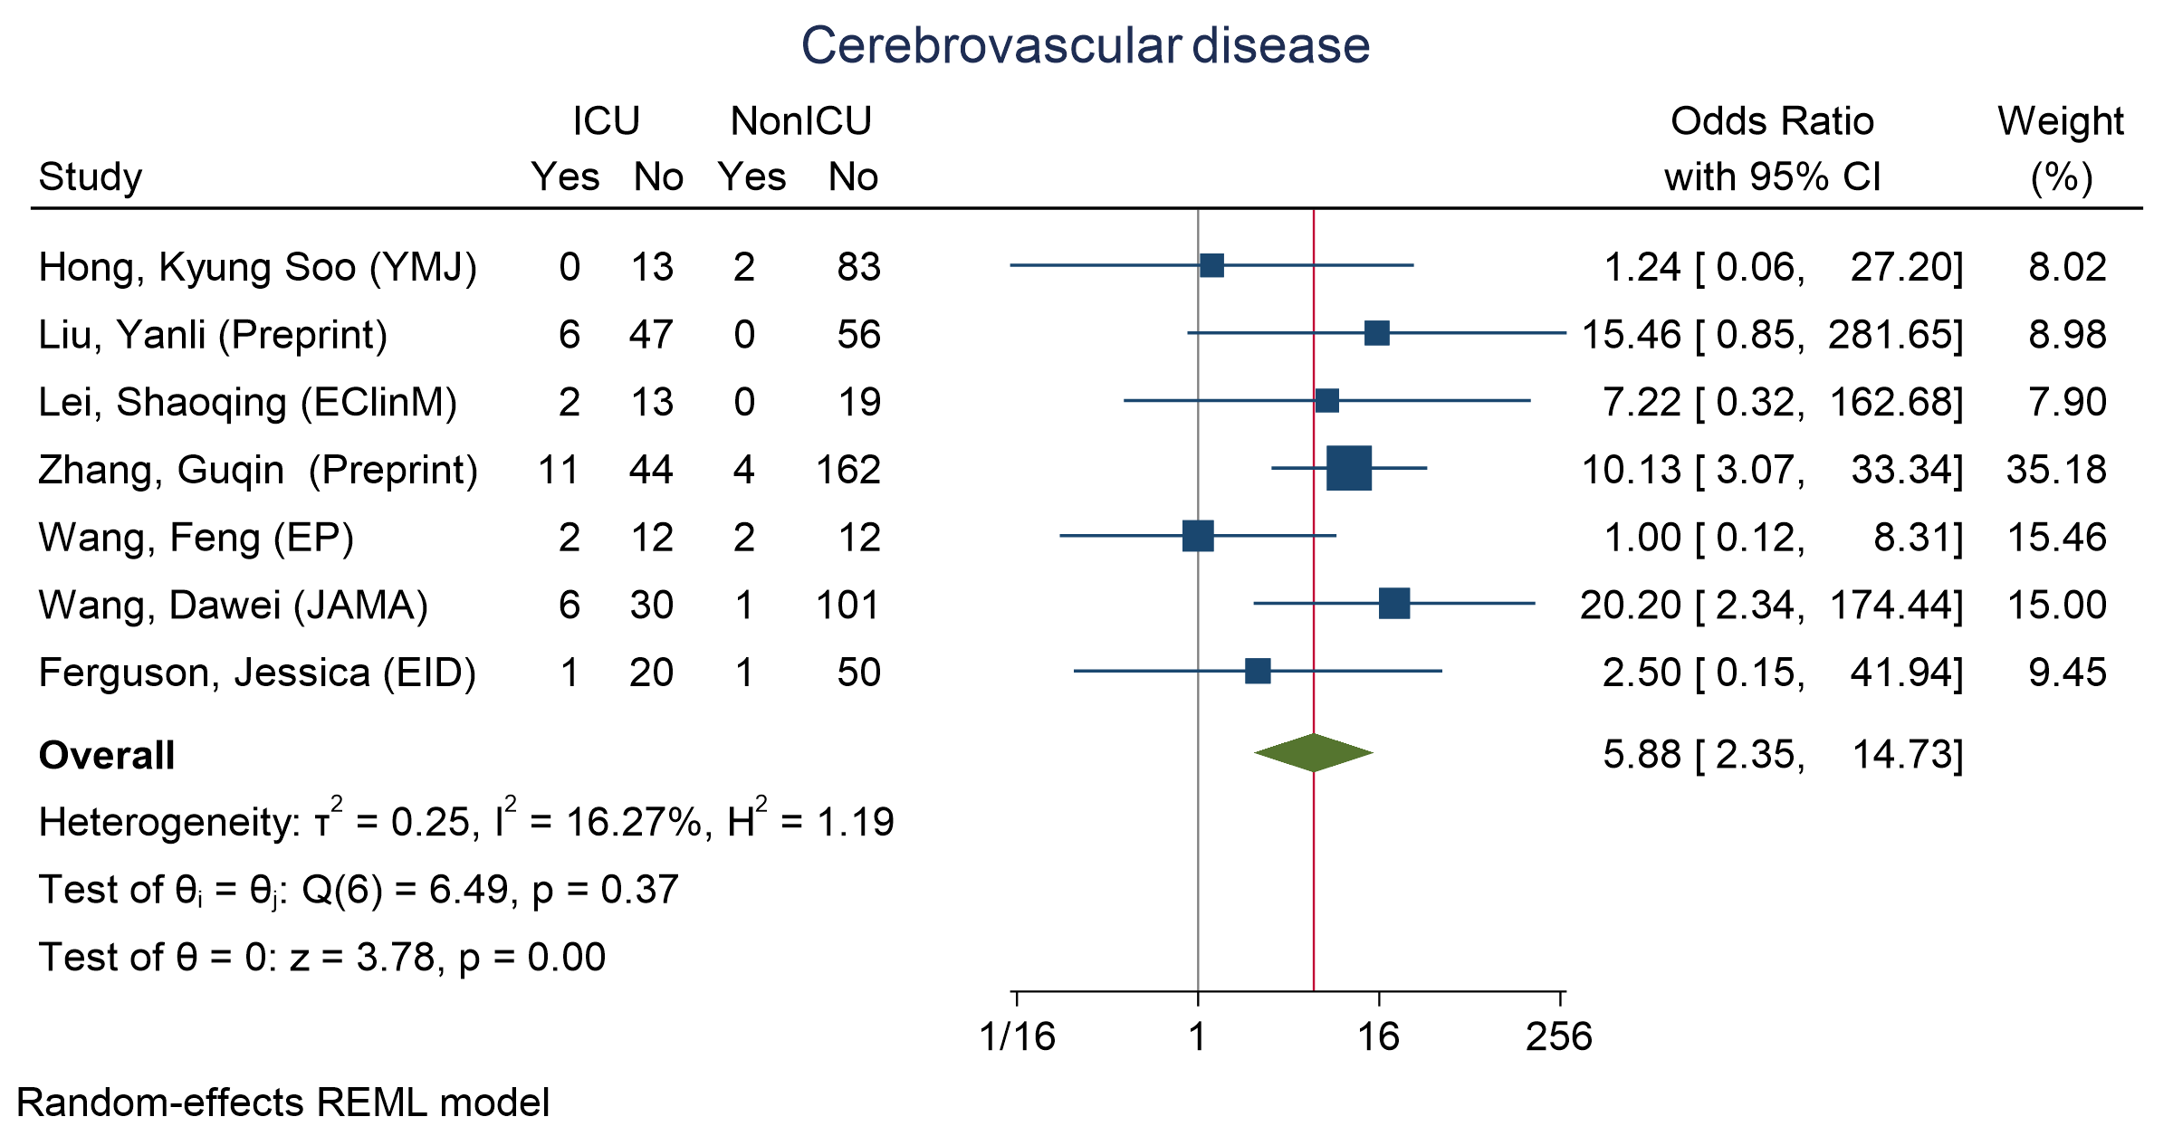
Figure 42 - Forest plot for Odds Ratio and 95% Confidence Interval (CI) of Cerebrovascular disease for those who require ICU admission vs. non-ICU admission
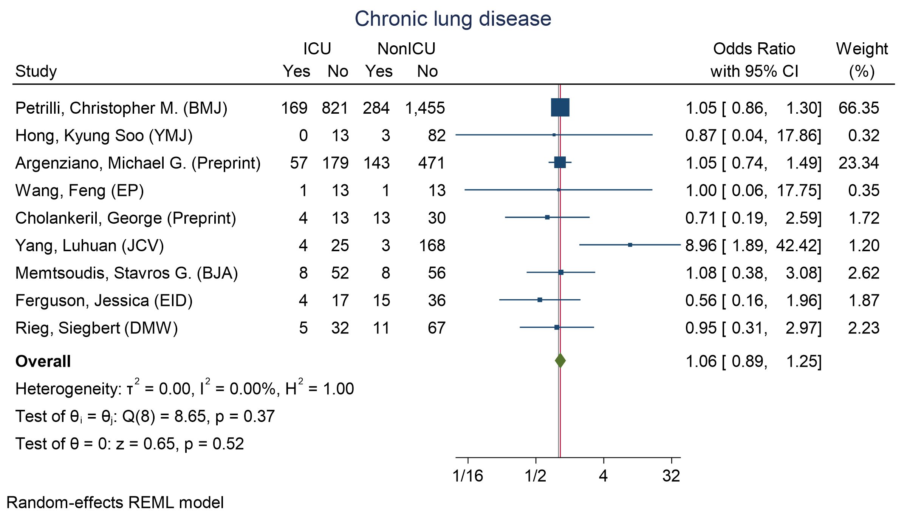
Figure 43 - Forest plot for Odds Ratio and 95% Confidence Interval (CI) of Chronic Lung disease for those who require ICU admission vs. non-ICU admission

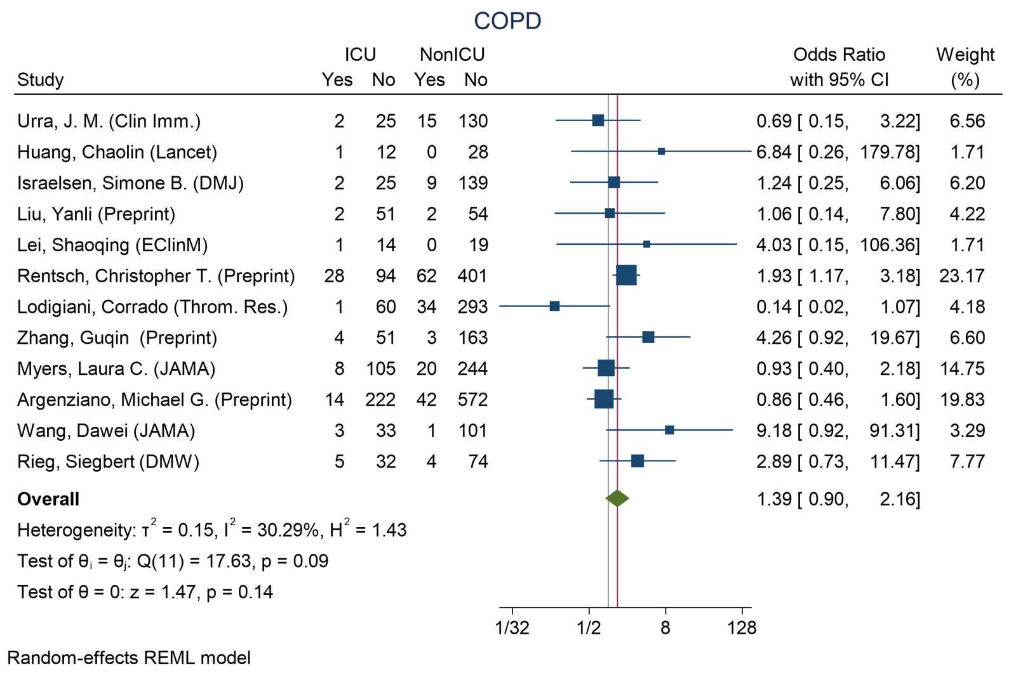
Figure 44 - Forest plot for Odds Ratio and 95% Confidence Interval (CI) of COPD for those who require ICU admission vs. non-ICU admission
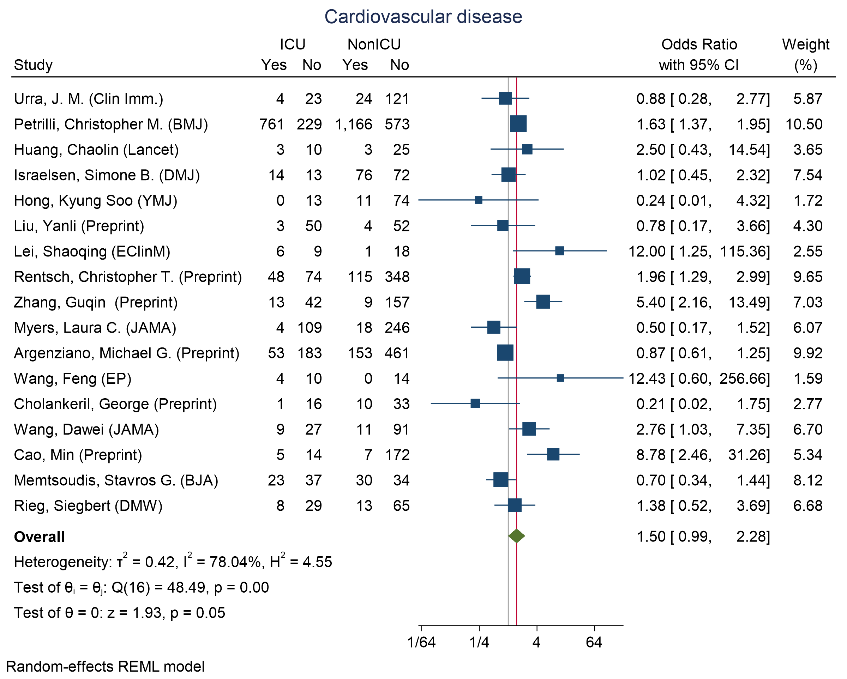
Figure 45 - Forest plot for Odds Ratio and 95% Confidence Interval (CI) of Cardiovascular disease for those who require ICU admission vs. non-ICU admission
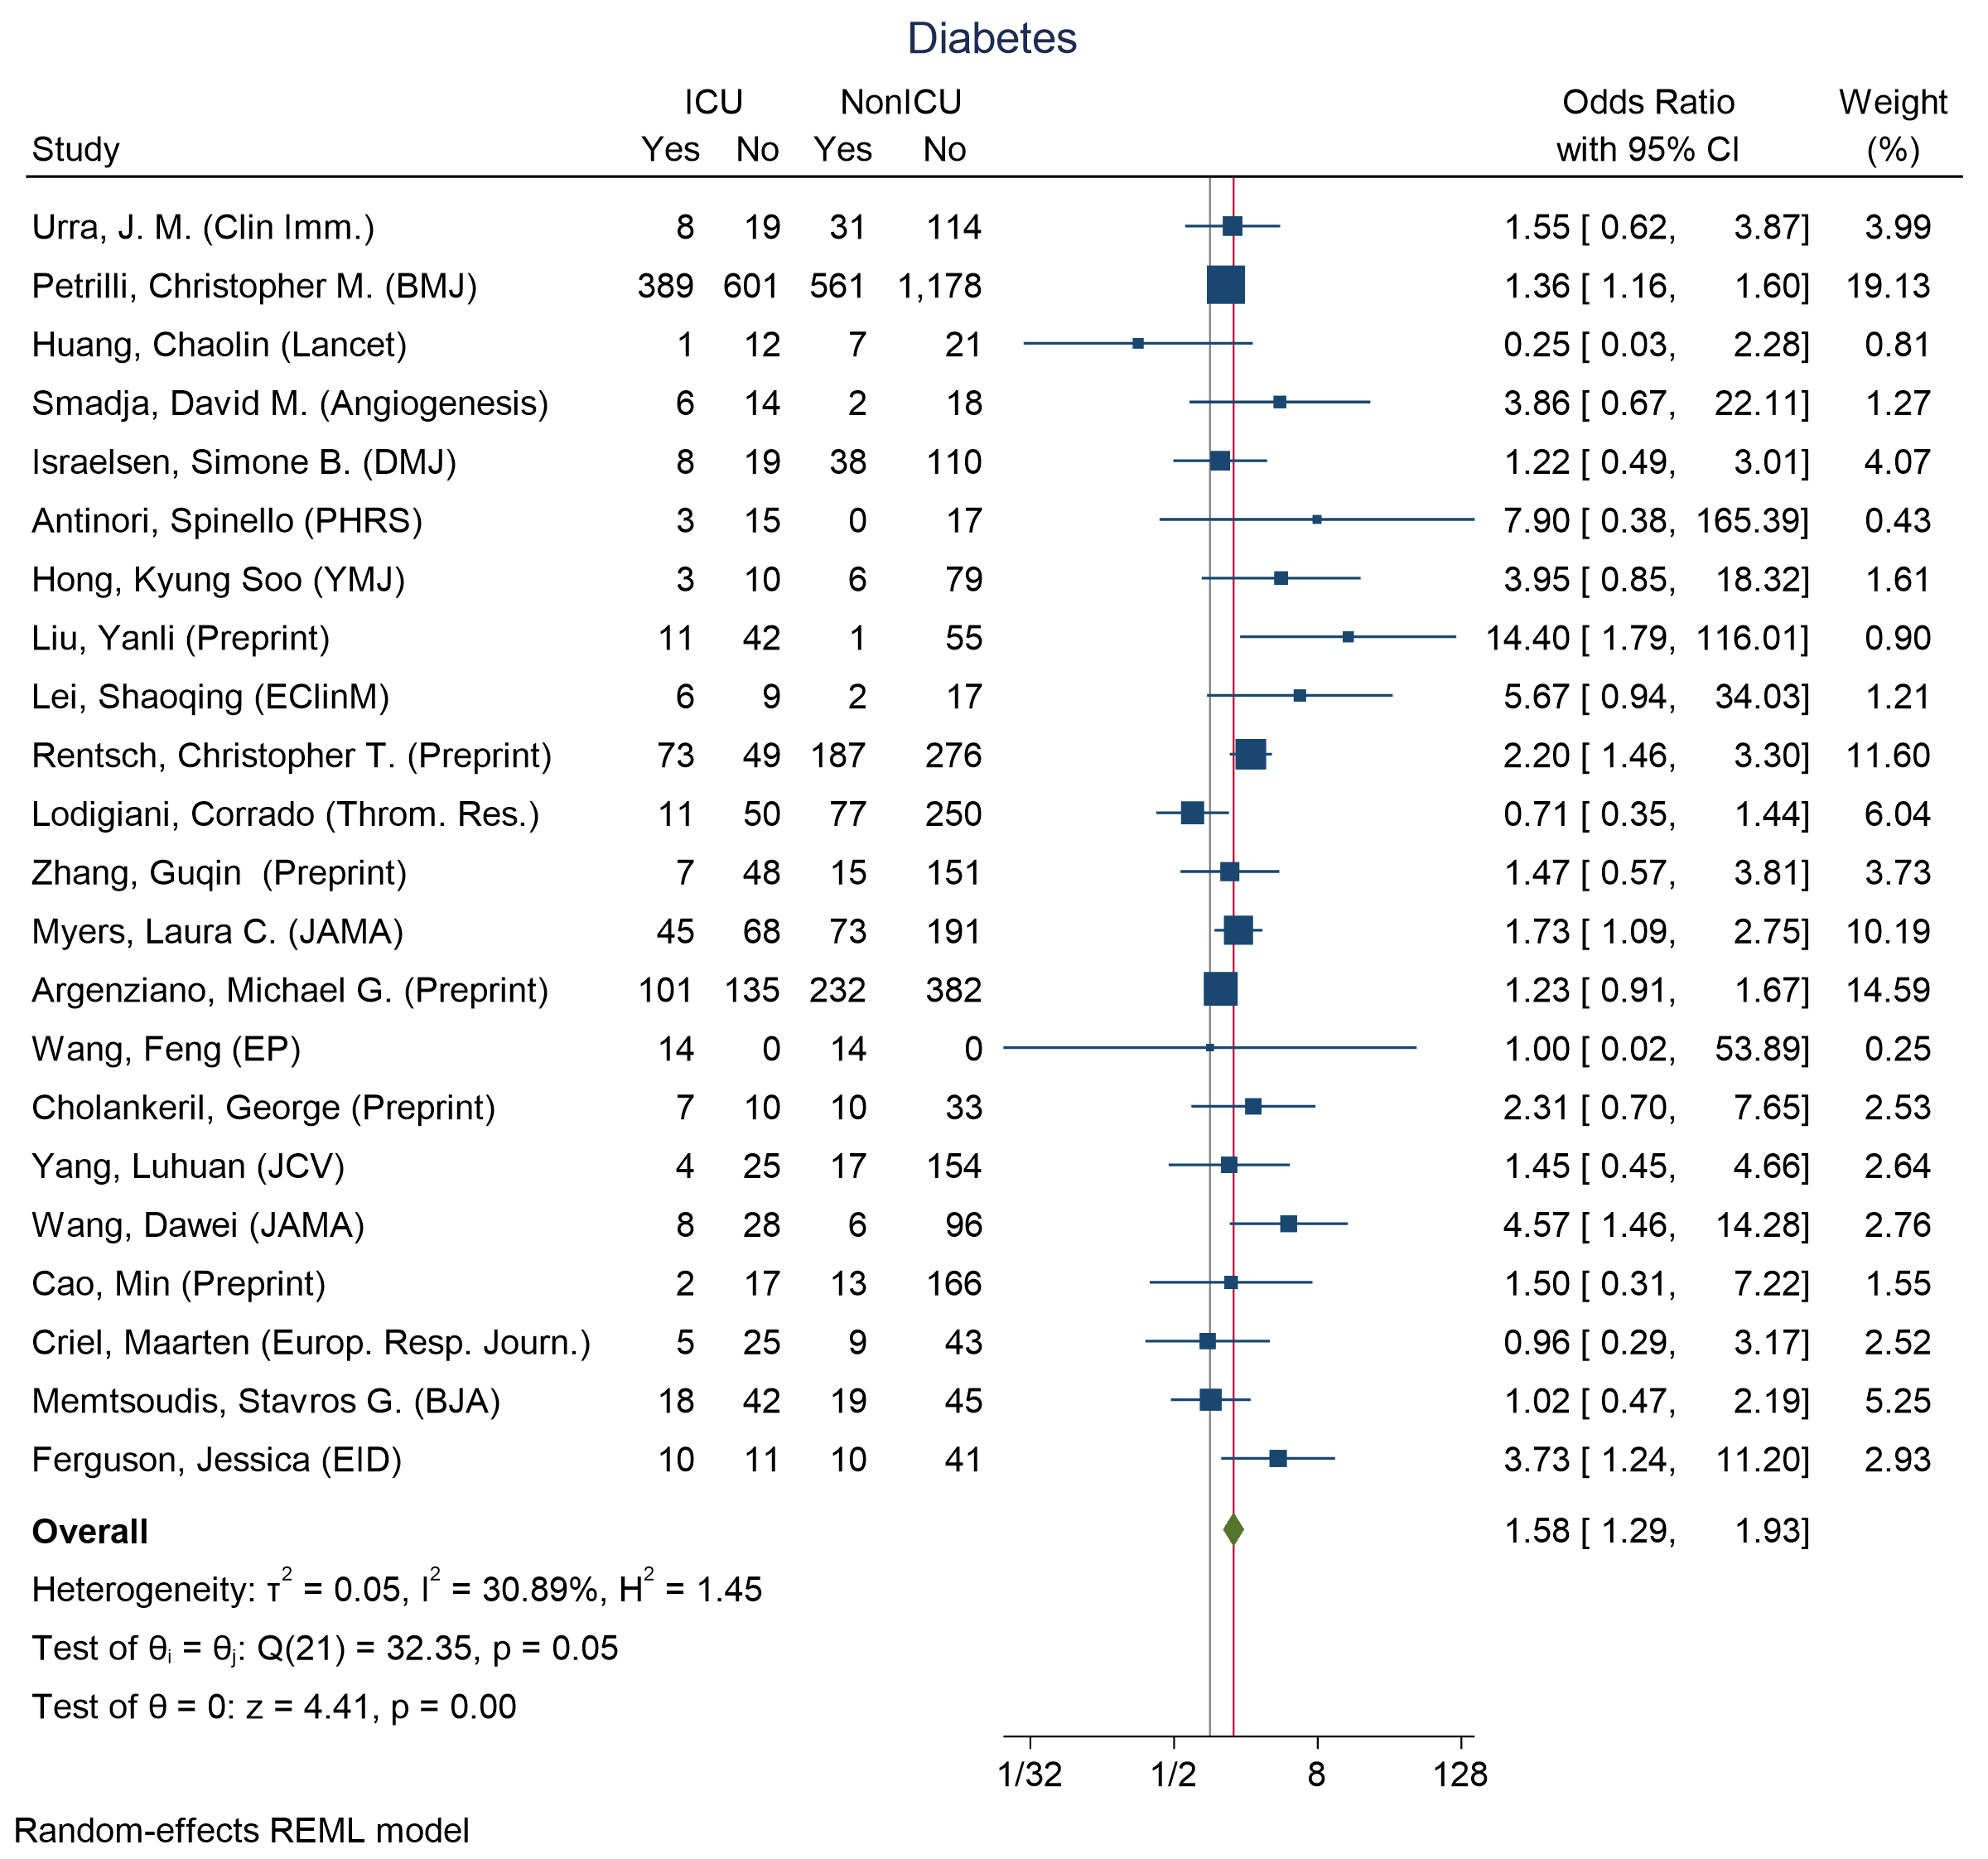
Figure 46 - Forest plot for Odds Ratio and 95% Confidence Interval (CI) of Diabetes for those who require ICU admission vs. non-ICU admission

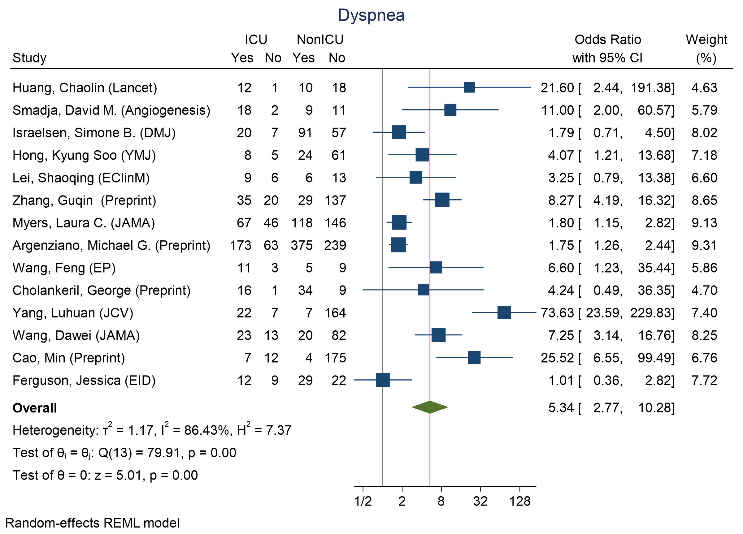
Figure 47 - Forest plot for Odds Ratio and 95% Confidence Interval (CI) of Dyspnea for those who require ICU admission vs. non-ICU admission

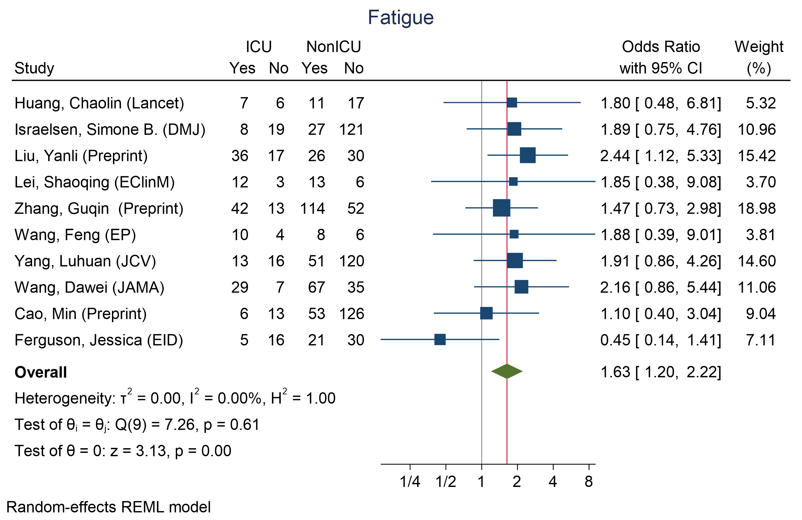
Figure 48 - Forest plot for Odds Ratio and 95% Confidence Interval (CI) of Fatigue for those who require ICU admission vs. non-ICU admission
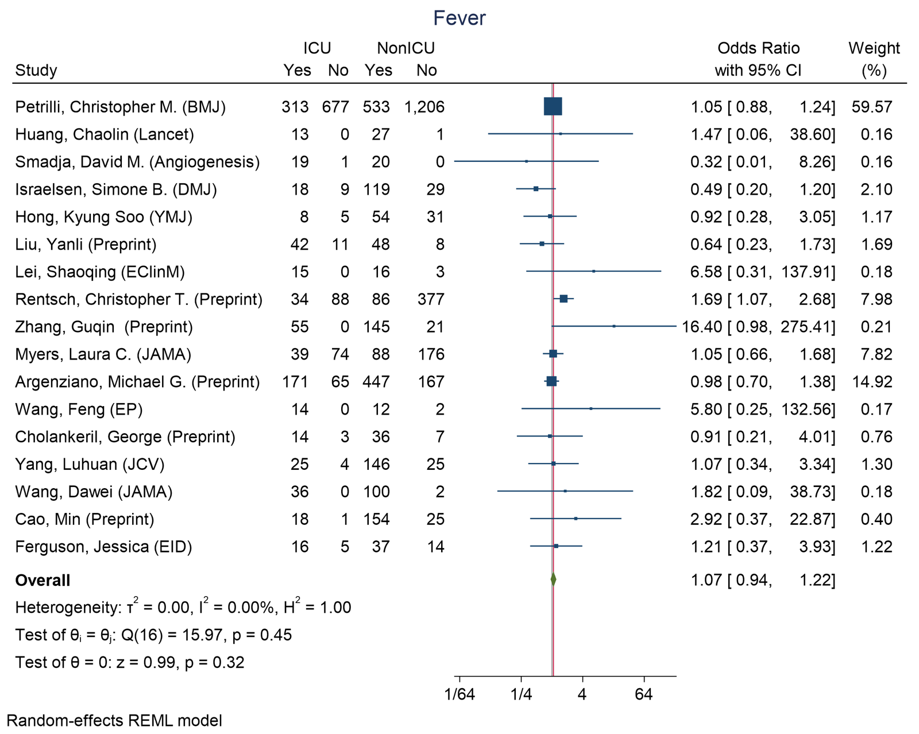
Figure 49 - Forest plot for Odds Ratio and 95% Confidence Interval (CI) of Fever for those who require ICU admission vs. non-ICU admission

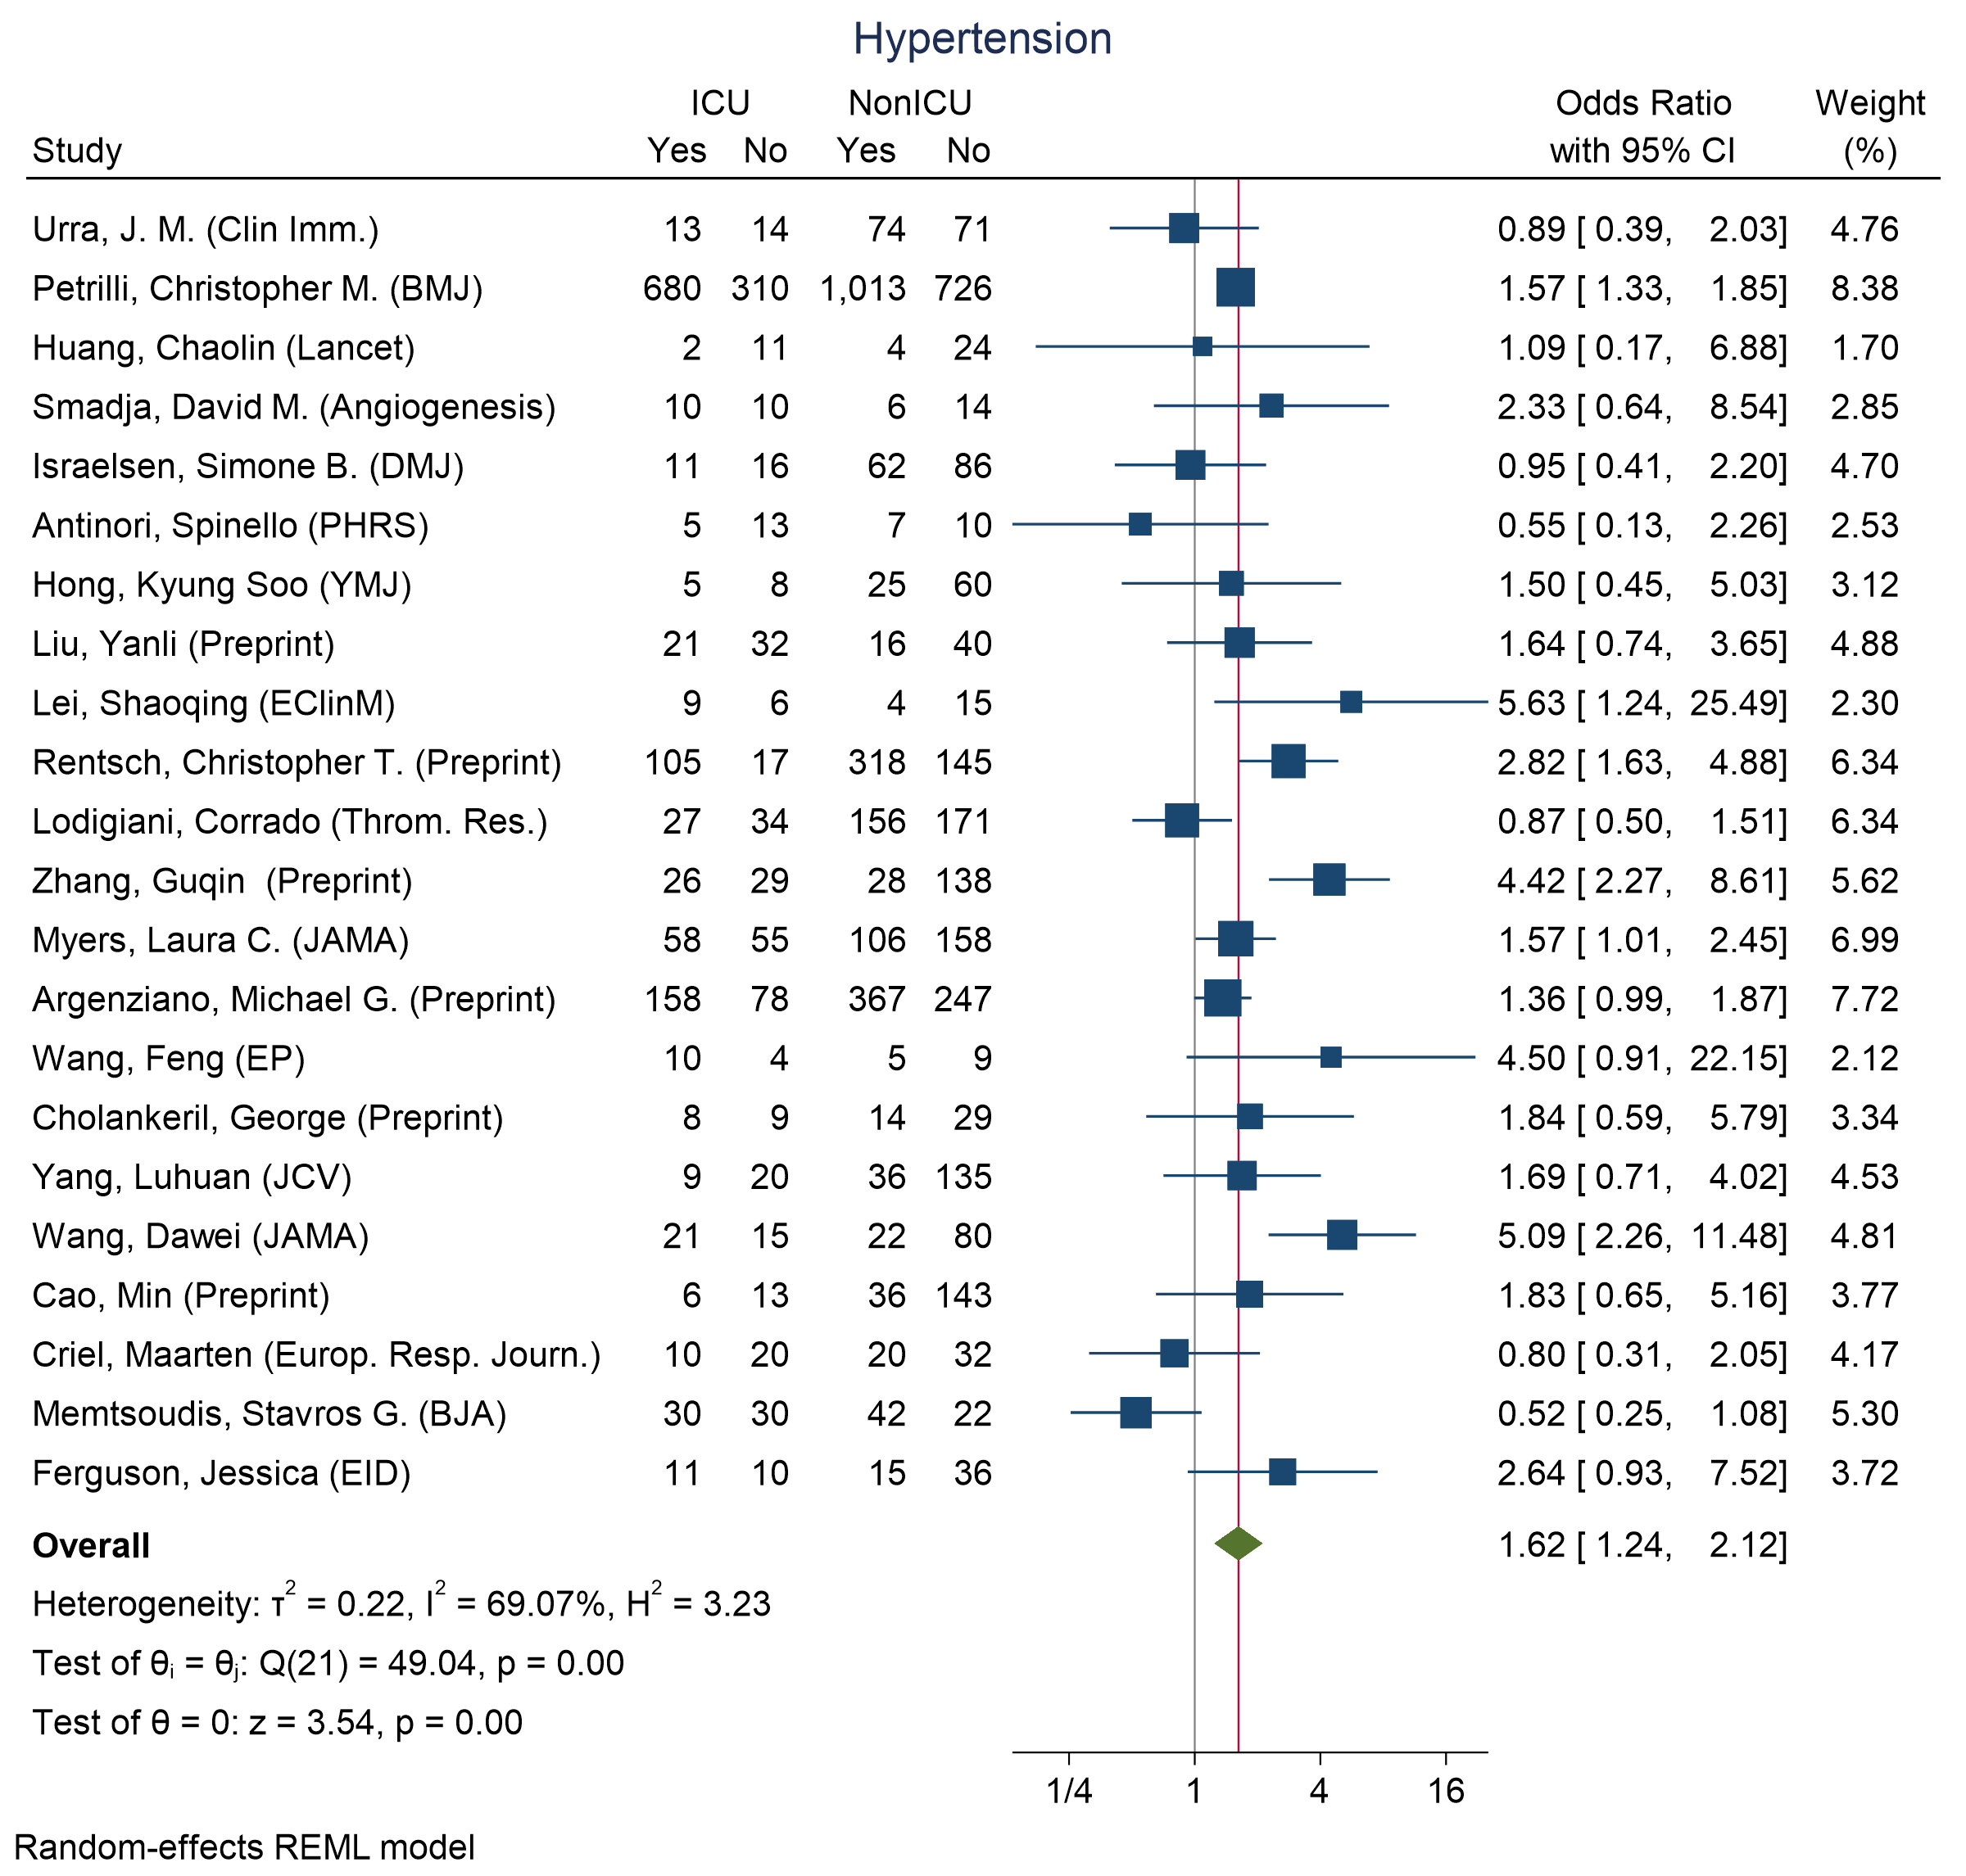
Figure 50 - Forest plot for Odds Ratio and 95% Confidence Interval (CI) of Hypertension for those who require ICU admission vs. non-ICU admission
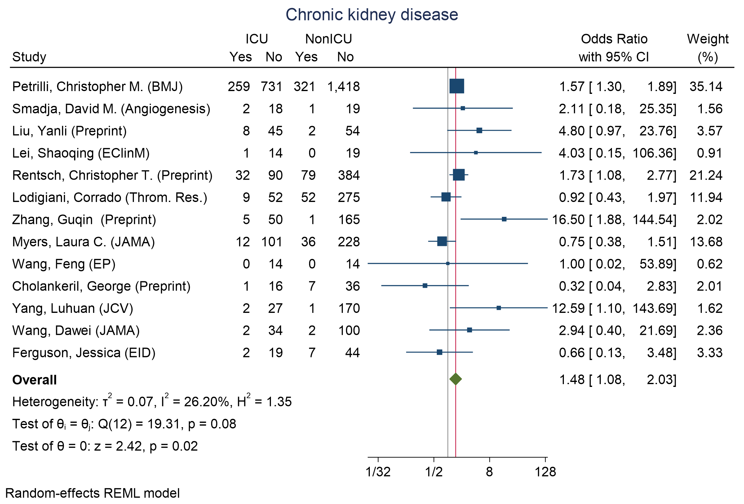
Figure 51 - Forest plot for Odds Ratio and 95% Confidence Interval (CI) of chronic kidney disease for those who require ICU admission vs. non-ICU admission
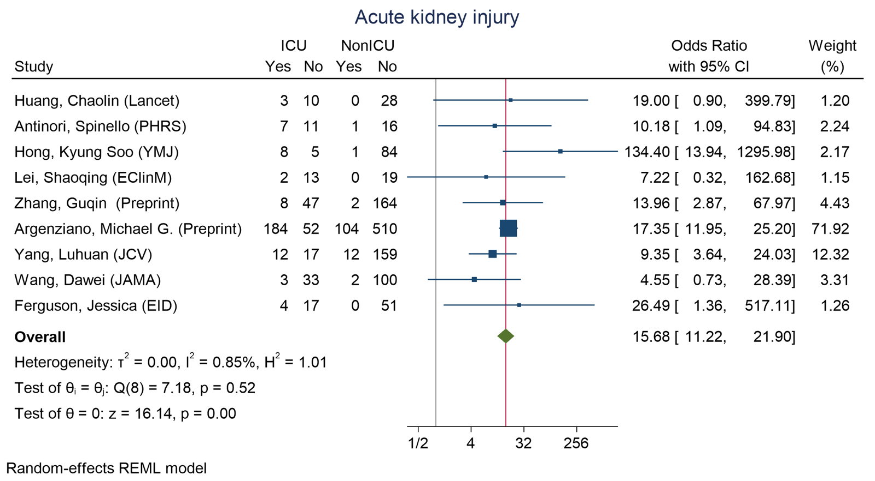
Figure 52 - Forest plot for Odds Ratio and 95% Confidence Interval (CI) of acute kidney injury for those who require ICU admission vs. non-ICU admission
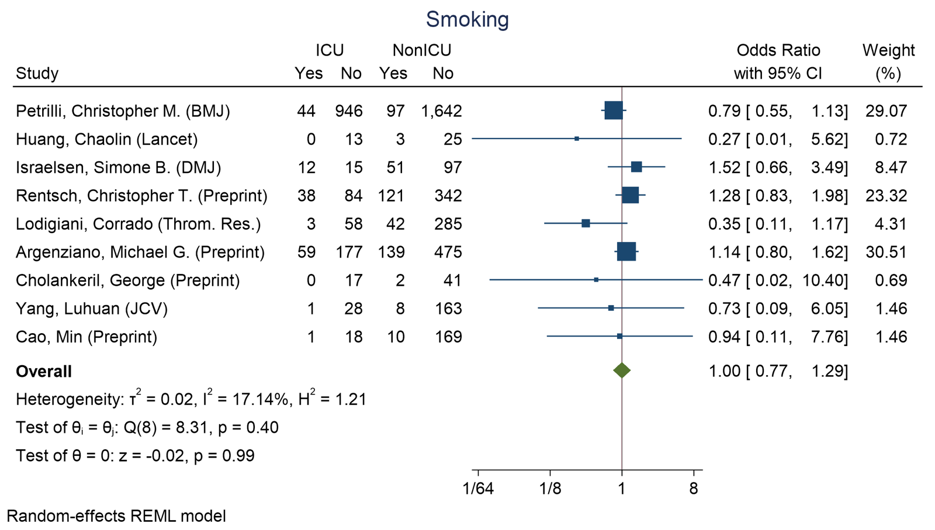
Smoking
Figure 53 - Forest plot for Odds Ratio and 95% Confidence Interval (CI) of Smoking for those who require ICU admission vs. non-ICU admission

S7 Results for all available indicators in Intubated vs Non-Intubated analyses

Figure 54 - Pooled Odds Ratios (OR) & 95% Confidence Interval (CI) for those who required intubation vs. non intubation 59

Indicator | N. Studies | Pooled DoM | I²
Demographics
Age (years) | 4 | 8.82 [3.06, 14.58] | 0
Laboratory Values
Leukocyte (10⁹/L) | 4 | -1.04 [-5.78, 3.7] | 89.27
Lymphocyte (10⁹/L) | 4 | -0.18 [-0.41, 0.05] | 63.75
Table 4 - Pooled difference of medians results for all indicators in Intubated vs Non-Intubated analyses

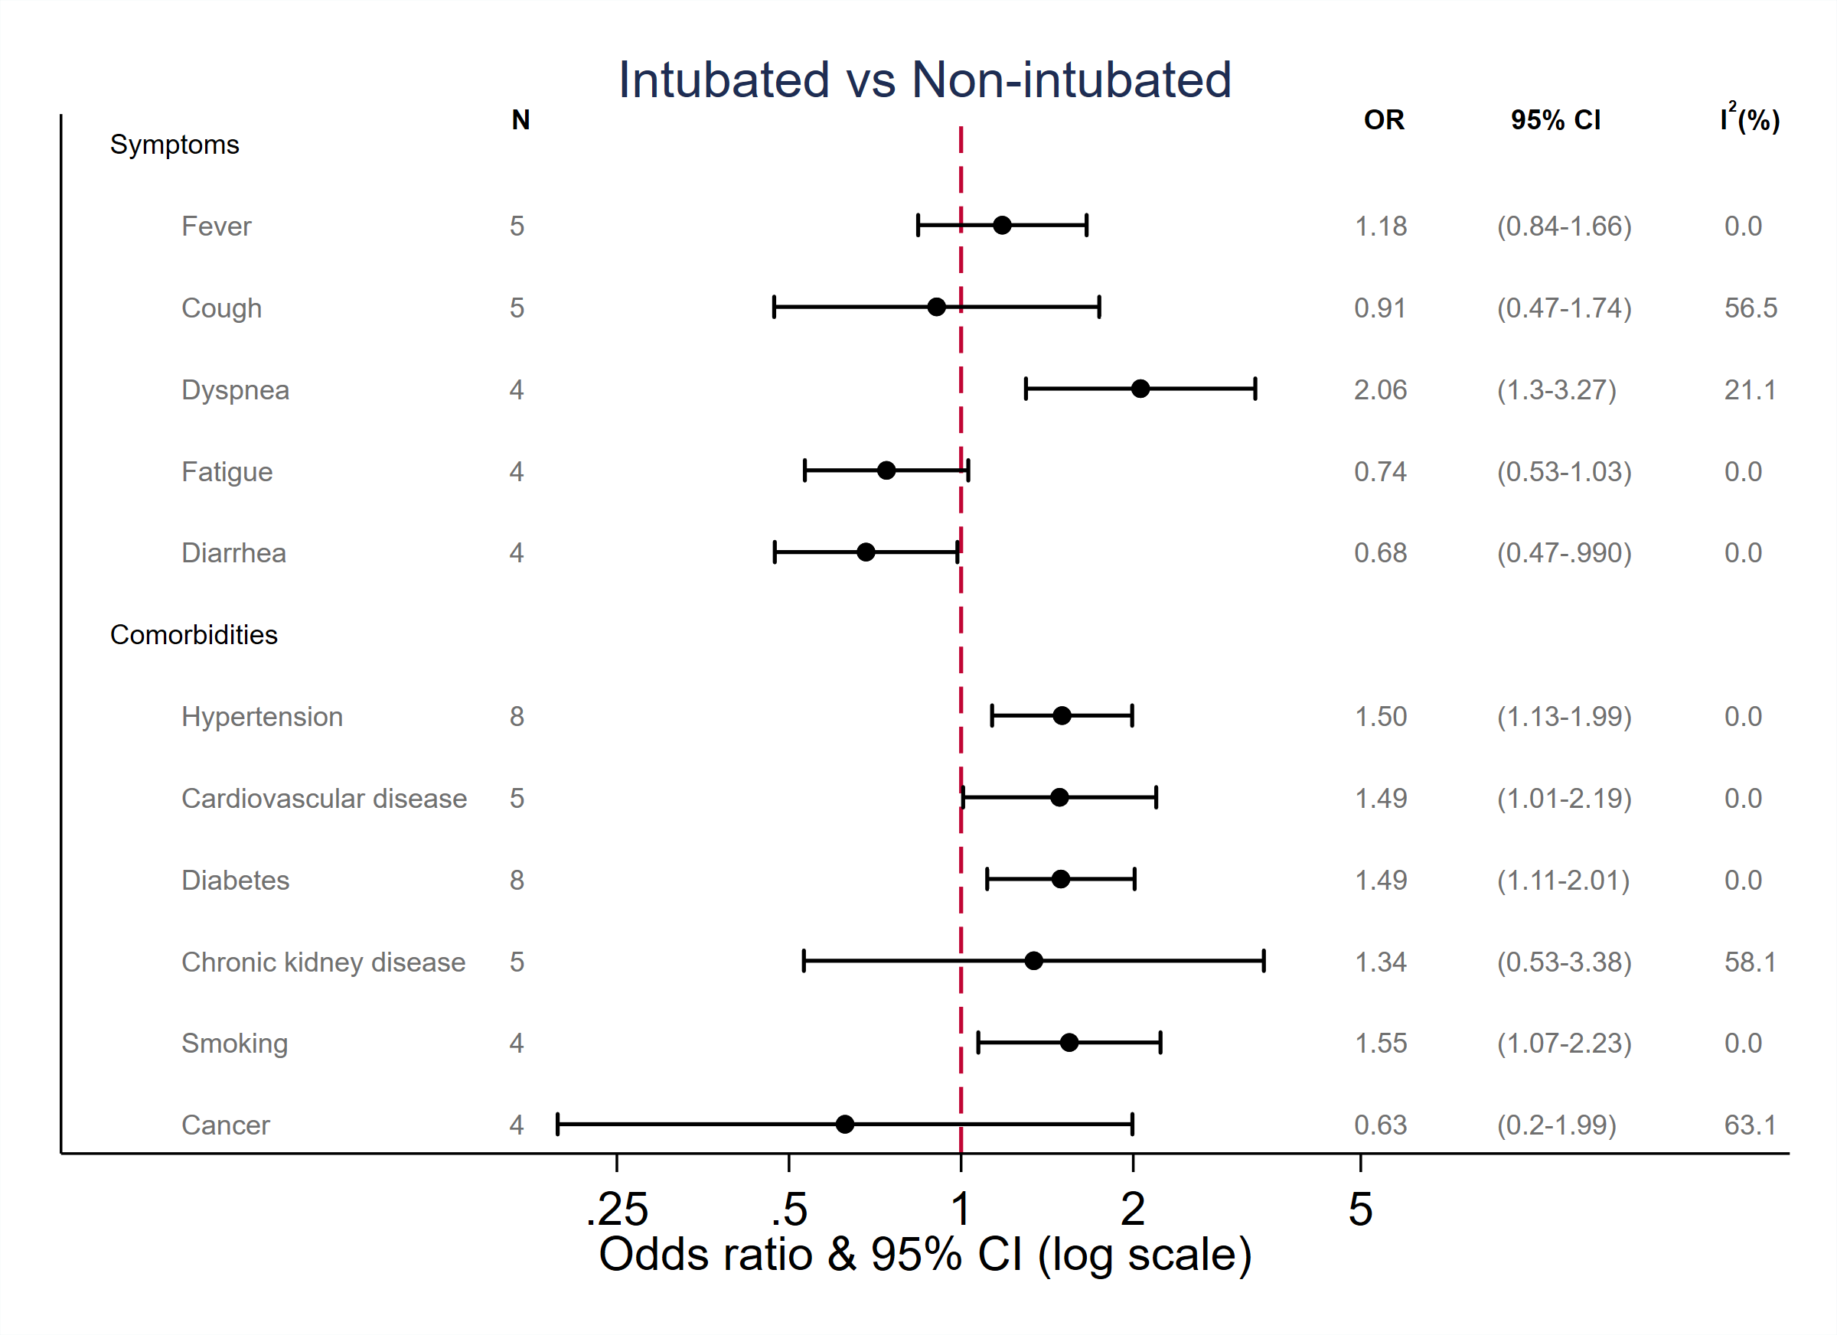

Figure 54 - Pooled Odds Ratios (OR) & 95% Confidence Interval (CI) for those who required intubation vs. non intubation

S8 Results for all available indicators in hospitalization vs. non hospitalization

Figure 55 - Pooled Odds Ratios (OR) & 95% Confidence Interval (CI) of those who required hospitalization vs. non hospitalization 60

Indicator | N. Studies | Pooled DoM | I²
Demographics
Age (years) | 10 | 13.16 [8.63, 17.68] | 94.74
Laboratory Values
Leukocyte (10⁹/L) | 5 | -0.44 [-1.07, 0.19] | 39.44
Lymphocyte (10⁹/L) | 4 | -0.40 [-0.62, -0.19] | 74.75
Platelets (10⁹/L) | 4 | -28.68 [-39.61, -17.75] | 4.16
Creatinine (µmol/L) | 4 | 7.67 [-2.98, 18.31] | 63.77
Table 5 - showing pooled difference of medians results for all biomarkers in Hospitalized vs Non-Hospitalized analyses
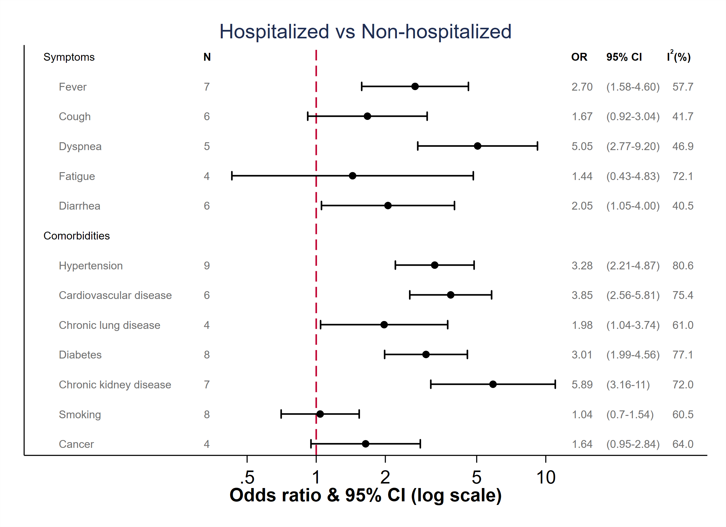
Figure 55 - Pooled Odds Ratios (OR) & 95% Confidence Interval (CI) of those who required hospitalization vs. non hospitalization

S9 Sensitivity analyses

In the following sensitivity analyses, we considered excluding studies with outlier difference of medians values.

We considered removing the study of Yang, Xia (CCM) in the analysis of D-Dimer across those who died and those who survived. When including this study, we obtain a pooled difference of medians of 1.2914 [95% CI: 0.8964, 1.6865] and I² = 81.53 (Fig. 11). When excluding this study, we obtain a pooled estimate of 1.2902 [95% CI: 0.8957, 1.6846] and I² = 81.98.

We considered removing the studies of Liu, Yanli, Zhang, Guqin, and Wang, Dawei in the analysis of D-Dimer across those who required ICU and those who did not. When including this study, we obtain a pooled difference of medians of 0.3024 [95% CI: -0.2041, 0.8088] and I² = 83.97 (Fig. 37). When excluding this study, we obtain a pooled estimate of 0.3123 [95% CI: -0.1472, 0.7718] and I² = 84.21.

We considered removing the study of Xie, Jianfeng in the analysis of CRP across those who died and those who survived. When including this study, we obtain a pooled difference of medians of 69.1016 [95% CI: 50.4309, 87.7724] and I² = 95.99 (Fig. 13). When excluding this study, we obtain a pooled estimate of of 59.2534 [95% CI: 41.5901, 76.9167] and I² = 95.66.

S10 Funnel plots for mortality vs. survival across different indicators

Figure 56 - Funnel plots for differences of medians of Age and D-Dimer in those who died vs. survived 62
Figure 57 - Funnel plots for differences of medians of Leukocyte and Lymphocyte in those who died vs. survived 62
Figure 58 - Funnel plots for differences of medians of Neutrophil and Platelets in those who died vs. survived 63
Figure 59 - Funnel plots for differences of medians of Oxygen Saturation (SpO2) without oxygen (O2) and Respiratory Rate in those who died vs. survived 63
Figure 60 - Funnel plots for differences of medians of Troponin I (TnI) and C-reactive protein (CRP) in those who died vs. survived 64
Figure 61 – Funnel plots for differences of medians of Blood Urea Nitrogen (BUN) and Lactate Dehydrogenase (LDH) in those who died vs. survived 64
Figure 62 - Funnel plots for Odds ratios of Acute kidney injury and Smoking in those who died vs. survived 64
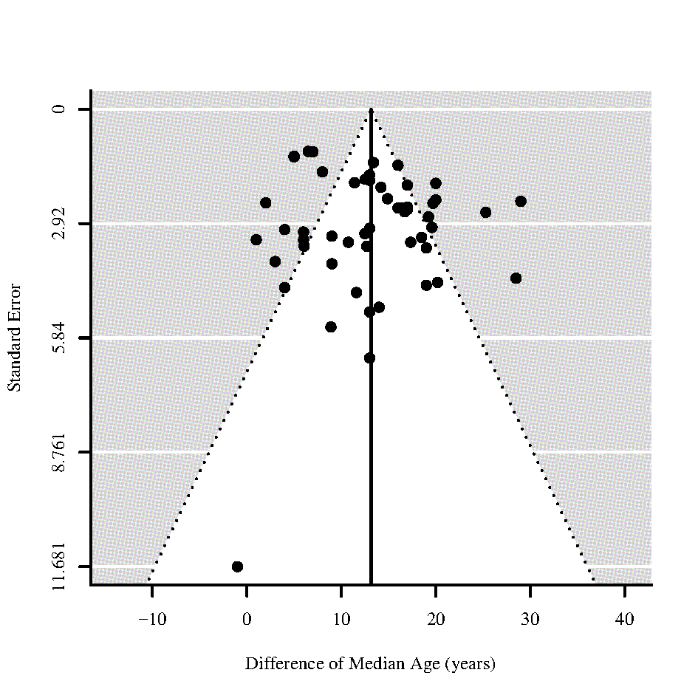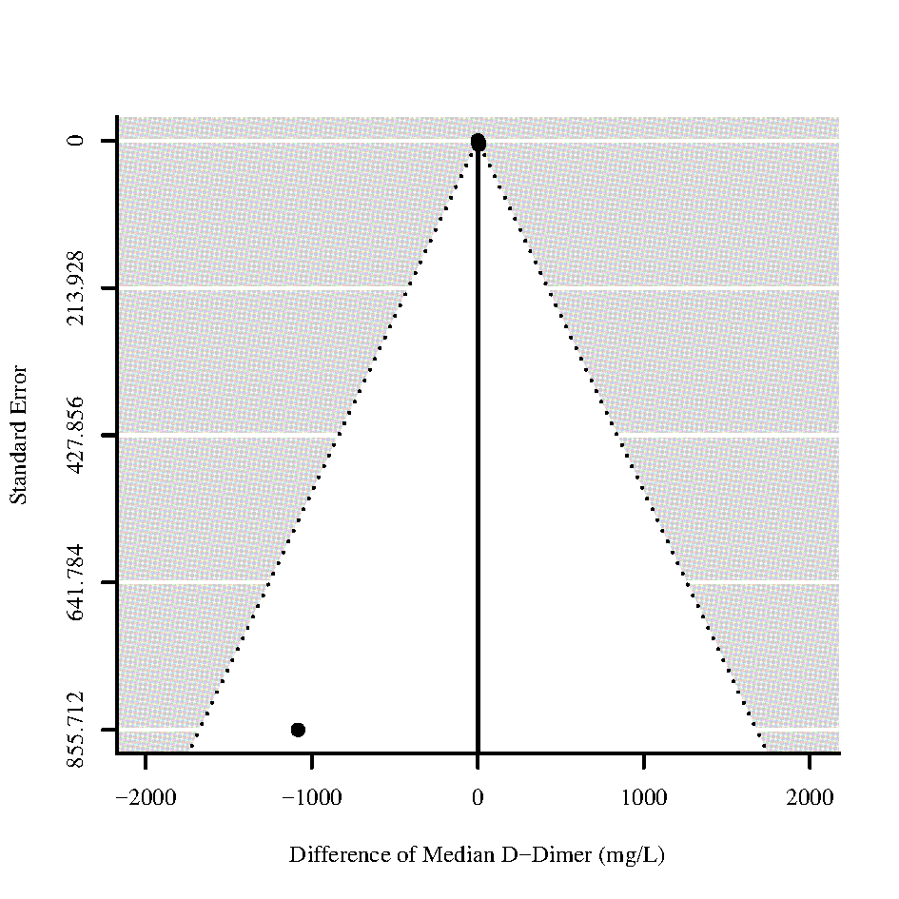
Figure 56 - Funnel plots for differences of medians of Age and D-Dimer in those who died vs. survived
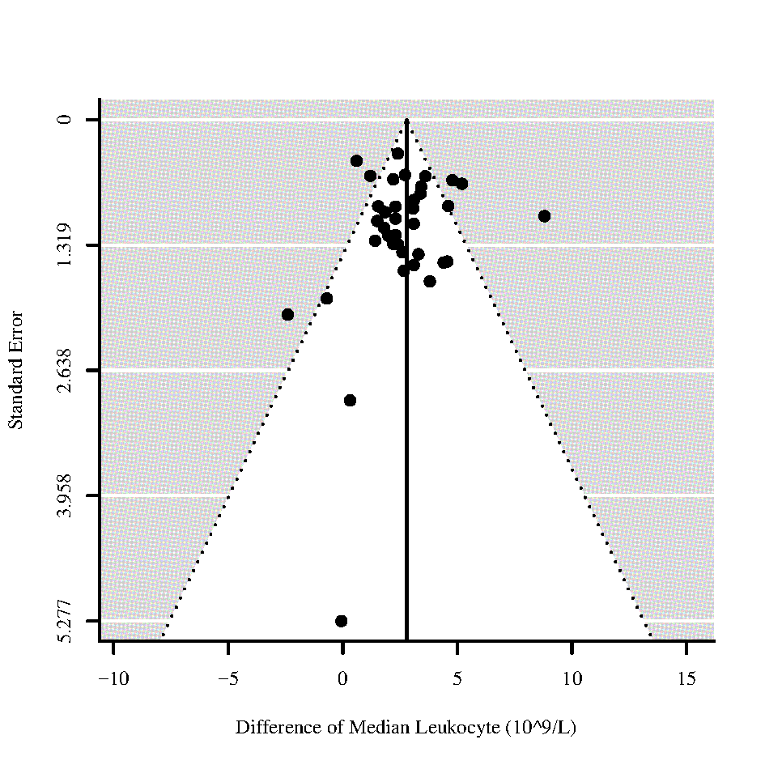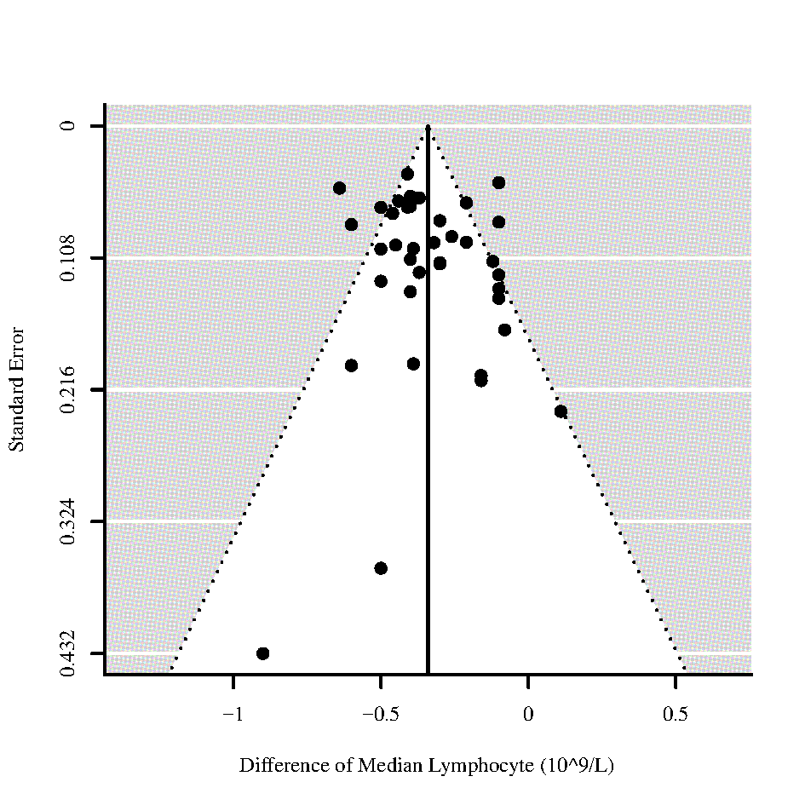
Figure 57 - Funnel plots for differences of medians of Leukocyte and Lymphocyte in those who died vs. survived
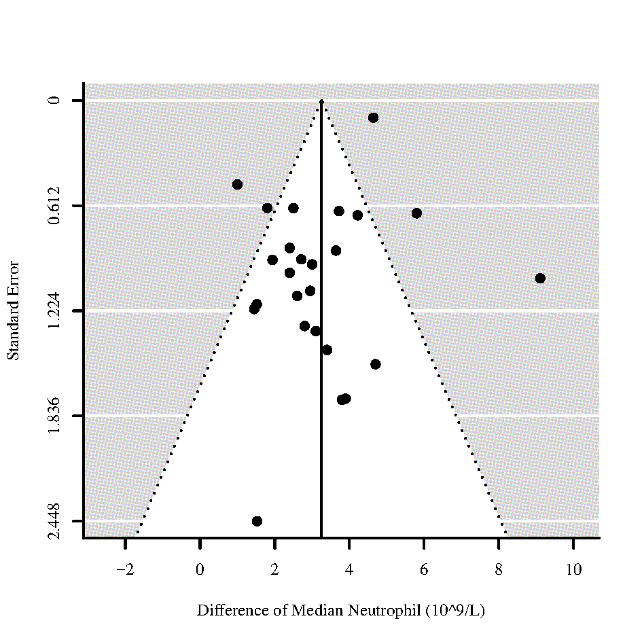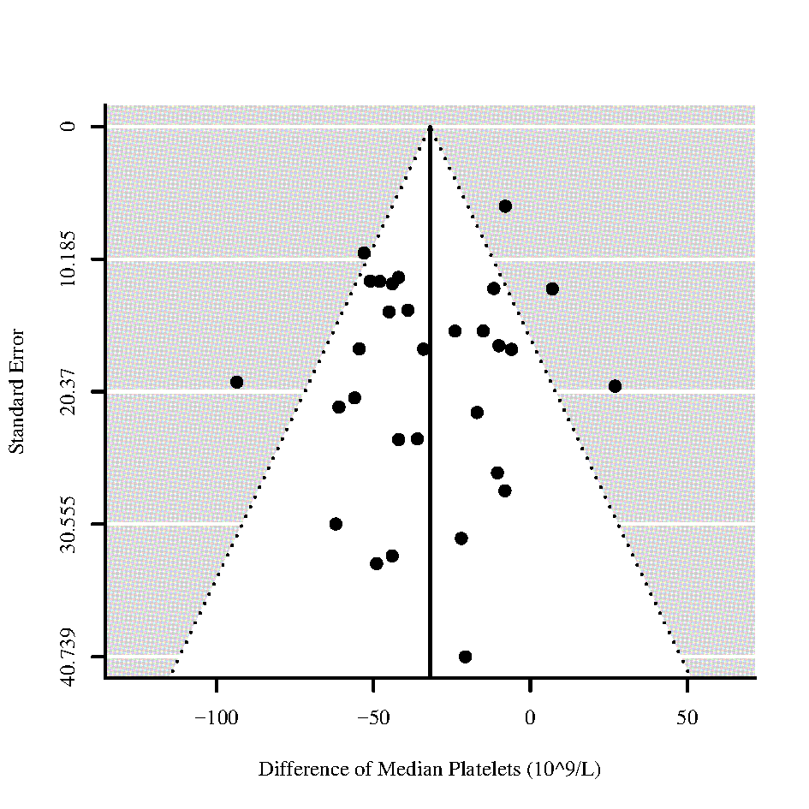
Figure 58 - Funnel plots for differences of medians of Neutrophil and Platelets in those who died vs. survived
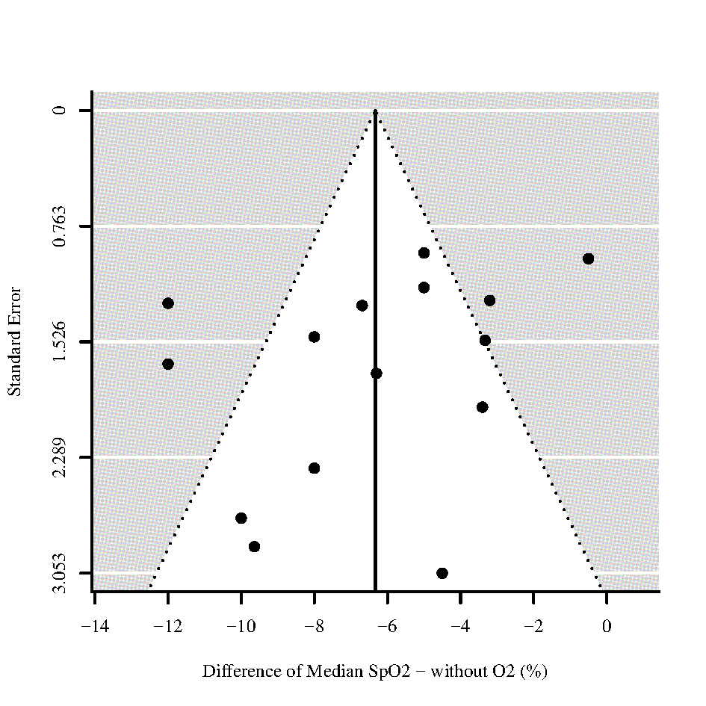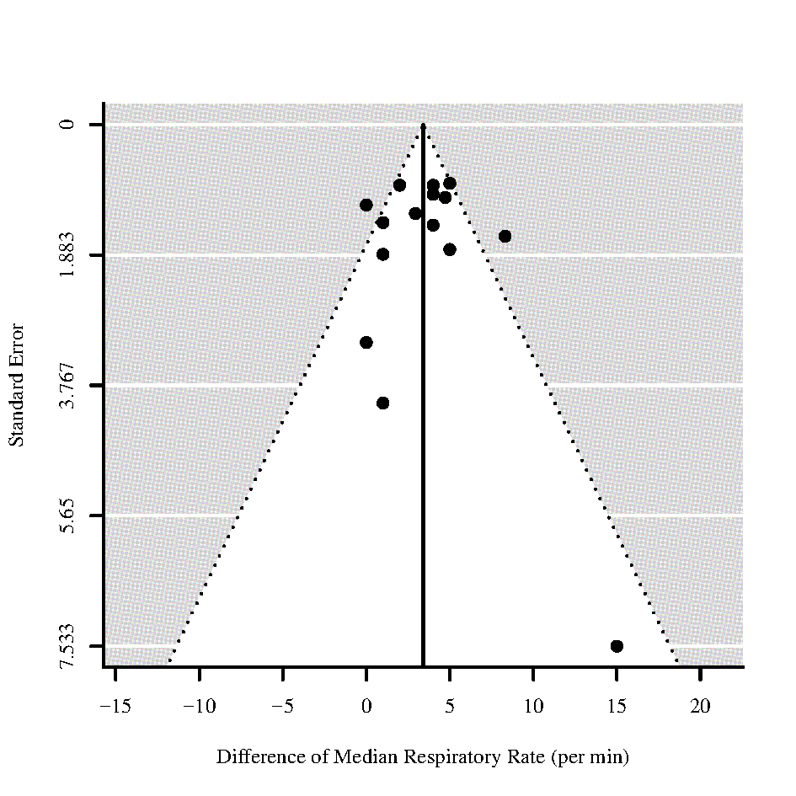
Figure 59 - Funnel plots for differences of medians of Oxygen Saturation (SpO2) without oxygen (O2) and Respiratory Rate in those who died vs. survived

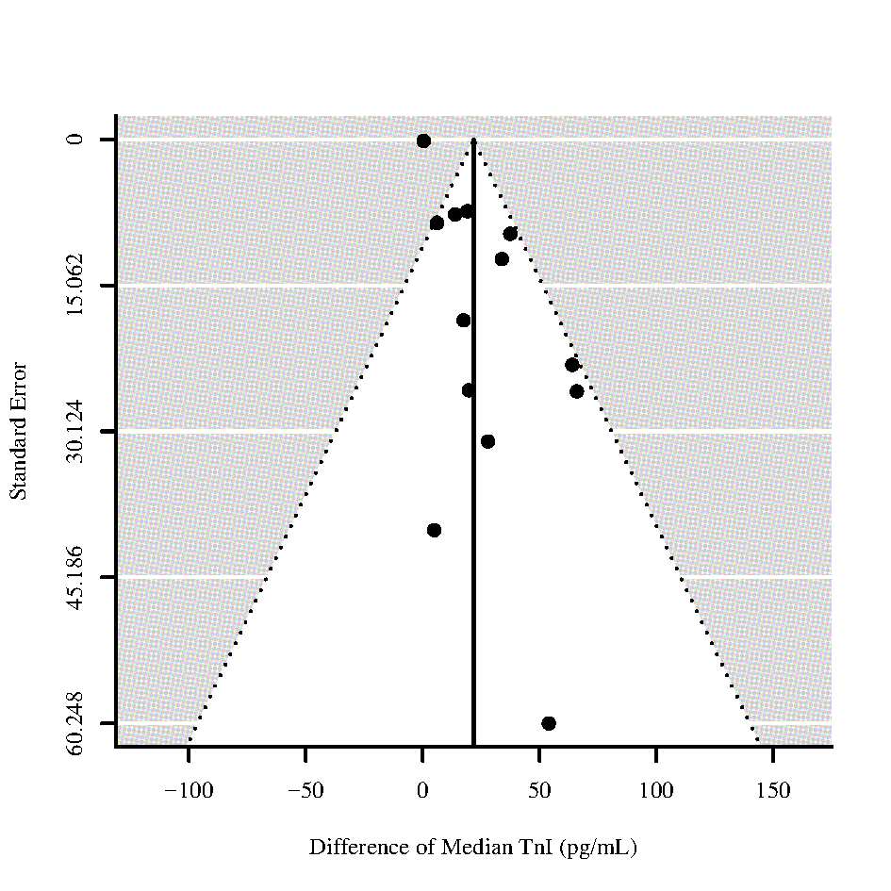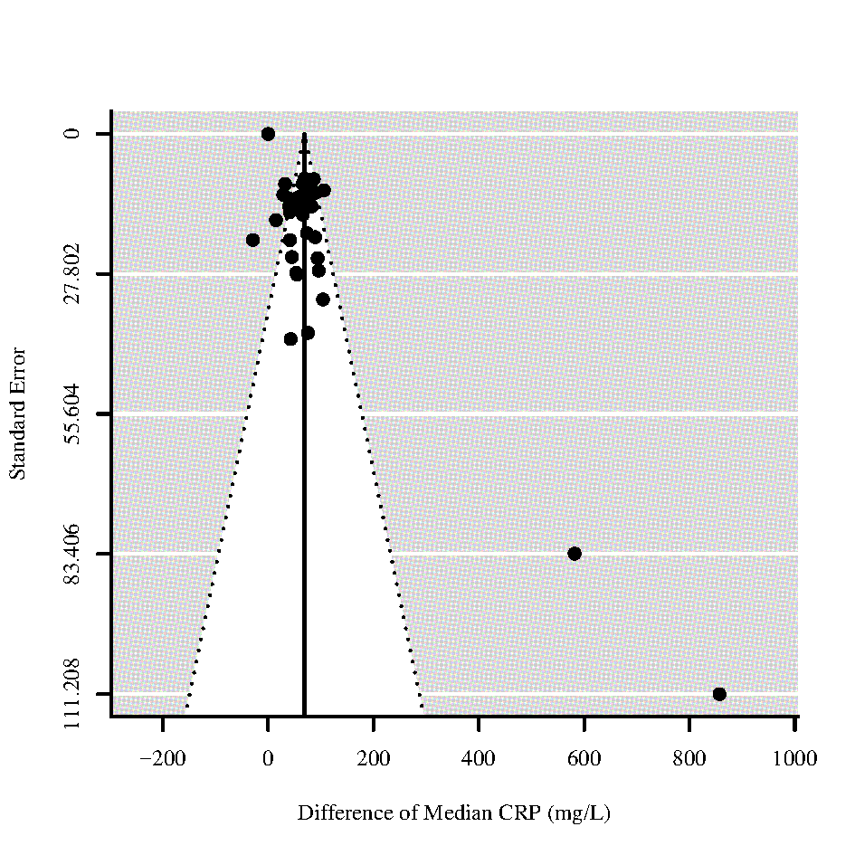
Figure 60 - Funnel plots for differences of medians of Troponin I (TnI) and C-reactive protein (CRP) in those who died vs. survived
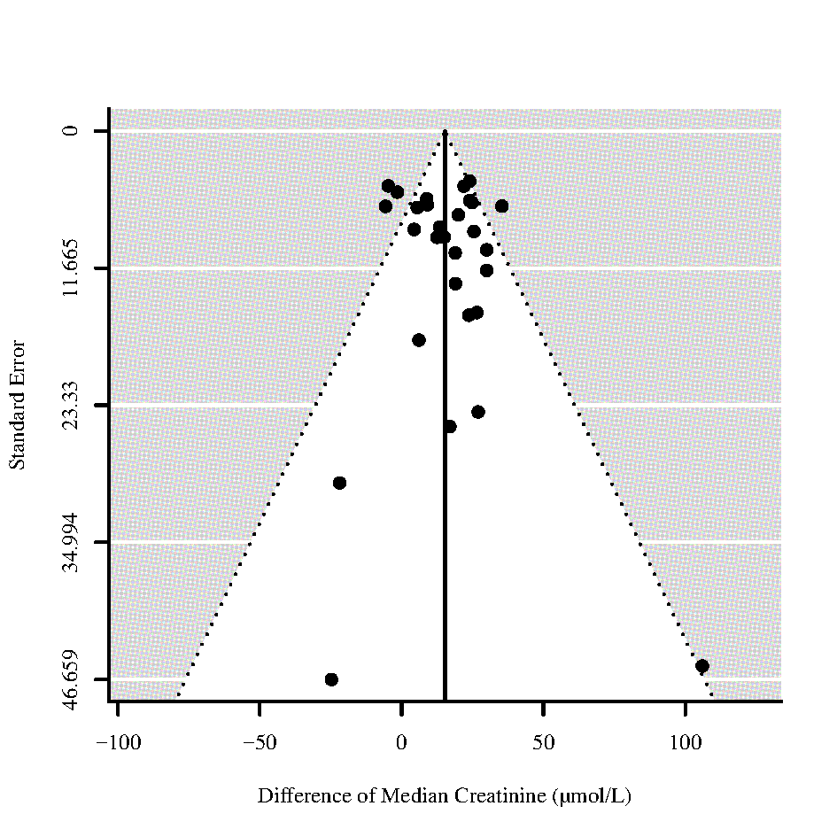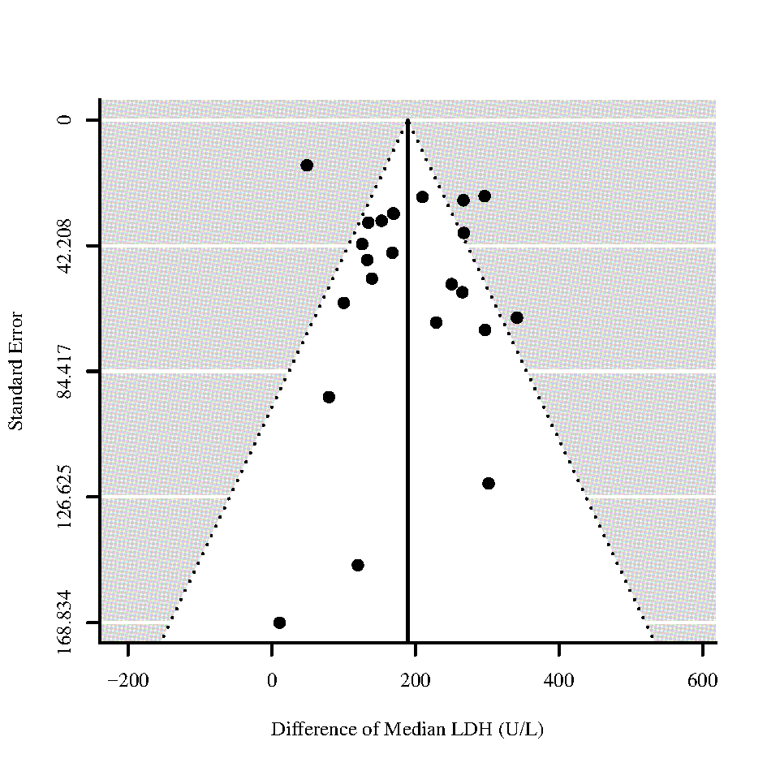

Figure 61 – Funnel plots for differences of medians of Blood Urea Nitrogen (BUN) and Lactate Dehydrogenase (LDH) in those who died vs. survived
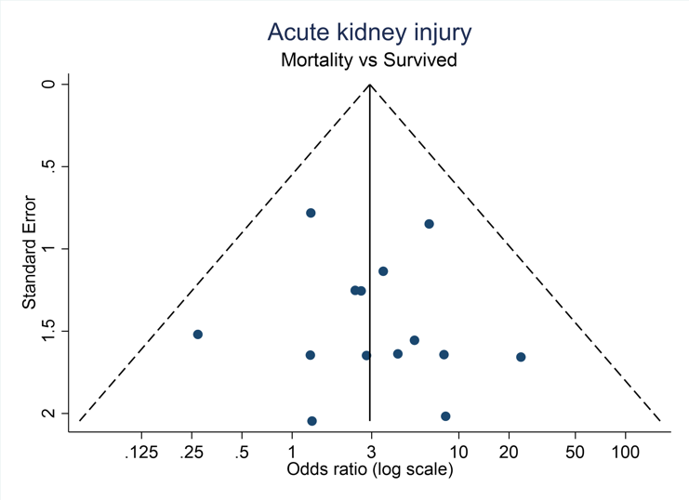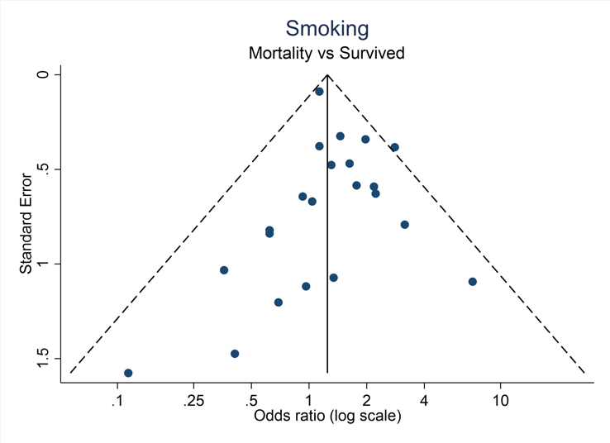
Figure 62 - Funnel plots for Odds ratios of Acute kidney injury and Smoking in those who died vs. survived

S11 Funnel plots for ICU admission vs. non-ICU admission across different indicators

Figure 63 - Funnel plot for difference of medians of Age for those who require ICU admission vs. non-ICU admission 65
Figure 64 - Funnel plots for differences of medians of Leukocyte and Lymphocyte for those who require ICU admission vs. non-ICU admission 65
Figure 65 - Funnel plots for differences of medians of Neutrophil and Respiratory Rate for those who require ICU admission vs. non-ICU admission 66
Figure 66 - Funnel plots for differences of medians of D-Dimer and Creatinine for those who require ICU admission vs. non-ICU admission 66
Figure 67 - Funnel plots for differences of medians of Troponin I (TnI) and C-reactive protein (CRP) for those who require ICU admission vs. non-ICU admission 67
Figure 68 - Funnel plots for difference of medians of Lactate Dehydrogenase (LDH) and Odds ratio of Acute kidney injury for those who require ICU admission vs. non-ICU admission 67
Figure 69 - Funnel plot for Odds of Smoking for those who require ICU admission vs. non-ICU admission 67
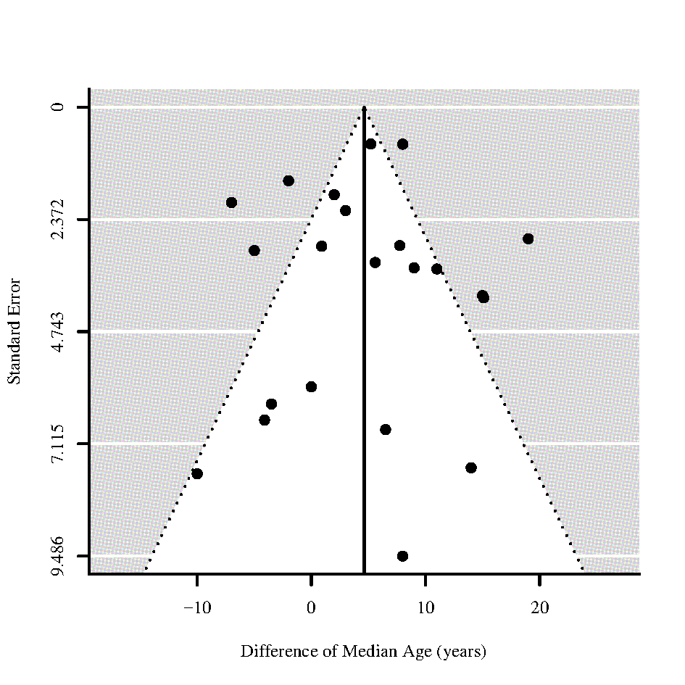
Figure 63 - Funnel plot for difference of medians of Age for those who require ICU admission vs. non-ICU admission
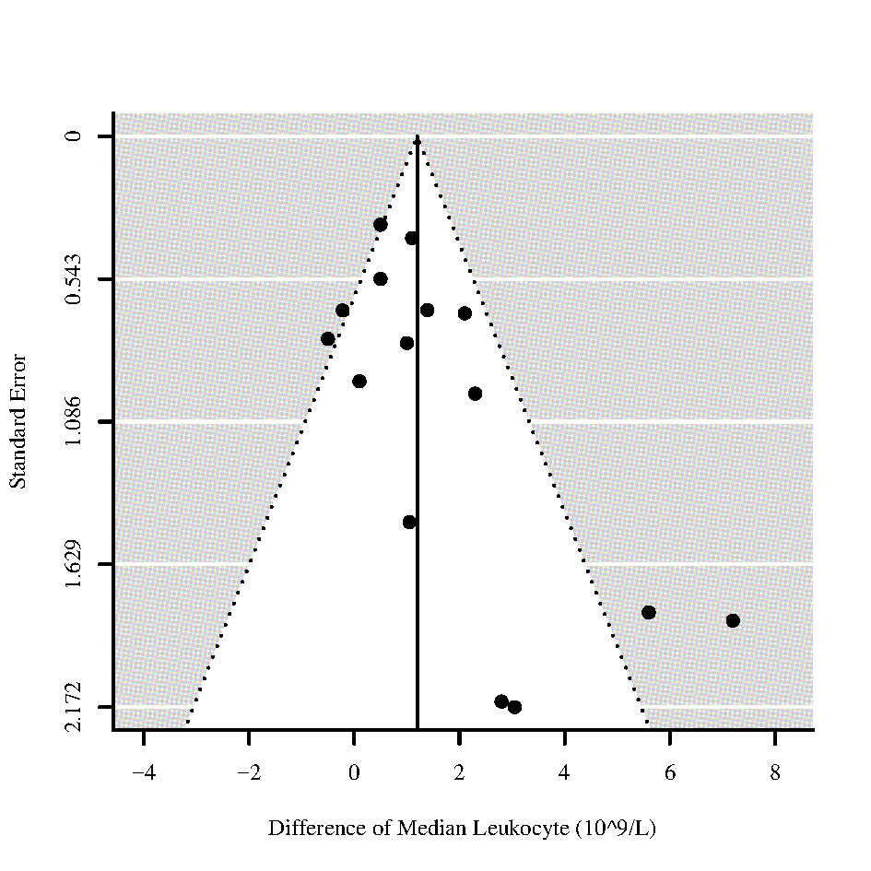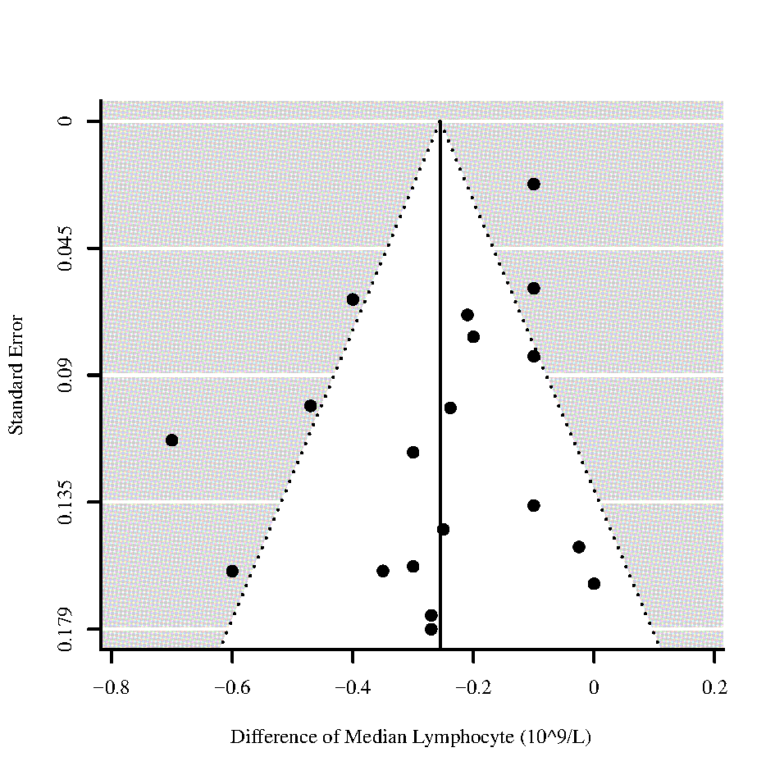
Figure 64 - Funnel plots for differences of medians of Leukocyte and Lymphocyte for those who require ICU admission vs. non-ICU admission
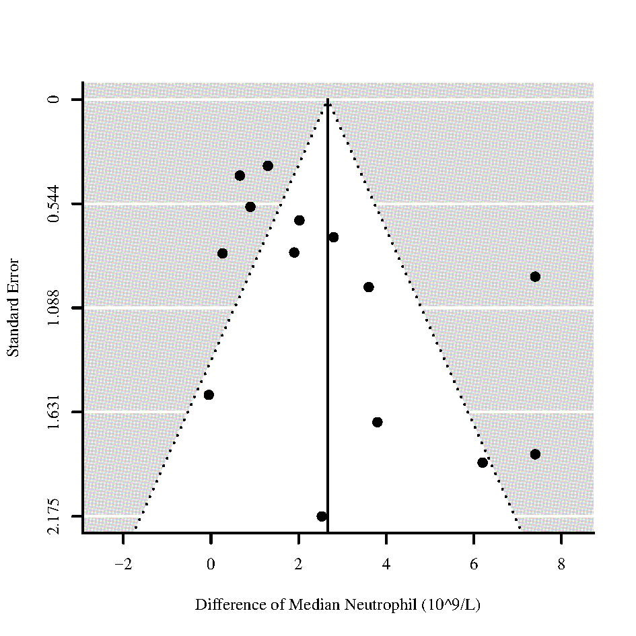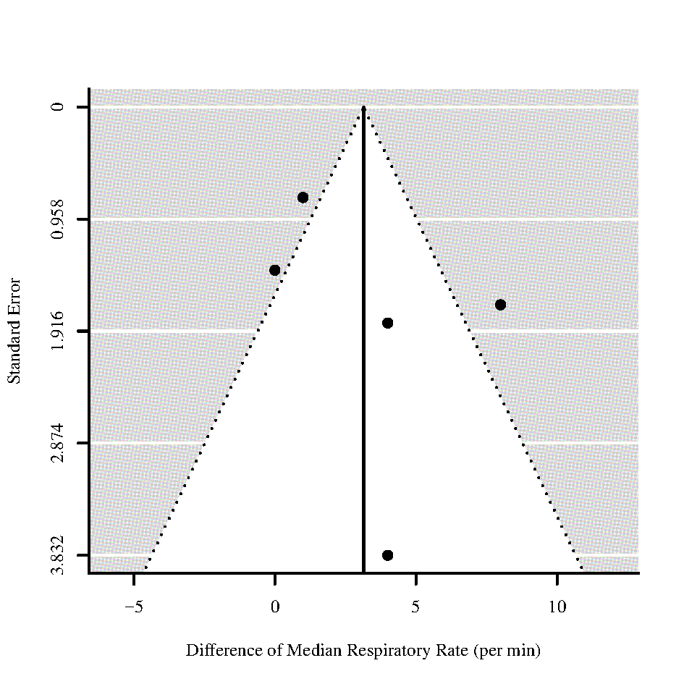

Figure 65 - Funnel plots for differences of medians of Neutrophil and Respiratory Rate for those who require ICU admission vs. non-ICU admission

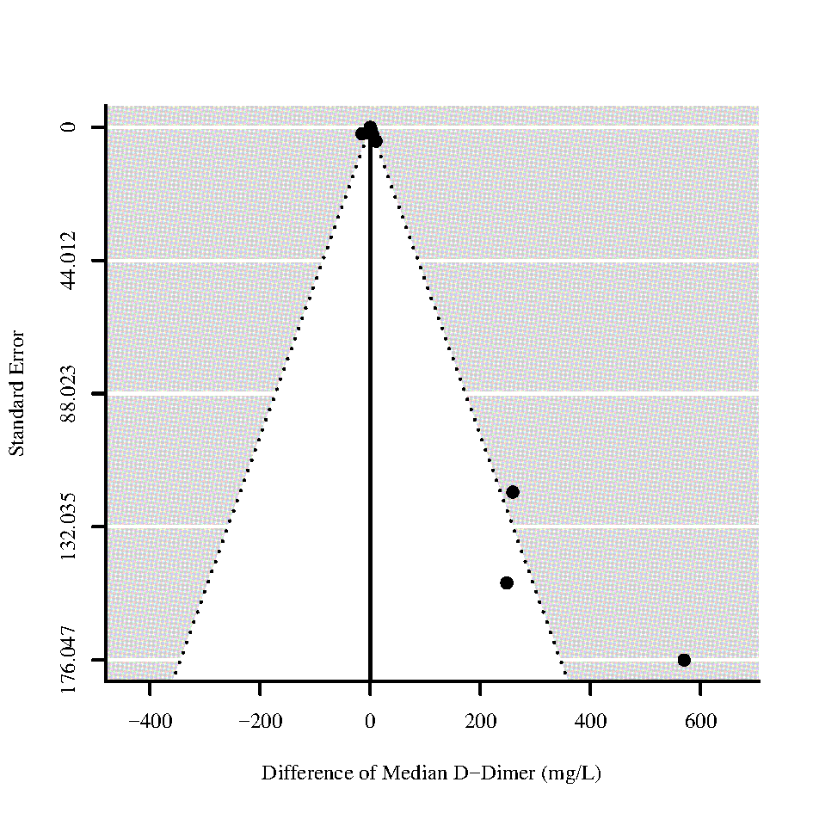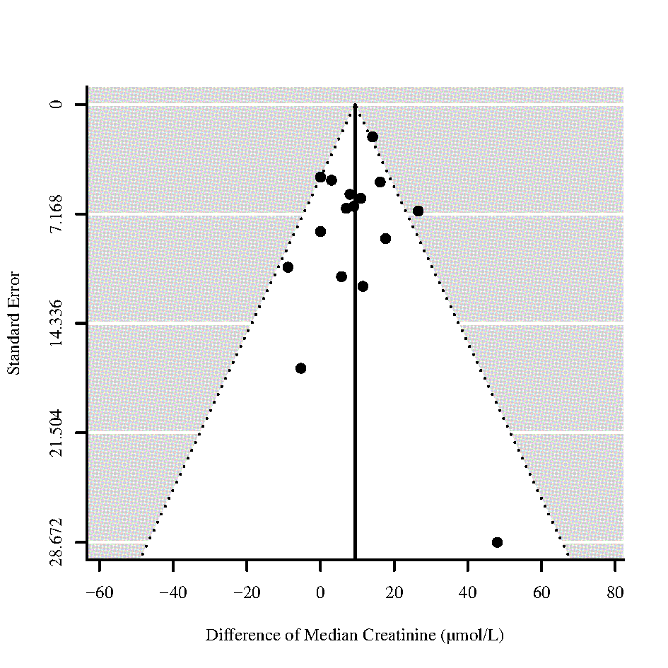
Figure 66 - Funnel plots for differences of medians of D-Dimer and Creatinine for those who require ICU admission vs. non-ICU admission
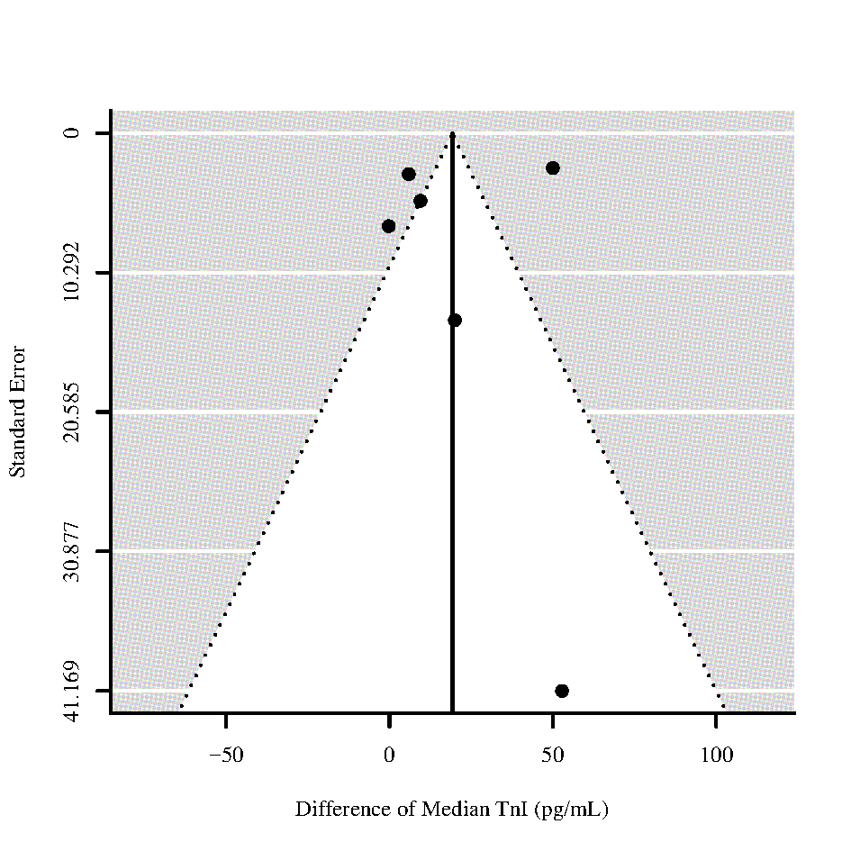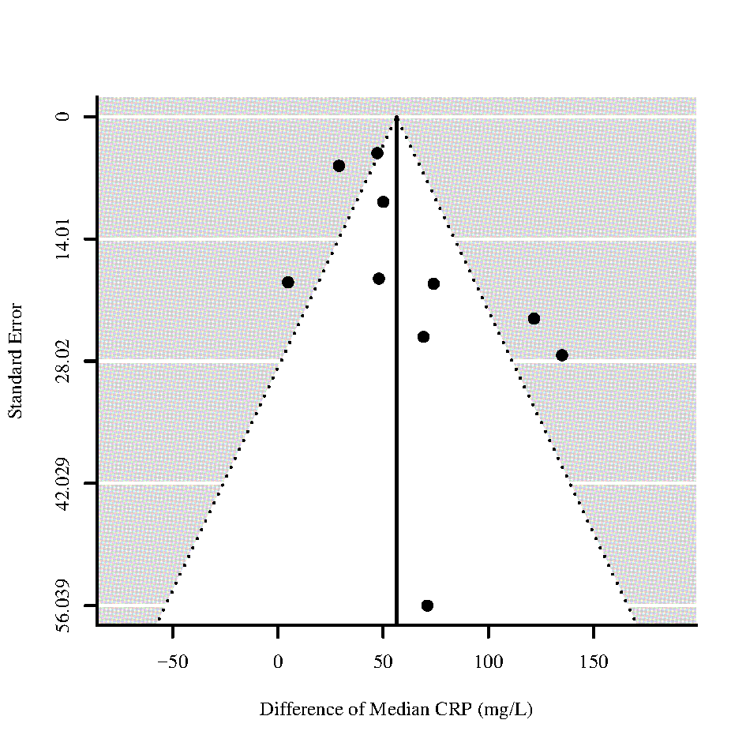
Figure 67 - Funnel plots for differences of medians of Troponin I (TnI) and C-reactive protein (CRP) for those who require ICU admission vs. non-ICU admission
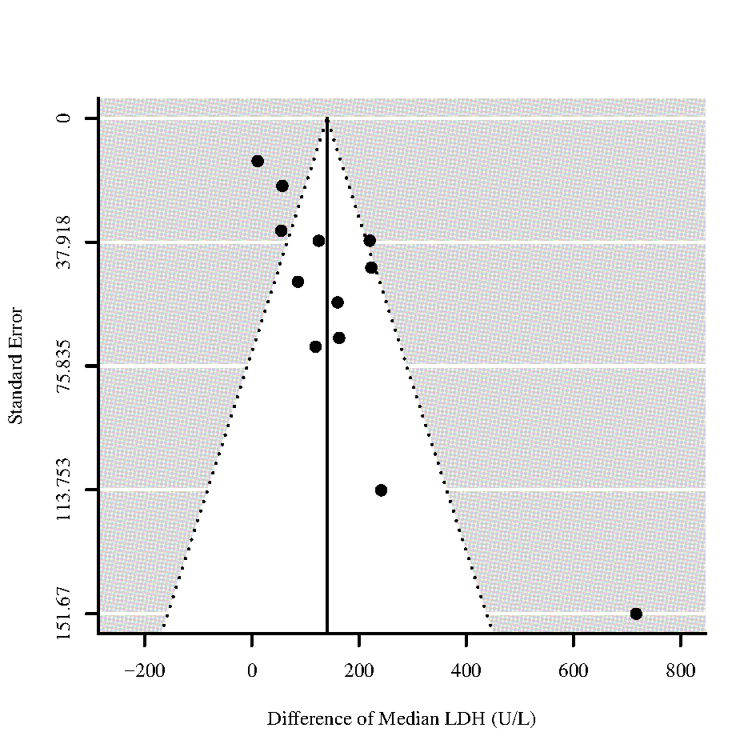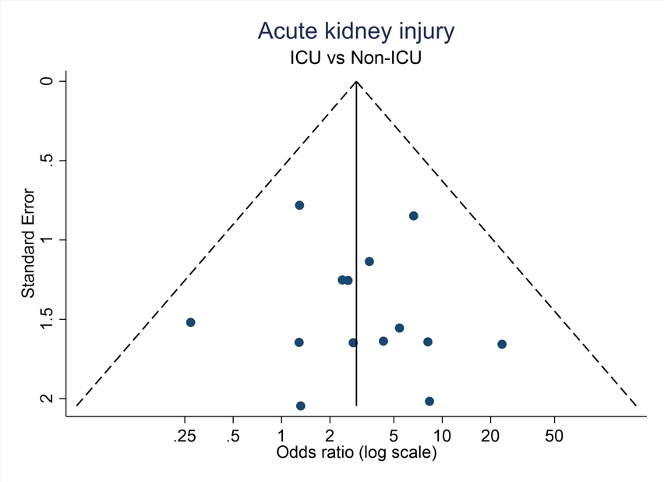
Figure 68 - Funnel plots for difference of medians of Lactate Dehydrogenase (LDH) and Odds ratio of Acute kidney injury for those who require ICU admission vs. non-ICU admission
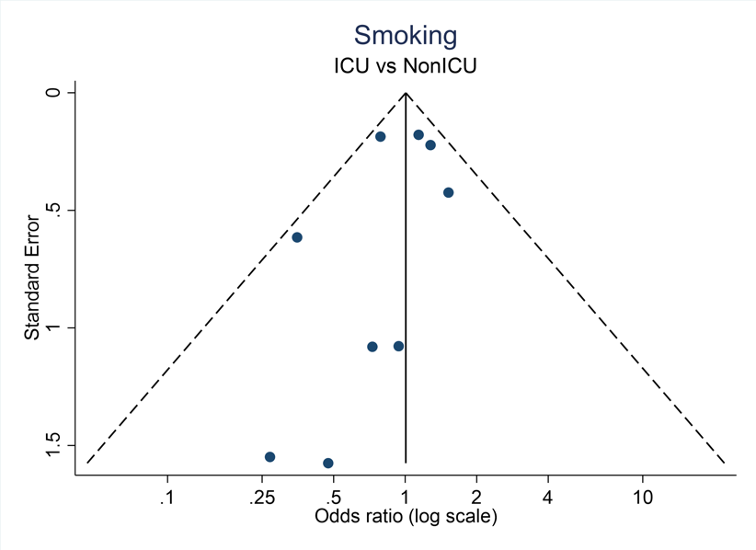
Figure 69 - Funnel plot for Odds of Smoking for those who require ICU admission vs. non-ICU admission

S12 List of data items extracted from studies

Demographics
Age
Gender
Laboratory values
Platelets
Lymphocytes
Neutrophils
Hemoglobin
Hematocrit
Leukocytes
C-reactive protein
Procalcitonin
Interleukin-6
CD-4
Viral load
Creatinine
Blood Urea Nitrogen
Glomerular filtration rate
Lactate dehydrogenase
Albumine
Creatine Kinase
Creatine kinase – myocardial band
Troponin I
Troponin T
Brain natriuretic peptide
D-Dimer
Prothrombin
Activated partial thrombin time
Internationalized normalized ratio
Fibrinogen
Antithrombin activity
Clinical
Oxygen saturation without oxygen
Oxygen saturation with oxygen
Respiratory rate
CURB-65
SOFA
qSOFA
APACHE II
Treatment
Antiviral treatment
TNF-alpha
Non-invasive ventilation
Oxygen supplementation
ECMO
Renal replacement therapy
Co-Morbidities
Hypertension
Cardiomyopathy
Cardiovascular disease
Cerebrovascular disease
Previous Pneumonia
COPD
Asthma
Any chronic lung disease
Diabetes
Acute kidney injury
Smoker
Cancer
Chronic liver disease
Digestive system disease
Immunodeficiency
Tuberculosis
Existing medication
ACE Inhibitors
ARBS
Ibuprofen
ASS
DAPT
Diuretic
OAK
Symptoms
Fever
Cough
Dyspnea / Shortness of breath
Headache
Abdominal pain
Fatigue
Confusion
Pharyngalgia
Anosmia
Asymptomatic

