SUPPLEMENTAL MATERIAL
Supplementary figure 1. Types of acute arterial and venous events occurred in the cohort of EGPA patients after diagnosis. In bold are events with frequency of 5 or more.

EGPA: Eosinophilic Granulomatosis with Polyangiitis

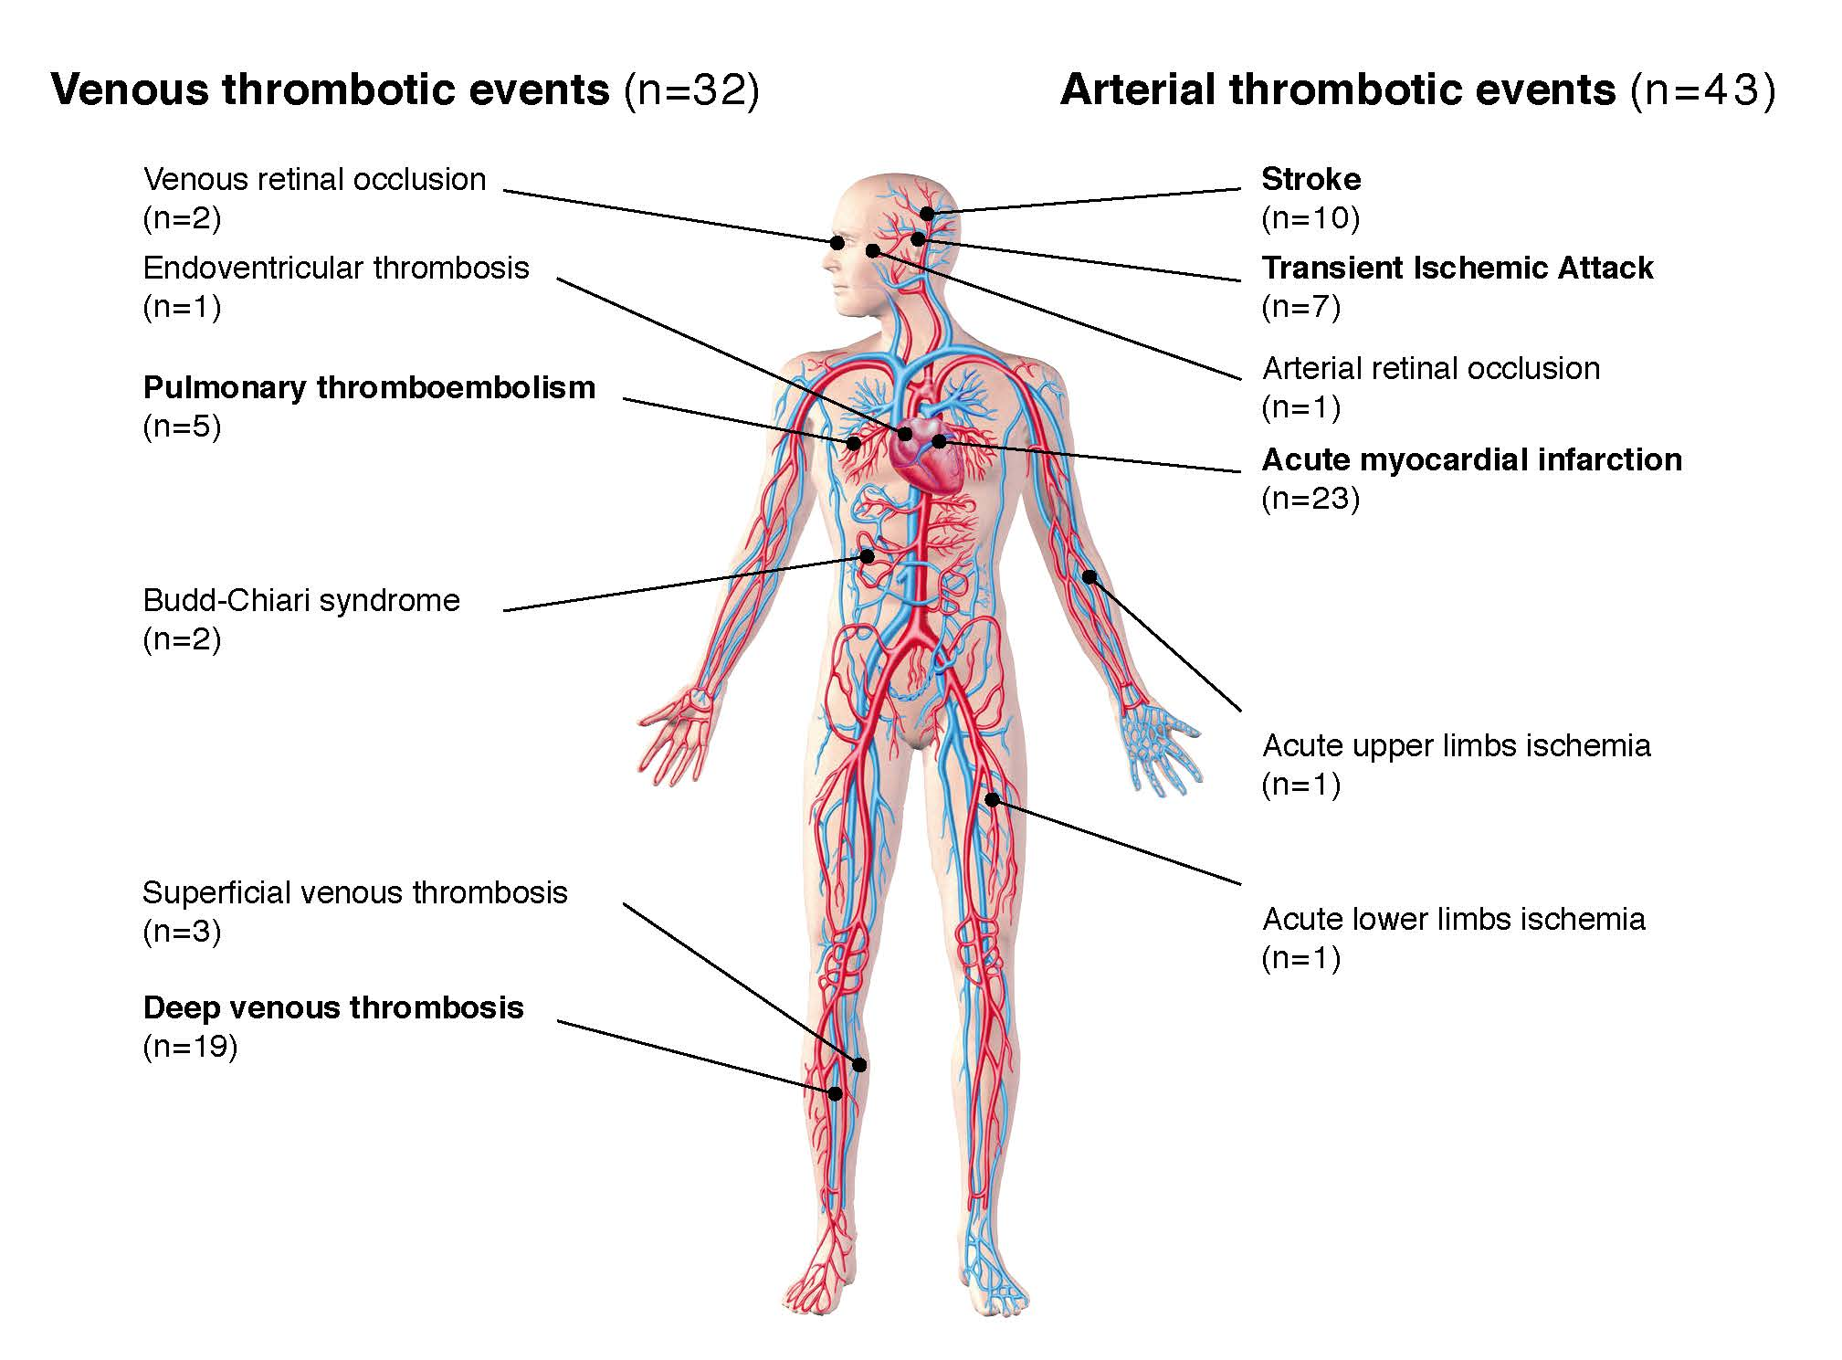
Supplementary table 1. Descriptive summary of the Bruneck cohort (n=933).
 | N (% out of 933)
Year of recruitment of the cohort | 1990
Demographic features
Female sex | 459 (49⋅2%)
Median age at entry (IQR), years | 59⋅2 (49⋅1-68⋅8)
Cardiovascular risk factors and comorbidities
Smoking | 228 (24⋅44)
Others
Hypercholesterolemia | 658 (70⋅53)
Hypertension | 597 (63⋅99)
Diabetes mellitus | 77 (8⋅25)
Cancer | 33 (3⋅54)
Cardiovascular therapy
Antiplatelets | 31 (3⋅32)
Anticoagulants | 3 (0⋅32)
Antihypertensive agents | 172 (18⋅44)
Statins | 16 (1⋅71)
Occurrence of AVTE
Median age at censoring (IQR), years | 77⋅2 (70⋅3-83⋅9)
Median duration of follow-up (IQR), years | 20⋅9 (10⋅3-25⋅6)
Thromboembolic event rate (95% CI), per 1000 person-years | 16⋅8 (15⋅0-18⋅9)
Venous thromboembolic event rate (95% CI), per 1000 person-years | 3⋅2 (2⋅5-4⋅2)
Arterial thromboembolic event rate (95% CI), per 1000 person-years | 13⋅6 (11⋅9-15⋅5)
AVTE: arterial and venous thromboembolic events; CI: confidence interval; IQR: interquartile range.

Supplementary table 2. Number of acute venous and arterial thromboembolic events in the Bruneck cohort.
 | Bruneck cohort (n=933)
Venous thromboembolic events
No. of events | 54
Deep vein thrombosis | 33
Pulmonary embolism | 13
Superficial vein thrombosis | 1
Budd-Chiari syndrome | 0
Retinal vein occlusion | 7
Intracardiac thrombosis | 0
Arterial thromboembolic events
No. of events | 226
Acute myocardial infarction | 73
Stroke | 105
Transient ischaemic attacks | 45
Retinal artery occlusion | 0
Acute upper limb ischaemia | 0
Acute lower limb ischaemia | 3
All thromboembolic events
No. of events | 280

Supplementary table 3. Adjusted Hazard Ratio [95% Confidence Intervals] of arterial and venous thromboembolic events (AVTE) among patients with no history of previous AVTE.

 | Adjusted HR [95% CI] # | p-value
Sex
Male | Ref.
Female | 0⋅75 [0⋅44 – 1⋅27] | 0⋅281
Age
<35 years | Ref.
35-65 years | 1⋅44 [0⋅56 – 3⋅71] | 0⋅451
≥65 years | 2⋅67 [0⋅93 – 7⋅67] | 0⋅069
Presence of CV risk factors
No | Ref.
Yes | 0⋅78 [0⋅45 – 1⋅32] | 0⋅352
ANCA
Negative | Ref.
Positive | 0⋅94 [0⋅51 – 1⋅74] | 0⋅846
Missing | 1⋅29 [0⋅62 – 2⋅70] | 0⋅497
BVAS
0-9 | Ref.
10-19 | 1⋅29 [0⋅67 – 2⋅44] | 0⋅2440
20+ | 2⋅22 [1⋅04 – 4⋅70] | 0⋅038*
Five-Factor Score
0 | Ref.
≥1 | 0⋅76 [0⋅38 – 1⋅52] | 0⋅438
Eosinophils
<500 cells/UL | Ref.
>=500 cells/UL | 0⋅52 [0⋅21 – 1⋅29] | 0⋅159
Missing | 0⋅71 [0⋅26 – 1⋅92] | 0⋅505
CRP
<0.9 mg/dL | Ref.
≥0.9 mg/dL | 1⋅06 [0⋅33 – 3⋅33] | 0⋅927
Missing | 2⋅00 [0⋅61 – 6⋅57] | 0⋅251
ESR
≤25 mm/h | Ref.
>25 mm/h | 0⋅56 [0⋅25 – 1⋅28] | 0⋅171
Missing | 1⋅15 [0⋅51 – 2⋅59] | 0⋅729
Immunosuppressive therapy
Only systemic steroids | Ref.
No systemic therapy | 3⋅08 [0⋅98 – 9⋅71] | 0⋅054
Traditional and/or biologic  immunosuppressants (+/- steroids) | 0⋅89 [0⋅51 – 1⋅55] | 0⋅671

# adjusted for age, sex, ANCA, BVAS, eosinophils, and presence of CV risk factors.
ANCA: Anti-Neutrophil Cytoplasmic Antibody; BVAS: Birmingham Vasculitis Activity Score; CV: Cardiovascular; CRP: C-Reactive Protein; ESR: Erythrocyte Sedimentation Rate
*statistically significant for p-value<0⋅05

