SUPPLEMENTARY MATERIAL
Supplementary Table-1. Correlations of circulating lipid levels with inflammatory serum markers and lymphocytes. A Spearman correlation analysis was used.

Variable† | Lymphocytes | C-Reactive protein | Ferritin | Interleukin-6 | Procalcitonin
Lipid laboratory profile at admission
Total cholesterol (mg/dL) | 0.191 * | -0.209 * | -0.054 | -0.301 * | -0.229*
HDL-c (mg/dL) | -0.053 | -0.228 * | -0.264 * | -0.052 | -0.189 *
LDL-c (mg/dL) | 0.179 * | -0.217 * | -0.054 | -0.334 * | -0.313*
Triglycerides (mg/dL) | 0.059 | 0.11 * | 0.257 * | -0.037 | 0.118 *
Lipid laboratory profile on the 7th day
Total cholesterol (mg/dL) | 0.203 * | -0.396 * | 0.071 | -0.266 * | -0.594*
HDL-c (mg/dL) | -0.06 | -0.315 * | -0.163 * | -0.211 | 0.361
LDL-c (mg/dL) | 0.165 * | -0.388 * | 0.062 | 0.224 | -0.547*
Triglycerides (mg/dL) | 0.178 * | -0.132 * | 0.186 * | 0.077 | 0.210
Lipid laboratory profile during follow-up††
Total cholesterol (mg/dL) | NA | -0.109 | 0.102 | -0.127 | NA
HDL-c (mg/dL) | NA | -0.205 * | -0.08 | - 0.140 | NA
LDL-c (mg/dL) | NA | -0.183 * | 0.137 | 0.019 | NA
Triglycerides (mg/dL) | NA | 0.148 * | 0.028 | 0.227 | NA
Abbreviations: HDL: High density lipoprotein cholesterol: LDL-c: Low density lipoprotein cholesterol; NA: Not applicable; TC: Total cholesterol: TG Triglycerides
* p <0.05
† Variables where compare at the specific given moment; †† Only applicable to survivors

Supplementary Figure 1. AUROC analysis for predicting 30-day mortality. Accuracy of the four components of the lipid profile were analyzed upon admission (panel A) and during the first week (panel B) for differentiating between survivors and non-survivors.
Only significant AUROC values ​​are shown in the tables.
Abbreviations: HDL: High density lipoprotein cholesterol: LDL-c: Low density lipoprotein cholesterol; TC: Total cholesterol: TG: Triglycerides; Sens: Sensitivity; Spc: Specificity
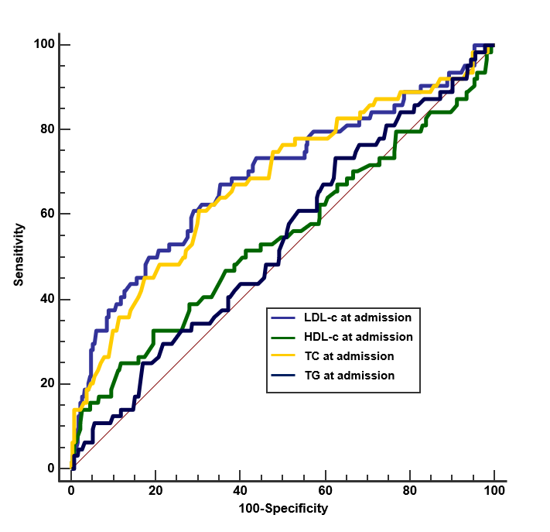

 | AUROC (95% IC) | p | Cut-off (mg/dl) | Sens | Spc
LDL-c | 0,7 (0.64 - 0.75) | <0,001 | 69 | 0.66 | 0.68
TC | 0,67 (0.63 - 0.71) | <0,001 | 132 | 0.61 | 0.68

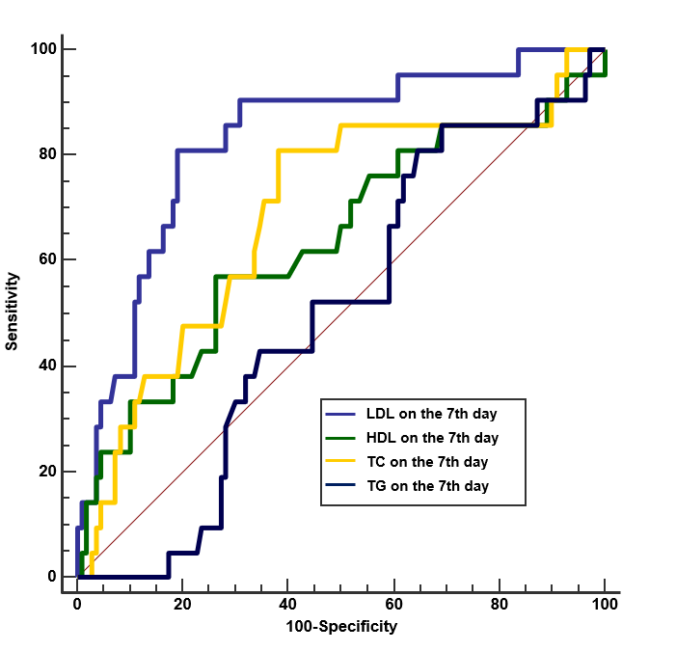

 | AUROC (95% IC) | p | Cutt-off (mg/dl) | Sens | Spc
LDL-c | 0,75 (0.63 - 0.82) | <0,001 | 75 | 0.70 | 0.69
TC | 0,70 (0.6-0.77) | <0,001 | 147 | 0.68 | 0.63

