Supporting Information
to

“Strategies for infection control and prevalence of anti-SARS-CoV-2 IgG in 4,554 employees of a university hospital in Munich, Germany”

Johanna Erber, Verena Kappler, Bernhard Haller, Hrvoje Mijočević, Ana Galhoz, Clarissa Prazeres da Costa, Friedemann Gebhardt, Natalia Graf, Dieter Hoffmann, Markus Thaler, Elke Lorenz, Hedwig Roggendorf, Florian Kohlmayer, Andreas Henkel, Michael P Menden, Jürgen Ruland, Christoph D Spinner, Ulrike Protzer, Percy Knolle, Paul Lingor, on behalf of the SeCoMRI Study Group

S1 Appendix: SeCoMRI Study Group - 1 -
S2 Appendix: Questionnaire - 2 -
S3 Appendix: Calculation of specificity and sensitivity of the SARS-CoV-2 antibody tests - 4 -
S1 Table: Samples with confirmed positive IgG against SARS-CoV-2 - 5 -
S2 Table: Summary of confirmatory assays - 8 -
S3 Table: Samples with positive IgG against SARS-CoV-2 that could not be confirmed - 8 -
S4 Table: Samples with positive IgM against SARS-CoV-2 that could not be confirmed - 8 -
S5 Table: Calculation of specificity and sensitivity - 9 -
S1 Figure - 10 -
S2 Figure - 11 -
S3 Figure - 12 -
S4 Figure - 13 -
S5 Figure - 14 -
S6 Figure - 15 -
S7 Figure - 17 -
S8 Figure - 18 -
S1 Video - 19 -
S2 Video - 19 -
S3 Video - 19 -

S1 Appendix: SeCoMRI Study Group

Balqees Al Darweesh
Clara Balzer
Felix Bauerdorf
Alexander Böhner
Dirk Busch
Lisena Cala
Ana Cirac
Adam Chaker
Anaïs Marie Theresa Doll
Johanna Erber
Manon Feuchtinger
Ana Galhoz
Friedemann, Gebhardt
Marisa Geisberger
Markus Gerhard
Oliver Goldhardt
Katharina Gresset-Kaliebe
Natalia Graf
Florian Groß
Roman Günthner
Martin Halle
Bernhard Haller
Joachim Hellemann
Andreas Henkel
Maximilian Hinz
Dieter Hoffmann
Klaus-Peter Janssen
Robert Kaczmarczyk
Verena Kappler
Percy Knolle
Florian Kohlmayer
Susanne Kossatz
Klaus Kuhn
Zsuzsanna Kurgyis
Vincent Lallinger
Judith Lammer
Paul Lingor
Elke Lorenz
Felix Mayr
Michael M. Menden
Hrvoje Mijočević
Caroline Sandra Moesta
Ruth Neuhauser
Andrea Pagani
Anna Caroline Pilz
Clarissa Prazeres da Costa
Sarah Preis
Ulrike Protzer
Michael Quante
Hedwig Roggendorf
Jürgen Ruland
Mine Sargut
Cora Scheerer
Roland M. Schmid
Paul Schmidle
Christine Schönmann
Florian Schraml
Christoph D. Spinner
Annette Susanne Steimle-Grauer
Christian Stöß
Pavel Stupakov
Markus Thaler
Dolores Thum
Dirk Tomsitz
Wolfgang Weber
Angelika Werner
Christof Winter

S2 Appendix: Questionnaire
The original survey was in German and was acquired by a standardized, electronic questionnaire.

Baseline characteristics
Date of assessment ..
Baseline characteristic: Age, sex
Department:
Worksite:

Occupation
Physician Nurse
Lab Worker Hygiene Staff Clinical Ancillary Staff Cleaning Staff Patient Transport
Administration Technical Staff IT Scientist Student Others

Do you have a patient facing role? Yes No

Exposure and personal protective equipment
In which area(s) have you been placed? (multiple answers possible)
Work area | Currently | Past 48 hours | Past 3 to 14 days | Past 3 to 8 weeks
COVID-19 assigned area
Emergency department
Ward
Intensive care unit
Other
Aerosol generating procedures*
*Endoscopy, bronchoscopy, tracheal intubation, non-invasive ventilation, transoesophageal echo, etc.

Have you been in contact with SARS-CoV-2-positive individuals? Yes No
COVID-19 contact | Currently | Past 48 hours | Past 3 to 14 days | Past 3 to 8 weeks
Patients at MRI
Co-worker at MRI
Private contact
Protected (mask and physical distance, or FFP2/N95 and eye protection when performing aerosol-generating procedures
Unprotected (none of the abovementioned, or mask only when performing aerosol generating procedures

Do you use personal protective equipment? Yes No
If so, which ones? (multiple answers possible)
Personal protective equipment | Currently | Past 48 hours | Past 3 to 14 days | Past 3 to 8 weeks
Mask
FFP2/N95
FFP3
Protective clothing
Eye protection or face shield
Others

Individual factors
What applies to you (multiple answers possible)?

Smoking Pulmonary disease Cardiovascular disease Diabetes mellitus
Immunodeficiency Immunosuppressive therapy
Other

Have you had COVID-19 compatible symptoms? Yes No (multiple answers possible)
Symptoms | Currently | Past 48 hours | Past 3 to 14 days | Past 3 to 8 weeks
Exhaustion
Fatigue
Cough
Shortness of breath
Rhinitis
Loss of smell
Loss of taste
Sore throat
Headache
Limb pain
Shivering
Diarrhoea
Elevated temperature (37.3–37.9°C)
Fever (> 38°C)
Current body temperature . °C

Have you ever been tested for SARS-CoV-2? Yes No
if so: Past 14 days More than 14 days ago

Where? MRI Registered physician Department Of Public Order
How? Nasopharyngeal swab Blood Stool

Test result:
Pending Positive for SARS-COV-2 Negative for SARS-CoV-2

COVID-19 disease

Have you already had COVID-19? Yes No

Treatment: Outpatient/at home Inpatient/normal ward Ward and intensive care unit

S3 Appendix: Calculation of specificity and sensitivity of the SARS-CoV-2 antibody tests
IgG and IgM antibodies were determined in 4554 and 1708 sera, respectively, using a paramagnetic particle chemiluminescent immunoassay (CLIA) on an iFlash 1800 immunoassay analyser (Shenzhen Yhlo Biotech Co., Shenzhen, China). This assay was selected as a screening assay as it detects antibodies directed against either SARS-CoV-2 S1 or N protein. According to the manufacturer’s instructions, values ≥ 10 AU/mL were considered positive. Anti-SARS-CoV-2 IgG titres were positive (≥ 10 AU/L) in 108 individuals, negative (< 5 AU/L) in 4411 individuals, and 35 subjects showed borderline results (5–10 AU/mL) (S5 Fig).
To determine the sensitivity and specificity of the screening assay, confirmatory testing was performed in all sera that tested positive for IgM or IgG, all sera with IgG values between 5 and 10 AU/mL, and all sera from SARS-CoV-2 PCR-positive individuals. For confirmation, the total antibodies against SARS-CoV-2 N protein were determined using an electrochemiluminescent immunoassay (ECLIA) on a Cobas e411 analyser (Roche Diagnostics, Mannheim, Germany). In all samples with incongruent results, IgG antibodies against SARS-CoV-2 S1 protein were determined using an enzyme-linked immunosorbent assay (ELISA) (Euroimmun, Luebeck, Germany), while immunoblot was used to differentiate antibodies against N, S1, and the receptor binding domain (RBD) of SARS-CoV-2 from those against seasonal coronaviruses (Mikrogen, Neuried, Germany).
Tests were considered correct if the presence of antibodies was confirmed by at least one more independent assay. Of the 108 sera that tested positive in the Yhlo screening assay, 93 also tested positive in the Roche IgG assay, eight were confirmed by immunoblotting (S1 and S4 Tables). In one individual the screening result was considered specific due to high antibody IgG titre and concomitant IgM positivity although no confirmatory testing could be performed (S1 and S4 Tables, Sample-ID 18). In another individual testing only IgG positive, the serum amount was insufficient for confirmatory testing (S3 Table, Sample-ID 114). Five IgG test results were considered false positive because screening IgG results were not confirmed by any of the other assays (S3 Table). This resulted in a specificity of 99.89% for the IgG assay (4441/4446; S5 Table).
IgM antibodies were screened in all subjects until May 4 (n=1620). Six subjects lacking prevalence of anti-SARS-CoV-2 IgG antibodies tested positive for IgM (6/1620). As this could not be confirmed by the Roche ECLIA detecting IgM and IgG antibodies, these samples were considered false positive (S4 Table). If the Roche assay would have a 100% sensitivity, this would result in a specificity of 99.63% for the IgM assay. Due to the lack of a third assay, this, however, has to be considered preliminary.
To determine the sensitivity of the Yhlo IgG screening assay, 35 samples with detectable values between 5 and 10 AU/mL, i.e. below the recommended cut-off of the assay, were retested with both the Roche and the Euroimmun assay. Four samples tested positive in the Roche and Euroimmun assays, and were therefore considered false negative in the Yhlo screening assay (S1 and S4 Tables). This allowed us to estimate the overall sensitivity of the IgG assay at 96.30% (104/108, S5 Table).
For estimation of seroprevalence, individuals with at least two positive antibody tests (n=106) as well as two individuals with positive SARS-CoV-2 PCR tests that seroconverted during follow-up, were considered seropositive (108/4554) resulting in a seroprevalence of 2•4%. The IgG antibody levels of seropositive individuals were inversely correlated with the time of testing (rho = -0.22, [95% CI -0.39 to -0.03]) (S5 Fig).
From May 5, subjects were tested for anti-SARS-CoV-2 IgM antibodies if specific anti-SARS-CoV-2 IgG antibodies were detected or typical symptoms of COVID-19 were reported (n=88). Overall, concomitant anti-SARS-CoV-2 IgG and IgM was found in 22 subjects (22/1708), of these nine before May 5 (S2 Fig).

S1 Table: Samples with confirmed positive IgG against SARS-CoV-2
Sample  ID | SARS-CoV-2 PCR | YHLO IgG  (AU/mL) |  | YHLO IgM  (AU/mL) |  | Roche IgG ‡ IgM  (COI) |  | Euroimmun IgG | Mikrogen recomLine
1 | •• | POSITIVE | (80.12) | POSITIVE | (19.27) | POSITIVE | (14.42) | •• | ••
2 | •• | POSITIVE | (92.39) | POSITIVE | (17.93) | POSITIVE | (52.30) | •• | ••
3 | •• | POSITIVE | (64.82) | POSITIVE | (31.04) | POSITIVE | (25.83) | •• | ••
4 | § | POSITIVE | (113.83) | NEGATIVE | (1.78) | POSITIVE | (66.12) | •• | ••
5 | §‡ | POSITIVE | (93.54) | NEGATIVE | (2.43) | POSITIVE | (21.33) | •• | ••
6 | § | POSITIVE | (109.62) | NEGATIVE | (3.46) | POSITIVE | (49.23) | •• | ••
7 | •• | POSITIVE | (102.26) | NEGATIVE | (2.36) | POSITIVE | (17.38) | •• | ••
8 | •• | POSITIVE | (33.60) | NEGATIVE | (2.80) | POSITIVE | (9.08) | •• | ••
9 | •• | POSITIVE | (28.28) | NEGATIVE | (2.80) | NEGATIVE | (0.06) | NEGATIVE | POSITIVE
10 | •• | POSITIVE | (38.15) | NEGATIVE | (4.40) | POSITIVE | (13.05) | •• | ••
11 | •• | POSITIVE | (113.58) | NEGATIVE | (3.05) | POSITIVE | (65.42) | •• | ••
12 | § | POSITIVE | (96.21) | NEGATIVE | (1.91) | POSITIVE | (47.08) | •• | ••
13 | § | POSITIVE | (78.86) | NEGATIVE | (2.29) | POSITIVE | (32.81) | •• | ••
14 | ‡ | POSITIVE | (107.45) | NEGATIVE | (0.59) | POSITIVE | (14.49) | •• | ••
15 | •• | POSITIVE | (41.99) | NEGATIVE | (2.59) | POSITIVE | (2.98) | •• | ••
16 | ‡ | POSITIVE | (69.45) | NEGATIVE | (0.60) | NEGATIVE | (0.055) | NEGATIVE | POSITIVE
17 | •• | POSITIVE | (84.41) | NEGATIVE | (5.78) | POSITIVE | (40.43) | •• | ••
18 | •• | POSITIVE | (78.97) | POSITIVE | (34.76) | * | •• | * | ••
19 | §‡ | POSITIVE | (12.45) | NEGATIVE | (0.83) | NEGATIVE | (0.45) | BORDERLINE | POSITIVE
20 | •• | POSITIVE | (86.18) | NEGATIVE | (1.14) | POSITIVE | (19.89) | •• | ••
21 | •• | POSITIVE | (22.12) | NEGATIVE | (0.73) | POSITIVE | (1.81) | •• | ••
22 | •• | POSITIVE | (92.35) | POSITIVE | (19.96) | POSITIVE | (28.59) | •• | ••
23 | •• | POSITIVE | (100.84) | POSITIVE | (11.19) | POSITIVE | (84.33) | •• | ••
24 | •• | POSITIVE | (30.86) | NEGATIVE | (0.48) | NEGATIVE | (0.054) | NEGATIVE | POSITIVE
25 | ‡ | POSITIVE | (95.56) | NEGATIVE | (6.06) | POSITIVE | (27.94) | •• | ••
26 | •• | POSITIVE | (91.06) | NEGATIVE | (1.41) | POSITIVE | (48.79) | •• | ••
27 | •• | POSITIVE | (25.61) | NEGATIVE | (1.89) | POSITIVE | (4.55) | •• | ••
28 | § | POSITIVE | (35.34) | NEGATIVE | (1.67) | POSITIVE | (7.32) | •• | ••
29 | •• | POSITIVE | (72.10) | POSITIVE | (22.39) | POSITIVE | (75.58) | •• | ••
30 | § | POSITIVE | (97.45) | NEGATIVE | (4.91) | POSITIVE | (65.48) | •• | ••
31 | § | POSITIVE | (59.51) | POSITIVE | (10.26) | POSITIVE | (79.13) | •• | ••
32 | •• | POSITIVE | (42.14) | POSITIVE | (17.68) | POSITIVE | (14.92) | •• | ••
33 | § | POSITIVE | (49.91) | NEGATIVE | (1.19) | POSITIVE | (27.04) | •• | ••
34 | §‡ | POSITIVE | (97.02) | NEGATIVE | (10.00) | POSITIVE | (99.14) | •• | ••
35 | §‡ | POSITIVE | (91.68) | NEGATIVE | (1.89) | POSITIVE | (14.13) | •• | ••
36 | •• | POSITIVE | (35.20) | NEGATIVE | (1.98) | POSITIVE | (2.63) | •• | ••
37 | § | POSITIVE | (55.52) | NEGATIVE | (0.53) | POSITIVE | (10.45) | •• | ••
38 | •• | POSITIVE | (27.81) | NEGATIVE | (0.48) | POSITIVE | (14.44) | •• | ••
39 | •• | POSITIVE | (98.57) | NEGATIVE | (4.07) | POSITIVE | (70.04) | •• | ••
40 | •• | POSITIVE | (86.47) | NEGATIVE | (9.97) | POSITIVE | (89.22) | •• | ••
41 | •• | POSITIVE | (12.51) | NEGATIVE | (1.06) | POSITIVE | (2.87) | •• | ••
Sample ID | SARS-CoV-2 PCR | YHLO IgG  (AU/mL) |  | YHLO IgM  (AU/mL) |  | Roche IgG ‡ IgM  (COI) |  | Euroimmun IgG | Mikrogen recomLine
42 | •• | POSITIVE | (45.40) | NEGATIVE | (0.79) | POSITIVE | (21.43) | •• | ••
43 | §‡ | POSITIVE | (40.13) | NEGATIVE | (1.65) | POSITIVE | (25.15) | •• | ••
44 | §‡ | POSITIVE | (35.65) | NEGATIVE | (9.91) | POSITIVE | (51.67) | •• | ••
45 | §‡ | POSITIVE | (91.08) | NEGATIVE | (0.43) | POSITIVE | (89.17) | •• | ••
46 | •• | POSITIVE | (45.18) | NEGATIVE | (1.76) | POSITIVE | (30.29) | •• | ••
47 | §‡ | POSITIVE | (113.23) | NEGATIVE | (2.61) | POSITIVE | (40.58) | •• | ••
48 | •• | POSITIVE | (73.79) | NEGATIVE | (0.67) | POSITIVE | (43.39) | •• | ••
49 | •• | POSITIVE | (93.50) | POSITIVE | (10.14) | POSITIVE | (27.46) | •• | ••
50 | §‡ | POSITIVE | (84.28) | NEGATIVE | (0.68) | POSITIVE | (50.96) | •• | ••
51 | §‡ | POSITIVE | (96.75) | NEGATIVE | (4.80) | POSITIVE | (100.30) | •• | ••
52 | •• | POSITIVE | (36.27) | NEGATIVE | (0.85) | POSITIVE | (2.72) | •• | ••
53 | •• | POSITIVE | (10.52) | NEGATIVE | (0.37) | NEGATIVE | (0.061) | NEGATIVE | POSITIVE
54 | § | POSITIVE | (49.49) | NEGATIVE | (0.94) | POSITIVE | (39.16) | •• | ••
55 | •• | POSITIVE | (50.98) | NEGATIVE | (1.54) | POSITIVE | (78.15) | •• | ••
56 | §‡ | POSITIVE | (83.97) | NEGATIVE | (5.40) | POSITIVE | (45.04) | •• | ••
57 | ‡ | POSITIVE | (32.83) | NEGATIVE | (0.24) | POSITIVE | (19.70) | •• | ••
58 | § | POSITIVE | (72.67) | NEGATIVE | (3.55) | POSITIVE | (11.77) | •• | ••
59 | •• | POSITIVE | (60.13) | NEGATIVE | (2.74) | NEGATIVE | (0.055) | NEGATIVE | POSITIVE
60 | •• | POSITIVE | (66.95) | NEGATIVE | (2.27) | POSITIVE | (39.01) | •• | ••
61 | ‡ | POSITIVE | (47.80) | NEGATIVE | (1.08) | POSITIVE | (19.42) | •• | ••
62 | •• | POSITIVE | (82.89) | NEGATIVE | (4.19) | POSITIVE | (60.83) | •• | ••
63 | § | POSITIVE | (23.44) | NEGATIVE | (0.42) | POSITIVE | (14.57) | •• | ••
64 | •• | POSITIVE | (20.75) | NEGATIVE | (1.49) | POSITIVE | (21.14) | •• | ••
65 | •• | POSITIVE | (45.24) | NEGATIVE | (0.72) | POSITIVE | (53.24) | •• | ••
66 | •• | POSITIVE | (33.84) | NEGATIVE | (0.29) | POSITIVE | (17.67) | •• | ••
67 | •• | POSITIVE | (14.69) | NEGATIVE | (0.49) | POSITIVE | (10.88) | •• | ••
68 | ‡ | POSITIVE | (54.55) | POSITIVE | (22.09) | POSITIVE | (62.24) | •• | ••
69 | ‡ | POSITIVE | (46.11) | NEGATIVE | (0.95) | POSITIVE | (36.16) | •• | ••
70 | ‡ | POSITIVE | (10.01) | NEGATIVE | (1.34) | POSITIVE | (9.90) | •• | ••
71 | •• | POSITIVE | (52.17) | NEGATIVE | (0.62) | POSITIVE | (32.00) | •• | ••
72 | •• | POSITIVE | (13.79) | NEGATIVE | (0.73) | POSITIVE | (8.11) | •• | ••
73 | •• | POSITIVE | (69.38) | POSITIVE | (29.99) | POSITIVE | (91.78) | •• | ••
74 | •• | POSITIVE | (68.40) | NEGATIVE | (4.42) | POSITIVE | (90.23) | •• | ••
75 | •• | POSITIVE | (27.70) | NEGATIVE | (0.40) | POSITIVE | (6.11) | •• | ••
76 | •• | POSITIVE | (82.56) | POSITIVE | (19.32) | POSITIVE | (102.00) | •• | ••
77 | •• | POSITIVE | (58.50) | NEGATIVE | (0.41) | POSITIVE | (84.81) | •• | ••
78 | §‡ | POSITIVE | (74.31) | NEGATIVE | (0.78) | POSITIVE | (68.42) | •• | ••
79 | •• | POSITIVE | (69.18) | NEGATIVE | (0.50) | POSITIVE | (81.05) | •• | ••
80 | •• | POSITIVE | (35.63) | NEGATIVE | (1.11) | POSITIVE | (62.51) | •• | ••
81 | ‡ | POSITIVE | (64.48) | NEGATIVE | (0.80) | POSITIVE | (56.41) | •• | ••
82 | •• | POSITIVE | (82.53) | POSITIVE | (22.54) | POSITIVE | (81.01) | •• | ••
83 | •• | POSITIVE | (10.52) | NEGATIVE | (0.48) | NEGATIVE | (0.053) | NEGATIVE | POSITIVE
Sample ID | SARS-CoV-2 PCR | YHLO IgG  (AU/mL) |  | YHLO IgM  (AU/mL) |  | Roche IgG ‡ IgM  (COI) |  | Euroimmun  IgG | Mikrogen recomLine
84 | •• | POSITIVE | (68.97) | NEGATIVE | (2.00) | POSITIVE | (51.00) | •• | ••
85 | •• | POSITIVE | (80.39) | NEGATIVE | (5.54) | POSITIVE | (94.25) | •• | ••
86 | ‡ | POSITIVE | (52.70) | POSITIVE | (30.33) | POSITIVE | (40.29) | •• | ••
87 | •• | POSITIVE | (35.43) | NEGATIVE | (0.36) | POSITIVE | (16.54) | •• | ••
88 | § | POSITIVE | (27.04) | NEGATIVE | (5.83) | POSITIVE | (1.15) | •• | ••
89 | •• | POSITIVE | (75.74) | NEGATIVE | (2.60) | POSITIVE | (85.36) | •• | ••
90 | •• | POSITIVE | (57.12) | NEGATIVE | (2.73) | NEGATIVE | (0.055) | NEGATIVE | POSITIVE
91 | •• | POSITIVE | (26.50) | NEGATIVE | (0.45) | POSITIVE | (52.46) | •• | ••
92 | •• | POSITIVE | (63.67) | NEGATIVE | (0.46) | POSITIVE | (31.93) | •• | ••
93 | •• | POSITIVE | (56.33) | NEGATIVE | (0.67) | POSITIVE | (100.70) | •• | ••
94 | •• | POSITIVE | (85.75) | NEGATIVE | (0.66) | POSITIVE | (112.80) | •• | ••
95 | •• | POSITIVE | (41.98) | NEGATIVE | (0.63) | POSITIVE | (87.69) | •• | ••
96 | •• | POSITIVE | (14.15) | NEGATIVE | (0.97) | POSITIVE | (11.00) | •• | ••
97 | § | POSITIVE | (83.09) | NEGATIVE | (1.92) | POSITIVE | (112.00) | •• | ••
98 | •• | POSITIVE | (43.75) | NEGATIVE | (0.63) | POSITIVE | (77.74) | •• | ••
99 | ‡ | POSITIVE | (54.46) | NEGATIVE | (22.17) | POSITIVE | (73.22) | •• | ••
100 | §‡ | POSITIVE | (86.86) | NEGATIVE | (1.45) | POSITIVE | (70.92) | •• | ••
101 | •• | POSITIVE | (15.87) | NEGATIVE | (1.08) | POSITIVE | (3.05) | •• | ••
102 | §‡ | POSITIVE | (63.04) | NEGATIVE | (5.02) | POSITIVE | (120.80) | •• | ••
103 | §‡ | NEGATIVE | (6.55) | •• | •• | POSITIVE | (1.76) | POSITIVE | ••
104 | ‡ | NEGATIVE | (5.26) | •• | •• | POSITIVE | (2.22) | POSITIVE | ••
105 | •• | NEGATIVE | (8.81) | •• | •• | POSITIVE | (5.85) | POSITIVE | ••
106 | ‡ | NEGATIVE | (6.64) | •• | •• | POSITIVE | (1.75) | POSITIVE | ••
107† | § | POSITIVE† | (37.99) | POSITIVE† | (20.47) | •• | •• | •• | ••
108† | § | POSITIVE† | (45.70) | NEGATIVE | (1.14) | •• | •• | •• | ••
* No material for further tests available, † positive at follow-up visit, COI: Cut-off index, ‡ positive SARS-CoV-2 PCR extern, § positive SARS-CoV-2 PCR in-house, •• not available

S2 Table: Summary of confirmatory assays
YHLO IgG  (AU/ml) | YHLO IgM  (AU/ml) | Roche IgG ‡ IgM  (COI) | Euroimmun IgG  (ratio) | Mikrogen recomLine  immunoblot | Final result | No. of subjects
POSITIVE | •• | POSITIVE | •• | •• | POSITIVE | 93
POSITIVE | •• | NEGATIVE | NEGATIVE | POSITIVE | POSITIVE | 8
POSITIVE | NEGATIVE | NEGATIVE | NEGATIVE/BORDERLINE | NEGATIVE | NEGATIVE | 5
POSITIVE | POSITIVE | * | * | * | POSITIVE | 1
POSITIVE | NEGATIVE | * | * | NEGATIVE | Excluded from calculation of specificity | 1
BORDERLINE | •• | POSITIVE | POSITIVE | •• | POSITIVE | 4
POSITIVE† | •• | •• | •• | •• | POSITIVE | 2§
† Initially negative, but positive at follow-up visit, * no material for further tests available, § in-house SARS-CoV-2 PCR positive, COI: Cut-off index

S3 Table: Samples with positive IgG against SARS-CoV-2 that could not be confirmed
Sample ID | YHLO IgG  (AU/mL) |  | YHLO IgM  (AU/mL) |  | Roche IgG ‡ IgM  (COI) |  | Euroimmun IgG | Mikrogen recomLine
109 | POSITIVE | (26.78) | NEGATIVE | (0.19) | NEGATIVE | (0.079) | NEGATIVE | NEGATIVE
110 | POSITIVE | (23.75) | NEGATIVE | (1.17) | NEGATIVE | (0.055) | BORDERLINE | NEGATIVE
111 | POSITIVE | (10.14) | NEGATIVE | (0.82) | NEGATIVE | (0.126) | NEGATIVE | NEGATIVE
112 | POSITIVE | (21.46) | NEGATIVE | (0.44) | NEGATIVE | (0.102) | NEGATIVE | NEGATIVE
113 | POSITIVE | (12.13) | NEGATIVE | (0.50) | NEGATIVE | (0.055) | NEGATIVE | NEGATIVE
114 | POSITIVE | (11.75) | NEGATIVE | (0.28) | * | •• | * | ••
* No material for further tests available

S4 Table: Samples with positive IgM against SARS-CoV-2 that could not be confirmed
Sample ID | YHLO IgG  (AU/mL) |  | YHLO IgM  (AU/mL) |  | Roche IgG ‡ IgM  (COI)
115 | NEGATIVE | (0.98) | POSITIVE | (11.51) | NEGATIVE | (0.054)
116 | NEGATIVE | (0.41) | POSITIVE | (13.71) | NEGATIVE | (0.055)
117 | NEGATIVE | (2.90) | POSITIVE | (13.41) | NEGATIVE | (0.055)
118 | NEGATIVE | (0.28) | POSITIVE | (12.23) | NEGATIVE | (0.056)
119 | NEGATIVE | (0.45) | POSITIVE | (10.27) | NEGATIVE | (0.056)
120 | NEGATIVE | (0.14) | POSITIVE | (265.82) | NEGATIVE | (0.056)

S5 Table: Calculation of specificity and sensitivity
 | ≥ 2 Positive confirmatory tests or concomitant IgM | < 2 Positive confirmatory tests | Total
Screening assay positive | True positive  n =104 | False positive  n = 5 | n = 109†
Screening assay negative | False negative  n = 4 | True negative  n = 4441 | n = 4445
Total | n = 108 | n = 4446 | 4554
†Serum material was insufficient for confirmatory testing in one seropositive subject, two subjects seroconverted at follow-up visit.

S1 Figure
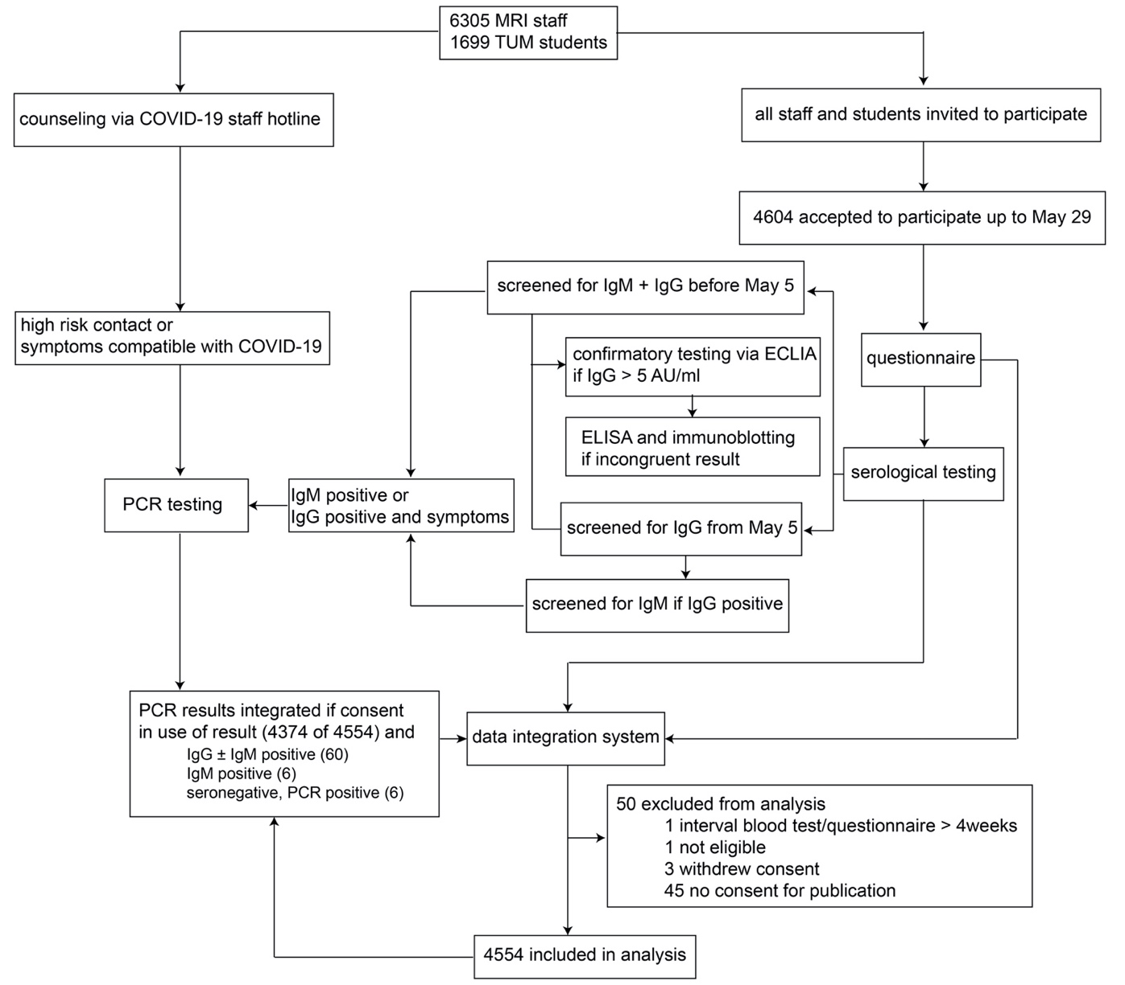
S1 Fig: Study flow chart illustrating the testing algorithm and included results
CLIA: Chemiluminescent immunoassay, ECLIA: Electrochemiluminescent immunoassay, ELISA: Enzyme-linked immunosorbent assay, MRI: Munich rechts der Isar Hospital, PCR: Polymerase chain reaction, TUM: Technical University Munich

S2 Figure
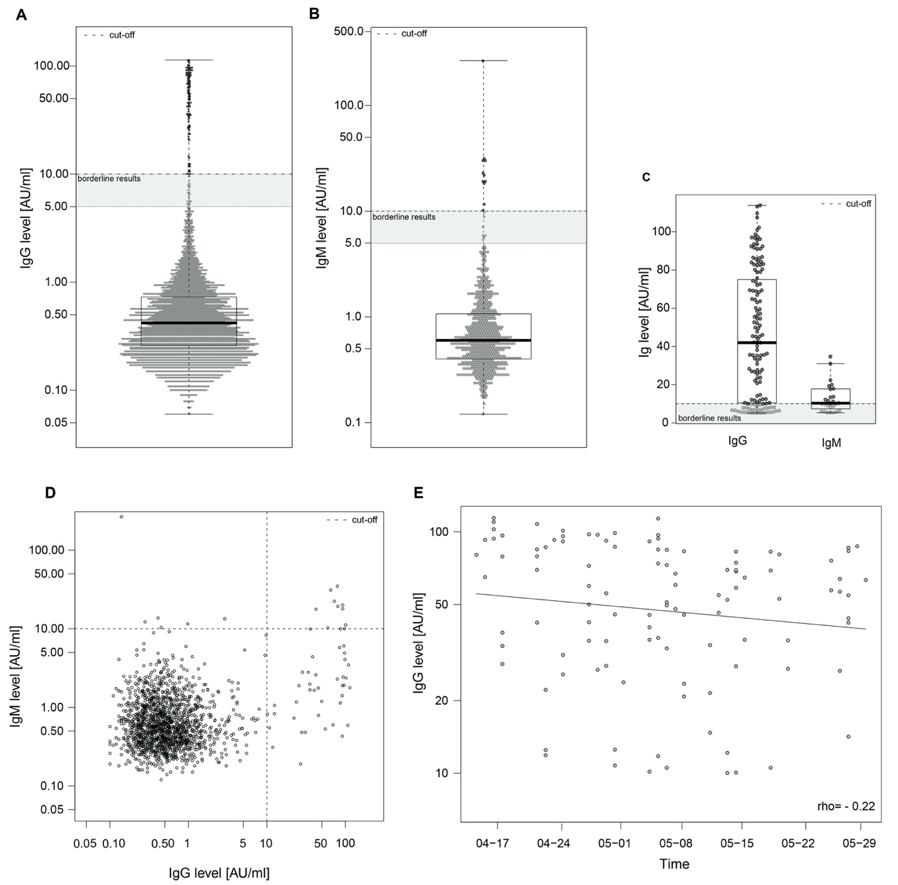
S2 Fig: Anti-SARS-CoV-2 IgG and IgM levels
Anti-SARS-CoV-2 IgG and IgM antibodies were detected using a paramagnetic particle chemiluminescent immunoassay (Shenzhen Yloh Biotech; Shenzhen, China). The cut-off was defined as ≥ 10 AU/mL per assay instruction, and is indicated by a dashed line. Boxplots show medians (thick middle line), as well as first and third quartiles (box boundaries), while the whiskers indicate ranges. IgG antibodies were measured in all participants (n = 4554) (A). The IgM levels of all participants tested up to May 4, 2020 (n = 1620) are depicted in (B). Thereafter, IgM was only tested in cases with positive IgG results (n = 88, data not shown). All positive IgG and IgM results (up to May 4), as well as borderline results (> 5 AU/L and < 10) are depicted in (C). (D) Shows the correlation of IgG and IgM levels of all participants tested for both immunoglobulins (n=1620 = 1708). (E) IgG levels detected in seropositive individuals are plotted per study day. Spearman’s rank correlation coefficient was used to evaluate the association between the time point of IgG testing and the IgG titre level.

S3 Figure
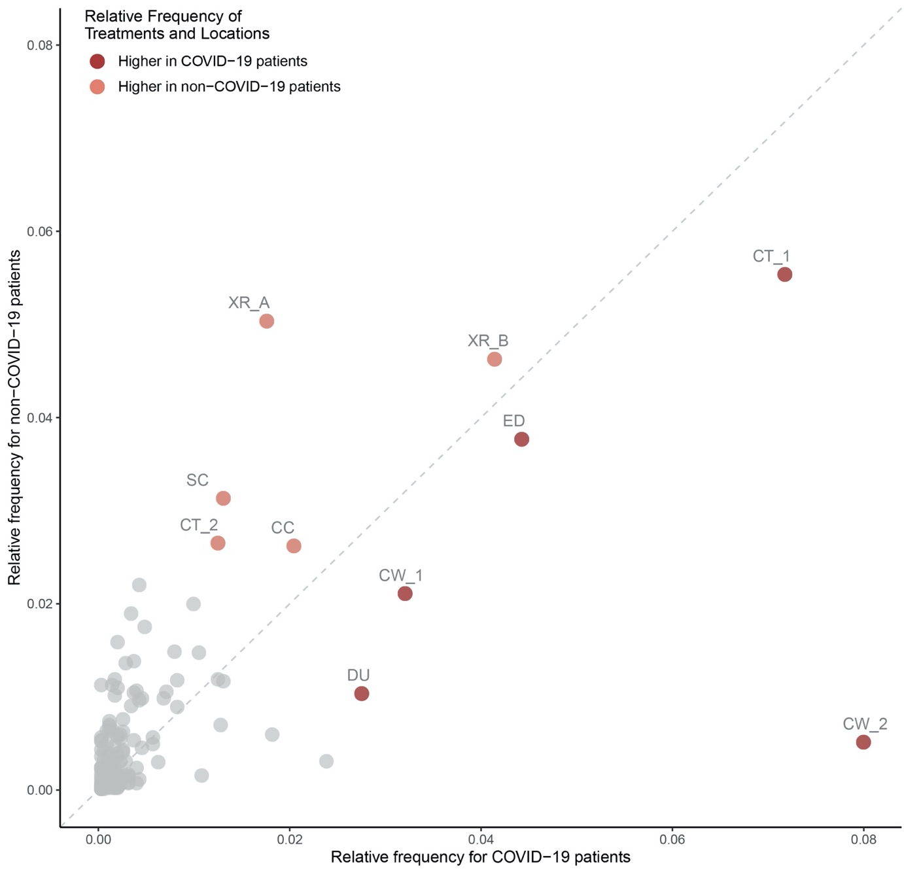

S3 Fig: Relative frequency of requested diagnostics, therapies, and spatial information between patients diagnosed with COVID-19 and non-COVID-19 pneumonia from December 1, 2019 to June 10, 2020 normalized by each patient group
Diagram demonstrating that the diagnostic and therapeutic facilities for patients with COVID-19 and non-COVID-19 pneumonia were used differentially by the two patient groups, further limiting the possibilities of infection. CC: Cardiovascular clinic, CT_1 and CT_2: Spatially distinct CT scanners, CW_1: COVID-19 admission ward, CW_2: COVID-19 ward, DU: dialysis unit, ED: Emergency department, SC: Social counselling, XR_A and XR_B: Spatially distinct X-ray units.

S4 Figure
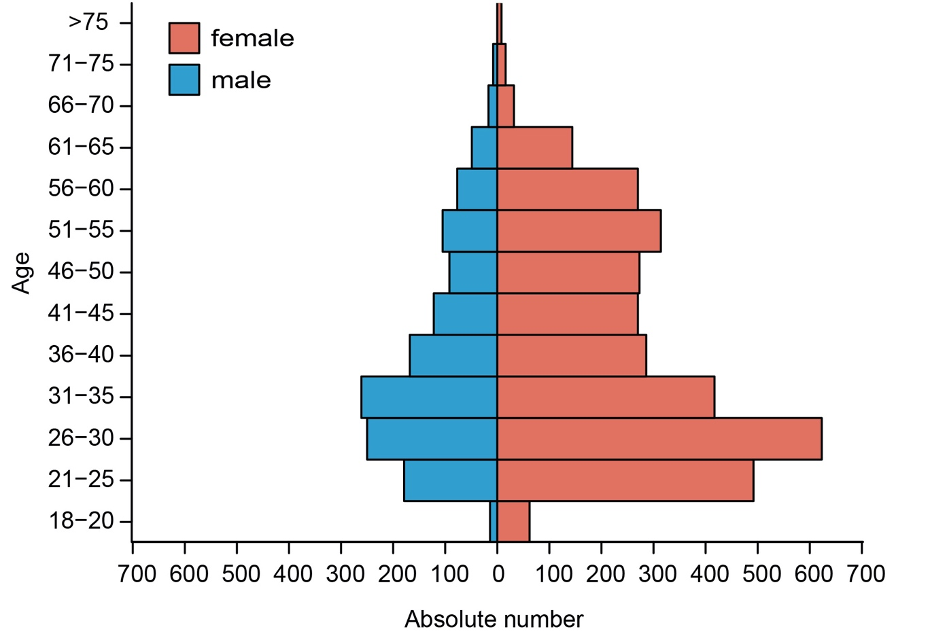
S4 Fig: Age and sex distribution of the study participants
The population pyramid depicts the age and sex distribution of the subjects.

S5 Figure
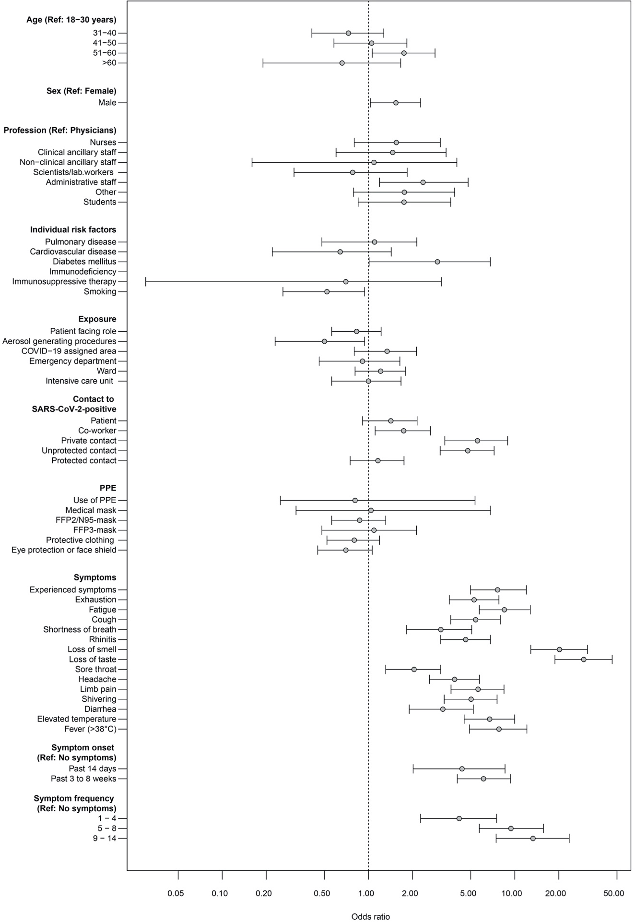
S5 Fig: Graphic representation of all odds ratios for seropositivity to SARS-CoV-2 IgG represented in S1–S3 Tables
Odds ratios with exact 95% confidence intervals (mid-p intervals) are presented. FFP: Filtering face piece, FFP 2: Use of masks with 94% or ≥ 95% filter capacity for particles > 0.6 µm, FFP3: Use of masks with 99% filter capacity for particles > 0.6 µm, Lab: Laboratory, Ref: Reference, PPE: Personal protective equipment.

S6 Figure
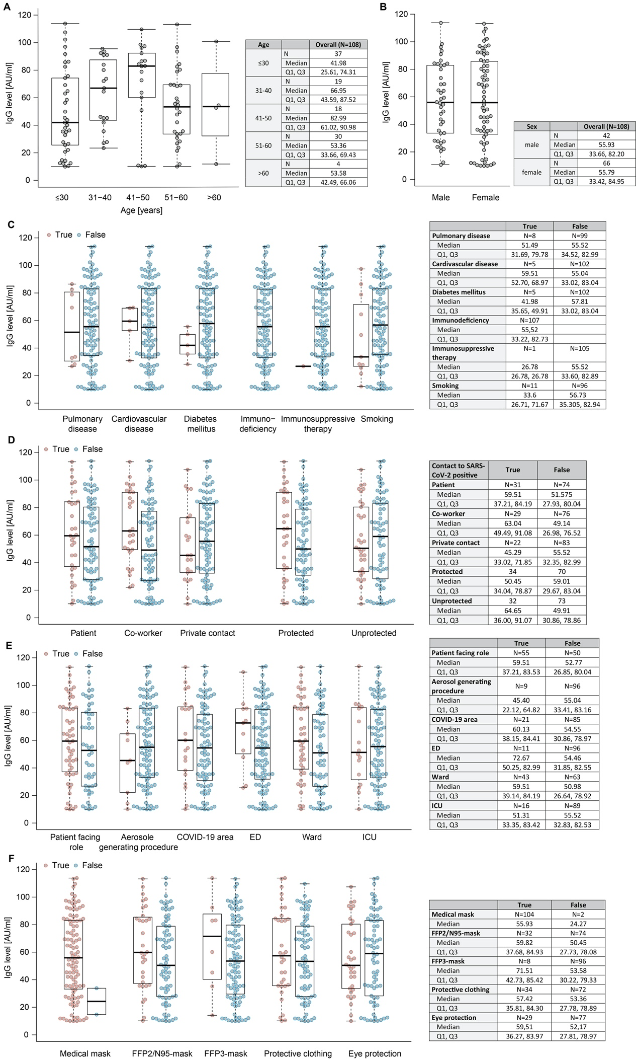

S6 Fig: Distribution of anti-SARS-CoV-2 IgG levels stratified for personal/occupational risk factors
IgG levels were compared in seropositive staff of different age (A), sex (B), and with different comorbidities or smoking status (C), reported COVID-19 contact (D), as well as occupational exposures (E) and use of distinct personal protective equipment. Boxplots show medians (thick middle line), as well as the first and third quartiles (box boundaries), while the whiskers indicate ranges. Medians and quartiles are depicted in the adjacent table. ED: Emergency department, FFP: Filtering face piece, ICU: Intensive care unit.

S7 Figure
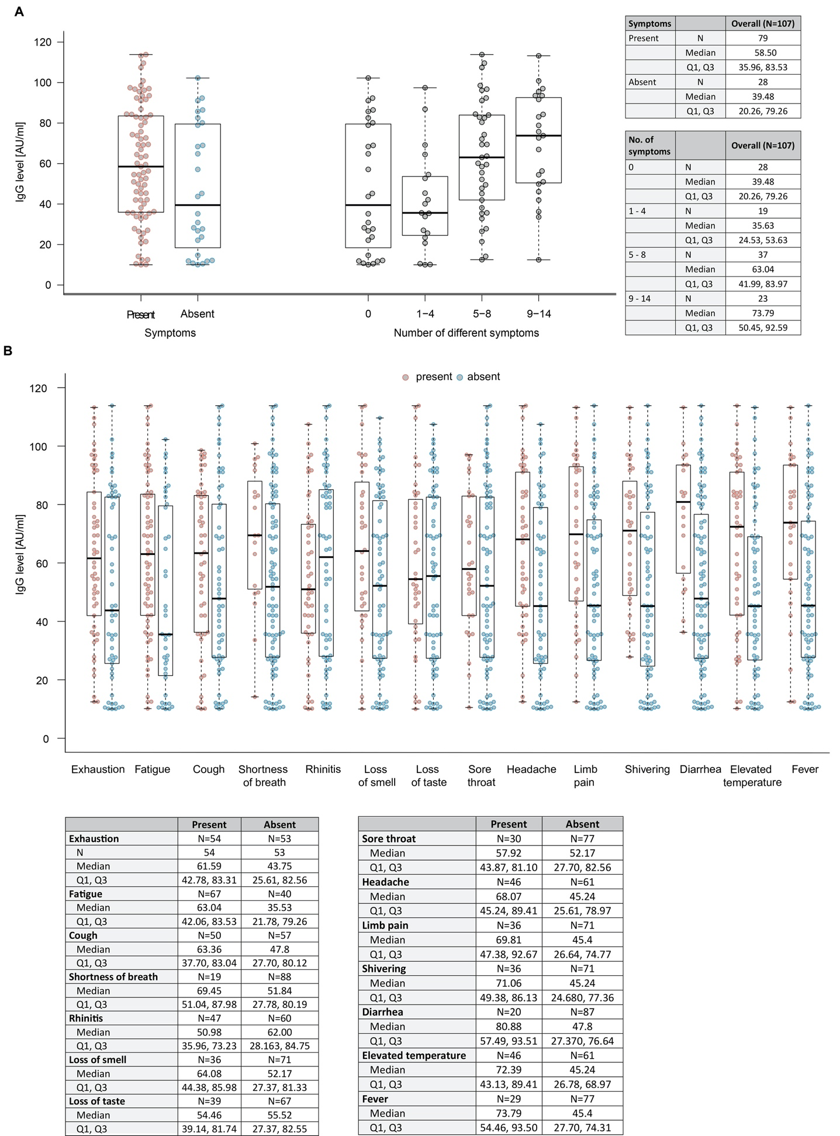
S7 Fig: Anti-SARS-CoV-2 IgG levels and symptoms
Distribution of antibodies stratified for symptom frequency (A) and character (B). Boxplots show medians (thick middle line), as well as first and third quartiles (box boundaries). The values are annotated in the adjacent table. The whiskers indicate ranges. Q: Quartile.

S8 Figure
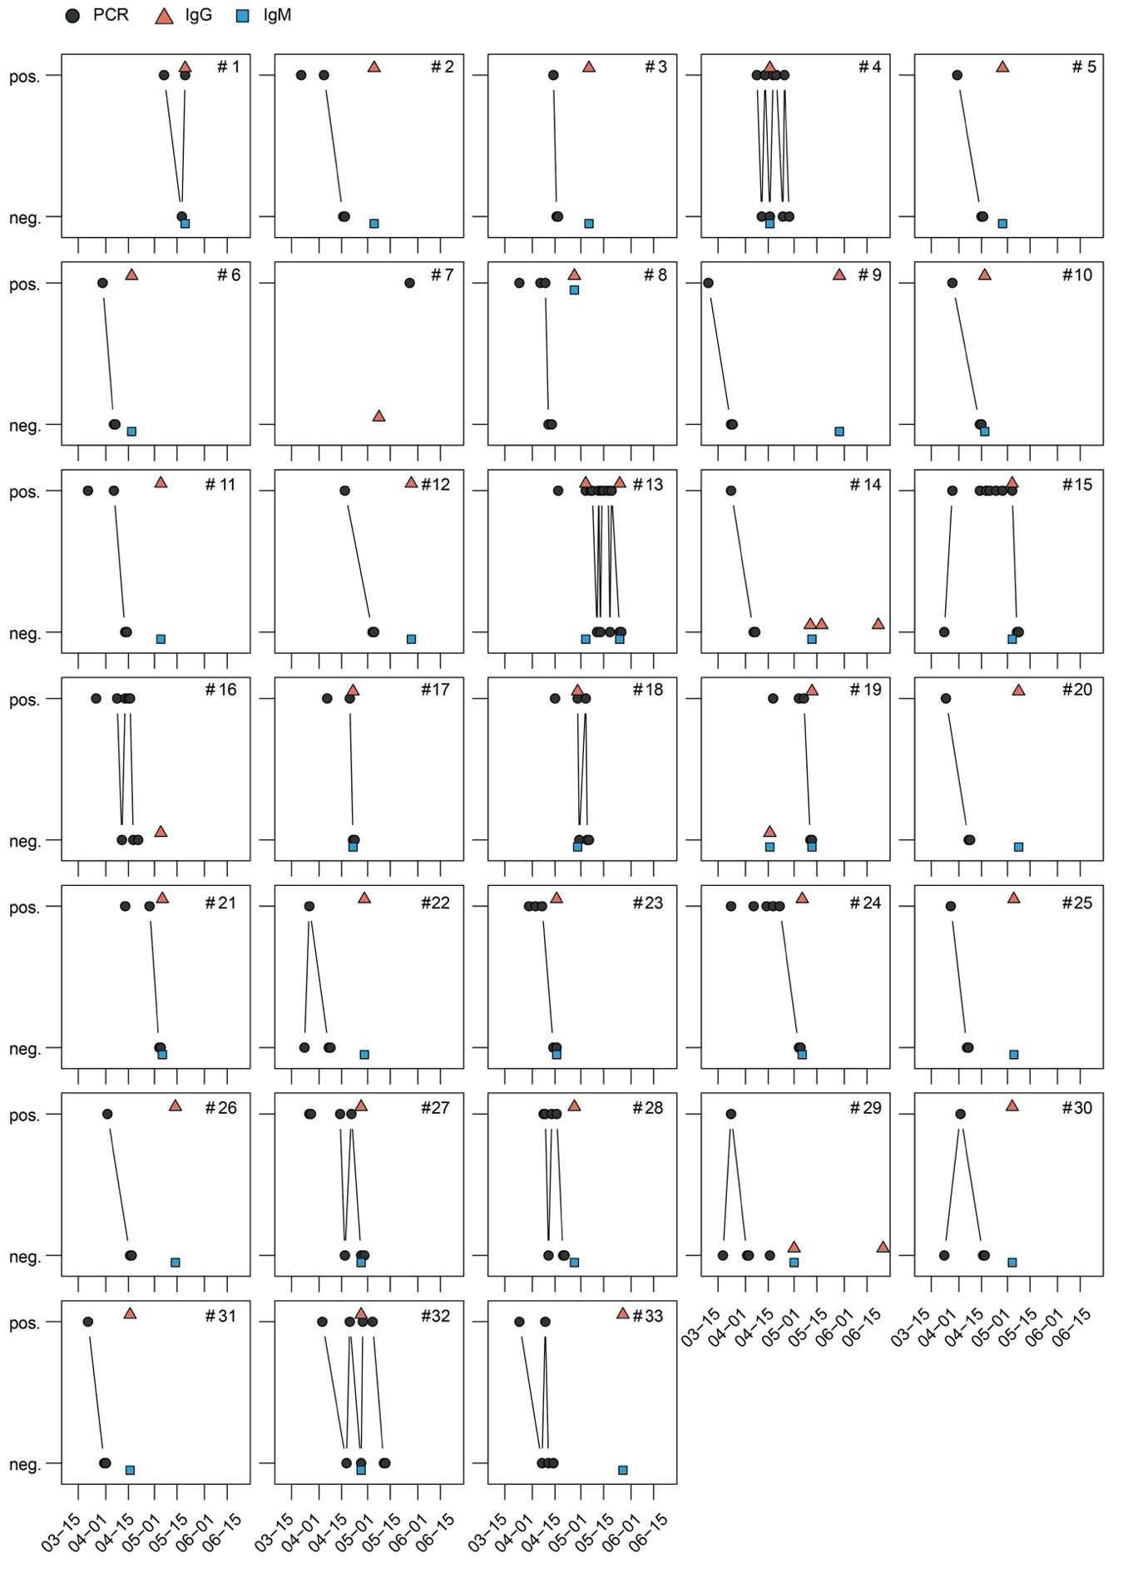
S8 Fig: Time course of anti-SARS-CoV-2 antibody and PCR test results in 33 employees
PCR test results were available for 33 employees (numbered consecutively) who had tested positive for SARS-CoV-2 via PCR at least once. Plots show all anti-SARS-CoV-2 IgG and IgM, as well as PCR tests performed before June 15, 2020, in these subjects. Five subjects (No.’s 7, 14, 16, 19, and 29) tested negative for IgG antibodies at the time of the serosurvey. Seroconversion could be detected in No. 19 on follow-up assessment. Pos: Positive, Neg: Negative.

S1 Video
Time lapse of the relative frequencies of all trajectories for COVID-19 cases
Frequencies in distinct hospital locations were normalized by all timeframes between February 1, 2020 and May 29, 2020. Some patients who later tested positive for SARS-CoV2 were already in the hospital prior to March 6, 2020, and are therefore visualized starting February 1.

S2 Video
Time lapse of the relative frequencies of trajectories available for SARS-CoV-2-positive staff working on campus
Frequencies were mapped for 14 days on their last location before staff either tested positive or were sent to quarantine. Results were normalized by all timeframes between March 22, 2020 to May 29, 2020.

S3 Video
Time lapse of the relative frequencies for the difference in trajectories available for COVID-19 cases and for SARS-CoV-2-positive staff
Frequencies in distinct hospital locations were normalised by all timeframes between February 1, 2020 and May 29, 2020.

For the purposes of discretion, graphic representation of spatial information is partially distorted.

STROBE Statement—Checklist of items that should be included in reports of cross-sectional studies
 | Item No | Recommendation | Page  No
Title and abstract | 1 | (a) Indicate the study’s design with a commonly used term in the title or the abstract | 3
 |  | (b) Provide in the abstract an informative and balanced summary of what was done and what was found | 3
Introduction
Background/rationale | 2 | Explain the scientific background and rationale for the investigation being reported | 5
Objectives | 3 | State specific objectives, including any prespecified hypotheses | 5
Methods
Study design | 4 | Present key elements of study design early in the paper | 7
Setting | 5 | Describe the setting, locations, and relevant dates, including periods of recruitment, exposure, follow-up, and data collection | 7
Participants | 6 | (a) Give the eligibility criteria, and the sources and methods of selection of participants | 7
Variables | 7 | Clearly define all outcomes, exposures, predictors, potential confounders, and effect modifiers. Give diagnostic criteria, if applicable | 7
Data sources/ measurement | 8* | For each variable of interest, give sources of data and details of methods of assessment (measurement). Describe comparability of assessment methods if there is more than one group | 7-9
Bias | 9 | Describe any efforts to address potential sources of bias | 17
Study size | 10 | Explain how the study size was arrived at | 7
Quantitative variables | 11 | Explain how quantitative variables were handled in the analyses. If applicable, describe which groupings were chosen and why | 10
Statistical methods | 12 | (a) Describe all statistical methods, including those used to control for confounding | 10
 |  | (b) Describe any methods used to examine subgroups and interactions | 10
 |  | (c) Explain how missing data were addressed | 10
 |  | (d) If applicable, describe analytical methods taking account of sampling strategy | N/A
 |  | (e) Describe any sensitivity analyses | S3 Appendix
Results
Participants | 13* | (a) Report numbers of individuals at each stage of study—eg numbers potentially eligible, examined for eligibility, confirmed eligible, included in the study, completing follow-up, and analysed | 11
 |  | (b) Give reasons for non-participation at each stage | S1 Fig
 |  | (c) Consider use of a flow diagram | S1 Fig
Descriptive data | 14* | (a) Give characteristics of study participants (eg demographic, clinical, social) and information on exposures and potential confounders | 11, 12
 |  | (b) Indicate number of participants with missing data for each variable of interest | 23, 24
Outcome data | 15* | Report numbers of outcome events or summary measures | 11
Main results | 16 | (a) Give unadjusted estimates and, if applicable, confounder-adjusted estimates and their precision (eg, 95% confidence interval). Make clear which confounders were adjusted for and why they were included | 11, 12
 |  | (b) Report category boundaries when continuous variables were categorized
 |  | (c) If relevant, consider translating estimates of relative risk into absolute risk for a meaningful time period
Other analyses | 17 | Report other analyses done—eg analyses of subgroups and interactions, and sensitivity analyses | 12-14
Discussion
Key results | 18 | Summarise key results with reference to study objectives | 14
Limitations | 19 | Discuss limitations of the study, taking into account sources of potential bias or imprecision. Discuss both direction and magnitude of any potential bias | 17
Interpretation | 20 | Give a cautious overall interpretation of results considering objectives, limitations, multiplicity of analyses, results from similar studies, and other relevant evidence | 18
Generalisability | 21 | Discuss the generalisability (external validity) of the study results | 14
Other information
Funding | 22 | Give the source of funding and the role of the funders for the present study and, if applicable, for the original study on which the present article is based | Online portal

*Give information separately for exposed and unexposed groups.

Note: An Explanation and Elaboration article discusses each checklist item and gives methodological background and published examples of transparent reporting. The STROBE checklist is best used in conjunction with this article (freely available on the Web sites of PLoS Medicine at http://www.plosmedicine.org/, Annals of Internal Medicine at http://www.annals.org/, and Epidemiology at http://www.epidem.com/). Information on the STROBE Initiative is available at www.strobe-statement.org.

