Supplementary material

Supplementary Figure 1: Secondary attack rates from pre-symptomatic index cases to their contacts

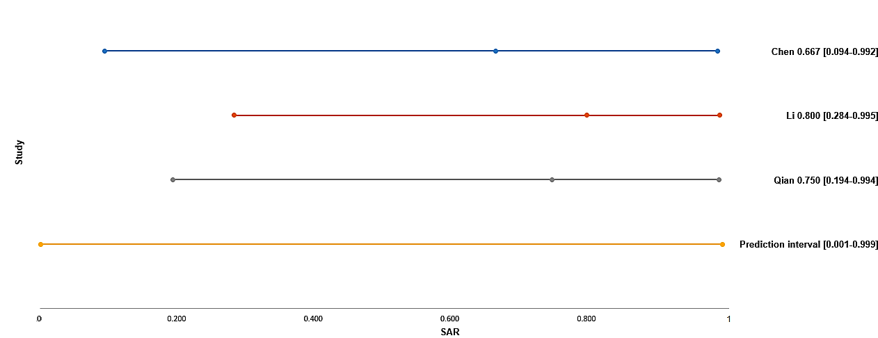

For each study the SAR is reported with its 95% CI.
A prediction interval at the bottom of the forest is depicted.

Supplementary Table 1: Quality assessment of studies

Author | 1. Was the research question or objective in this paper clearly stated? | 2. Was the study population clearly specified and defined? | 3. Was the index case(s) well identified with clear diagnose or demographic information? | 4. Was an acceptable definition of (household, hospital) close contacts used in the study? | 5. Was it including/representing all potential close contacts of the index case(s) based on study question? | 6. Was the settings/environment of the infections clear? | 7. Was an acceptable case definition used in the study (numerator for the research question)? | 8. Was the length of follow-up appropriate to get final outcome of all contacts?
Chaw, et al | Y | Y | Y | Y | Y | Y | Y | Y
Chen M, et al | Y | Y | Y | U | Y | Y | Y | Y
Cheng, et al | Y | Y | Y | Y | Y | Y | Y | Y
Gao, et al | Y | Y | Y | Y | Y | Y | Y | U
Hong, et al | Y | U | Y | Y | U | Y | Y | U
Huang, et al | Y | Y | Y | U | U | Y | Y | Y
Jiang, et al | Y | Y | U | Y | Y | U | Y | Y
Li P, et al | Y | Y | Y | Y | Y | Y | Y | Y
Luo, et al | Y | Y | Y | Y | Y | Y | Y | Y
Mandic-Rajcevic, et al | Y | Y | Y | Y | U | Y | Y | Y
Pang, et al | Y | Y | Y | Y | Y | U | Y | Y
Park, et al | Y | Y | Y | U | Y | Y | Y | Y
Qian G, et al | Y | U | Y | U | Y | Y | Y | Y
Qian, et al | Y | Y | Y | Y | Y | Y | Y | Y
Yang, et al | Y | Y | Y | Y | Y | Y | Y | Y
Ye F, et al | U | Y | Y | U | U | U | Y | U
Zeng, et al | Y | Y | Y | Y | Y | U | Y | Y
Zhang W, et al | Y | Y | Y | Y | Y | Y | Y | Y
Zhao, et al | Y | Y | Y | Y | Y | Y | Y | Y

Search terms

1. (nCoV or n-Cov or 2019-nCoV or "coronavirus disease 2019" or "coronavirus disease-19" or Covid-19 or Covid19 or "novel coronavirus" or COVID or "Middle East Respiratory Syndrome Coronavirus" or "Middle East respiratory syndrome" or MERS or SARS or "severe acute respiratory syndrome" or 2019nCoV or SARS-CoV-2 or Coronavirus or "Corona virus" or corona-virus or "corona viruses" or coronaviruses or SARS-CoV or Orthocoronavirinae or MERS-CoV or "Severe Acute Respiratory Syndrome" or "Middle East Respiratory Syndrome").mp.

2. (secondary attack rate or contact attack rate or close contact or contact transmission or household transmission or contact transmission or contact attack rate or family transmission).mp.

3. ("cluster outbreak*" or "cluster case*" or ((famil* or household) adj4 cluster*)).mp.

4. 2 or 3

5. 1 and 4

6. 5 not (exp animals/ not humans.sh.)

7. limit 6 to last year

